AP Chemistry
Unit 10 IMFs – Liquids, Solids, and Phase Changes
This unit focuses on liquids, solids and phase changes. It addresses Topic II (States of Matter) in the College Board's Advanced Placement Chemistry Topic Outline. In particular it focuses on Liquids and solids. We’ll introduce properties of the condensed states: liquids and solids, beginning with a discussion of the forces that hold molecules together in the condensed states. We'll then explore the properties of liquids and solids that come from these intermolecular forces. We'll look at the four types of crystalline solids: metallic, ionic, molecular, and network. Finally, we'll explore unit cells, the building blocks of solids. In exploring the transitions between states of matter, we'll first look at vapor pressure of liquids and solids. Then, we'll introduce a graphical tool called a phase diagram that depicts the physical state of a substance as a function of temperature and pressure.
Learning Targets
8.1 Distinguish between INTRAmolecular forces and INTERmolecular forces.
8.2 Classify intermolecular forces.
8.3 Justify differences in properties of substances in terms of intermolecular forces.
8.4 Apply the Clausius-Clapeyron Equation to relate the vapor pressure of any substance to temperature
8.5 Interpret phase diagrams and phase changes according to the intermolecular forces.
8.6 Describe forms and properties of solids.

READ AND OUTLINE CHAPTERS 11 AND 12.
CHAPTER 11 PROBLEM SET: 2, 5, 7, 16, 29, 37, 39, 50, 81, 89, 97

Podcast 8.1 Types of Forces Between Molecules
INTRAMolecular Forces = ____________
- Covalent (100)

- Ionic (85)

- Metallic (65)

Intermolecular Forces
- Interaction of molecules with other molecules
- __________________ forces than bonds
- Less energy is required to overcome the force of an intermolecular attraction than a chemical bond.
- Examples of “breaking” intermolecular forces:

  - The stronger the IMF, the ______________ the melting point/boiling point.
Types of Intermolecular Forces
1.
2.
3.
4.
- All are considered __________________________ in nature (attractions between + and – species)
Ion-Dipole Forces
- Exist between an ion and the ______________ ______________ on the end of a polar molecule
- Remember that polar molecules are dipoles and have a dipole moment
Sketch an ion and a dipole below

Dipole-Dipole Forces
- The ___________________ end of one polar molecule is attracted to the __________________ end on another polar molecule.
- Effective only when polar molecules are close together and in correct ____________________
- ___________________than ion-dipole forces
- Dipole-dipole interactions involve both attractive and _____________________ forces
Sketch dipole-dipole interaction below

- Molecules of equal mass and size exhibit stronger intermolecular attractions with increasing ______
Hydrogen Bonding – NOT a true bond!
- Attraction between a hydrogen atom in a polar bond and an unshared electron pair on a nearby small __________________________ ion or atom (generally _____, _____, or _____)
- A strong intermolecular attraction that accounts for high m.p. and b.p., specific heat, and heat of vaporization
- Special kind of dipole-dipole attraction
- Strong because protons are more massive in size than electrons
- Reason ice is ________ ___________ than water
Boiling Points

Hydrogen Bonds in Water
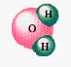

London Dispersion Forces
- Attraction based on ________________ location of one molecule to electron location on a _________________ molecule
- Non - polar molecules also exert forces on each other – otherwise, there would be no nonpolar solids or liquids.
- ____________________ _____________ ________________ can be induced by attraction of opposite dipoles
Sketch Interaction of Oxygen Molecules

- More __________________ molecules (“squishy electron clouds”) have _____________ L-D forces, dependent on shape
- This force increases with ________________ molecule size (larger molar mass)
- Weak, short-lived.
- Lasts longer at low ____________________.
- Explains the trend for bigger molecules, higher melting and boiling points.
- Much, much weaker than other forces.
- Also called ___________ _______ ______________ forces.
Example
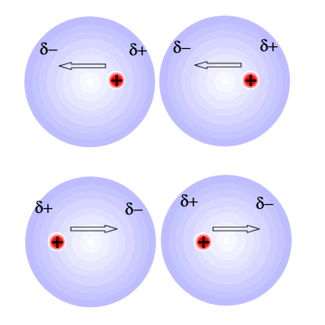
- Vibrations of the nucleus within the electron charge cloud creates a ___________________ dipole, shown here as δ⁺ and δ⁻ charges.
- This causes sympathetic vibrations of the nucleus in _____________________ atoms, so that the δ⁺ and δ⁻ charges become arranged opposite one another (plus near minus, minus near plus)
- There is now attraction between the induced dipole of opposite δ charges on neighboring atoms, creating Van der Waal's forces.
- Eventually all of the atoms or molecules vibrate in unison, making the partial charges ________ ___ enough to hold the structure together.
- When enough energy is given to a substance held together by only Van der Waal's forces, they are overcome and the compound _______________.

Compare Boiling Points of Alkanes
Paraffins C₂₀ and up are low-melting solids (candles)
Asphalt C₃₆ and up only produce gummy residues on heating

Comparing Intermolecular Forces – Complete the Flow-Chart Below

NETWORK COVALENT | METALLIC | IONIC | MOLECULAR COVALENT
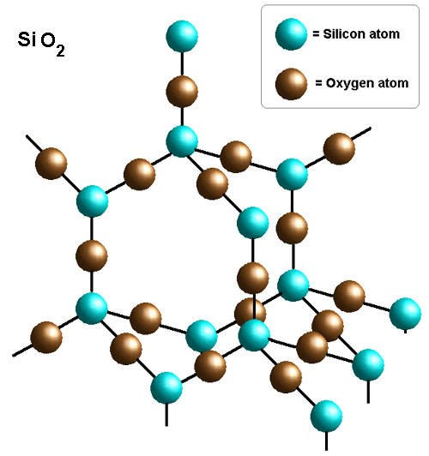 | 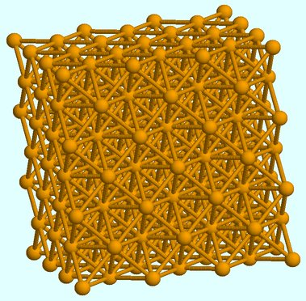 | 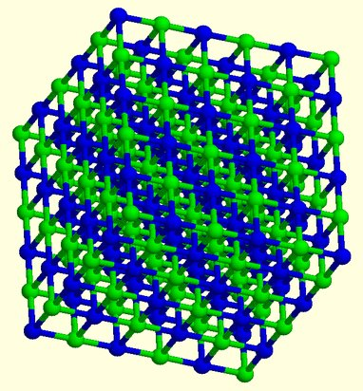 | 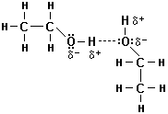  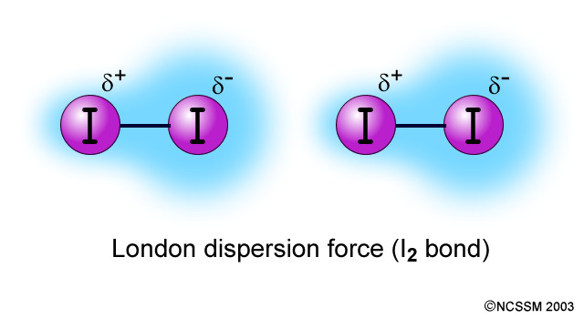
T_{m}: Glass ~1450ºC, Diamond ~3500ºC | T_{m}: 60ºC to over 3000ºC | T_{m}: Can be over 3000ºC | T_{m}: -272 (He) to >100ºC (I₂ is 113ºC)

Assignment 1: Identifying Intermolecular Forces
1. Identify the most important types of inter-particle (between “molecules”) forces present in the solids of each of the following substances
a) BaSO₄
b) H₂S
c) Xe
d) CHCl₃
e) NH₃
2. Predict which substance from the following pairs would have the greater intermolecular forces. (you WILL need to draw the Lewis structures to answer correctly)
a) CO₂ or OCS
b) PF₃ or PF₅
c) SO₃ or SO₂
d) HF or HBr
e) CH₃OH or H₂CO
f) CH₃CH₂CH₂NH₂ or H₂NCH₂CH₂NH₂
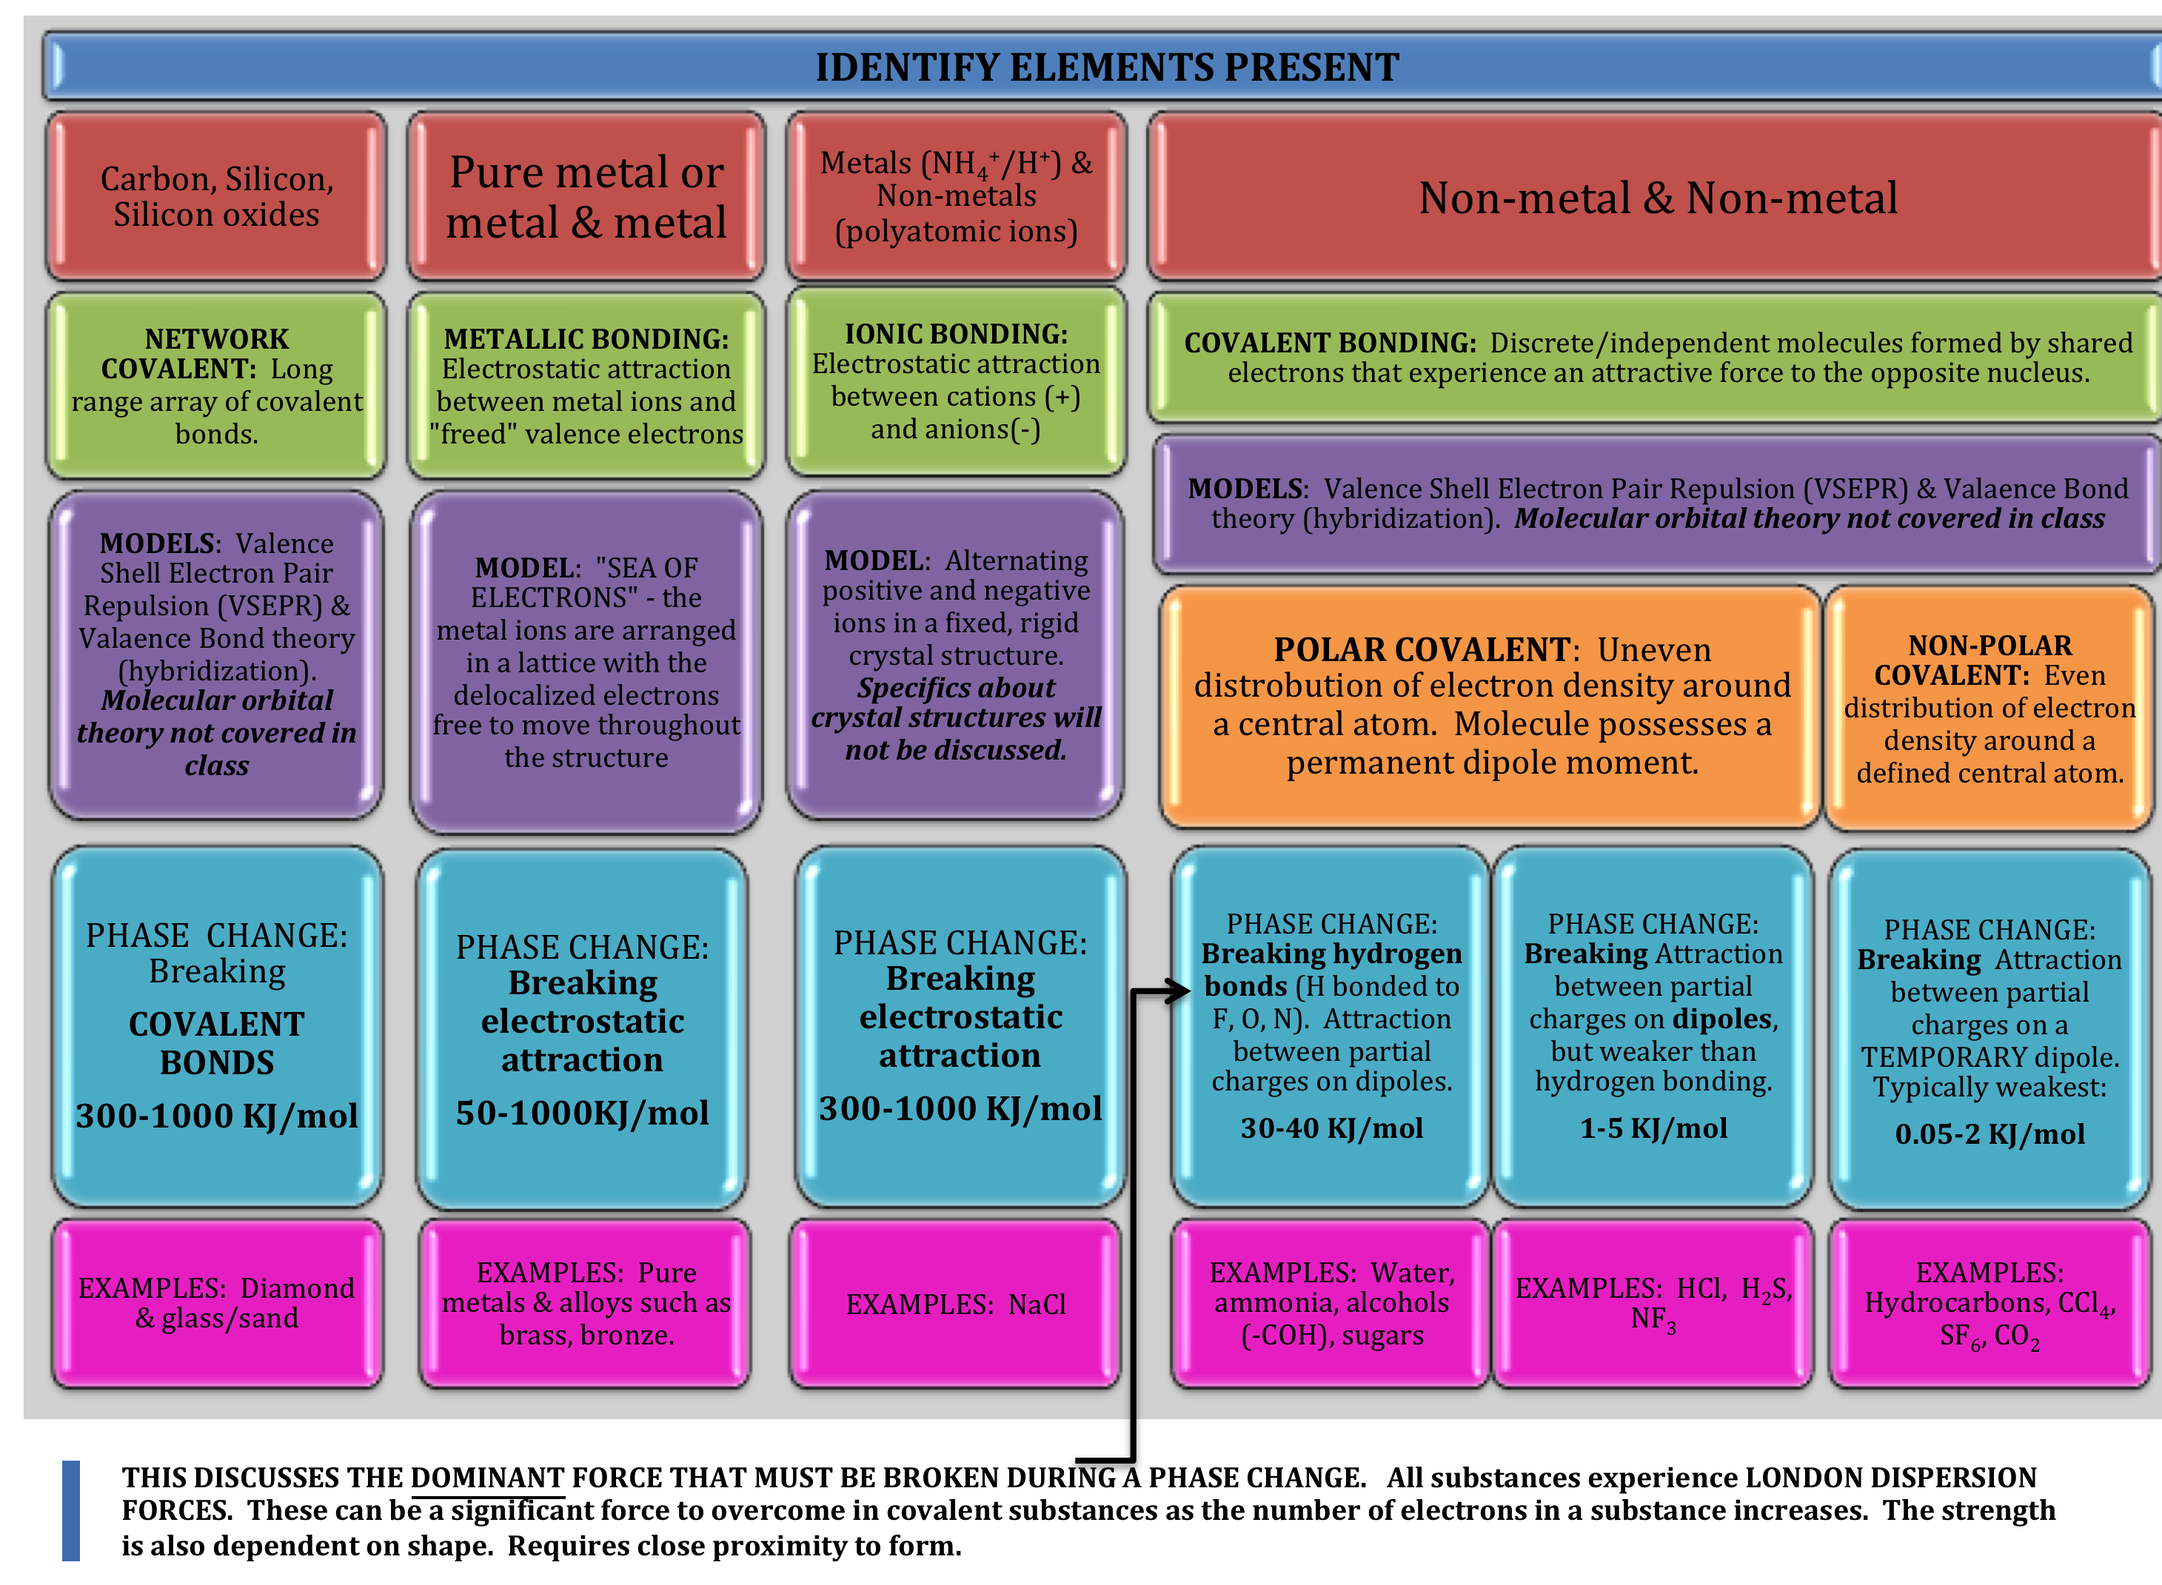
Podcast 8.2 Influence of IMFs on Properties
Properties of Liquids – Many of the properties are due to internal _________________ of atoms.
Viscosity – the resistance of a liquid to _____________.
  - The greater the viscosity, the slower it flows
  - Can be measured as a rate of flow through a metal tube or the rate at which an object falls through the liquid.
  - Viscosity increases with an increase in _______________________________
- Large IMFs = ________________ viscous liquid
- Large molecules can get tangled up.
- Cyclohexane has a _______________ viscosity than hexane because it is a circle- more compact.
Sketch molecular structures of cyclohexane and n-hexane below

Surface Tension: Energy required to increase the surface area of a liquid by a unit amount
- Inward forces that must be overcome
- Atoms at surface are closer together
- Sketch Surface Tension Below: Molecules in the middle are attracted in all directions.

Cohesion vs Adhesion
- Forces that bind similar molecules (such as H-bonding) are called _____________________forces
- Forces that bind a substance to a surface are called ____________________ forces
Example:
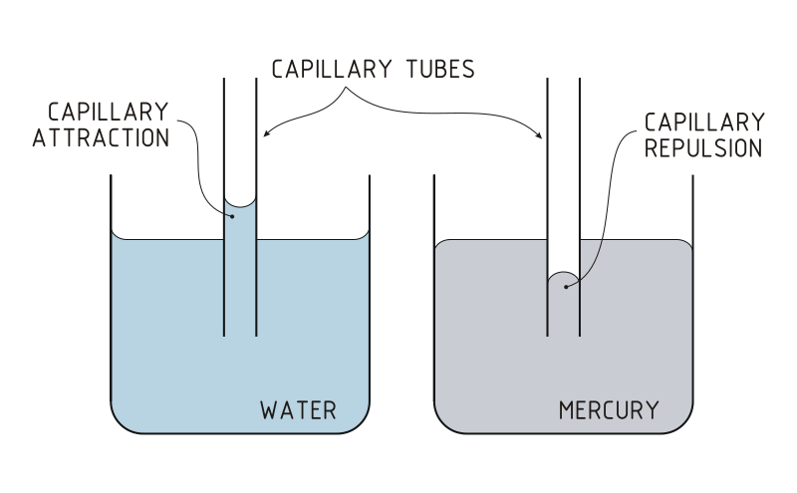
- Water in a glass adheres to the glass because the adhesive force is larger than the cohesive forces of the H₂O molecules

- Mercury is the opposite

Capillary Action
- Liquids spontaneously rise in a narrow tube
- Occurs when a small tube is placed in H₂O and the water rises into the tube
- Glass is ___________. It attracts water molecules

Beading: If a polar substance is placed on a non-polar surface.
  - There are ________________, but no adhesive forces.
  - And Visa Versa
Sketch

Assignment 2: Intermolecular Forces
The following answer choices can be used in questions 1-3. Each answer may be used once, more than once, or not at all.
(A) London dispersion forces
(B) Hydrogen bonding
(C) Dipole-dipole intermolecular forces
(D) Ionic bonding
(E) Covalent bonding

- The interaction that occurs between molecules of water but NOT between molecules of chlorine.
- The interaction that occurs between molecules of hydrogen chloride but NOT between molecules of chlorine
- The interaction that accounts for the increasing melting and boiling points of the halogens on descending group 17.

- When sodium chloride dissolves in water, which of the following statements is true?
I. As part of the process, the lattice energy of the sodium chloride must be overcome.
II. The attraction between the sodium and chloride ions and the water molecules can be
described as an ion-dipole interaction.
III. The polarity of the water molecules is essential to the process.

(A) I only
(B) II only
(C) III only
(D) I and II only
(E) I, II, and III

5. Which of the following molecules will have London dispersion forces that form some part of the intermolecular attractions present?
I. Fluorine, F2
II. Ammonia, NH3
III. Hydrogen fluoride, HF

(A) I only
(B) III only
(C) I and II only
(D) II and III only
(E) I, II, and III

6. Which of the following has the substances listed in order of increasing boiling point?
I. Water < nitrogen < ammonia
II. Nitrogen < water < chlorine
III. Chlorine < bromine < iodine

(A) I only
(B) II only
(C) III only
(D) II and III only
(E) I, II, and III

7. Which of the following statements is true on descending group 17?
I. The boiling points of the halogen molecules decrease.
II. The molecules become more polarizable.
III. The dipole-dipole intermolecular interactions increase.

(A) I only
(B) II only
(C) III only
(D) II and III only
(E) I, II, and III

8. 2008 FRQ #6 Answer the following questions by using principles of molecular structure and intermolecular forces.

a) Structures of the pyridine molecule and the benzene molecule are shown below. Pyridine is soluble in water, whereas benzene is not soluble in water. Account for the difference in solubility. You must discuss both of the substances in your answer.

Pyridine Benzene

b) Structures of the dimethyl ether molecule and the ethanol molecule are shown below. The normal boiling point of dimethyl ether is 250 K, whereas the normal boiling point of ethanol is 351 K. Account for the difference in boiling points. You must discuss both of the substances in your answer.

Dimethyl ether Ethanol

c) SO₂ melts at 201 K, whereas SiO₂ melts at 1883 K. Account for the difference in melting points. You must discuss both of the substances in your answer.

d) The normal boiling point of Cl₂(l) (238 K) is higher than the normal boiling point of HCl(l) (188 K). Account for the difference in normal boiling points based on the types of intermolecular forces in the substances. You must discuss both of the substances in your answer.

Podcast 8.3: Phase Changes
Phase Changes
- Every phase change is accompanied by a change in the ____________________ of the system
- ∆H_{fus} (_______ ___ ___________) – molecules of a solid free up, having more ability to move.
- ∆H_{vap} (_______ ___ __________________) – molecules of a liquid break free
- ∆H_{vap} is almost always larger in comparison to ∆H_{fus} WHY?
Explain

- ∆H_{sub} (_______ ___ ___________________) – molecules transition from a solid to a gas
- ∆H_{sub} = ∆H_{fus} + ∆H_{vap}
Example: A 5.00 g sample of H₂O is removed from a freezer and heated from an initial temperature of -5.00ºC to a final temperature of 102.0ºC.
- Given the following data, calculate the amount of energy that has to be absorbed by the H₂O during the whole process.
Freezing point of H₂O=0.00ºC; Boiling point of H₂O = 100.ºC
ΔH_{fus} of H₂O = 6.01 kJmol⁻¹
ΔH_{vap} of H₂O = 40.7 kJmol⁻¹
specific heat capacity of water = 4.18 Jg⁻¹K⁻¹
specific heat capacity of steam = 2.08 Jg⁻¹K⁻¹

- Calculate the percentage of the total energy required for the overall process in a) that is used just in heating the liquid water.

- Calculate the mass of ice at 0.00ºC that can be melted in 30 minutes by a heater that produces 8000 kJ of energy per hour but in such a way that only 70% of the heat produced is absorbed by the ice.

Phase Diagrams
- A graphical way to summarize the conditions under which __________________________ exist between different states of matter
- Predicts the phase of a substance at a given temperature and pressure
Interpreting a Phase Diagram
- Critical Temperature: The highest temperature at which a distinct liquid phase can form
- Critical Pressure: pressure required to bring about liquefaction at this critical temperature
- ______________ and/or low __________ ___________ substances have lower values for critical temperature and pressure

Vapor Pressure: The pressure exerted by a vapor in the ________________________________________
- ______________ intermolecular forces = ________________ vapor pressure
- _________________ Equilibrium: rates of changing from gas to liquid and liquid to gas is the same
- Volatile Liquids: substances with higher vapor pressure that allow liquids to evaporate to dryness (no dynamic equilibrium exists)
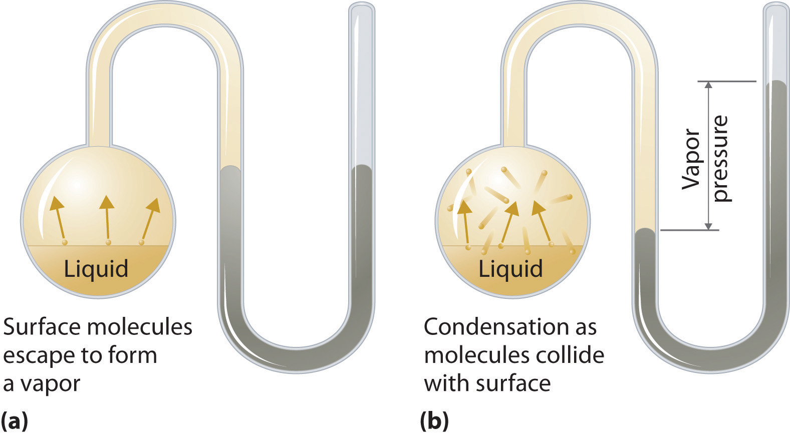
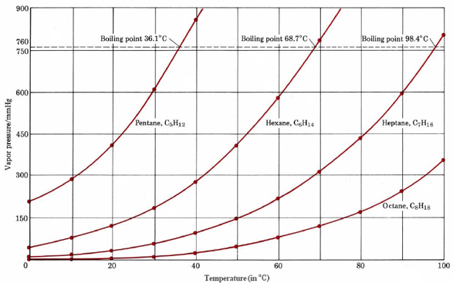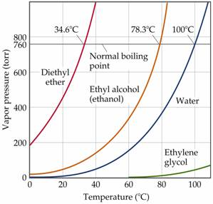
Boiling
- Liquids boil when the vapor pressure equals the _________________ pressure acting on the surface of the liquid.
- Bubbles of vapor form within the interior of the liquid
- Lower pressure = _______________ boiling point
- Vapor pressure and temperature are related through The Clausius-Clapeyron Equation

Assignment 3: Interpreting Phase Diagrams
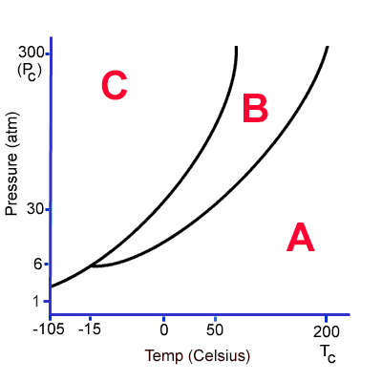
1. The area of the graph that represents the liquid phase is:
    - C
    - B
    - A
2. Condensation occurs by:
A. release of energy
B. absorption of energy
- At 30 atmospheres pressure, the melting point of this substance is:
  - 200 ºC
  - 0 ºC
  - 50 ºC
  - -15 ºC
  - -105 ºC
- At 30 atmospheres pressure, the boiling point of this substance is:
  - 0 ºC
  - -15 ºC
  - -105 ºC
  - 50 ºC
  - 200 ºC

- A phase change from Phase C to Phase A is known as:
  - Melting
  - Condensation
  - Vaporization
  - Sublimation
  - Deposition
  - Freezing

- Vaporization occurs by:
  - Release of energy
  - Absorption of energy
- A phase change from Phase A to Phase B is known as:
  - Melting
  - Condensation
  - Vaporization
  - Sublimation
  - Deposition
- Above 300 atm (P_{c}), this substance cannot exist as:
  - A solid
  - A liquid
  - A gas
- If the temperature of the substance is held constant at -15 ºC, the phase change that would occur with a pressure increase from 1 atmosphere to 30 atmospheres is:
  - Melting
  - Condensation
  - Vaporization
  - Sublimation
  - Deposition
  - Freezing

- Sublimation occurs by:
  - Release of energy
  - Absorption of energy

- A phase change from Phase A to Phase C is known as:
  - Melting
  - Condensation
  - Vaporization
  - Sublimation
  - Deposition
  - Freezing

- At STP, this substance can exist as:
  - A solid only
  - A liquid only
  - A solid or a gas
  - A gas only

- A phase change from Phase B to Phase A is known as:
  - Melting
  - Condensation
  - Vaporization
  - Sublimation
  - Deposition
  - Freezing

- Freezing (solidification) occurs by:
  - Release of energy
  - Absorption of energy
- Melting occurs by:
  - Release of energy
  - Absorption of energy

- Deposition occurs by:
  - Release of energy
  - Absorption of energy

- The triple point of this substance occurs at:
  - 200 ºC and 300 atm
  - -15 ºC and 6 atm
  - 0 ºC and 6 atm
  - -15 ºC and 1 atm

- Above 200 ºC (T_{c}), this substance can only exist as:
  - A solid
  - A liquid
  - A gas

- The area of the graph that represents the gas phase is:
  - A
  - B
  - C

- A phase change from Phase C to Phase B is known as:
  - Melting
  - Condensation
  - Vaporization
  - Sublimation
  - Deposition
  - Freezing

- A phase change from Phase B to Phase C is known as:
  - Melting
  - Condensation
  - Vaporization
  - Sublimation
  - Deposition
  - Freezing

- The area of the graph that represents the solid phase is:
  - A
  - B
  - C

Assignment 4: Clausius-Clapeyron Equation
Temperature (°C) | Water Vapor Pressure (mm Hg)
0 | 4.58
20 | 17.54
40 | 55.32
60 | 149.38
80 | 355.1

(a) From the data in the above table, use a graph to find the standard enthalpy of vaporization of water.
(b) Find the boiling point temperature of water when the ambient pressure is 1 atm.

Podcast 8.4: Forms and Properties of Solids
Structures of Solids
- Crystalline Solid – atoms, ions, or molecules are ordered in ___________________ arrangements
  - Have flat surfaces, or faces
  - Definite angles
  - Regular shapes – “structured”
- Amorphous Solid – solid whose particles have no orderly structure
  - Lack of well-defined faces and shapes
  - Mixtures of molecules that do not ___________together well
  - Generally composed of large, complicated molecules
- Crystalline solids – melts at a ______________ temperature
- Amorphous solids – soften over a ________________________ of temperatures.
- Metals and Alloys
  - Substitutionary (brass)

  - Interstitial (steel)

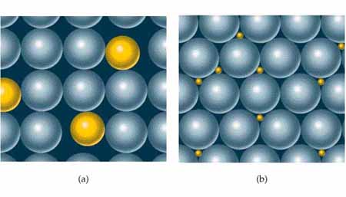
Bonding Models for Metals
- _______________: A regular array of metals in a “sea” of electrons. Metals conduct heat and electricity very efficiently because of the availability of highly mobile e⁻
- Metallic Bonds: Band (_______________ _________ Model: Electrons assumed to travel around metal crystal in MOs formed from valence atomic orbitals of metal atoms.
- Network Solids: Composed of strong directional _________________ bonds that are best viewed as a “giant molecule”. (Examples: graphite, diamond, ceramics, glass )

Assignment 5:
1. Which one of the following statements does not describe the general properties of solids accurately?
a. Solids have characteristic volumes that do not change greatly with changes in temperature.
b. Solids have characteristic volumes that do not change greatly with changes in pressure.
c. Solids diffuse only very slowly when compared to liquids and gases.
d. Solids are not fluid.
e. Most solids have high vapor pressures at room temperature.

2, Which one of the following statements is not applicable to molecular solids?
a. The units that occupy the lattice points are molecules.
b. The binding forces in molecular solids are dispersion forces or dispersion forces and dipole-dipole interactions.
c. Molecular solids have relatively low melting points.
d. Molecular solids are usually excellent conductors of electric current.
e. Molecular solids are soft compared to covalent solids.

3. Which one of the following is a covalent solid?
a. sulfur trioxide
b. nickel
c. ammonium chloride
d. silicon carbide, SiC
e. sucrose, C12H22O11

4. Which one of the following is an ionic solid?
a. graphite
b. nickel
c. ammonium chloride
d. silicon carbide, SiC
e. sucrose, C12H22O11

5. Which one of the following crystallizes in a metallic lattice?
a. C10H8
b. graphite
c. In
d. LiF
e. KMnO4

6. Which one of the following pairs is incorrectly matched?

Substance
a. H2O
b. paraffin
c. KF
d. CsI
e. Ni
Classification
molecular solid
molecular solid
ionic solid
covalent solid
metallic solid

7. Which of the following compounds would be expected to have the highest melting point?
a. BaF2 b. BaCl2 c. BaBr2
d. BaI2 e. NaF

8. Arrange the following in order of increasing melting points.
KCl, He, H2O, HF
a. He < H2O < HF < KCl b. H2O < HF < He < KCl c.KCl < H2O < HF < He d. He < HF < H2O < KCl e. H2O < He < KCl < HF
Assignment 6: Unit 8 Review
1. Describe the interparticle forces at work in the following:

a. within a water molecule H₂O
b. in a crystal of the salt NaCl
c. in a solution of potassium nitrate
d. in diamond
e. in a fiber of nylon
f. in liquid butane
g. between water molecules in ice
h. between the two strands in the double helix of DNA
i. in paraffin wax
j. between the molecules of carbon dioxide CO₂ in dry ice
k. between the molecules of HCl in liquid HCl
l. in tungsten metal
m. in a solution of perchloric acid

2. Which one of the following pairs of molecules would you expect to have the higher melting point?

a. Cl₂ or Br₂
b. C₄H₁₀ or C₅H₁₂
c. NH₃ or PH₃
d. Na or Mg
e. BeO or KCl
f. ICl or Br₂

3. Which states or types of matter would be characterized by each of the following statements?
a. High individual molecular speeds.
b. A melting point spread over a wide temperature range.
c. A regular repeating array of structural units.
d. Molecules move with respect to one another but are held together in a condensed state.
e. Molecules close together but having sufficiently high kinetic energies to overcome the intermolecular forces.
f. Valence electrons delocalized over huge arrays of atoms.
g. Totally random molecular order with comparatively great distances between individual molecules.
h. A three-dimensional network of covalent bonds.

4. Acetone and chloroform form an unusually strong intermolecular bond. Why is this? Draw a picture of how the molecules attract each other.

5. a. How much heat is required to melt 15 grams of ice at 0°C?
b. How much heat is released when 100 grams of steam condenses at 100°C?
c. If a system of ice and water has a mass of 12 grams, and it is converted completely to water at 0.0°C by supplying 1.33 kJ of heat, how much water was initially present?

Heat of fusion of ice = 333 J/g Heat of vaporization of water = 2250 J/g

6. Solve Problem 11.89 in your textbook using the Clausius-Clapyeron Equation.

7. List five alloys that contain copper, underlining those that are greater than 50% copper.

8. What is pewter? Give its composition and a use. Which metal dominates the composition?

9. What is an amalgam? Which metal dominates the alloy? Give a use for an amalgam.

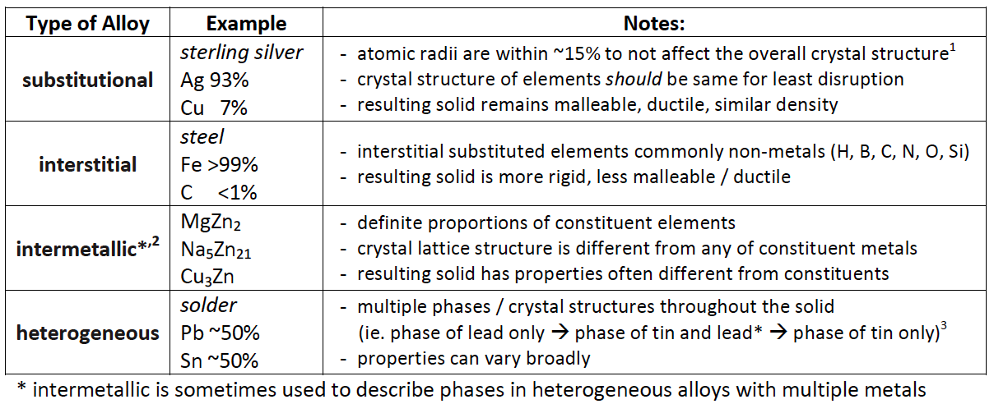
10. A student is assigned the task of determining the mass percent of silver in an alloy of copper and silver by dissolving a sample of the alloy in excess nitric acid and then precipitating the silver as AgCl. First the student prepares 50. mL of 6 M HNO3 .
The student is provided with a stock solution of 16 M HNO3 , two 100 mL graduated cylinders that can
be read to ±1 mL, a 100 mL beaker that can be read to ±10 mL, safety goggles, rubber gloves, a glass stirring rod, a dropper, and distilled H2O.
- Calculate the volume, in mL, of 16 M HNO3 that the student should use for preparing 50. mL of 6 M HNO3 .
- Briefly list the steps of an appropriate and safe procedure for preparing the 50. mL of 6 M HNO3. Only materials selected from those provided to the student (listed above) may be used.
- Explain why it is not necessary to use a volumetric flask (calibrated to 50.00 mL ±0.05 mL) to perform the dilution.
- During the preparation of the solution, the student accidentally spills about 1 mL of 16 M HNO3 on the bench top. The student finds three bottles containing liquids sitting near the spill: a bottle of distilled water, a bottle of 5 percent NaHCO3(aq), and a bottle of saturated NaCl(aq). Which of the liquids is best to use in cleaning up the spill? Justify your choice.

PAPER CHROMATOGRAPHY LAB
INTRODUCTION/THEORY
The process of chromatography involves a means of separating mixtures of materials based on differences in migration rates among sample components. All chromatographic methods have in common the use of a stationary phase and a mobile phase. Components of a mixture are carried through the stationary phase by the flow of a gaseous or liquid mobile phase. The time in which components flow differs with the interaction of each component with the stationary phase, leading to differences in time of travel. Thus, parts of the mixture emerge at the other end of the stationary phase at different times (see figure 1).
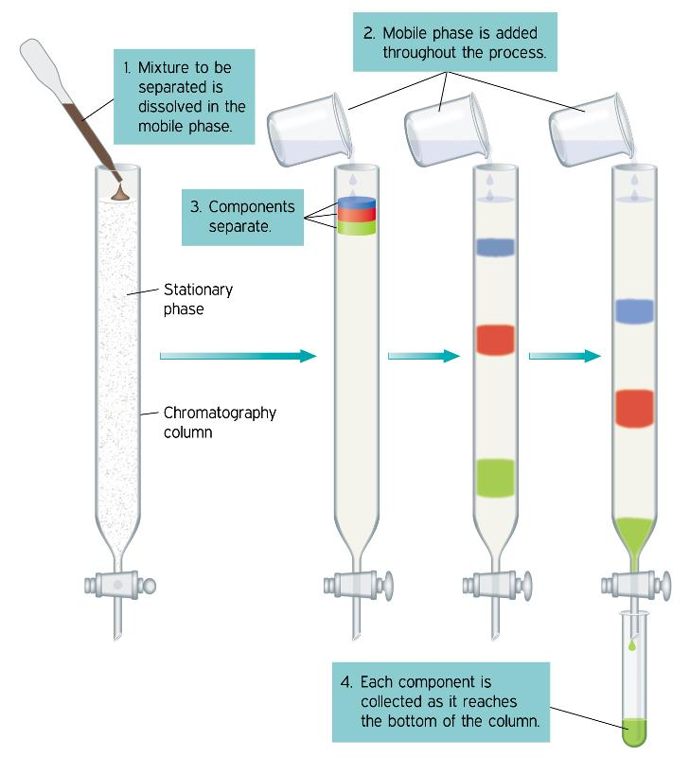
Paper chromatography makes use of a flat, relatively thin layer of material (such as filter paper) that is either self-supportive or is coated. The mobile phase moves through the stationary phase by capillary action. The theory behind how paper chromatography works is identical to column chromatography, but instead of packed columns the columns are flat media.
All important data from paper chromatography comes from movement of substances, particularly the distance moved by the component in question along the paper related to the overall movement of the solvent. This can be represented mathematically by the retardation factor, R_{f}:
Rf = Ds/Df
where Ds and Df are the distances moved by the unknown component and solvent, respectively. The lab that will be done following this discussion deals with paper chromatography techniques. The goal will be to obtain Rf values for all unknown dyes in question (See figure 2 below).

OBJECTIVE
The goal of this experiment is to show how ink can be separated into its component dyes by chromatography. This is an illustration of an important technique used in all chemical sciences.

PROCEDURE

I. Separation of Ink

- Put a 50 mL of 0.1 M NaCl in a beaker or flask, so as to barely cover the bottom. Cover the flask with parafilm to allow the solvent vapors to saturate the air inside the flask.
- Cut a strip of filter paper about 15 cm long. Mark the paper with a horizontal PENCIL line 2 cm from the bottom.
- Place a 2 mm spot of ink from a black marker in the middle of the bottom line. With a PENCIL, label the strip with the BRAND of marker you used and the solvent, NaCl.
- Place the paper with the spot down into the solvent. The spot should not touch the solution in the bottom of your beaker/bottle!!! The strip should also not touch the sides of the glassware.
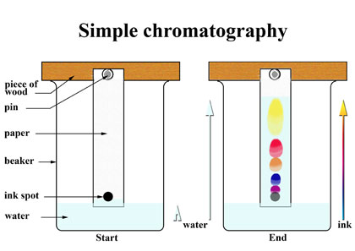
- Remove the paper from the solvent when the solvent has advanced to within about 2 cm from the top of the paper. MARK the top point that the solvent actually advances.
- On a separate sheet of paper labeled DATA, both group members should trace their chromatograph, labeling all pertinent information. Included in this should be the colors produced in the separation and the following distances:
  - Distance traveled by solvent in cm (a constant, Df)
  - Distances traveled by the leading edge of the colored dyes (Ds) and
  - Rf values (Rf = Ds/Df)
- Repeat the above using distilled water then with isopropyl alcohol in the beaker/bottle instead of salt water. Compare the color patterns produced with each solvent.

II. Radial Chromatography (Refer to figure 3 for assistance in setup)
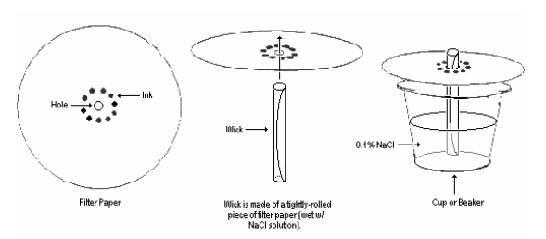
This part of the lab gives you and your lab partner an opportunity to be artistic. Step 3 below is meant to follow figure 2, but you are permitted to make any distribution of dots around the center. You can try to spell things, make a design, or whatever. Be creative!
Each person can do a radial chromatograph if they want. Two can be done simultaneously.

- Cut a circular piece of filter paper into 8 pie shaped wedges. These wedged shaped sections will serve as wicks. Obtain a wedge and roll it into a cone.
- Punch a pencil sized hole in the center of a second piece of filter paper.
- Place a series of 6-8 one cm spots of water soluble ink (you may use any colors!) around the hole in the second filter paper. The ink spots should be dark and concentrated. On your data sheet draw a picture of your setup with the colors of markers that make up each dot. We want to know the mixtures of colors that go into each color tested.
- Roll up the paper wedge from part one and insert it into the hole in the filter paper.
- Fill your Petri dish to within a few mm of the top.
- Set the circle on top of the dish with the wick down in the water. Watch what happens as the water spreads out over the filter paper. Record all observations on your data sheet.
- When the water has advanced to within 1-2 cm of the outside edge of the paper, carefully lift off the paper, remove the wick and place it on a new beaker to dry.
- Display your chromatograph proudly.

CALCULATIONS

Calculate the Rf values for both the ink/water and ink/alcohol systems in part I. These calculations should be on your data sheet you made above.

QUESTIONS
- (a) Why do the colored bands appear at different positions on the chromatography paper? Discuss in terms of interactions between the dyes in the ink and the water.
(b) Which colored dye from the ink from part I was most strongly attracted to the solvent? Explain
your choice.

- How did the behavior of the dyes differ in the two solvents (water vs. alcohol)? Explain.

- Provide an example on how paper chromatography could be used in real life.

- Name two other separation techniques used by scientists, describe how they work, and give a practical application.

- Describe the mixtures of colors that go into some of the colors you tested (use part II for help). Are there any colors that seem to consist of only one color? What are they?

- Different brands of pen create different separation patterns. List some factors you would think would affect the separation patterns of different pens.

