**AP Chemistry Unit 8 Atomic Structure and Periodicity**

**Unit 8 Problem Set**

Ch 6, p 251; 3, 9, 29, 33, 49, 71

Ch 7, p 292; 9, 13, 17, 21, 25, 39, 67

Read and Outline Chapters 6 and 7 in Your AP Chem Textbook. You may also need to review your outline of Chapters 1 and 2. You should be able to answer the following review questions about the structure of atoms. If necessary, go to my website and click on General Chemistry, Unit 3 to review Atomic Structure.

|  |  |  |  |
| --- | --- | --- | --- |
| **Big Idea 1: Atomic Structure** | | | |
|  | Achievement Level 3 | Achievement Level 4 | Achievement Level 5 |
| ***Periodicity*** | Uses the shell structure of the atom to determine electron configurations and relates these to the structure of the periodic table. Communicates the form and basic consequences of Coulomb's law. Recounts the shape of the *s*and *p* atomic orbitals. | Portrays the properties of atoms and/or binary compounds by recounting periodic trends. Relates what evidence regarding the atom requires shifts between different models of the atom. Analyzes elementary atomic data/properties through the context of the shell model of the atom. | Given a set of data, delineates periodic trends, or deviations from periodicity, using Coulomb's law, including electron shielding and the concept of effective nuclear charge. Uses the concept of periodicity in predicting reactivity and properties of binary compounds. Relates the agreement between data and various models of the atom, and how this influences the utility of a particular model. |
| ***Spectroscopy*** | States the types of molecular motions that are related to the different spectral ranges. Applies Beer's law to calculate energy of a photon. Uses conservation of energy to connect energy of the photon to the energies involved in the processes induced by the photon | Justified the choice of a particular type of spectroscopy to probe a target aspect of a molecule. Interprets data from a spectroscopy experiment involving Beer's law. Communicates the basic structure of a spectroscopy experiment (light of different wavelengths is passed through a system, and the amount absorbed or emitted is measured). Relates mass spectra to abundances of the relevant chemical species. | Designs an experiment involving spectroscopy to quantify amount of a substance. Interprets data in which spectroscopy is used for qualitative analysis, e.g., connecting the data to symbolic representations such as electron configurations, or affirming that spectral patterns often indicate the presence of a particular functional group. |

**NOVA Video Discussion Questions—Atoms: The Space Between**

****[**http://www.youtube.com/watch?v=kypne21A0R4**](http://www.youtube.com/watch?v=kypne21A0R4)

1. What are some characteristics of the "space" inside an atom?
2. If an atom is mostly empty space, what keeps other matter from moving through the space inside an atom?
3. To get an idea of the size of the parts of an atom, including the nucleus and the amount of space, the video segment compares a courtyard at Cambridge University and a bit smaller than a grain of sand. Think of another comparison that uses places or objects that are familiar to you.

**Assignement #1: ATOMIC STRUCTURE REVIEW**

1. What are cathode rays? Why are they called cathode rays? Do the cathode rays have a charge, if so what is the charge on each particle?
2. What are the differences in charge and mass among protons, neutrons, and electrons?
3. A particular atom of potassium contains 19 protons, 19 electrons, and 20 neutrons. What is the atomic number of this atom? What is the mass number? Write the symbol for this potassium nucleus in isotope notation.
4. How many electrons, neutrons, and protons are in neutral atoms of chlorine with a mass number of 35?
5. Yttrium was discovered in 1794. It is one of the elements used in superconductors. How many electrons, protons, and neutrons are in an atom of yttrium-88 (neutral state)?
6. How many neutrons and protons are in each of the following nuclides?
7. carbon-14
8. phosphorus-32
9. nickel-63
10. iridium-192
11. iron-54
12. neptunium-235
13. ****Find the average atomic mass of the unknown element if the relative amounts are as follows

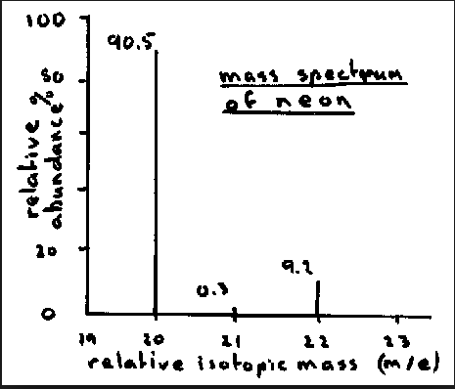8. Use the data provided in the graph to determine the average atomic mass of neon.

9. Complete the following table:



**Podcast 6.1 Electromagnetic Waves**

_____________________ is made up of electromagnetic radiation.

Electromagnetic Radiation consists of __________ of electric and magnetic fields at right angles to each other.

**Parts of a wave**

1.

2.

3.

**Kinds of EM waves**

* There are many types of EM waves
* Each has a different __________ and _________
* _____________ is only the part our eyes can detect.

**The speed of light**

* Speed of Light, c, in a vacuum is ___________
* c =

Example 1: What is the wavelength of light with a frequency 5.89 x 105 Hz?

Example 2: What is the frequency of blue light with a wavelength of 484 nm?

* Matter and energy were seen as ________________________ from each other in fundamental ways.
* Matter was made of _____________________.
* Energy could come in ___________________.
* **Max Planck** found that as the cooling of hot objects could NOT be explained by viewing energy as a ____________.

Energy is Quantized

* Planck found E came in chunks with a predictable magnitude
* where n is an _________________ and h is _____________ ____________________
* h = _____________________________
* these “packets” of h are called ______________

**Albert Einstein**: electromagnetic radiation is quantized in particles called ______________.

* Each photon has measureable energy
* Combine this with ______________________
* You get the apparent mass of a photon.

**Which is it?**

* Is energy a wave like light, or a particle?
* _____________-______________ __________________ describes the nature of energy to exist as both a particle and a wave.
* What about the other way, is **matter** a wave?

**Evidence for Wave-Particle Duality: Diffraction Patterns**

* When light passes through, or reflects off, a series of thinly spaced lines, it creates a rainbow effect
* The waves ____________________ with each other, causing white light to disperse.
* What will an electron do?
* It has mass and volume, so it is matter.
* A particle can only go through ________ slit.
* A wave can go through _________ slits.
* An electron goes though __________ and makes an interference pattern.
* Taken INDIVIDUALLY, it behaves like a ________________.
* Taken AS A WHOLE, they behave like a ________________.
* <http://rdg.ext.hitachi.co.jp/rd/moviee/doubleslite-n.wmv>

**Matter as a Wave**

* Using the velocity v instead of the wavelength, to describe the speed of the wave, we get…
* De Broglie’s equation
* Can calculate the wavelength of any object.
* **Larger matter has wavelengths ___________ _______________ to notice as predicted by DeBroglie’s Equation.**

Example 3: The laser light of a CD is 7.80 x 102 m.

1. What is the frequency of this light?
2. What is the energy of a photon of this light?
3. What is the apparent mass of a photon of this light?
4. What is the energy of a mole of these photons?

Example 4: What is the wavelength…

1. of an electron with a mass of 9.11 x 10-31 kg traveling at 1.0 x 107 m/s?
2. Of a softball with a mass of 0.10 kg moving at 125 mi/hr?

**Assignment #2: Practice Problems: *Wavelength, Frequency, Energy Content of Light.***

$$c=λν$$

$$E=hν$$

$$E=mc^{2}$$

$$c=3.00x{10}^{8}m/s$$

$$h=6.626x{10}^{-34}J∙s$$

$$Hz=1/s$$

$$λ=\frac{h}{mv}$$

$$m_{e}=9.11x{10}^{-31}kg$$

1. A certain photon of light has a wavelength of 422 nm. What is the frequency of the light? What is the energy of a quantum of this light?
2. What is the energy of a quantum of light with a frequency of 7.39 x 1014 Hz? What is the wavelength of the quantum of this light?
3. A certain red light has a wavelength of 680 nm. What is the frequency of the light? What is the energy of a quantum of this light?
4. A certain blue light has a frequency of 6.91 x 1014 Hz. What is the wavelength of the light? What is the energy of a quantum of this light?
5. The energy for a quantum of light is 2.84 x 10-19 J. What is the wavelength of this light?
6. What is the energy of a quantum of light with a frequency of 4.31 x 1014 Hz?
7. What is the energy of light with a wavelength of 662 nm? First find the frequency in hertz of this wavelength of light.
8. What is the de Broglie wavelength of an electron moving at 80.0% the speed of light.

**Wave Simulation Exploration**

1. Please go to <http://phet.colorado.edu/> and click on *Play with Sims*, then find *Wave on a String* in the category of Physics, Sound and Waves. Click on it and then select *Run now*. You should now see a virtual string wave lab.
2. Wave aspects: Select Pulse mode and click on pulse. Experiment with the various controls. Describe the changes to the wave pulse when you vary each of the 4 controls: amplitude, pulse width, damping, and tension.
3. Using pulse mode, set the tension to high and lower the damping to 1. What happens to a single pulse when it reflects from the 3 different ends: stiff end, loose end, no end.
4. 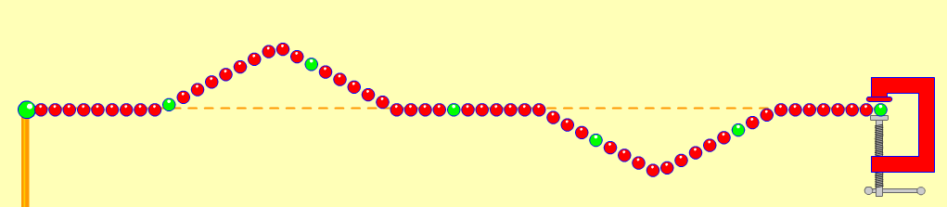Colliding pulses: Set the damping to zero. Using a stiff end, send one pulse then another when the first one starts to reflect. What happens when two opposite pulses collide (as in diagram)? Try it several times. You can use the reset button to clear it. Use the pause and step buttons to help you see it in slow motion. Especially note what happens when the 2 pulses are exactly superimposed.
5. 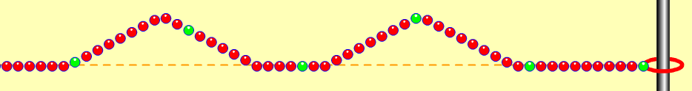Now repeat the above collision experiment using a loose end. What happens when two pulses on the same side collide?
6. Wave speed: Set tension on high and damping zero. Now click on the timer and ruler and determine the velocity of a single pulse. Experiment and see which of the 4 wave controls affects the wave speed. How (increase or decrease?)
7. Standing Waves: Set the amplitude down to 5, and the damping to zero, tension high, fixed end. Select the oscillate mode. Watch the standing waves for a few minutes. Describe what happens to the amplitude. How is this an example of Resonance? What happens if the driving frequency is slightly off? (Try setting f = 49, and f = 51).
8. Use the pause and step buttons to see what the standing wave looks like at various points. Where is the wave energy when it’s flat?
9. The initial frequency display is 50 units. Is this 50 Hertz? How can you tell? Use the timer to time 10 complete vibrations and then calculate the frequency in Hz.
10. How many whole wavelengths are there? Compute the wavelength in meters.
11. Compute the velocity using the wave equation: c = λν. Why should your answer be similar to your result in step 8?
12. Try making standing waves with the *No end* setting. Explain your observations.

**Podcast 6.2: Atomic Spectra**

* Spectrum:
* White light has a ________________spectrum – All the colors are possible.

**Hydrogen Emission Spectrum – Please sketch below**

* Gives off or emits only certain colors
* Called a _________ _____________.
* Only certain energies are “allowed” for electrons in the hydrogen atom.
* Use equation
* Energy in the in the atom is ________________.

<http://phet.colorado.edu/simulations/sims.php?sim=Models_of_the_Hydrogen_Atom>

**Niels Bohr**

* Developed the ______________ model of the hydrogen atom.
* He said the atom was like a ______________ _______________.
* The _________________ were attracted to the __________________ because of opposite charges.
* Didn’t fall into the nucleus because it was moving around (________________).
* Only certain energies were ____________.
* He called them energy _____________.
* Putting Energy ____________ the atom moved the electron ___________ from the nucleus.
* From ___________ state to ___________ state.
* When it returns to ground state it gives off _________________ of a certain energy.

Rydberg Equation

* _______ is the energy level
* Z is the _________ ___________, which is +1 for hydrogen.
* n = 1 is called the ground state
* when the electron is _______________, n = **,** E = 0
* We measure the CHANGE in energy
* electron moves from one energy level to another.
* E = Efinal - Einitial

Example 1: Calculate the energy need to move an electron from its ground state to the third energy level.

Example 2: Calculate the energy released when an electron moves from n= 4 to n=2 in a hydrogen atom.

Example 3: Calculate the energy released when an electron moves from n= 5 to n=3 in a He+1 ion

When is it true?

* Only for _____________ atoms and other ___________________ species.
* Why the negative sign?
* To increase the energy of the electron you bring it ___________ to the nucleus.
* the maximum energy an electron can have is ________, at an infinite distance.
* The Bohr Model doesn’t work for all atoms.
* Only works well for ________ atoms.
* Electrons __________ move in circles.
* 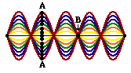The quantization of energy is correct, but not because they are circling like planets.
* 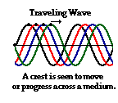If experiments do not verify the theory, then:

Podcast 6.3: Quantum Mechanical Model

* _______________said matter could be like a wave.
* like standing waves – like the vibrations of a stringed instrument.

**Traveling Waves and Standing Waves**

* Standing waves result in _____ ______movement of the particles, simply an oscillation of the particles.
* What are the factors that influence the wave properties?

[Wave on a String -- PhET](http://phet.colorado.edu/en/simulation/wave-on-a-string)

* Identify the nodes and antinodes in the wave.
* There are only certain “allowed” waves (described by nodes and antinodes).
* In the atom there are certain allowed waves called ___________.
* 1925 ________________________described the wave function of the electron.
* Complex math but what is important are the solutions.

**Schroedinger’s Equation**

* The wave function is three dimensional, F(x, y, z)
* Solutions to the equation are called ____________.
* Each solution is tied to a certain amount of energy.

**Heisenberg Uncertainty Principle:** There is a Limit to What We Can Know

* We can’t know how the electron is moving or how it gets from one energy level to another.
* There is a limit to how well we can know both the _______________ and the ________________ of an object.

Mathematical Predictions of Heisenberg Uncertainty Principle

* x is the uncertainty in the position.
* (mv) is the uncertainty in the momentum.
* the _________________ uncertainty is h/4p

Example 1

What is the uncertainty in the position of an electron of mass 9.31 x 10-31 kg with an uncertainty in the speed of 0.100 m/s?

What is the uncertainty in the position of a baseball, mass .145 kg with an uncertainty in the speed of .100 m/s?

**What does the wave Function mean?**

* The square of the function is the __________________ of finding an electron near a particular spot.
* best way to visualize it is by _____________ the places where the electron is _________ to be found.
* Defining the size and shape of Atomic Orbitals
* Define the ________________ surface.
* Define the size that encloses __________ of the total electron probability.
* NOT at a certain distance, but a most likely distance.
* For the first solution the shape of the graph is a ________________.

**Quantum Numbers**

* There are many solutions to Schroedinger’s equation
* Each solution can be described with ______________ numbers that describe some aspect of the solution.
* ________________ quantum number (n) describes the size and energy of an orbital.
* Has integer values >0

n = principal quantum number (energy level)

l = ______________ quantum number (shape)

ml = ____________ quantum number

* integer values between - l and + l
* tells spatial orientation in each shape.

ms= _______ ______________

or spin quantum number

either + ½ or – ½ (spin up or spin down)

**Angular Momentum, l,** Defines Shape

* Determine the shape of the orbital.
* integer values from 0 to n - 1

l = 0 is called s

l = 1 is called p

l = 2 is called d

l = 3 is called f

l = 4 is called g

|  |  |  |  |  |
| --- | --- | --- | --- | --- |
| **Name** | **Symbol** | **Orbital Meaning** | **Range of Values** | **Value Example** |
| Principal Quantum Number |  | Shell |  |  |
| Azimuthal Quantum Number (angular momentum) |  | Subshell or Shape |  | For: |
| Magnetic Quantum Number (projection of angular momentum) |  | Energy shift |  | For: |
| Spin Projection Quantum Number |  | Spin |  | For an electron, either: |

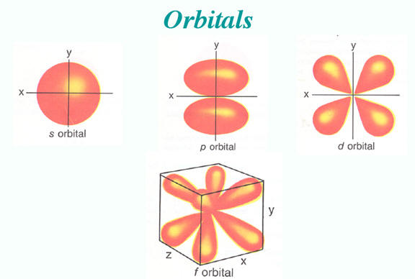

**Nova Video: Quantum Mechanics** – [**Discussion Questions**](javascript:void(0);)

[**http://youtu.be/a6o9XjQOvHc**](http://youtu.be/a6o9XjQOvHc)

1. What did Rutherford think an atom looked like and what was the "hole" in his theory?
2. What model did Bohr propose for the structure of an atom?
3. What is a quantum or photon?
4. How did Schrodinger's theory contrast with Bohr's?
5. How would you explain why it is impossible to measure the position and momentum of an electron at the same time?

**In Class Activity: Photoelectron Spectroscopy – Locating Electrons**

Match the models of the atom with the historical experiment that was used to generate the model.

|  |  |  |  |
| --- | --- | --- | --- |
| Match | Model |  | Experiment |
|  | **1.** |  | **A. Reasoning about other scientist’s data on the ratios of elements in various materials** |
|  | **2.** |  | **B. Atomic emission spectrum of electrified hydrogen gas** |
|  | **3.** |  | **C. Cathode ray tube deflection with a magnet** |
|  | **4.** |  | **D. Aiming alpha particles at gold foil** |

The table below shows the successive ionization energies of the 3rd period of the periodic table expressed in kJ/mol.

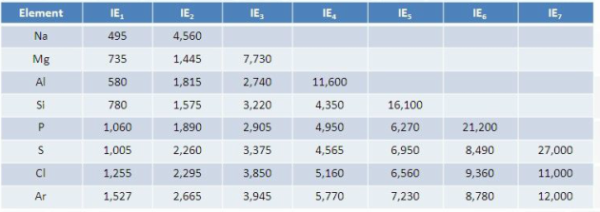

5. What is the amount of energy required to remove 2 electrons form the neutral gaseous magnesium atoms?

A. 735 kJ/mol B. 1445 kJ/mol C. 2180 kJ/mol D. 7730 kJ/mol

Question: How are electrons “arranged” in an atom?

1. Describe the nature of the interaction between protons and electrons in an atom. Consider using some or all of the following terms in your description: attraction, repulsion, neutral, positive, negative, charge, distance, nucleus, force, energy, Coulomb’s Law.
2. Compare the relative energy necessary to separate positive and negative electrical charges in the following situations. Compare a and b, then compare a and c.



1. Consider the following diagram:



* 1. How many electrons do you see in the picture? ______ How many protons? ______
  2. Which of these electrons is the easiest to remove? (i.e., which requires the least amount of energy to ionize?)
  3. Explain your response in b.
  4. How does the energy required to remove the outermost electron in 3 compare to 2a? to 2c?

This activity has been adapted from a draft generated by John Gelder of Oklahoma State University. I have   
altered some of the questions and presented the data slightly differently than the original. The original version   
of this activity can be found in the AP® Chemistry Teacher Community resources section.

The first ionization energy is defined as the minimum energy that must be added to a neutral atom, in the gas phase, to remove an electron from that atom. This definition can be represented in the following chemical equation: **energy + A(g) → A+(g) + 1e–**

1. In the ionization equation above, which is at lower energy? A(g) or A+(g) and 1e–?   
   Which is at higher energy? A(g) or A+(g) and 1e –?   
   Explain.
2. Explain why energy is required to remove the electron in a neutral atom.
3. The value of the first ionization energy for hydrogen is 1312 kJ/mol. In Figure 1 below, use a short horizontal line to indicate the energy of H(g) (reactant) and a short horizontal line to indicate the energy of H+(g) + 1e- (product). (NOTE: Be sure to consider your responses to Q4 and Q5 above.)

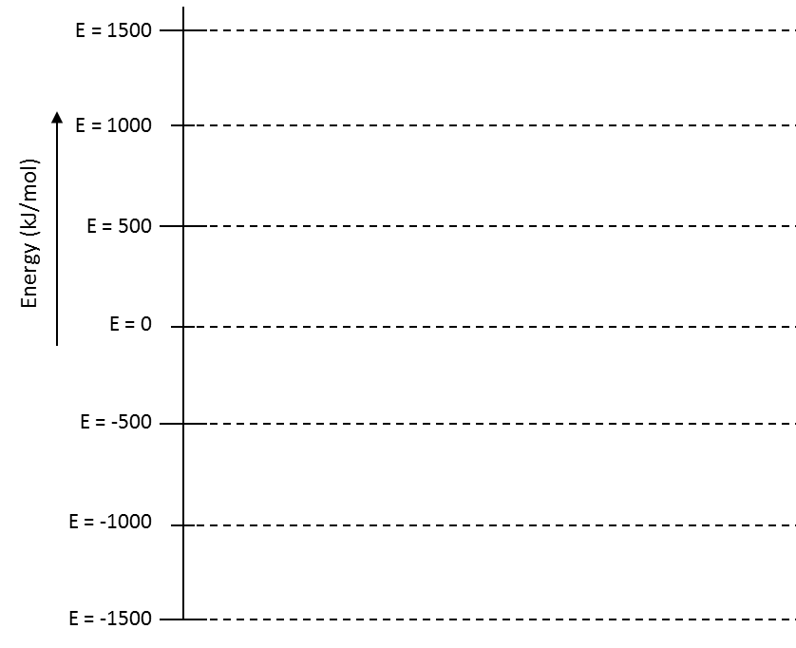

**Figure 1**

1. What does the difference in energy in the lines in your diagram above represent?
2. The values for the first ionization energy for a hydrogen and helium atom are provided in the table below.

|  |  |  |  |
| --- | --- | --- | --- |
| Atom | **H** | **He** | **Li** |
| Ionization energy (kJ/mol) | 1312 | 2373 |  |

Based on comparisons you made in Question 2, how would you explain the difference in the values for the first ionization energy for hydrogen and helium? How does your explanation account for the relative charge on hydrogen and helium and the distance of the electron(s) from the nucleus?

1. In the energy diagram below draw a horizontal line to represent the first ionization energy for hydrogen and the first ionization energy for helium.

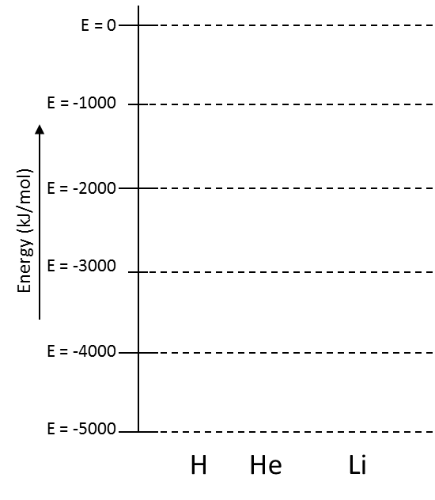

**Figure 2**

1. How does your diagram illustrate the relative ease with which an electron can be removed from hydrogen and from helium? Which one is easier to remove?
2. Predict an approximate value for the first ionization energy for lithium. Do not add your prediction to Figure 2 just yet. Justify your prediction based on Question 2.
3. The value of the first ionization energy of lithium is 520 kJ/mol. Add this value for lithium to Figure 2 above. Based on comparisons you made in Question 2, how would you explain the ionization energy for lithium compared to the ionization energy for helium? Compared to hydrogen?
4. Predict the relative value of the energy necessary to remove a second electron (called the second ionization energy) from lithium. Support your prediction with an explanation.
5. Based on the first ionization energies for hydrogen, helium, and lithium that you represented in Figure 2, what can you say about the distance of the electrons from their respective nuclei in these three atoms?
6. The first ionization energies for selected elements from the second period of the periodic table follow:

|  |  |  |  |  |  |  |
| --- | --- | --- | --- | --- | --- | --- |
| Atom | **3Li** | **4Be** | **6C** | **7N** | **9F** | **10Ne** |
| Ionization Energy (kJ/mol) | 520 | 899 | 1086 | 1302 | 1681 | 2081 |

Explain the trend in ionization energies in terms of the relative location of the electrons and the charge of the nucleus.

1. The first ionization energy for the element sodium is given in the following table. Predict the other values for the first ionization energy for the selected third period elements:

|  |  |  |  |  |  |  |
| --- | --- | --- | --- | --- | --- | --- |
| Atom | **11Na** | **12Mg** | **14Si** | **15P** | **17Cl** | **18Ar** |
| Ionization Energy (kJ/mol) | 495 |  |  |  |  |  |

How did you arrive at your predictions?

1. The table below contains the ionization energy for each of the 18 electrons in an argon atom. The graph of this data is shown in Figure 3.

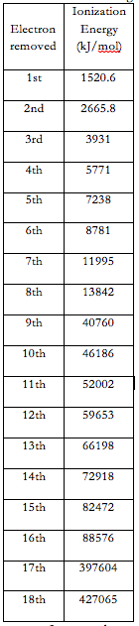

|  |
| --- |
| Ionization Energy (kJ/mol) |

1. Interpret the graph in Figure 3. Put a box around the electrons that are easiest to remove. Circle the electrons that are the most difficult to remove.
2. Based on your responses from the previous questions, how many ‘groups’ (levels or shells) of electrons are shown for Argon in Figure 3?
3. Indicate the number of electrons in each group/level that you identified.
4. On the graph in Figure 3, label the groups/levels/shells with 1, 2, 3, etc.
5. An electron from which energy level requires the least amount of energy to remove? An electron from which energy level requires the largest amount of energy to remove?
6. Describe the electron structure (location of the electrons) of the atom. Consider using some or all of the following terms in your description: nucleus, electron, energy, distance, level, proton, shell, arrangement, attraction, repulsion, positive, negative, charge, location. You may use extra paper, if needed.

**Photoelectron Spectroscopy, PES**

Photoelectron Spectroscopy is a technique that is used to gather information about the electrons in an atom. An atom is bombarded with photons. Some of the photons are absorbed and electrons are emitted. The emitted electrons are collected and their energy is analyzed. Since we can know the energy of the photons, and we know that energy is conserved, we can then calculate the difference in the energy between the photons sent INTO the atom and the energy of the electrons emitted. This difference will be the electrical potential energy of the electrons when they are attached to the atom. Remember that the potential energy of the electron in the atom is also equal to the WORK needed to remove the electron from the atom. Watch the video to learn how the PES Instrument works: <http://media.collegeboard.com/digitalServices/swf/ap-webcasts/chemistry/ap_chem_pes.html> (start with number 24, PES Instrument).

Energy of emitted electron = Energy of photon – Work needed to remove electron from atom

1. Visit this URL: <http://www.chem.arizona.edu/chemt/Flash/photoelectron.html>
2. Select the button labeled “Mono.”
3. Select the element Hydrogen.
4. You will see a graph with two numbers. The whole number is the integration of the number of electrons in the spectrum. The decimal number is the work needed to remove the electron from the atom in MJ/mol.
   1. Sketch the graph and write the numbers below:
5. Now select Helium.
   1. Sketch the graph and write the numbers below:
   2. How does the energy in Helium compare to the energy in Hydrogen?
   3. Why do you think there is a difference?
6. Look at the spectrum for Lithium.
   1. Sketch the graph and write the numbers below:
   2. Justify the differences between these three elements.

**NOTE: on the PES spectra, a HIGH energy number means the electron is closer to the nucleus, and a low number means it is farther from the nucleus (due to the way physicists define potential energy).

1. Now look at Boron.
   1. Sketch the graph and write the numbers below:
   2. Why are the 2 electrons at 1.36 different from the single electron at 0.8?
2. Look at scandium. What does this spectrum reveal about the energies of s, p, and d orbitals?

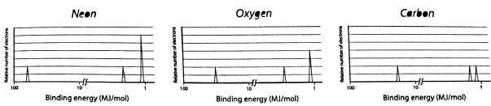

1. Use Coulomb’s Law to explain why the energy associated with the first peak is larger in neon and smaller in oxygen. Do the same for the third peak.
2. Why are the first and second peaks the same height for all three elements while the third peak heights vary?
3. 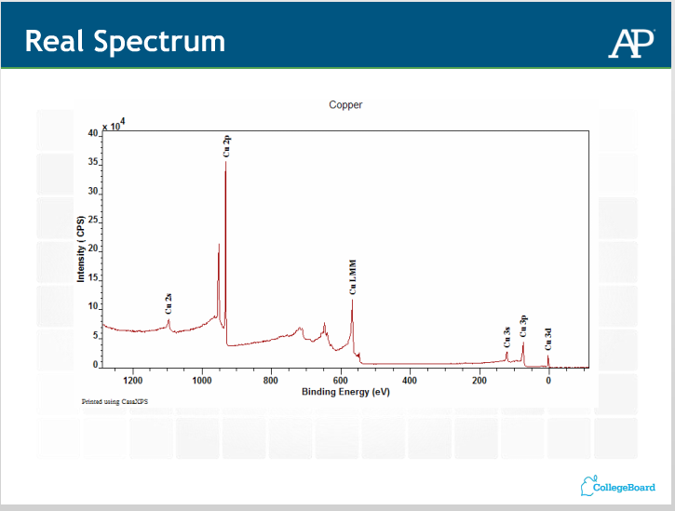 Compare the real PES Spectrum for Copper below to the simplified spectra we have been interpreting.

**Podcast 6.4: Locating Electrons**

Bohr Diagram: Use The Periodic Table of Elements to sketch the location of electrons in each energy level

Shortcut for Large Atoms

* Circles can be drawn as Arcs
* Nucleus can be represented using __p+ and __no

SPDF

* Electrons are mapped out on The Periodic Table
* Each section represents a different orbital shape

**Aufbau Diagrams**

Aufbau = “build up” -- Represent the opposing spin of electrons using arrows (up or down)

1. Aufbau Principle:

2s __

2p __ __ __

1s __

3s __

3p __ __ __

4s __

4p __ __ __

3d __ __ __ __ __

5s __

5p __ __ __

4d __ __ __ __ __

1. Hund’s Rule:
2. Pauli Exclusion Principle:

**Diamagnetism and Paramagnetism**:

Diamagnetism: elements have _____ ___________________ spins paired. These are not affected by magnetic fields.

Paramagnetism: Elements that ______ _________________ their electrons spin paired. These elements are strongly affected by magnetic fields

**Electron Configuration**

* Giving the electrons an address
* Utilize SPDF notation

Short-hand Electron Configuration

* Noble Gas configuration represents a COMPLETE energy level
* Noble Gases are used to represent all but the valence-shell electrons

Putting it All Together

* Use electron configuration to help you draw the Bohr Diagram and the Aufbau Diagram
* Go from Top to Bottom, Left to Right until you get to the element of interest.

Elements in s and p Blocks

Elements in the d Block

Elements in the f Block

**Exceptions:** Half filled orbitals are more stable.

Ti = [Ar] 4s2 3d2

V = [Ar] 4s2 3d3

Cr = [Ar] 4s1 3d5

Mn = [Ar] 4s2 3d5

Cu [Ar] 4s1 3d10

Lanthanum La: [Xe] 6s2 5d1

Cerium Ce: [Xe] 6s2 4f1 5d1

Promethium Pr: [Xe] 6s2 4f3 5d0

Gadolinium Gd: [Xe] 6s2 4f7 5d1

Lutetium Lu: [Xe] 6s2 4f14 5d1

* We’ll just pretend that all except Cu and Cr families follow the rules.
* Elements in the same ____________ have the same electron configuration, thus have similar ___________
* Noble gases have _________________ energy levels.
* Transition metals are filling the ______ orbitals
* ______________ ______________ _______________ fill f orbitals
* All metals have either ______or ______ valence electrons, so their properties are VERY similar – makes them hard to tell apart

**Assignment #3: Quantum Mechanical Model Practice Problems**

1. Draw a Bohr model for the following elements: (you must use numbers…NO DOTS!)
   1. Osmium (Os) C. Nitrogen (N)

* 1. Mendelevium (Md) D. Boron (B)

1. Which statements are incorrect? Explain why.

a. If ml = 1, the orbital must be a p orbital.

b. If n = 2, only two orbitals are allowed, one s and one p.

c. If l = 3, there are 3 possible values for the quantum number ml.

d. If ml = 0, the value of l must equal 0.

3. Calculate the frequency of the line in the hydrogen spectrum corresponding to the electron transition from n=9 to n=8. Whereabouts in the electromagnetic spectrum does this line occur?

4. What is the energy needed to raise an electron in the hydrogen atom from the second energy level to the third energy level?

5. Give the possible quantum numbers for a neutral bromine atom.

6. The amount of energy that is required to remove a mole of electrons from the surface of solid lithium is

279.7 kJ / mol. Calculate the wavelength of the light capable of removing **ONE ELECTRON** from the surface of

a lithium atom.

7. Write the electron configuration and the Aufbau Diagram (long form, using “arrows”) for neutral silver in its

ground state. Is it diamagnetic or paramagnetic?

8. Which of the following orbital designations are incorrect: 1*s*, 1*p*, 7*d*, 9*s*, 3*f*, 4*f*, 2*d,* 3*s*, 5*p*, 2*p*?

9. Write the electron configuration (long or short form) and Aufbau Diagram for the barium ion (with a +2 charge)

in its ground state? Is it diamagnetic or paramagnetic? Also, what other atoms and ions is barium (with a +2

charge) isoelectronic with?

10. Write the electron configurations of the following elements using the shorthand notation for the noble gas cores.

a. phosphorus

b. nickel

c. osmium

d. californium

e. titanium

11. How many electrons can be accommodated in

a. a d subshell

c. the n = 4 shell

d. the 7s orbital

e. a px orbital?

12. What is wrong with the following ground state electron configurations?



13. How many **unpaired** electrons are there in

a. a nitrogen atom

b. an iodine atom

c. a nickel (II) cation

d. an oxide ion?

14. How many orbitals make up the **4d** subshell?

15. The value of l that is related to the orbital depicted is:

16. Which of the following sets of quantum numbers is possible for a **3d** electron?

a) n = 3, l = 3, ml = –2, ms = +

b) n = 2, l = 1, ml = +1, ms = –

c) n = 3, l = 1, ml = 0, ms = –

d) n = 3, l = 2, ml = –2, ms = +

e) n = 4, l = 1, ml = +1, ms = +

17. Which of the following particles would be most paramagnetic?

a) P

b) Ga

c) Br

d) Cl-

e) Na+

**Podcast 6.5: The Periodic Table**

* Developed independently by German ________________ ________________ ___________________ and Russian ___________________ _______________________ (1860s).
* Didn’t know much about atoms.
* Put elements in columns by similar ________________.
* Mendeleev Predicted properties of _____________________ elements.

What Keeps Electrons in an Atom?

* Electrostatic Force and Coulomb’s Law
* Where Q is the _________ of the particle and r is the _______, or distance between charges.
* Higher nuclear charge = higher force
* Higher distance between charges (radius) = weaker attractive force
* Which factor seems to have more influence? Nuclear Charge or the Distance from the Nucleus?

**Effective Nuclear charge**

Can be calculated from

and

We can use __________ to predict properties

Use the amount of energy it takes to remove an electron.

__________________________ The energy necessary to remove an electron from a gaseous atom.

Remember this…

E = -2.18 x 10-18 J(Z2/n2)

For a **mole** of electrons being removed:

Ionization energy = 1310 kJ/mol(Zeff2/n2)

So we can measure Zeff

* The ionization energy for a **1s** electron from sodium is 1.39 x 105 kJ/mol .
* The ionization energy for a **3s** electron from sodium is 4.95 x 102 kJ/mol .

Demonstrates _________________.

**Shielding**

* Electrons on the _____________ energy levels tend to be farther out.
* Have to “look” through the other electrons to see the nucleus.
* They are less effected by the nucleus.
* _____________ effective nuclear charge

**Penetration**

* There are levels to the _________________ __________________________ for each orbital.
* Graphically

Sketch Graph for each type of orbital

Penetration Effect

* The _______________ energy levels penetrate the _______________ levels so the shielding of the core electrons is not totally effective.
* from most penetration to least penetration the order is …

(within the same energy level).

* This is what gives us our order of filling, electrons are more stable in s and p orbitals.
* The **more ______________** the nucleus, the smaller the orbital.
* A sodium 1s orbital is the same shape as a hydrogen 1s orbital, but it is _____________ because the electron is more strongly attracted to the nucleus.

**Periodic Trends**

* Ionization energy :_____________________________________________________________________ ____________________________________________________________________________________
* First ionization energy (I1)-_______________________________________________________________

____________________________________________________________________________________

* Second ionization energy (I2) - ____________________________________________________________

**Trends in ionization energy**

for Magnesium

I1 = 735 kJ/mole

I2 = 1445 kJ/mole

I3 = 7730 kJ/mole

* The effective nuclear charge increases as you remove electrons.
* It takes much more energy to remove a __________ electron than a valence electron because there is less shielding.

Explain this trend

For Al

I1 = 580 kJ/mole

I2 = 1815 kJ/mole

I3 = 2740 kJ/mole

I4 = 11,600 kJ/mole

**Across a Period**

* Generally from **left to right**, I1 increases because…

there is a greater ______________________ with the same amount of shielding.

* As you go **down a group** I1 decreases because…

electrons are farther away (effect of _______________ is greater)

It is not that simple

Zeff changes as you go across a period, so will I1

____________________ and filled orbitals are harder to remove electrons from.

**Parts of the Periodic Table:** Looking for Patterns

* Know the special groups
* It is the number and type of valence electrons that determine an atom’s chemical properties.
* Metals **_________** electrons have the lowest IE
* Nonmetals **____________** electrons, most negative electron affinities.

The Alkali Metals

* Doesn’t include hydrogen- it behaves as a nonmetal
* From top to bottom:
  + decrease in IE
  + increase in radius
  + decrease in density
  + decrease in melting point
* Behave as ___________________ agents
* Reducing ability
* Lower IE = better reducing _______________ (donate e- )

Fr > Cs > Rb > K > Na > Li

* works for _____________, but not in aqueous solutions.
  + In solution Li > K > Na … Why?
  + It’s the water – there is an energy change associated with dissolving
* ______________________ Energy
  + It is exothermic
  + for Li+ -510 kJ/mol
  + for Na+ -402 kJ/mol
  + for K+ -314 kJ/mol
* Li is so big because of it has a high charge ______________, a lot of charge on a small atom.
* Li loses its electron more easily because of this in aqueous solutions

Alkaline Earth Metals

* Group 2 – ________________, ________________, ________________, ________________, ________________, ________________
* ______ electrons in valence shell
* Very ________________ – not usually found pure in nature

Noble Gases

* Group 18 – ________________, ________________, ________________, ________________, ________________, ________________
* _________ valence electron shell
* Very ________________ (not reactive)
* Under normal conditions do not form compounds with other elements
* ________________________________ is the first reported stable compound of a noble gas - 1962

Halogens

* Group 17 – ______________, _____________, ______________, _______________, _______________
* _____ electrons in valence shell
* Halogen means “________________ - ________________”
* Compounds they form are called salts

Transition Metals

* Groups 3 to 12, periods 4 to 7
* _____, _____, or _____ electrons in valence electron shell
* Hard and have a high melting point
* Often used to form alloys (mixtures of metals)

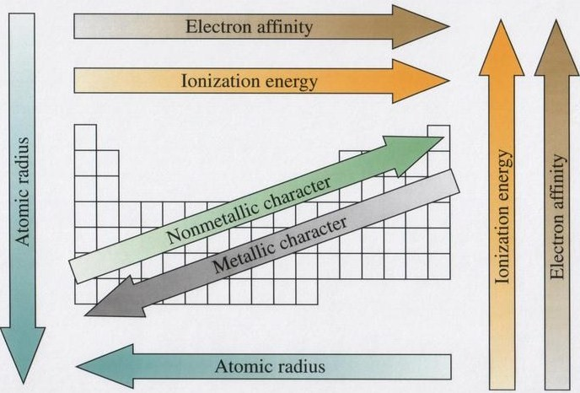

**Assignments #4: Practice Problems: Predicting Properties Using Periodic Trends**

1. Use your knowledge of the periodic table of the elements to answer the following questions.

a) Explain the trend in electronegativity from P to S to Cl.

b) Explain the trend in electronegativity from Cl to Br to I.

c) Explain the trend in atomic radius from Li to Na to K.

d) Explain the trend in atomic radius from Al to Mg to Na.

2. Explain each of the following in terms of atomic and molecular structures and / or forces.

a) The first ionization energy for magnesium is greater than the first ionization energy for calcium.

b) The first and second ionization energies for calcium are comparable, but the third ionization energy is much greater.

3. Arrange the elements S, Ge, P, and Si in order of increasing atomic size.

4. Arrange the ions Na+, K+, Cl, and Br in order of increasing size.

5. Which one of the following isoelectronic species has the smallest radius? *EXPLAIN YOUR REASONING!*

Mg2+, F – , Na+, O2– , Ne

6. Arrange the elements Be, Ca, N, and P in order of increasing ionization energy.

7. Which one of each of the following pairs would you expect to have the higher electron affinity?

a. Cl or Cl

b. Na or K

c. Br or I

8. Which elements fit the following descriptions:

a. the smallest alkaline earth metal

b. has a valence shell configuration 4f14 5d10 6s1

c. the halogen with the lowest ionization energy

d. has 13 more electrons than argon

e. the smallest non metal

f. the Group 4A element with the largest ionization energy

g. its 3+ ion has the electron configuration [Kr] 4d10

9. FRQ 1980

1. Write the ground state electron configuration (short form or long form) for an arsenic atom.
2. Give one permissible set of four quantum numbers for each of the outermost electrons in a single As atom when it is in its ground state

|  |  |  |  |
| --- | --- | --- | --- |
|  |  |  |  |

|  |  |  |  |
| --- | --- | --- | --- |
|  |  |  |  |

|  |  |  |  |
| --- | --- | --- | --- |
|  |  |  |  |

|  |  |  |  |
| --- | --- | --- | --- |
|  |  |  |  |

|  |  |  |  |
| --- | --- | --- | --- |
|  |  |  |  |

1. Is an isolated arsenic atom in the ground state paramagnetic or diamagnetic? Explain briefly.
2. What ion would As be expected to form?
3. Write the electron configuration for the arsenic ion.

10. Study the following simulated photoelectron spectrum

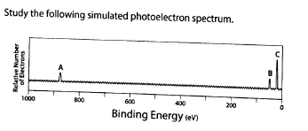

1. What element is represented by the simulated spectrum?
2. What orbitals’ binding energies are represented by peaks A, B, and C?
3. Why is peak A so far to the left of peaks B and C?
4. Why is peak C three times higher than peak B?

11. FRQ 2000: Answer the following questions about the element selenium, Se (atomic number 34)

a) Samples of natural selenium contain six stable isotopes. In terms of atomic structure, explain what these isotopes have in common, and how they differ.

(b) Write the complete electron configuration (e.g., 1*s*2 2*s*2. . . etc.) for a selenium atom in the ground state. Indicate the number of unpaired electrons in the ground-state atom, and explain your reasoning.

(c) In terms of atomic structure, explain why the first ionization energy of selenium is

(i) less than that of bromine (atomic number 35), and

(ii) greater than that of tellurium (atomic number 52).

(d) Selenium reacts with fluorine to form SeF4. Draw the complete Lewis electron-dot structure for SeF4 and sketch the molecular structure. Indicate whether the molecule is polar or nonpolar, and justify your answer.

**Lab Report – Abstract Template**

Purpose of the Experiment

* An introductory statement of the reason for investigating the topic of the project.
* A statement of the problem or hypothesis being studied.

Procedures Used

* A summarization of the key points and an overview of how the investigation was conducted.
* An abstract does not give details about the materials used unless it greatly influenced the procedure or had to be developed to do the investigation.
* An abstract should only include procedures done by the student. Work done by a mentor (such as surgical procedures) or work done prior to student involvement must not be included.

Observation/Data/Results

* This section should provide key results that lead directly to the conclusions you have drawn.
* It should not give too many details about the results nor include tables or graphs.

Conclusions

* Conclusions from the investigation should be described briefly. State your claim, explain your reasoning, and support it with evidence.
* The summary paragraph should reflect on the process and possibly state some applications and extensions of the investigation.

**Prelab Questions**

1. Name the colors of visible light, beginning with that of lowest energy (longest wavelength)
2. Distinguish between absorption and emission of energy.
3. A system proposed by the US Navy for underwater submarine communication, called ELF, operates with a frequency of 76 Hz. What is the wavelength of the radiation in meters? In miles? (1 mile = 1.61 km)
4. What is the energy in joules of the frequency in question 3?
5. Red and green light have wavelengths of about 650 nm and 490 nm, respectively. Which light has the higher frequency – red or green? Which light has the higher energy, red or green?
6. Mg emits radiation at 285 nm. Could a spectroscope be used to detect this emission?
7. If boron emits radiation at 518 nm, what color will boron impart to a flame?
8. From the wavelengths and colors given for the mercury emission spectrum in this experiment, construct a graphical representation of the mercury emission spectrum as it would appear on the scale of a spectroscope

**Data Analysis**

1. Obtain a calibration (best fit line) adjustment for spectroscope from calibration curve of mercury spectrum. wavelength = m(scale reading) + b (slope-intercept form)
2. Calculate error for Hydrogen lines.
3. Translate scale readings for metals into wavelengths using calibration curve.

wavelength = m(scale reading) + b (slope-intercept form)

1. Convert wavelength from nanometers to meters. 1 nm = 10-9m
2. Calculate the frequency associated with each wavelength. c=λν
3. Evaluate the amount Energy for each frequency.E=hν
4. Describe the quantum number for a given energy emission. $n=\sqrt{\frac{h}{E}}$
5. Calculate error and percent error for each element.
6. Identify the Unknowns based on the best match.

**Post-Lab Questions**

1. What is the purpose of the slit in the spectroscope?
2. Why is the spectroscope scale illuminated?
3. Why was the emission spectrum of mercury used to calibrate the spectroscope?
4. Could the emission of some other element be used to calibrate the spectroscope?
5. In addition to the spectral lines that you observed in the emission spectrum of hydrogen, several other lines are also present in other regions of the spectrum. Calculate the wavelengths of the n = 4 → n = 1 and n = 4 → n = 3 transitions and indicate in which regions of the spectrum these transitions would occur (what wavelength and type of radiation?)
6. Of the metal ions tested, sodium gives the brightest and most persistent color in the flame. Do you think that potassium could be detected visually in the presence of sodium burning in this mixture in a flame? Could you detect both with a spectroscope?
7. The minimum energy required to break the oxygen-oxygen bond is 495 kJ/mol. What is the longest wavelength of radiation that possesses enough energy to break the O – O bond? What type of electromagnetic radiation is this? What layer in earth’s atmosphere protects us from this type of radiation? BONUS – draw the molecular structure of this gas.