**AP Chemistry**

**Unit 7: Bonding and Molecular Structure**

*This unit focuses on chemical bonding. Bonding is dependent on the structure of the outer electron clouds around atoms. It also focuses on how to determine molecular structure, shape and properties for various types of molecules.*

***Read and Outline Chapters 8 and 9.***

***Objectives:***

7.1 Explain how/why bonds form between atoms.

7.2 Apply Periodic Trends to justify the types of bonds that form.

7.3(a) Calculate the Lattice Energy in ionic bonds.

7.3 (b) Calculate the Bond Energy in covalent bonds.

7.4 Sketch the most stable molecular structure of a compound

7.5 Apply the VSPER Theory to predict molecular shape.

7.6 Classify structural isomers and stereoisomers.

***Skills to Master:***

1. Define the term valence electron and determine the number of valence electrons in an atom, based on its electron configuration.
2. Draw a Lewis structure of an atom, given its atomic number.
3. State the octet rule and explain the octet rule in terms of the stability of a noble gas electron configuration.
4. Evaluate the correctness of a Lewis structure, using the octet rule and apply the octet rule in drawing Lewis structures.
5. Identify exceptions to the octet rule.
6. Define the term resonance structure or resonance hybrid.
7. Write a mathematical expression for formal charge then calculate the formal charge on all atoms in molecules or ions with more than one resonance form to compare resonance structures of a given molecule and determine which structure is preferred.
8. Distinguish between covalent bonds and ionic bonds and predict what kind of bond is formed between two atoms.
9. Predict bond polarity by using the electronegativity values of the bonded atoms.
10. Apply resonance theory to molecules whose bonding can't be described by a single Lewis structure.
11. Define the term ionic bond and describe the formation of an ionic bond using electron configuration or Lewis electron dot diagrams.
12. Explain how an ionic bond differs from a covalent bond.
13. Define lattice energy, then interpret the sign and magnitude of a lattice energy value.
14. Use the Born-Haber cycle to calculate the lattice energy of an ionic compound.
15. Define bond energy and use a potential energy diagram to determine the bond energy of a pair of atoms. Explain why bond energy tables contain average values rather than exact values of bond energy for most pairs of atoms.
16. Use the data in bond energy tables to calculate the enthalpy of a reaction.
17. Explain the difference between reaction enthalpies calculated using bond energies and those determined experimentally.
18. Define bond length. Use a potential energy diagram to determine the bond length of a pair of atoms.
19. Arrange single, double, and triple bonds in order of increasing bond length.
20. Define bond order. Calculate the bond order in a molecule or ion, including those with resonance structures.
21. Define the term atomic orbital. Explain what's meant by a hybrid orbital. Identify the atomic orbitals used to create hybrid orbitals in molecules.
22. Predict the shape of a molecule on the basis of its orbital hybridization.
23. Explain multiple bonds in terms of the orbitals involved in the formation of the bond.
24. Describe the basic concept of VSEPR. Distinguish between electron pair geometry and molecular geometry. Apply VSEPR to determine a molecule's electron pair geometry and molecular geometry.
25. Define dipole moment. Apply VSEPR and bond polarity to predict the overall polarity of a molecule.
26. Define the term isomer. Explain the difference between structural isomers and stereoisomers. Identify the main subsets of structural isomers and stereoisomers.
27. Classify molecules according to the type of isomerism they exhibit. Define the term chirality. Explain how polarized light can be used to determine whether a molecule is chiral.

**Podcast 7.1: Forming Bonds**

What is a Bond?

* A force that holds atoms together.
* Why? _____________ __________
* Bond energy: the energy required to break a bond.
* Why are compounds formed?
* Because it gives the system the ____________ energy.

The Key: Coulomb’s Law

* What holds things together is ___________________ attraction
* Coulomb's Law

Write equation below

* Q is
* r is
* If charges are opposite, E is negative
* -E , ________ - thermic
* Same charge, positive E, ___________ energy to bring them together.

Ionic Bonding: _____________ of Electrons

* An atom with a low ______________ energy reacts with an atom with high _______________ _____________.
* Opposite charges hold the atoms together.

Sketch Example

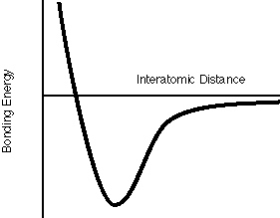

Covalent Compounds: _________________ of Electrons

* The electrons in each atom are attracted to the nucleus of the other.
* The electrons repel each other,
* The nuclei repel each other.
* The reach a distance with the ________ possible energy.
* The distance between is the bond length.

Sketch Example

Metallic Bonding: _____________ of Electons

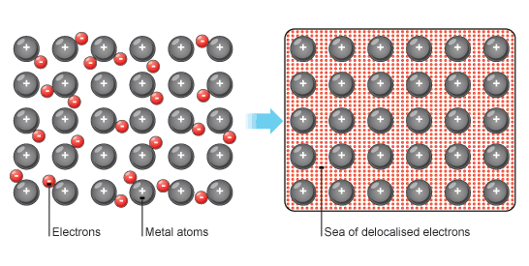

Polar Covalent Bonds

* Ionic and Covalent Bonds are two extremes.
* In between are ________________.
* The electrons are not shared evenly.
* One end of the ______________ is slightly positive, the other negative.
* Indicated using small __________.

Sketch Example

**Podcast 7.2: Using Periodic Trends to Predict Bonding**

Electronegativity: The ability of an electron to ___________ shared electrons to itself.

* Pauling method
* Imaginary molecule HX
* Expected H-X energy =

H-H energy + X-X energy 2

*  = (H-X) actual - (H-X)expected

Electronegativity

* 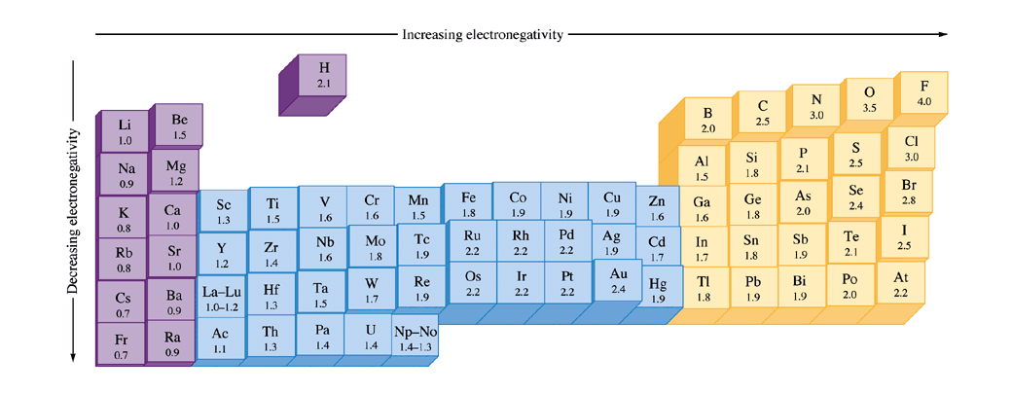 is known for almost every element
* Gives us ________________ electronegativities of all elements.
* Tends to increase ________________ across a period.
* Decreases as you go ________ a group.
* Noble gases aren’t discussed.
* Difference in electronegativity between atoms tells us how _____________ the bonds will be.

|  |  |
| --- | --- |
| Electronegativity  Difference | Bond Type |
|  |  |
|  |  |
|  |  |

Dipole Moments

* A molecule with a center of negative charge and a center of positive charge is dipolar (two poles), or has a ___________ __________
* Center of charge doesn’t have to be on an atom.
* Will line up in the presence of an electric field.
* How It is drawn
* Which Molecules Have Them?
* Any two-atom molecule with a polar bond.
* With three or more atoms there are two considerations.
  + There must be a ___________ _________
  + _________________ can’t cancel it out.

Geometry and polarity

* 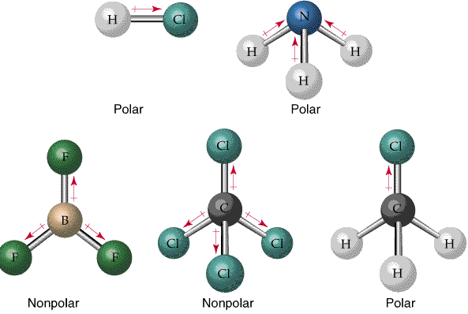Three shapes will cancel them out.
* Linear
* Planar triangles
* Tetrahedral

Others don’t cancel

* Bent
* Trigonal Pyramidal

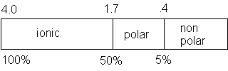

Electronegativity and Bond Polarity

**Assignment 1: ELECTRONEGATIVITY**

Use the Table on p. 3 to determine electronegativity of each element as you answer the following questions.

1. In each pair of bonds, put a star (★) next to the more polar bond and use an arrow (+→) to show the

direction of polarity in each bond.

a) C—O and C—N c) B—O and B—S

b) P—Br and P—Cl d) B—F and B—I

2. For each of the bonds listed below, indicate (+→) which atom is the more negatively charged.

a) C—N b) C—H c) C—Br d) S—O

It is somewhat artificial to classify bonds based on the differences in the electronegativities (Δ*X*) of the two atoms. However, we will use these ranges to do so:

Ionic Δ*X* > 1.7 (symbolized as A+ and Z-)

Polar Covalent 1.7 ≥ Δ*X* ≥ .5 (symbolized as Aδ+ and Zδ-)

Pure Covalent Δ*X* < .5 (no charges)

3. For each of the bonds listed below, classify each bond and indicate full or partial charges, if any.

a) Na—Cl e) Mg—H

b) C—O f) Cs—F

c) Cu—O g) Cl—Cl

d) C—H h) Al—Cl

**Assignment 2: Bond Polarity**

Determine if the molecule is non-polar covalent, polar covalent, or ionic. Then draw the Lewis structure. Then determine if the molecule is Polar or Non-Polar:

Reminder

Lewis Structures: Two Dimensional representation of the molecules electrons and arrangement. Rules for Lewis:

1. Determine the TOTAL number of electrons for the molecule. Determine which atom in the molecule will be the central atom.
2. Place the External Atoms around the Central Atom, and be sure that **EACH** external atom has an octet of electrons (exception: Hydrogen – only 2 total electrons).
3. Place the **REMAINING** electrons (in pair(s)) on the Central Atom ( Be sure that the central atom has access to **AT LEAST** eight electrons ).
4. PCl3
5. C3H8
6. NaCl
7. N2
8. HCN

**Podcast 7.3: Bond Energy, Ions and Ionic Bonding, Covalent Bonds**

Ions

* Atoms tend to react to form noble gas configuration.
* Metals _______ electrons to form cations
* Nonmetals can ___________ electrons in covalent bonds.
* 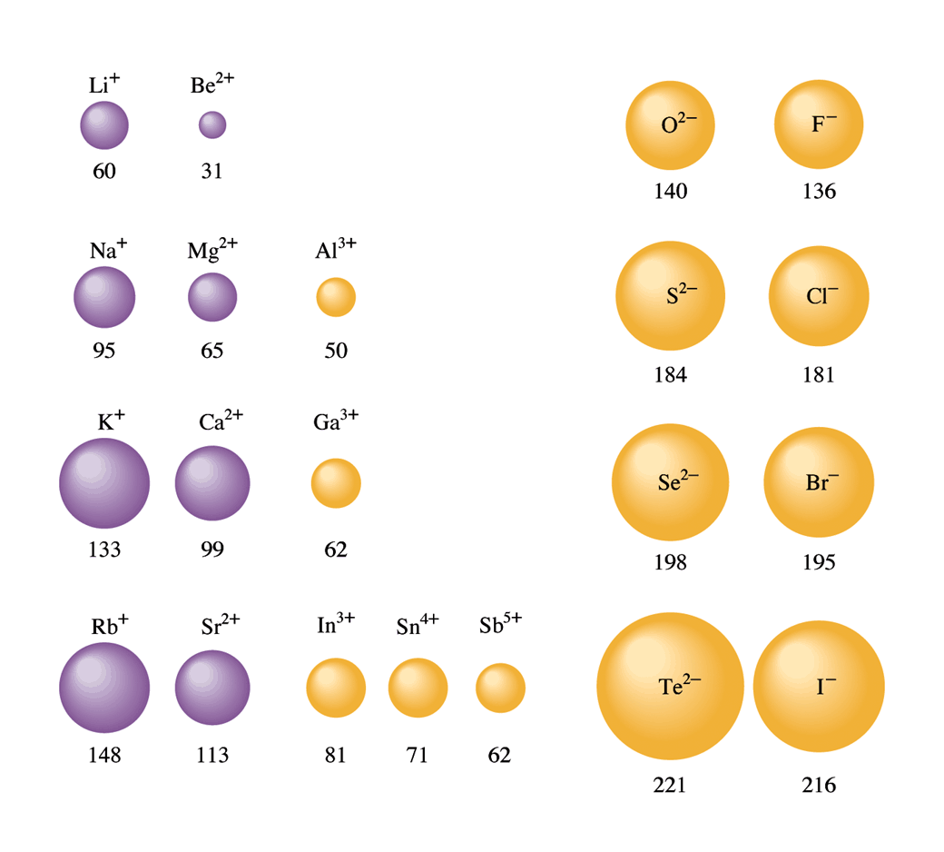Or they can __________ electrons to form anions.

Ionic Compounds

* We mean the solid crystal.
* Ions align themselves to maximize attractions between opposite charges, and to minimize __________________ between like ions.
* React to achieve noble gas configuration

Size of ions

* Ion size _____________ down a group.
* Cations are _______________ than the atoms they came from.
* Anions are ____________.
* Across a row they get smaller, and then suddenly larger.
* First half are ____________.
* Second half are ________________.

Periodic Trends

* Across the period nuclear charge ___________ so ions get smaller.
* Energy level changes between anions and cations, so anions are larger.

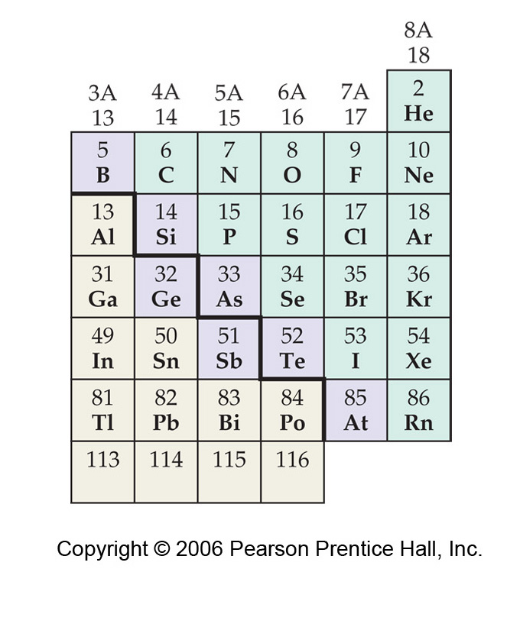Review Question: Order the following according to increasing atomic radius.

1. Ge < Si < Se < Cl
2. Se < Si < Ge < Cl
3. Si < Cl < Ge < Se
4. Cl < Si < Se < Ge
5. Si < Ge < Se < Cl

Size of Isoelectronic ions

* Iso - same
* Iso-electronic ions have the ________ # of electrons
* Al+3 Mg+2 Na+1 Ne F-1 O-2 and N-3
* All have 10 electrons.
* All have the configuration 1s22s22p6

Size of Isoelectronic ions

* ___________ ions have more protons so they are smaller.

Sketch ions below

Forming Ionic Compounds

* ____________ energy - the energy associated with making a solid ionic compound from its gaseous ions.
* M+(g) + X-(g) 🡪 MX(s)
* This is the energy that “pays” for making ionic compounds.
* Energy is a _________ __________ so we can get from reactants to products in a round-about way.

Born-Haber Cycle: Calculating Lattice Energy  
Na(s) + ½F2(g) 🡪 NaF(s)

First sublime Na Na(s) 🡪 Na(g) H = 109 kJ/mol

Ionize Na(g) Na(g) 🡪 Na+(g) + e- H = 495 kJ/mol

Break F-F Bond ½F2(g) 🡪 F(g) H = 77 kJ/mol

Add electron to F F(g) + e- 🡪 F-(g) H = -328 kJ/mol

Lattice energy: Add all the reactions together

Na(s) + ½F2(g) 🡪 NaF(s) H = ________ kJ/mol

Lattice Energy = k(Q1Q2 / r)

* k is a constant that depends on the structure of the crystal.
* Q’s are charges.
* r is internuclear distance.
* Lattice energy is greater with more __________ - _____________ ions.

Calculating Lattice Energy

* 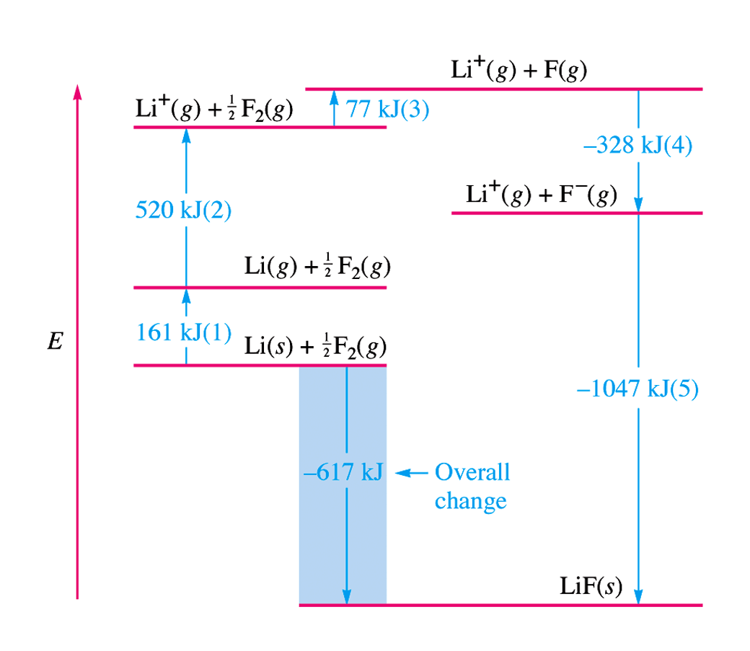This bigger lattice energy “pays” for the extra ionization energy
* Also “pays” for unfavorable electron affinity

Which of the following will have the largest lattice energy?

1. CsCl
2. ZnS
3. CaF2
4. NaCl
5. Diamond

The Covalent Bond

* Created by the forces that cause a group of ______________ to behave as a unit.
* Why?
* Due to the tendency of atoms to achieve the _______________ energy state.

The Truth About Bonds

* The bond is a ___________ invention.
* It is a method of explaining the energy change associated with forming molecules.
* Bonds don’t exist in nature, but are useful conceptual models.
* Example 1
* It takes 1652 kJ to dissociate a mole of CH4 into its ions
* Since each hydrogen is hooked to the carbon, we get the average energy = 413 kJ/mol

Sketch Molecule Below

Covalent Bond Energies

* We made some simplifications in describing the bond energy of CH4
* Each C-H bond has a different energy.
* CH4 🡪 CH3 + H H = 435 kJ/mol
* CH3 🡪 CH2 + H H = 453 kJ/mol
* CH2 🡪 CH + H H = 425 kJ/mol
* CH🡪 C + H H = 339 kJ/mol
* Each bond is sensitive to its environment.

Using Bond Energies

* We can find H for a reaction.
* It __________ energy to break bonds, and end up with atoms (+).
* We _________ energy when we use atoms to form bonds (-).
* Energy and Enthalpy are ______ functions.

Example 2: Find the energy for this reaction.

2 CH2 = CHCH3 + 2 NH3 + O2 🡪 2 CH2 = CHC N + 6 H2O

C – H 413 kJ/mol

C = C 614 kJ/mol

N – H 391 kJ/mol

C – C 347 kJ/mol

O – H 467 kJ/mol

O = O 495 kJ/mol

C $≡$ N 891 kJ/mol

**Four ways to calculate ∆H**

1. Hess Law version 1:



1. Hess Law Version 2: Add Reactions Method
2. Calorimetry:



1. Bond Energies: This is what this section is about

**∆H = Bonds Broken – Bonds Formed**

**= Reactants bonds – Products Bonds**

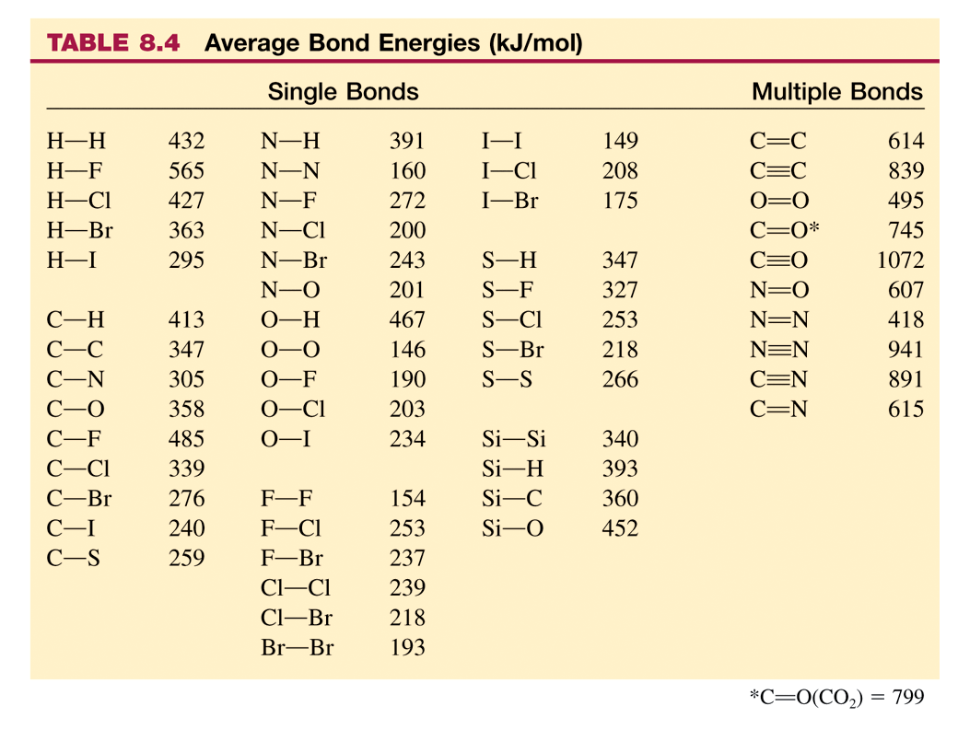

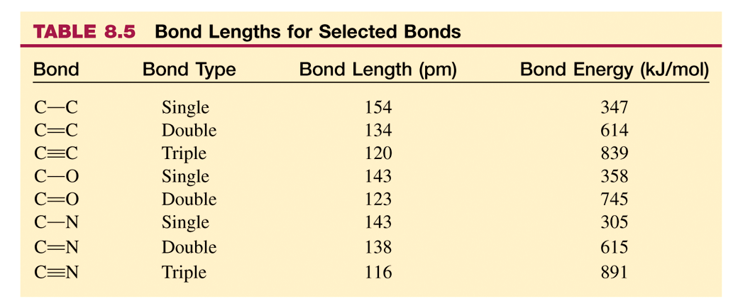

Assignment 3: BOND ENERGIES

|  |  |  |
| --- | --- | --- |
| Table 6.2 • Standard Enthalpies of Formation (kJ/mol) | | |
| C2H6(g) | ethane | -84.7 |
| H2O(g) | water vapor | -241.8 |
| CO2(g) | carbon dioxide | -393.5 |

1. Write the balanced chemical equation for the complete combustion of ethane, C2H6(g).

2. Draw structural formulas (shortcut Lewis structures) for each of the species in the chemical equation.

3. Calculate the energy needed to break the bonds in the reactants. ________

Calculate the energy released as the bonds in the products are formed. ________

4. What is the ΔHcombustion based on bond energies? ____________

5. Calculate the ΔHcombustion using Hess’s Law and the thermochemical data from Unit 4.

6. Which of the following ionic compounds has the smallest lattice energy? EXPLAIN

A) CaCl2 B) MgS C) LiF D) CaO E) Na2O

7. Calculate the Lattice Energy of calcium chloride (CaCl2), given the following:

* ΔHsublimation for Ca = 121 kJ/mol
* Δ*H*°*f* for CaCl2 = -795 kJ·mol-1
* 1st ionization energy for Ca = 589.5 kJ·mol-1 (*i.e.,* Δ*H*ionization = +589.5 kJ·mol-1)
* 2nd ionization energy for Ca = 1,145 kJ·mol-1
* Electron affinity for Cl = 349 kJ·mol-1 (*i.e.,* Δ*H* = -349 kJ·mol-1)
* Homolytic bond dissociation energy for Cl2 = 242.8 kJ·mol-1

**Podcast 7.4: Structural Formulas**

Formal Charge

* For molecules and polyatomic ions that ____________ the octet there are several different structures.
* Use ______________ on atoms to help decide which structure is best.
* Trying to use the oxidation numbers to put charges on atoms in molecules doesn’t work.
* The ________________ between the number of valence electrons on the free atom and those assigned in the molecule.
* We count _______ the electrons in each bond as “belonging” to the atom.

Example 1: Draw the structure of SO4-2

* Molecules try to achieve as low a formal charge as possible.
* Negative formal charges should be on ______________ elements.

Resonance

* Sometimes there is more than one valid structure for an molecule or ion.

Example: NO3-

* Use ____________ arrows to indicate it is the “average” of the structures.
* It doesn’t switch between them.

Example 2: NO2-

* Localized electron model is based on _________ of electrons, not odd numbers.

Basic Rules for Lewis Structures

STEP 1. Count the number of valence electrons for each atom and add them up. If the system is charged, _______ one for each negative charge on the system or ________ one for each positive charge on the system.

STEP 2. Determine the arrangement of the atoms. The __________________ electronegative atom is usually written first and is the central atom. Hydrogen atoms and Halogen atoms are always on the _____________ because they only form one bond.

STEP 3. Place __________ ________ between the atoms.

STEP 4. Multiply the number of single bonds in step 3 by _______ and subtract that number from the number determined in step 1. This gives the number of available electrons.

STEP 5. Arrange the available electrons in __________ around the peripheral atoms, except hydrogen, to fulfill the __________ rule. Arrange any remaining electrons around the ___________ atom(s) to fulfill the octet rule. If all of the atoms except hydrogen have an octet of electrons then you are finished.

STEP 6. If necessary to complete the central atom octet move electron pairs from the peripheral atoms to form ______________ bonds with the central atoms.

Exceptions to the Octet Rule

1. Molecules have _______#’s of electrons -- it is not possible to complete an octet without an unfavorable distribution of electrons

Example: NO, nitrogen monoxide  
Total valence electrons = 5 + 6 = 11

Sketch

2. Some _____ atoms: B, Be, and Al which do not have room for a full octet in some molecules.

Example:

3. Large atoms are surrounded by so many small electronegative atoms that it must have __________ than an octet around it.

**Usually seen with atoms in the 3rd row because of empty d-sublevels

Sketch

* Examples  
  PCl5, phosphorus pentachloride  
  total valence electrons = 5 + 5(7) = 42
* Similar structures can be shown for larger atoms like Sulfur in SF6, Silicon in SiF6, Arsenic in AsF6, Xenon in XeF4 and Iodine in ICl4 . This is called ________________

Bond Order: The number of ____________ e – pairs shared between two atoms, less the number of _______________ e - pairs describes the bond order.

* The number of e- pairs being shared between atoms

What is the average bond order in the molecule ozone, O3?

1. 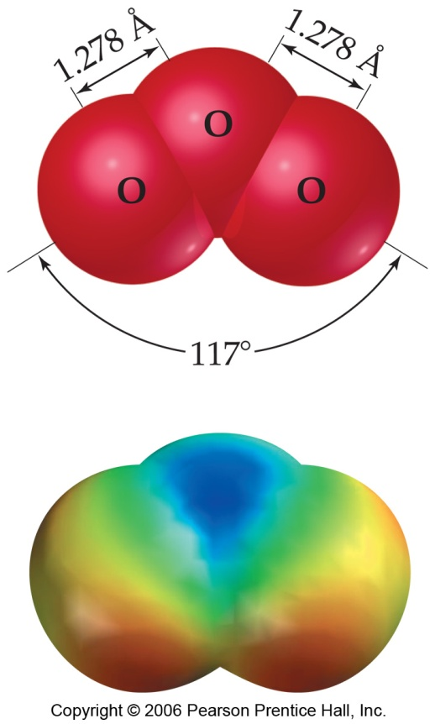1
2. 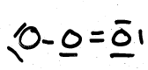1.33
3. 1.5
4. 1.67
5. 2

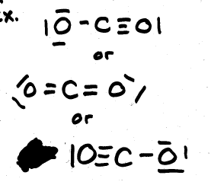

Example (Sketch)

Carbon dioxide

Bond order =(3+1)/2

Bond order = (2+2)/2

Bond order = (3+1)/2

Bond order = 2

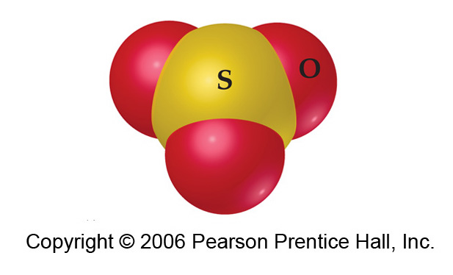What is the average S—O bond order in the Lewis structure of sulfur trioxide, SO3? (Sketch Below)

1. 0.5
2. 1
3. 1.33
4. 1.5
5. 2

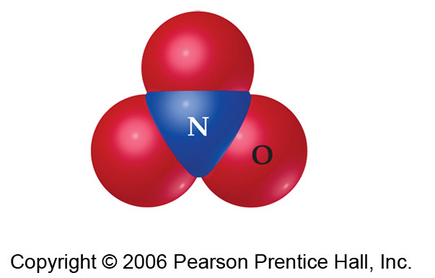How many resonance structures can be drawn for NO3- ?

1. 1
2. 2
3. 3
4. 4
5. 5

Sketch Possible Resonance Structures for NO3-.

**Assignment 4: Formal Charge**

Calculate the Formal Charge and then draw the “best” Lewis-dot structure representation for the molecule.

1) IO3 -1

2) PO4 -3

3) NO3 -1

4) CO3 -2

LEWIS STRUCTURES

Indicate the # of **VALENCE** electrons for each species. Write the correct Lewis electron-dot structure for each.

|  |  |  |  |
| --- | --- | --- | --- |
| **F**  # of valence e’s = ____ | **O**  # of valence e’s = ____ | **K**  # of valence e’s = ____ | **Al**  # of valence e’s = ____ |
| **F**  # of valence e’s = ____ | **O2**  # of valence e’s = ____ | **K+**  # of valence e’s = ____ | **Al3+**  # of valence e’s = ____ |
| **MgH2**  # of valence e’s = ____ | **LiH**  # of valence e’s = ____ | **AlH3**  # of valence e’s = ____ | **BH3**  # of valence e’s = ____ |

|  |  |  |  |
| --- | --- | --- | --- |
| **C2H4**  # of valence e’s = ____ | **C2F4**  # of valence e’s = ____ | **CO**  # of valence e’s = ____ | **O2**  # of valence e’s = ____ |
| **CN**  # of valence e’s = ____ | **SO42**  # of valence e’s = ____ | **PO43**  # of valence e’s = ____ | **ClO3**  # of valence e’s = ____ |
| **CO32**  # of valence e’s = ____ | **NO3**  # of valence e’s = ____ | **SO2**  # of valence e’s = ____ | **O3 (O O O)**  # of valence e’s = ____ |
| **SF6**  # of valence e’s = ____ | **XeF4**  # of valence e’s = ____ | **PCl5**  # of valence e’s = ____ | **SeF4**  # of valence e’s = ____ |

**Podcast 7.5: VSEPR Theory**

VSEPR: Valence Shell Electron Pair Repulsion

* Lewis structures tell us how the atoms are connected to each other but not anything about __________.
* The shape of a molecule can greatly affect its properties.
* Valence Shell Electron Pair Repulsion Theory allows us to predict ______________

Using VSEPR

1. Draw ____________ Structure
2. Count “Groups” of electrons, (bonding and nonbonding) around central atom.
3. 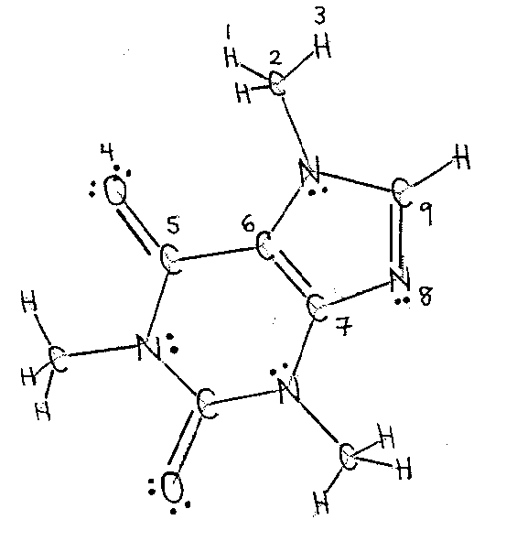Decide on overall ___________ ___________ geometry based on repulsions
4. Decide on _____________ geometry – electrons alone seem “invisible” but atoms are not
5. Angles can usually decrease slightly if electrons get “squished” or crowded

* The number of _____________ determines
  + bond angles
  + underlying structure
* The number of _____________ determines
  + actual molecular shape

What if there is NO central atom?

* Predict the geometry of each angle and build it piece by piece.

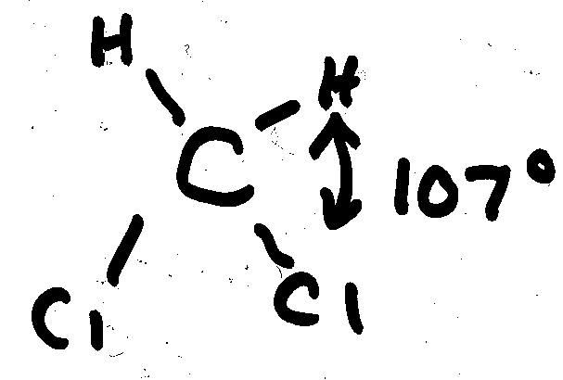There will be exceptions:

* + Lone pairs take up more space
  + Bigger atoms take up more space
* Hybrid Orbitals – describes the overlap of atomic orbitals to form molecular orbitals
* Atoms bond to form noble gas configurations
* Ionic Bonds are formed by the transfer of electrons from a metal to a nonmetal
* Nonmetals bond by the sharing of electrons

Hybrid Orbitals

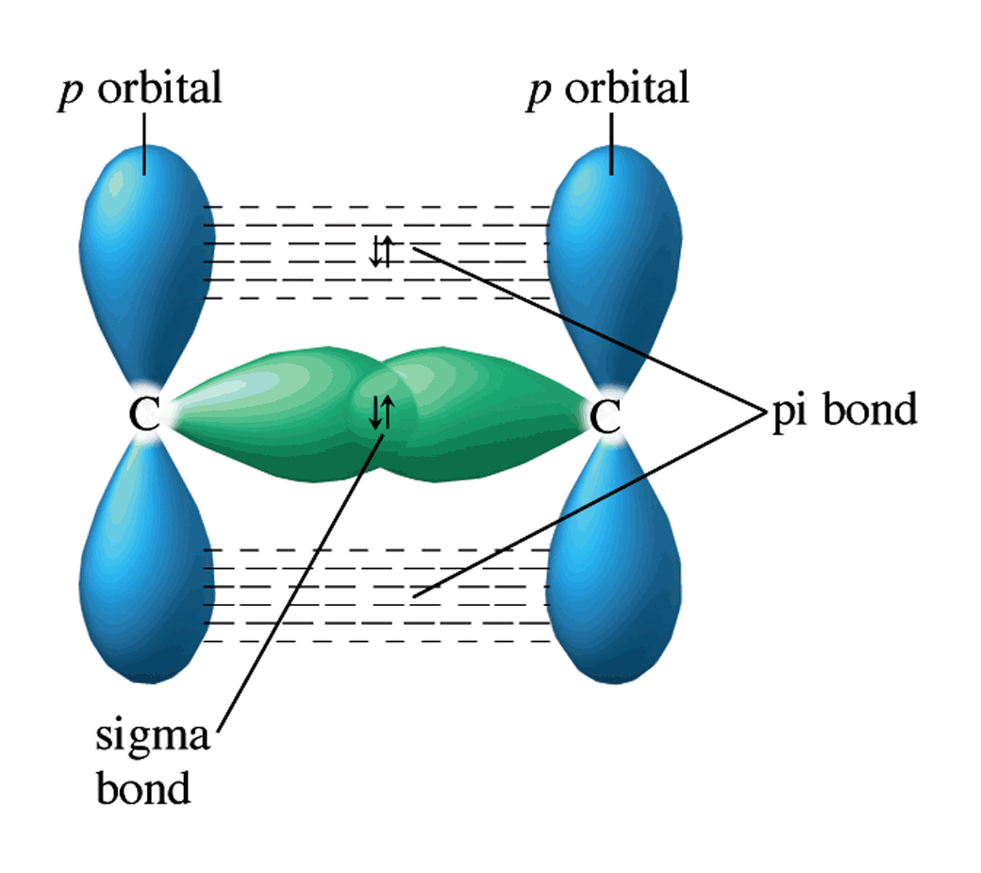Sigma Bond <http://winter.group.shef.ac.uk/orbitron/MOs/H2/1s1s-sigma/index.html>

When two orbitals directly overlap it forms a σ (sigma) bond, or a bond between the ____________________ axis

* + s+s or s+p
  + p+p

<http://winter.group.shef.ac.uk/orbitron/MOs/N2/2pz2pz-sigma/index.html>

Pi Bond

* When two p-orbitals overlap perpendicularly, the overlap is _______ to _______, not directly between internuclear axes, it is a π (pi) bond
* <http://winter.group.shef.ac.uk/orbitron/MOs/N2/2px2px-pi/index.html>

Combining Orbitals

<http://www.youtube.com/watch?v=g1fGXDRxS6k&feature=related>

Single Bond = σ

Double Bond = σ + π

Triple Bond = σ + π + π

**sp3**

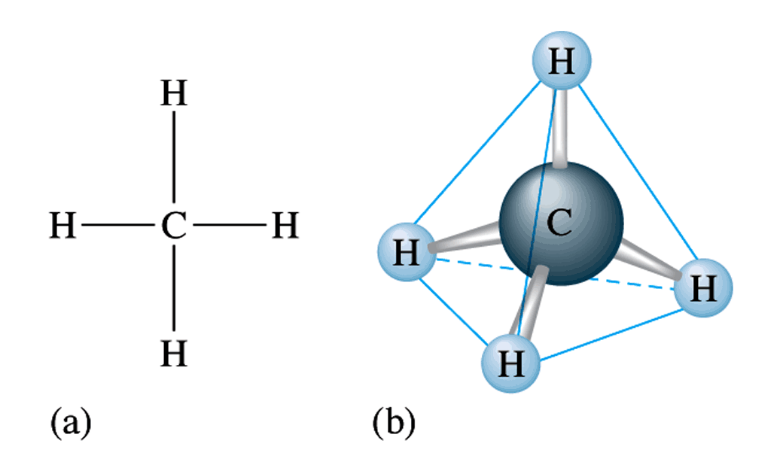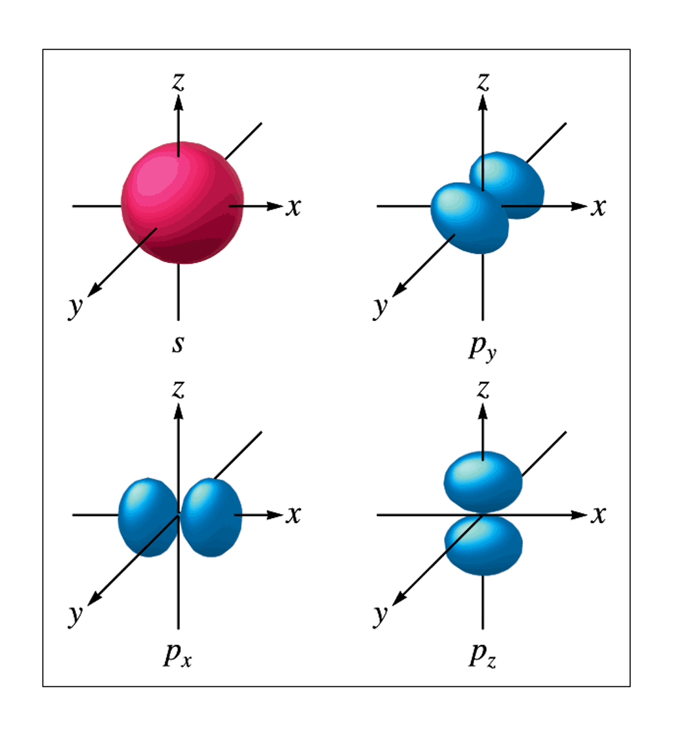

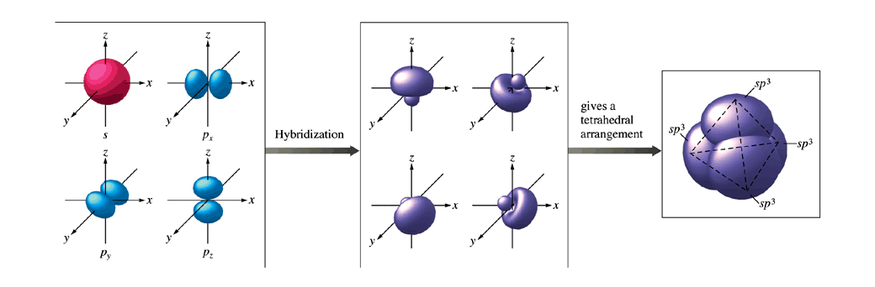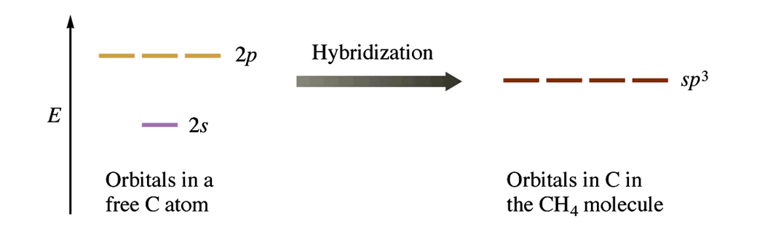

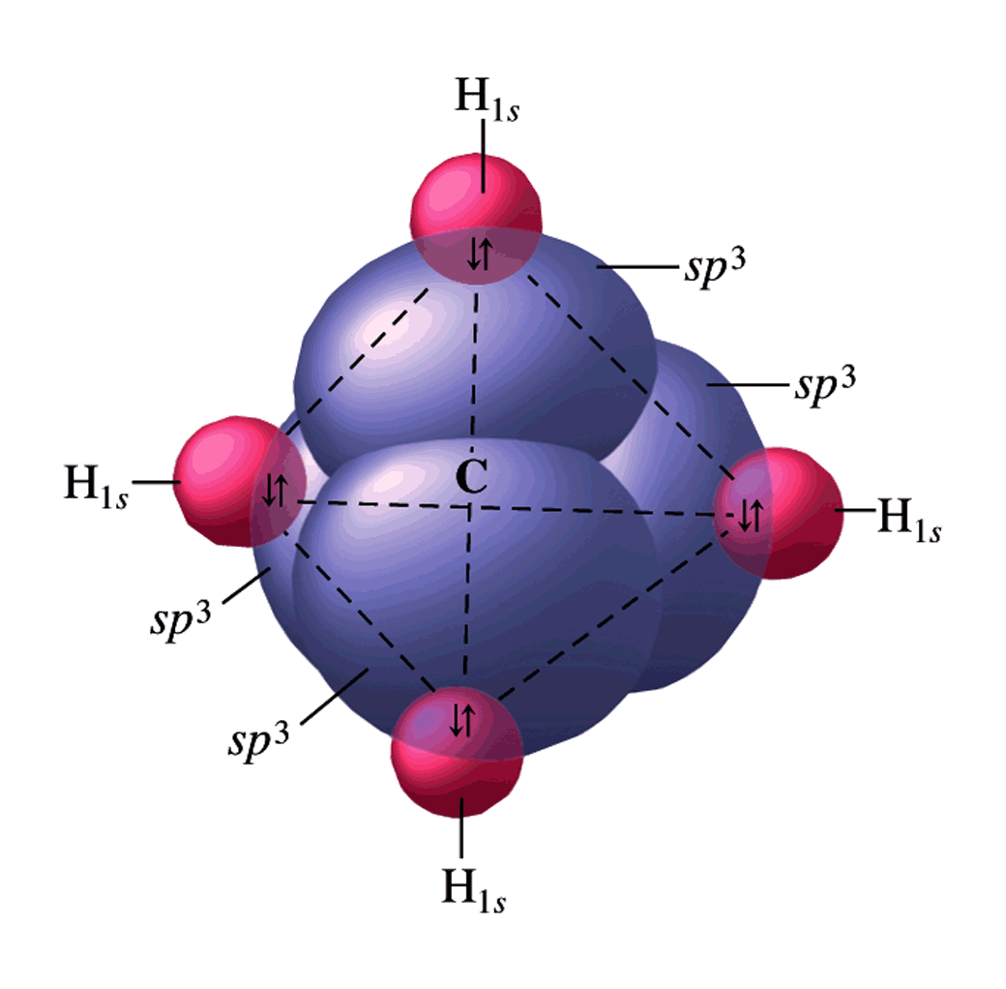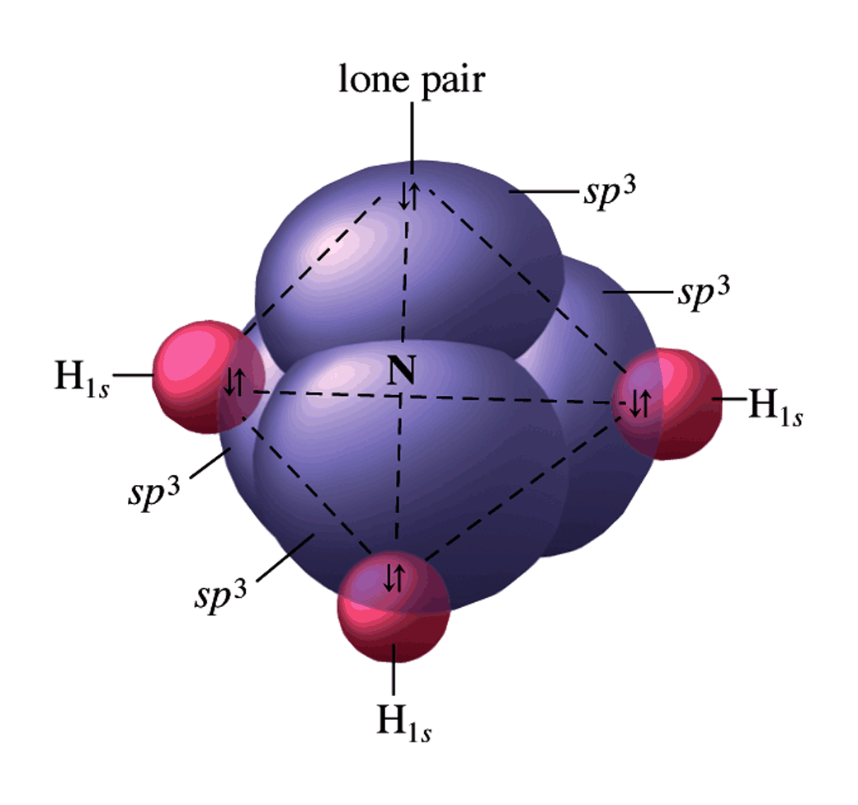

**sp2**

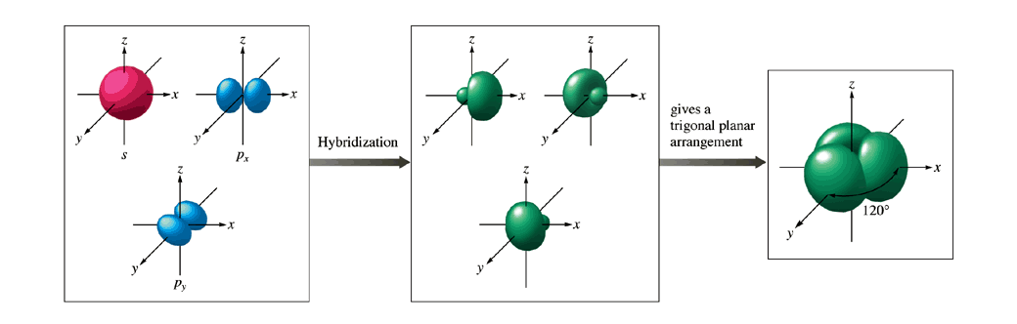

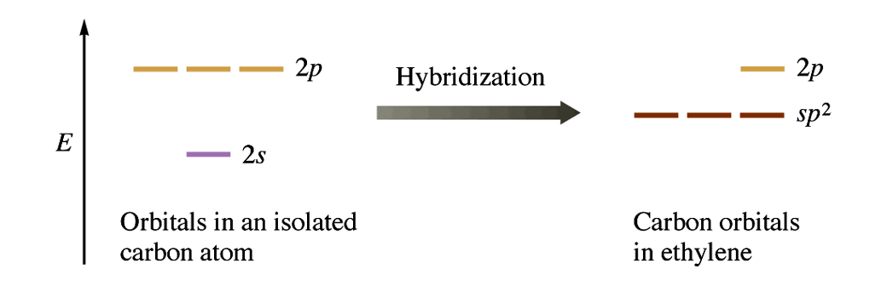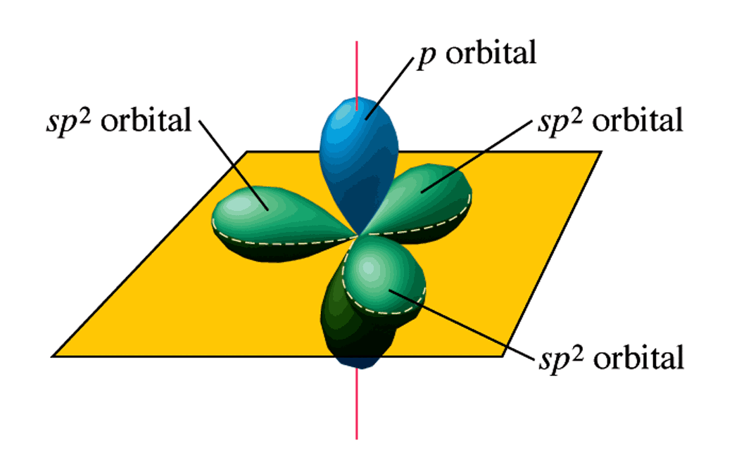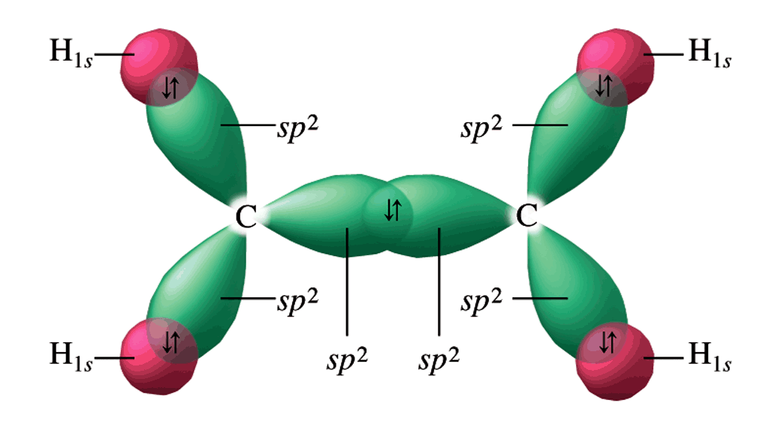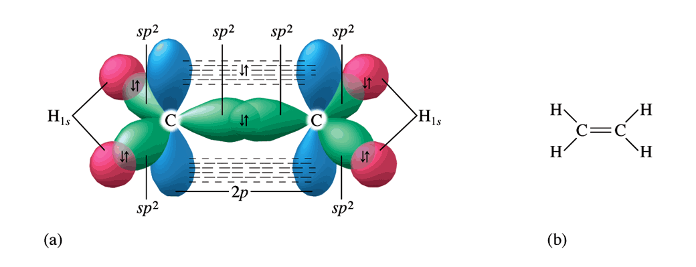

**sp**

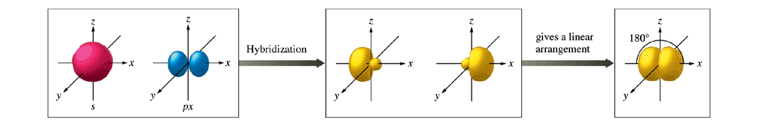

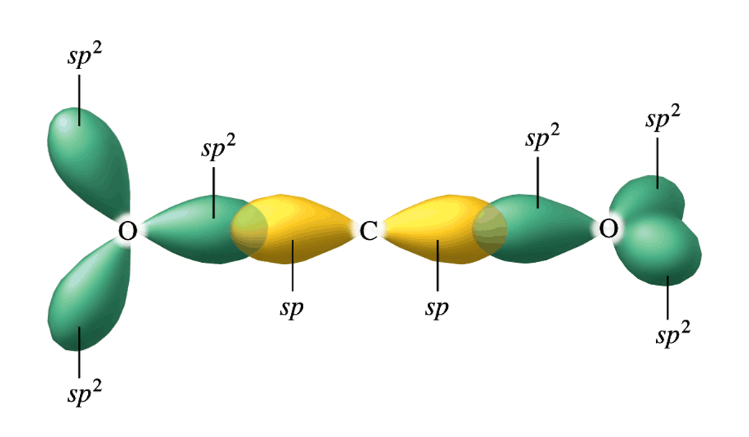

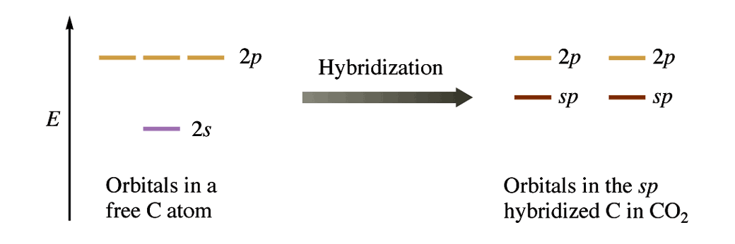

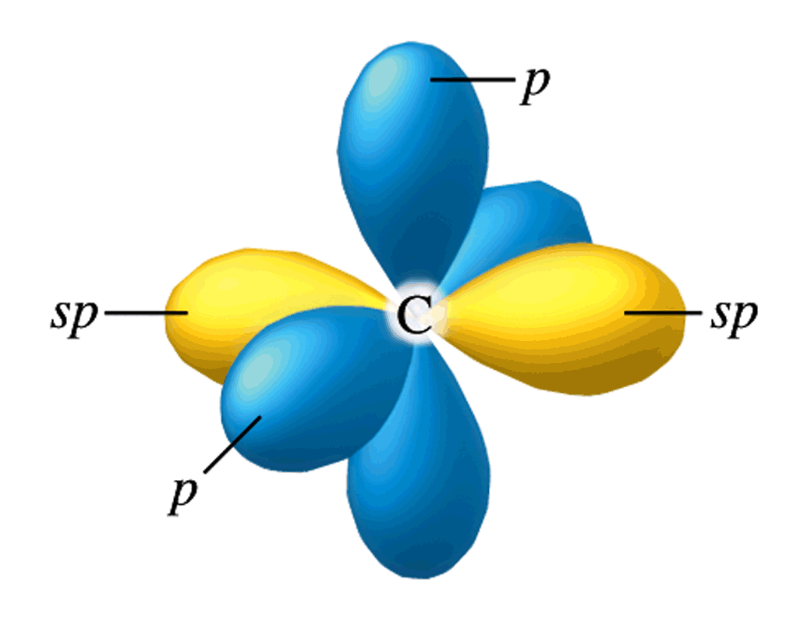

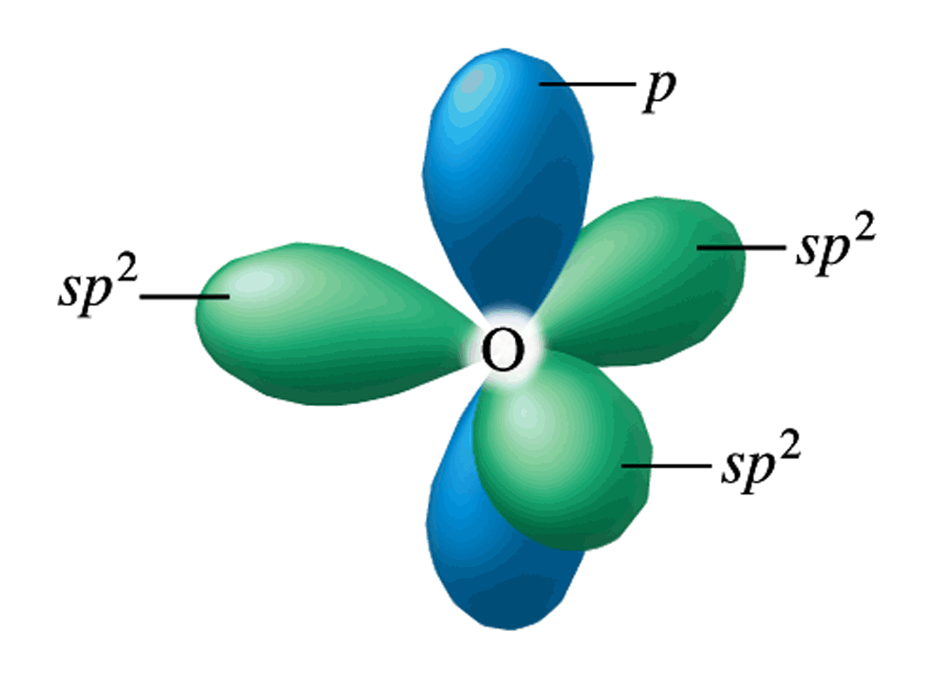

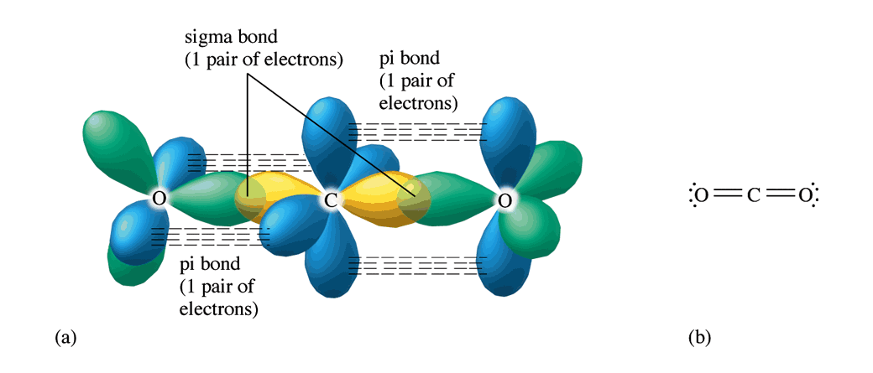

**dsp3**

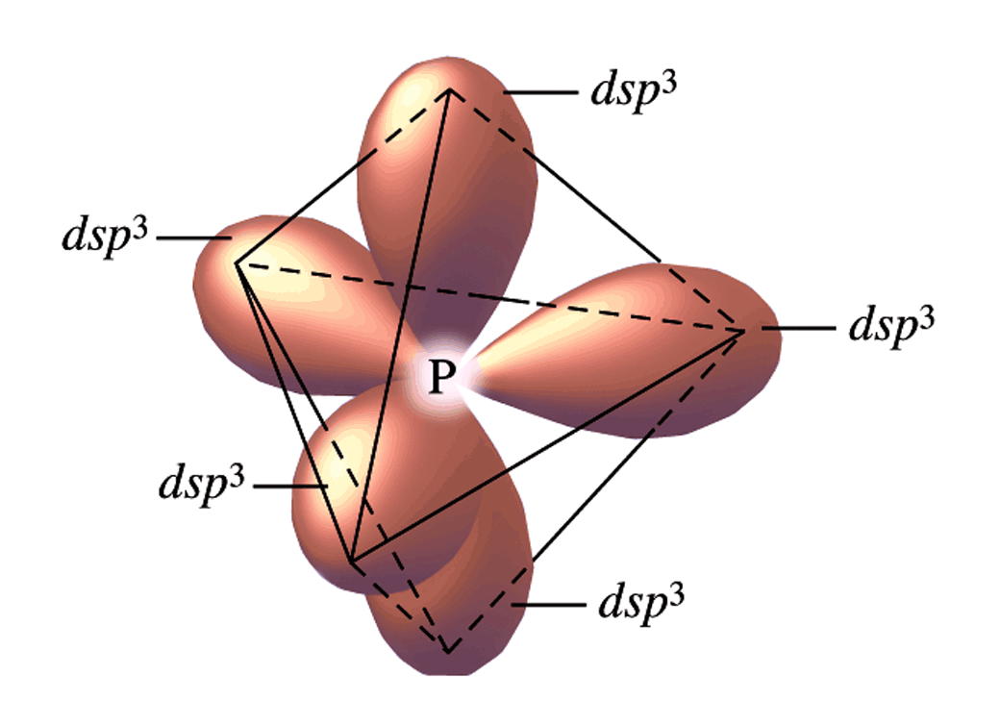

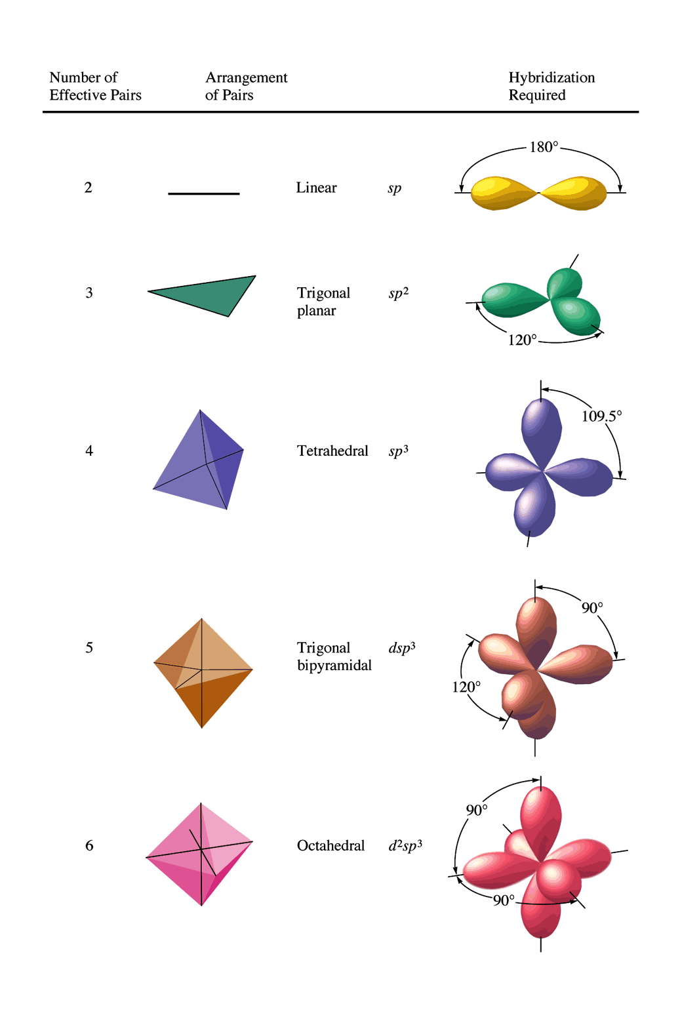

**d2sp3**

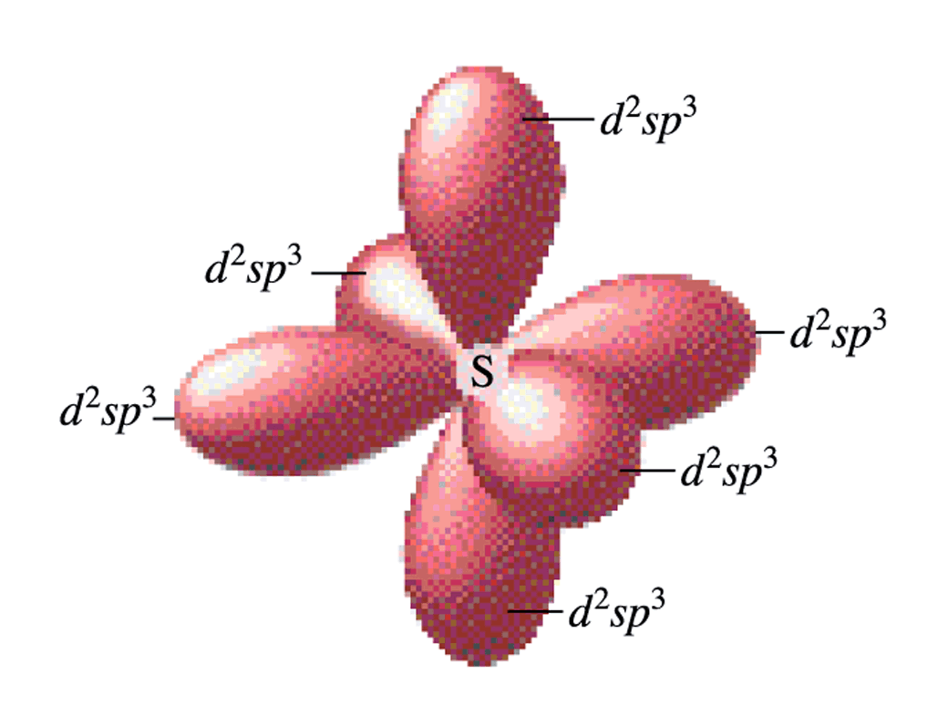

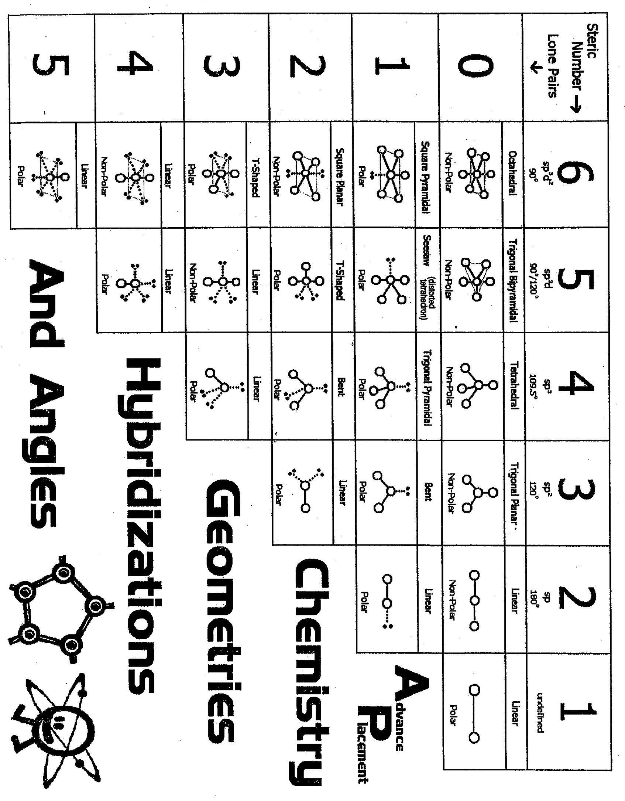

**Assignment 5: Hybridization**

1. What hybridization is required at the central atom of the following molecules or ions?

Sketch the Lewis electron-dot diagram and then state the hybridization.

|  |  |  |  |  |
| --- | --- | --- | --- | --- |
| a. AlCl3 | f. BCl3 | k. XeO4 | p. NO2 | u. NO2+ |
| b. PCl3 | g. ClO2 | l. CCl4 | q. XeF4 | v. ClO4 |
| c. PCl5 | h. O3 | m. SCl2 | r. SF4 | w. IF4 |
| d. SiCl4 | i. GaH3 | n. SF6 | s. OCS | x. ClF2+ |
| e. NCl3 | j. SO2Cl2 | o. BeCl2 | t. SO2 | y. BF3 |
| 2. In the organic chemistry of carbon, three hybridizations are common.  What are they, and why are they limited to three? | | | | z. CO2 |

3. Draw the Lewis electron dot structure of the nitrite ion. Describe the bonding in terms of valence bond theory. Then describe the  bonding in terms of molecular orbital theory.

**Assignment 5: Orbital Hybridization and Molecular Orbitals**

1. What is the hybridization of Br in BrF3?

a) sp d) sp3d

b) sp2 e) sp3d2

c) sp3

2. What type of hybridization is associated with a square planar molecular shape?

a) sp3 d) sp3d

b) sp2 e) sp3d2

c) sp

3. What shape for electron pairs (electron domains) is associated with sp3d2 hybridization?

a) linear d) tetrahedral

b) square planar e) octahedral

c) bent

4. What hybridization is predicted for phosphorus in the PCl3 molecule?

a) sp2 c) sp

b) sp3 d) sp3d2

5. A double bond contains ___ sigma bond(s)

and ___ pi bond(s).

a) 0, 2 b) 1, 2 c) 2, 0 d) 1, 1

6. What angle exists between orbitals in sp3d2 hybrid orbitals?

a) 90.0° d) 120.0°

b) 180.0° e) 78.5°

c) 109.5°

7. Which of the following elements is most likely to display sp3d hybridization?

a) oxygen d) carbon

b) nitrogen e) boron

c) phosphorus

8. How many sigma () and pi () electrons pairs are in a carbon dioxide molecule?

a) four  and zero  d) two  and four 

b) three  and two  e) one  and three 

c) two  and two 

9. What is the hybridization of the oxygen atoms in CH3OH and CO2, respectively?

a) sp3, sp3 d) sp2, sp2

b) sp3, sp2 e) sp3, sp

c) sp2, sp3

10. All of the following species contain two -bonds EXCEPT

a) SCN d) OCS

b) CO e) NO

c) H2CCO

11. Consider the structural formula for acetic acid, HC2H3O2 or CH3COOH. Indicate the type of hybridization used by each of the carbon and oxygen atoms.



12. Consider the structural formula for the acetate ion, C2H3O2– or CH3COO–. Indicate the hybridization used by each of the carbon and oxygen atoms.



**Podcast 7.6: Isomers**

Isomers:

* Two or more compounds that have the same ______________ but a different arrangement of atoms
* The arrangement of atoms in the compound results in different chemical or physical __________

Geometric Isomerism

* Atoms are arranged differently, but the _______ _________ are present
* -cis -trans

Sketch Below

Optical Isomers

* Also called ___________________
* Mirror images that cannot be superimposed on each other
* Molecules or ions that are not superimposable on the mirror image are said to be _____________
* Example: Left or Right Hand on mirror
* Non-Example: CH4 or CCl4 (see p. 964)

Linkage Isomerism (rare type)

* Occurs when a particular ___________ coordinates to a metal in two different ways (usually NO2- or SCN- )

Sketch Below

Coordination Isomers

* Differ in the ligands that are directly bonded to the __________ to form a positively charged complex ion

Sketch Below

**Assignment 6: Unit 7 Review**

*First draw the Lewis Structure, then name the electron domain shape AND the molecular shape (ignoring lone pairs, the shape the atoms form). Be sure to check formal charges as well. Finally, give the hybridization around the CENTRAL atom.*

1) AsO3 -1

2) ClO2-1

3) IBr3

4) RnO4-2

5) SiO2

FRQ 1997 #5

Consider the molecules PF3 and PF5.

1. Draw the Lewis electron-dot structures for PF3 and PF5 and predict the molecular geometry of each.
2. Is the PF3 molecule polar, or is it nonpolar? Explain.

(c) On the basis of bonding principles, predict whether each of the following compounds exists. In each case, explain your prediction.

(i) NF5

(ii) AsF5

FRQ 1997 #6

Explain each of the following obsevations using principles of atomic structure and/or bonding.

1. Potassium has a lower first-ionization energy than lithium.
2. The ionic radius of N3¯ is larger than that of O2¯.
3. A calcium atom is larger than a zinc atom.
4. Boron has a lower first-ionization energy than beryllium.