AP Chemistry

Unit 9 – Aqueous Solutions: Colligateive Properties & Reactions

This unit focuses on aqueous solutions: properties and reactions. It addresses Topic II (States of Matter) in the College Board's Advanced Placement Chemistry Topic Outline. In particular it focuses on Solutions. First we will explore the various kinds of solutions, the solution process, and the meaning of solubility. Then we will explore a number of colligative properties: the properties of a solution that depend on the number, but not the identity, of the solute particles. We'll look at four colligative properties in detail: vapor pressure lowering, boiling point elevation, freezing point depression, and osmotic pressure. Once we understand the molecular basis of each of these properties, we'll be able to determine the properties of the solute, such as its molar mass and the number of particles into which it dissociates in solution.

### Objectives

Define the term "solution."

Identify a mixture as a gaseous, liquid, or solid solution.

Describe the steps in the formation of a solution.

Explain the molecular basis for the heat of solution as a solute is added to water.

Define the term "solubility."

Describe several factors that influence solubility.

Define the term "saturated solution."

Define the term "colligative property."

Explain the molecular basis for vapor pressure lowering.

State Raoult's law and identify the terms it contains.

Calculate the vapor pressure of a solution using Raoult's law.

Determine the van't Hoff factor for any solute.

Explain the molecular basis of boiling point elevation.

Calculate the change in boiling point of a solution.

Explain the molecular basis of freezing point depression.

Calculate the change in freezing point of a solution.

Define the term "osmosis."

Describe the function of a semipermeable membrane.

Explain the molecular basis of osmotic pressure.

Use boiling point elevation, freezing point depression, or osmotic pressure to calculate the molar mass of a solute.

Identify an unknown solute from its empirical formula and its molar mass as determined from its colligative properties.

Define the term "colligative properties".

* Chapter 13 Problems 48, 50, 52, 53, 54, 57, 80

Podcast 9.1: Properties of Solutions

* A solution is formed when one substance disperses _____________ throughout another
* Solutions involved the interactions of _______
* Solutions form when the attractive force between solute and solvent particles are __________________ in magnitude to those that exist between solute-solute or solvent-solvent particles

Dissolving

* ___________________: occurs when solute particles are completely surrounded by solvent molecules
* ____________________: solvation that occurs when the solvent is H2O
* For solutions to form, “like must dissolve like”
  + Ex: Oil (nonpolar) doesn’t dissolve in water (polar)

Why oil and water don’t mix

Sketch Below

Describe Process:

Soap (Sketch Molecule)

A drop of grease in water

* Grease is _____________
* Water is ______________
* _________________ lets you dissolve the non-polar in the polar.

_________________________ ends dissolve in grease

_________________________ ends dissolve in water

* Water molecules can surround and dissolve grease.
* Helps get grease out of your way.

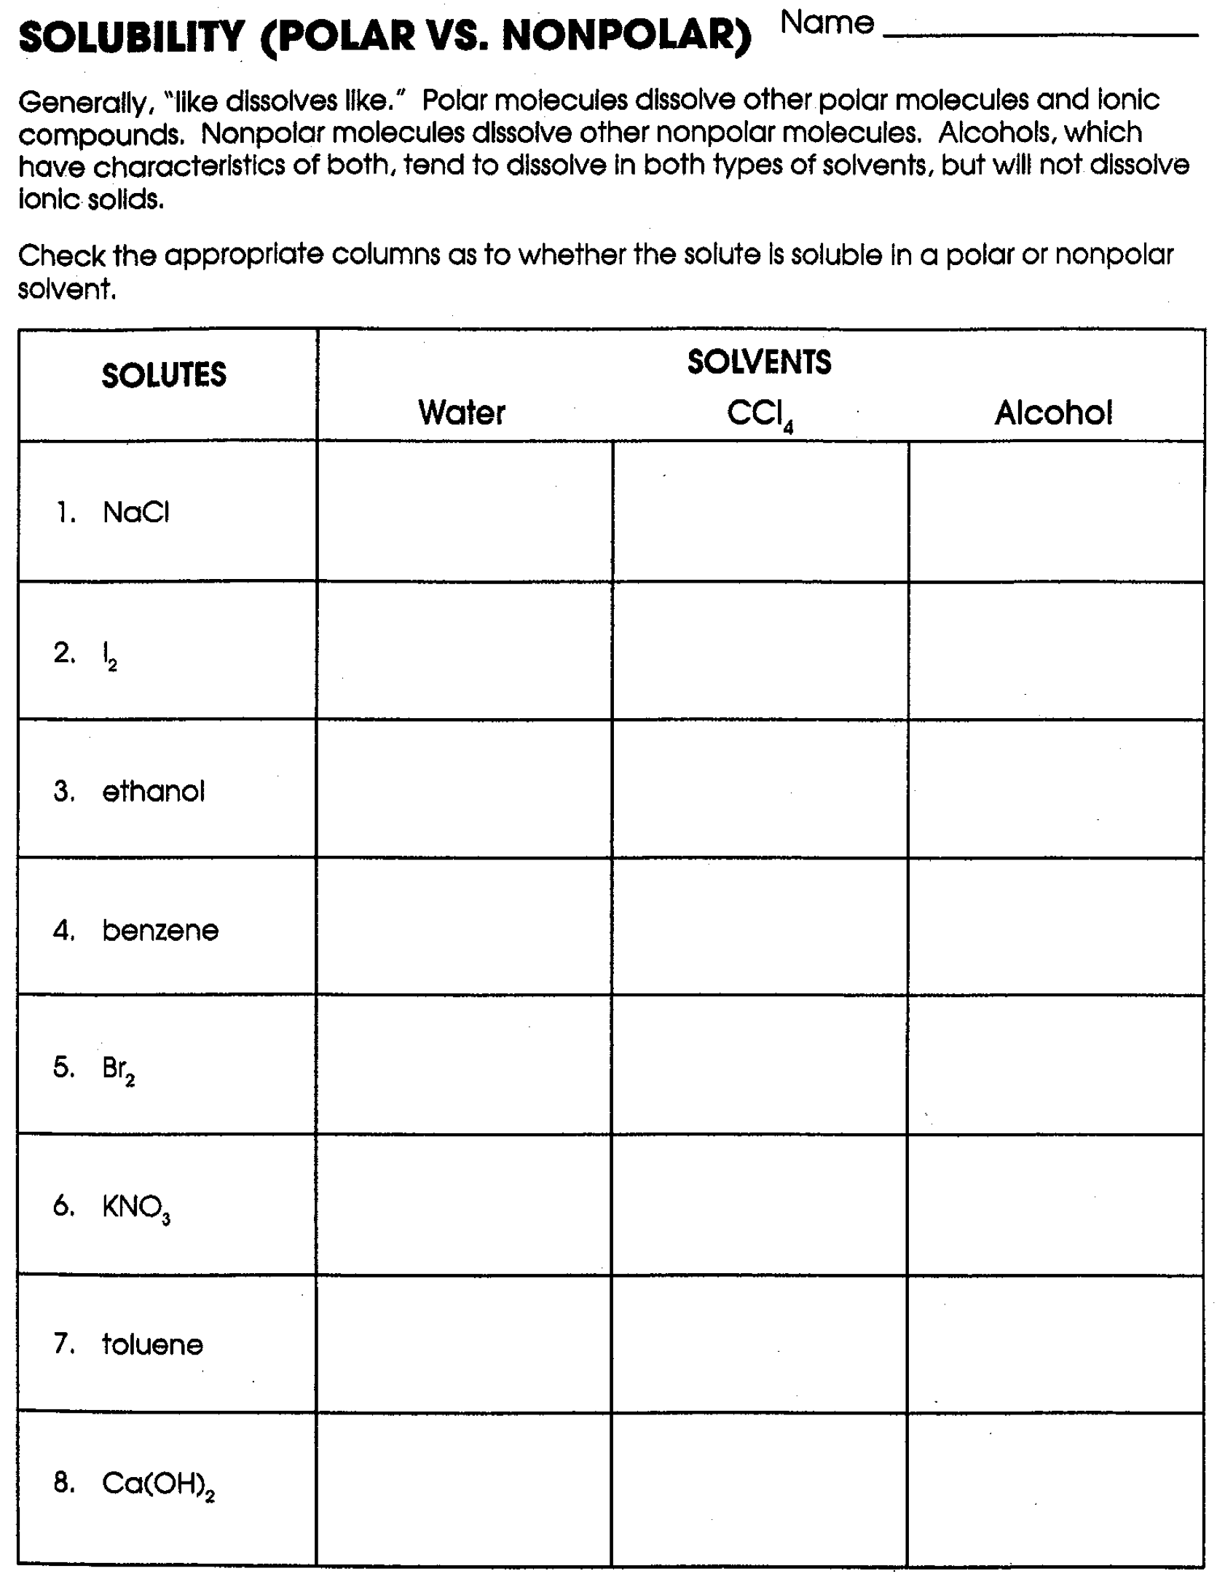

**Podcast 9.2: Measuring with Solutions**

In order for like to dissolve like, two things must be considered

________________: processes in which the energy content of the system **decreases** tend to occur **_______________________**

________________ (Entropy): processes in which the disorder of the system **increases** tend to occur **_______________________**

Formation of solutions is favored by the increase in entropy that accompanies mixing

Why do Things Dissolve?   
Energy of Course

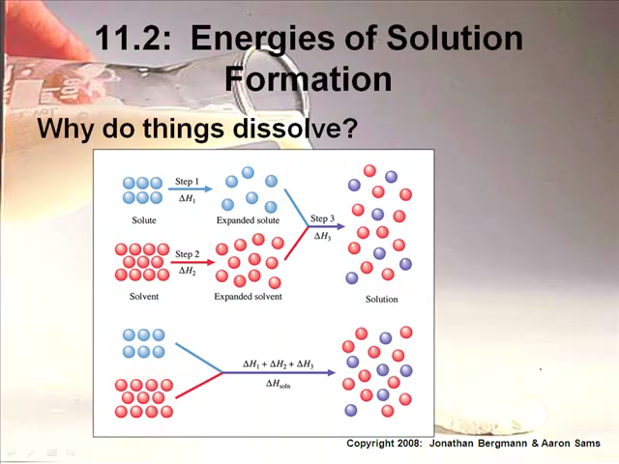

Size of H3 determines whether a solution will form

Sketch Graph of Energy

Comparing Heats of Solution

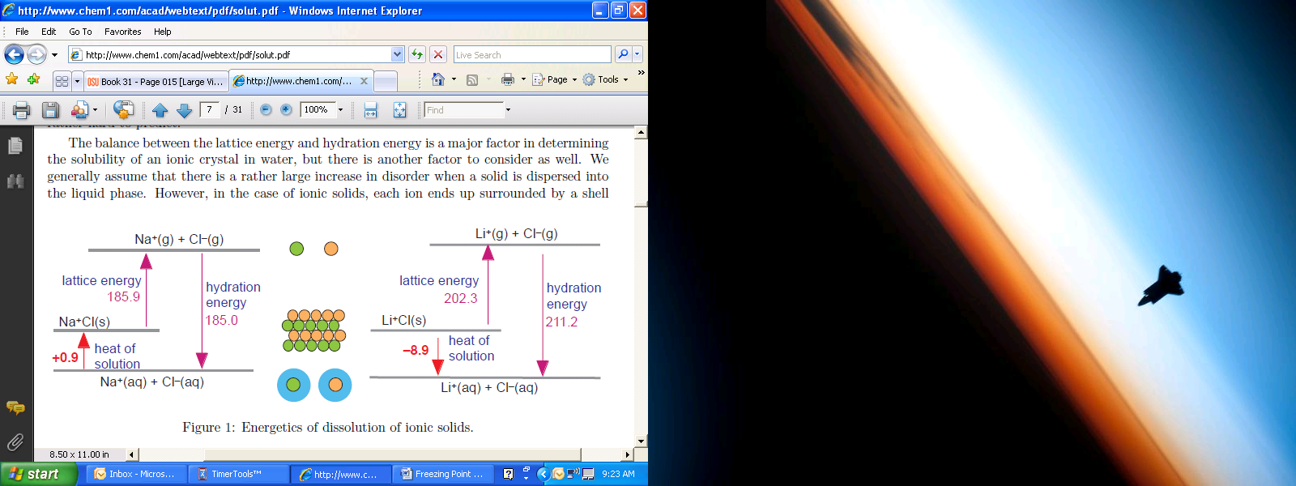

Will the NaCl dissolve in water? Why or why not?

Will the LiCl dissolve in water? Why or why not?

Types of Solvent and Solutes

If DHsoln is small and positive, a solution will still form because of __________________.

There are many more ways for them to become mixed than there is for them to stay separate.

Saturated Solutions and Solubility

______________________: opposite of solution or solvation process that occurs when increased concentrations of solid solutes collide with each other.

Dynamic Equilibrium occurs in this process → ___________

Saturated Solution: Solution which no further solute can dissolve

________________: given amount of solute that can dissolve to give a saturated solution

________________: one in which more solute can dissolve

__________________________: more solute is forced to dissolve with variations in temperature

Solution Equations

________________: number of moles of solute dissolved per liter of solution (M)

Equation

________________: Diluted solutions contain less solute

Equation

Percent Solution

For Two LIQUIDS we look at Percent by VOLUME

Equation

For a SOLID and a LIQUID we look at Percent(mass/volume)

Equation

Molality (m): # of moles of solute dissolved per kg of solvent

Equation

**TIP OF THE DAY:

Parts per million (ppm)

Equation

Parts per billion (ppb)

Equation

Mole Fraction: a ratio of one component to both components of a solution

Equation

**Solubility and Solubility Curves**

**Using the given solubility curves, please solve the following problems.**

1. What is the solubility of potassium nitrate (KNO3) in 100.0g of water at80.0°C?
2. What is the solubility of potassium chloride (KCl) in 100.0g of water at 50.0°C?
3. What is the solubility of sodium chloride (NaCl) in 100.0g of water at 90.0°C?
4. What is the minimum temperature needed to dissolve 180.0g of KNO3 in 100.0g of water?
5. What is the minimum temperature needed to dissolve 35.0g of KCl in 100.0g of water?
6. At what temperature do KCl and KNO3 have the same solubility?
7. How much more KCl will dissolve at 90.0°C, how much will not dissolve?
8. If 50.0g of NaCl is mixed with 100.0g of water at 80.0°C, how much will not dissolve?
9. If 15.0g of KCl is added to 100.0g of water at 30.0°C, how much more must be added to saturate the solution?
10. If a saturated solution of KNO3, at 20.0°C is heated to 80.0°C, how much more could be dissolved?
11. If a saturated solution if KCl at 90.0°C is cooled to 30.0°C. how much of the solid will precipitate?
12. How much NaCl will dissolve in 350.0g of water at 70.0°C?
13. How much KCl will dissolve in 50.0g of water at 50.0°C?
14. Classify as saturated or unsaturated a solution that contains 90.0g of KCl in 100.0g of water at 70.0°C.
15. Classify as saturated or unsaturated a solution that contains 50.0g of KCl in 100.0g of water at 70.0°C.
16. What temperature is needed to dissolve twice as much KNO3 as can be dissolved at 30.0°C in 100.0g of water?

**Please use the diagram on the right to answer questions 17 – 26.**

1. Which salt is least soluble in water at 200 C?

1. How many grams of potassium chloride can be dissolved in 200 g of water at 800 C?
2. At 400 C, how much potassium nitrate can be dissolved in 300 g of water?

1. Which salt shows the least change in solubility from 00 - 1000 C?

1. At 300 C, 90 g of sodium nitrate is dissolved in 100g of water. Is this solution saturated, unsaturated or supersaturated?
2. A saturated solution of potassium chlorate is formed from one hundred grams of

water. If the saturated solution is cooled from 800 C to 500C how many grams of precipitate are formed?

1. What compound shows a decrease in solubility from 00 to 1000 C?
2. Which salt is most soluble at 100 C?

25. Which salt is least soluble at 500 C?

26. Which salt is least soluble at 900 C?

**Podcast 9.3: Colligative Properties**

____________________________: the properties that deal with the number of particles dissolved in a given mass of solvent

The physical properties of a solution differ from the properties of the solvent

* Vapor Pressure __________________
* Boiling Point _________________
* _____________________ Point Depression
* Colligative Properties are properties of a solution that depend on the ____________ of solute _________________ in the solution.
* For colligative properties, the identity of the particles IS NOT IMPORTANT. In other words, size and molar mass do NOT matter – the number of the solute particles is what is important here!
* ______________ (not molarity) is the number of solute particles per kilogram of solvent.

Vapor Pressure Lowering

* Vapor Pressure: the pressure exerted by a vapor that is in dynamic equilibrium with its _________ in a closed system
* ________________ Law: The solubility of a gas is directly proportional to the pressure of the gas
* When solutes are added to a pure solvent, the vapor pressure is ____________________
  + Less solvent molecules escape liquid phase
  + The decrease is proportional to the number of solute _______________ dissolved

Glucose _______ NaCl _______ CaCl2

* Vapor Pressure decreases when a _______________ solute is added to a solvent
* Vapor Pressure lowering is directly proportional to a solution’s _______________________

Sketch

* Raoult’s Law
* An increase in the mole fraction of the solute will ___________________ the vapor pressure over the solution
* “Ideal Solutions” obey Raoult’s Law. Real solutions are considered ideal when solute concentration is ___________

Effect on Boiling Point

* **Boiling Point _______________________**: When a solute (that dissociates) is added to a solution the boiling point of the solution will increase.
* Boiling Point: the temperature where the vapor pressure of the liquid _______________ atmospheric pressure
* When solute is added, the vapor pressure is ________________ so the boiling temperature is ___________________
* Additional _______________________ is required to break apart solute/solvent interactions
* <http://www.chem.purdue.edu/gchelp/solutions/eboil.html>

Sketch

* Temperature difference between the boiling point of solution and pure solvent depends on the ____________ of solute ________________

Equation:

* Δ*Tb=* ***change in boiling point temperature***
* *kb= the boiling point elevation constant for the solvent*
* *i = the Van’t Hoff factor, m = molality*
* Occurs because additional solute particles __________________ vapor pressure so more pressure is needed to boil
* More energy is needed to break___________ and exert additional vapor pressure

*i = the Van’t Hoff factor,*

* *i =* the number of particles into which the added solute __________________
* for ALL molecular compounds, the Van’t Hoff factor is equal to _______
* for ionic compounds (that are STRONG), the Van’t Hoff factor is dependent upon the number of particles dissociating once dissolved

Examples

* NaCl → Na+1 + Cl-1
* Van’t Hoff factor = _____
* Na3PO4→ 3 Na+1 + PO4-3
* Van’t Hoff factor = _____

Freezing Point Depression: Temperature difference between the freezing point of solution and pure solvent

* Solutes disrupt the normal __________________ pattern of a pure frozen solvent in a solution
* Additional kinetic energy must be lost for solidification to occur

Equation

* Δ*Tf=* ***_________*** *in freezing point temperature*
* *kf = the freezing point elevation constant for the solvent*
* Δ*Tf and* Δ*Tb*can be used to find the __________________ of a substance

Example #1: A solution is prepared by dissolving 4.9 grams sucrose ( C12H22O11) in 175 grams of water. Calculate the boiling point of this solution. Sucrose is a nonelectrolyte.

Example 2: Calculate the freezing point for water if 320.0 grams of solid calcium nitrate is added to 2500 mL of water.

Example 3: Calculate the freezing point and boiling point for chloroform (polar) if 75 grams of Li3PO4 (which dissociates 100% in chloroform) is placed into 23.2 moles of chloroform.

Example 4: A solution containing 4.50 grams of a nonelectrolyte dissolved in 125 grams of water freezes at –0.3720C. Calculate the approximate molecular weight of the solute.

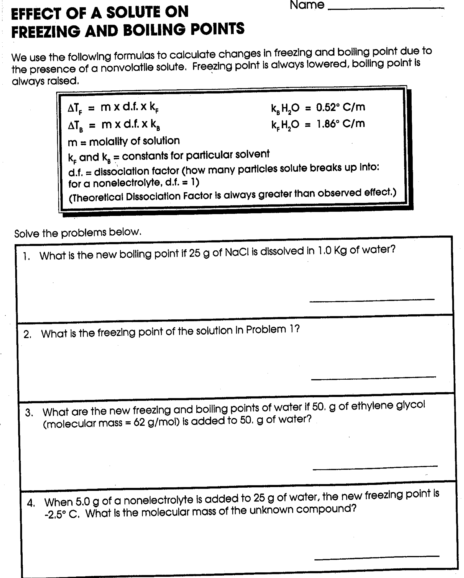



Example #1: A solution is prepared by dissolving 4.9 grams sucrose ( C12H22O11 ) in 175 grams of water. Calculate the boiling point of this solution. Sucrose is a nonelectrolyte.

Example #2: Calculate the freezing point for water if 320.0 grams of solid calcium nitrate is added to 2500 mL of water.

Example #3: Calculate the freezing point and boiling point for chloroform (polar) if 75 grams of lithium phosphate (dissociates 100% in chloroform) is placed into 23.2 moles of chloroform.

AP Chem Cooling Curve

The molar mass of an unknown solid, which is nonvolatile and a nonelectrolyte, is to be determined by the freezing-point depression method. The pure solvent used in the experiment freezes at 10 oC and has a known molal freezing-point depression constant, *Kf*. Assume that the following materials are also available.

Test tubes stirrer pipet thermometer balance

Beaker stopwatch graph paper hot-water bath ice

1. Using the two sets of axes provided below, sketch cooling curves for (i) the pure solvent and for (ii) the solution as each is cooled for 20 oC to 0.0 oC.

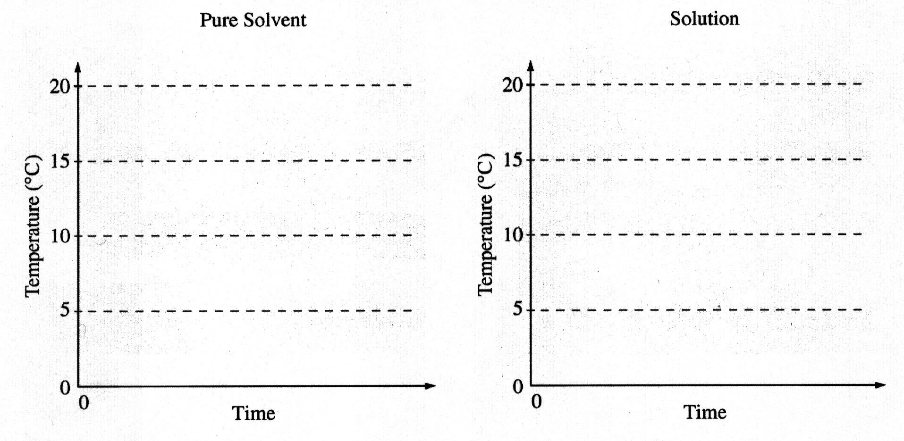

1. Information from these graphs may be used to determine the molar mass of the unknown solid.
2. Describe the measurements that must be made to determine the molar mass of the unknown solid by this method.
3. Show the setup(s) for the calculation(s) that must be performed to determine the molar mass of the unknown solid from the experimental data.
4. Explain how the difference(s) between the two graphs in part a) can be used to obtain information needed to calculate the molar mass of the unknown solid.
5. Suppose that during the experiment a significant but unknown amount of solvent evaporates from the test tube. What effect would this have on the calculated value of the molar mass of the solid (i.e., too large, too small, or no effect)? Justify your answer.
6. Show the setup for the calculation of the percentage error in a student’s result if the student obtains a value of 126 g mol-1 for the molar mass of the solid when the actual value is 120. g mol-1.

**Podcast 9.4: Osmosis and Colloids**

Osmosis

* Deals with _____________________ substance – substances that allow some molecules to pass through a network of tiny “pores”
* Substances move across a membrane from an area of __________ concentration to a ______ concentration

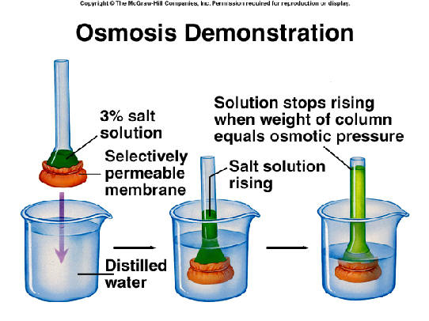

* Osmosis: _____________ molecules always move toward solution with ________ solute concentration… from ____ to ____
* Osmotic Pressure: the pressure required to stop the flow of osmosis (π)

Example 1: A solution containing 365.3 grams of a electrolyte (that dissociates into four particles) dissolved in 1200 grams of water boils at 107.44 0C. Calculate the approximate molecular weight of the solute.

Example 2: What mass of aluminum perchlorate must be dissolved in 3.53 kg of water to give a solution with a freezing point of –13.33 0C?

Colloids are the dividing line between solutions and __________________________ mixtures

* Also called colloidal ___________________
* Colloid particles consist of clusters of atoms, ions, molecules, or a single giant molecule

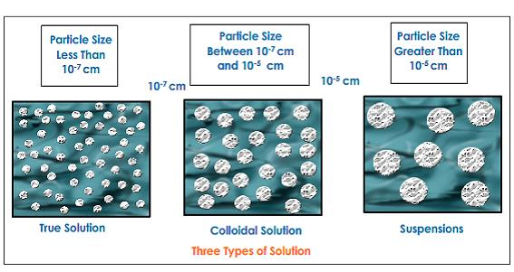

* Generally have a ____________ appearance
* The scattering of light by a colloid is called the _______________ Effect
  + Scattering of light as reflected off of particles in solution
  + Colloids are best seen when dispersing medium is water

Sketch

* Hydrophilic and hydrophobic colloids
* Colloidal particles are removed in a process called __________________
* Addition of __________ electrolytes to “grab” particles
* Filtration usually follows coagulation

Sketch

**FRQ Practice**

Answer the following questions about a pure compound that contains only carbon, hydrogen, and oxygen.

1. A 0.7549 g sample of the compound burns in O2(g) to produce 1.9061 g of CO2(g)

and 0.3370 g of H2O(g)

i) Calculate the individual masses of C, H, and O in the 0.7549 g sample

ii) Determine the empirical formula for the compound.

1. A 0.5246 g sample of the compound was dissolved in 10.012 g of lauric acid, and it

was determined that the freezing point of the lauric acid was lowered by 1.68 oC. The value of Kf of lauric acid is 3.90 oC m-1. Assume that the compound does not dissociate in lauric acid.

i) Calculate the molality of the compound dissolved in the lauric acid.

ii) Calculate the molar mass of the compound from the information

provided.

1. Without doing any calculations, explain how to determine the molecular formula of

the compound based on the answers to parts (a)(ii) and (b)(ii).

d) Further tests indicate that a 0.10 M aqueous solution of the compound has a pH of

2.6. Identify the organic functional group that accounts for this pH.

Answer the following questions, which refer to the 100 mL samples of aqueous solutions at 25°C in the stoppered flasks shown below.

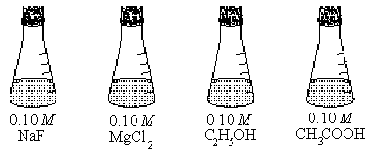

a. Which solution has the lowest electrical conductivity? Explain.

1. Which solution has the lowest freezing point? Explain.
2. Above which solution is the pressure of water vapor greatest? Explain.

**Elemental analysis of an unknown pure substance indicates that the percent composition by mass is as follows: Carbon - 49.02%, Hydrogen - 2.743%, Chlorine - 48.23%**

A solution that is prepared by dissolving 3.150 grams of the substance in 25.00 grams of benzene, C6H6, has a freezing point of 1.12°C. (The normal freezing point of benzene is 5.50°C and the molal freezing-point depression constant, Kf, for benzene is 5.12 C°/molal.)

1. Determine the empirical formula of the unknown substance.
2. Using the data gathered from the freezing point depression method, calculate the molar mass of the unknown substance.
3. Calculate the mole fraction of benzene in the solution described above.
4. The vapor pressure of pure benzene at 35°C is 150. millimeters of Hg. Calculate the vapor pressure of benzene over the solution described above at 35°C.

IT'S GETTING COLDER

FREEZING POINT DEPRESSION LAB

*PURPOSE

The purpose of this experiment is to demonstrate the effect of solutes on the freezing point of water.

*INTRODUCTION

Have you ever wondered how antifreeze lowers the freezing point of water in the cooling systems of automobiles? Adding a solute to water lowers the freezing point of water and raises the boiling point. Lowering the freezing point depends on the concentration of dissolved particles present. In the case of a nonelectrolyte, the molality of the nonelectrolyte and the molality of particles in solution are the same (a 1:1 ratio). For electrolytes, the molality of particles is equal to the molality of the electrolyte times the number of ions in the chemical formula of the compound.

Automobile manufacturers make use of the principle of freezing point depression to protect engines from freezing in cold weather. Antifreeze, a nonelectrolyte, is added to the water-filled radiator that cools the engine. Under most conditions the presence of the antifreeze molecules in the water is sufficient to keep the system from freezing. In the winter, salt is placed on the roads to lower the freezing point of the water on the road. Salt, NaCl, is ionic and dissociates into two ions, one Na+ ion and one Cl- ion.

In this investigation, you will determine the freezing point depression of antifreeze solutions by cooling them in an ice-salt bath. You will also use this information to find the molar mass of ethylene glycol. You will then determine the freezing point depression of salt water and use the information to calculate the freezing point constant.

The calculations require the use of the equation, [delta ]*T = (Kf ) (m) (i)*. In the first part of the experiment, various solutes are added to water and the resultant freezing points of the solutions are determined. The value of *i*, dissolved particles per formula unit, is calculated. In the second part, the molar mass of commercial antifreeze is determined.

*MATERIALS

Chemicals:

ice

C12H22O11 (sucrose)

NaCl

commercial automotive antifreeze

Equipment:

test tubes

thermometer

400-mL beaker

100-mL graduated cylinder

stirring rod

*HAZARDS

Since commercial antifreeze is primarily ethylene glycol, it is highly toxic and should not be ingested. The ice used in the experiment could become contaminated with antifreeze by accident; students should be warned not to eat the ice. Goggles must be worn throughout the experiment.

*PROCEDURE

Preparation of Ice Bath

Fill the large beaker 3/4 full with ice. Cover the ice with 1/4 to 1/2 inches of table salt.

Stir this ice-salt mixture with a stirring rod and make sure the temperature drops to at least

-10°C..

Determination of Freezing Points of Solutions:

Prepare a solution of NaCl by adding 5.8 grams of NaCl to 100 mL of water. Mix until all crystals dissolve.

Prepare a solution of sucrose by adding 34 grams of sucrose to 100 mL of water. Mix until all crystals dissolve.

Place a test tube that is 1/2 full of water in the ice bath.

Stir the water in the test tube gently with a thermometer while keeping track of the temperature.

When the first ice crystals appear on the inside wall of the test tube, record the temperature. This should be the freezing point of the liquid. (In this step water is the pure solvent).

Repeat steps 3-5 with the prepared NaCl and sucrose solutions.

Calculate the molalities of the NaCl and sucrose solutions.

Using the equation, [delta ]T = (Kf)(m)(i), determine the value of i, where i is the number of particles produced per formula unit and Kf for water = 1.86°C/m.

Molecular Mass Determination From Freezing Point Depression

Dissolve 6.2 grams of commercial antifreeze in 100 mL of water.

Freeze this solution in the same manner as in the previous experiment. Be sure to record the freezing point temperature.

Calculate the molecular mass of this solute based on the freezing point depression.  
Molecular mass of solute = [(Kf) (grams of solute)] ÷ [([delta ]T) (kg of solvent)]

*DISPOSAL

All solutions may be flushed down the drain with plenty of water.

*DISCUSSION

Colligative properties of solutions depend upon the concentration of solute particles. The freezing points of water solutions are always lower than that of pure water. The change in freezing point caused by the presence of a solute dissolved in water can be calculated from the equation,

T = (Kf)(m)(i)

where Kf is the molal freezing point depression constant (1.86°C/m for water), m is the molality of the solution, and i is the number of particles produced per formula unit.

Molality = moles of solute/kg solvent

Since colligative properties depend upon the number of particles in solution, a one molal solution of an electrolyte (NaCl), which dissociates in water, lowers the freezing point more than a one molal solution of a non-electrolyte (sucrose). The freezing point of a one molal solution of NaCl is actually -3.37°C, only 1.81 times that of a non-electrolyte, not the -3.62°C that would be expected if NaCl were completely dissociated. This difference is believed to be due to the interionic attractions that prevent the ions from behaving as totally independent particles. The activity or effective concentration of the ions is less than would be indicated by the actual concentration. Some of the ions may exist as solvated units called an ion pairs. The more dilute the solution of an electrolyte, the more widely separated the ions, the less the interionic attractions, and the closer the effective concentration of the ions approaches the actual concentration.

*REFERENCES

Holtzclaw, H.F., Robinson, W.R., and Nebergall, W.H.,*College Chemistry with Qualitative Analysis*, D. C. Heath and Company, Lexington, MA, 1984, p. 359. This work discusses colligative properties.

Data Table:

|  |  |
| --- | --- |
| Substance | Freezing Point (oC) |
| Water |  |
| Salt water |  |
| Sugar water |  |
| Antifreeze |  |

Calculations:

Part A:

Determine the freezing point depression for the salt.

∆FP = FPwater – FPsaltwater

Determine the molality of the solution.

$m=\frac{moles of solute}{kilograms of solvent}$

What is the solute? _______ What is the solvent? _______

Moles of solute = mass / formula mass

Kilograms of solvent =

molality =

1. Calculate the freezing point constant.

$\frac{∆FP}{2(m)}=K_{f}$

1. Determine the freezing point depression for the salt.

∆FP = FPwater – FPsugar-water

1. Determine the molality of the solution.

$m=\frac{moles of solute}{kilograms of solvent}$

What is the solute? ________ What is the solvent? _________

Moles of solute = mass / formula mass

Kilograms of solvent =

molality =

1. Calculate the freezing point constant.

$\frac{∆FP}{2(m)}=K_{f}$

**Questions:**

1. Permanent antifreeze is almost 100% ethylene glycol (1,2 ethanediol, C2H4(OH)2). Calculate its molar mass.
2. Calculate the percent error in Kf for both salt water and sugar water.
3. Calculate the percent error in Molar Mass for antifreeze.
4. Could freezing point depression be used for substances not soluble in water? Why or why not?
5. What effect on the freezing point of water would a 1 m solution of the ionic substance (NH4)3PO4 have as compared to a covalent substance?
6. Would rock salt or table salt be better to use when making ice cream? Explain.
7. Which substance used in this laboratory experiment lowered the freezing point of the water more? Explain why.

**Analysis**

1. Restate your percent error and comment on some possible errors that might have occurred.
2. How would each of the following errors affect the calculated molar mass of antifreeze (too high, too low, no effect). Explain your reasoning.

a. The thermometer used actually read 1.4°C too high.

b. After measuring the 100 mL of distilled water to make the antifreeze/water solutions, some was accidentally spilled while you weren’t looking.

c. While you weren’t looking, an evil lab destroying demon stole some of the antifreeze you had measured out before you added the water.

d. Some of the antifreeze/water solution was spilled from the test tube before you had a chance to determine the freezing point of the solution.

1. What is the least precise measurement in this lab? Explain. How should this limit your significant digits.
2. The following data was obtained in an experiment designed to find the molecular mass of a solute by freezing point depression:

Solvent: *para*-dichlorobenzene Freezing point depression constant: 7.1°C/*m*

Freezing point of pure solvent: 53.02 °C Mass of *para*-dichlorobenzene: 24.80 g

Mass of unknown substance: 2.04 g Freezing point of solution: 50.78°C

Calculate the molecular mass of the solute.

1. Would a 1 *m* aqueous solution of glucose, C6H12O6, or a 1 *m* aqueous solution of the ionic compound, (NH4)3PO4, have a lower freezing point? Explain your reasoning and prove it with ΔTf calculations. Kf for water is 1.86 °C/*m*.
2. Give a definition of colligative properties. Draw a phase diagram of a pure substance, and show how addition of a solute affects this diagram.