**AP Chemistry Unit One – Chemical Foundations**

**Chapter One Problem Set p. 30-35:** 9, 19, 27, 32, 33, 41, 46, 52

**Chapter Two Problem Set p. 70-76:** 9, 23, 47, 95, 97

**Chapter Three Problem Set: p. 111-115;** 3.1, 3.4, 3.6, 3.7, 3.38, 3.50, 3.59

AP Achievement Level 3 Level 4 Level 5

|  |  |  |  |
| --- | --- | --- | --- |
| ***Stoichiometry*** | Uses the mole concept to connect quantities between the macroscopic and particulate levels, both quantitatively and qualitatively. Performs routine stoichiometric computations of reactants to products, including balancing an equation. Successfully communicates and flexibly uses different measures of a substance, e.g., volume, mass, concentration, density. Recognizes connections between macroscopic and particulate-level representations. | States the utility of the mole to connect measurements made at the macroscopic level to the particulate level. Applies conservation of number atoms to analyze systems both quantitatively and qualitatively. Interprets experiments designed to determine concentration and composition, such as gravimetric analysis, titrations, and Beer's law. Relates isotopic distributions to the average atomic mass, both qualitatively and quantitatively. Translates between different representations, including macroscopic and particulate level views | Uses stoichiometric reasoning in situations that involve impure substances. Designs experiments to determine concentration, composition, and identity of a substance. Generates appropriate representations, including macroscopic and particulate level views |

**Assignment 1: Create a Lab Safety Meme to share with the class.**

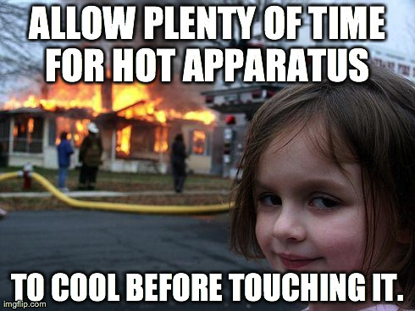[***https://imgflip.com/memegenerator***](https://imgflip.com/memegenerator)[***http://memegenerator.net/***](http://memegenerator.net/)

[***http://imgur.com/memegen***](http://imgur.com/memegen)

**Assignment 2:**

1. Please describe what average “means” to you.
2. Record your observations of our average calculations (and other statistical measures) after “Faux Fish Figuring.”

**Podcast: Scientific Measurement** <https://youtu.be/gQc0d2XaR9o>

Measurement: Every measurement has two parts

1. ________________________ 2. ________________________

Metric System uses “Prefix + base unit”: Prefix tells you the ________________________ to multiply by

**SI Metric Prefixes** (feel free to do a screen capture)

**Accepted Units Outside SI**

Metric System: ____________________ Units cannot be derived from other units (capitalization counts – BE CAREFUL!)

Mass -

Length-

Time -

Temperature-

Electric current-

Amount of substance-

* Dimensional Analysis: Using Units to Solve Problems

Use conversion factors to change the ________

Conversion factors = ____

1 foot = __________ (equivalence statement)

You have two conversion factors to choose from. Multiply by the one that will give you the correct units in your answer.

**Example 1**

11 yards = 2 rod

40 rods = 1 furlong

8 furlongs = 1 mile

The Kentucky Derby race is 1.25 miles. How long is the race in rods, furlongs, meters, and kilometers?

**Example 2**

Warp 1.71 = 5.00 times the speed of light

speed of light=3.00 x 108 m/s

1 knot = 2000 yd/h exactly

Science fiction often uses nautical analogies to describe space travel. If the starship U.S.S. Enterprise is traveling at warp factor 1.71, what is its speed in knots?

Mass and Weight

* _____________ is measure of resistance to change in motion
* ________is force of gravity acting on an object
* Sometimes used interchangeably
* ____________ can’t change without altering the _____________ of matter
* _____________ depends on the strength of the ____________________ ____________

Density

Ratio of mass to volume

* An intrinsic property –
* Useful for

**Example 3**

An empty container weighs 121.3 g. Filled with carbon tetrachloride (density 1.53 g/cm3 ) the container weighs 283.2 g. What is the volume of the container?

Temperature: A measure of the average ___________________ NOT heat (even though they’re related)

Different temperature _______________, all are talking about the same height of mercury in a thermometer.

Derive an equation for converting ºF toºC



Significant Figures: ______________________ digits in a MEASUREMENT

* Exact numbers are counted, have unlimited significant figures
* _________________ except zero are significant.
* Some zeros are, some aren’t…
* Which Zeroes Count?

1. ______________ other sig figs
2. NOT before the first number
3. After the last number counts if and only if…
   * + it is after the decimal point
     + the decimal point is written in

Doing The Math

* Multiplication and division: same number of _____________ in answer as the LEAST in the problem
* Addition and subtraction: same number of ______________ in answer as LEAST in problem.

1. 2.00 x 3.0 x 0.020 =
2. 1.40 ÷ 0.604 =
3. 10.01 + 4.70 + 0.3 =
4. 9.663 – 0.15 =

**Podcast: Communicating Your Results**

Uncertainty: Basis for significant figures

______________ measurements are uncertain to some degree

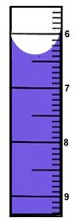

6

5

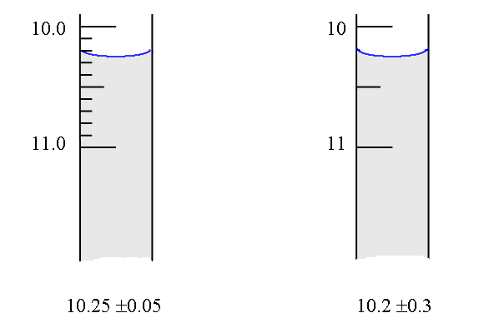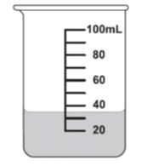

Looking for Trends in Your Data

* ______________ - how repeatable
  + Reported as ___________________________________
* ______________ - how close to true (or accepted) value
* Reported as ________________________________
* Error – Measurement Discrepancies

____________________- equal chance of being too high or too low, addressed by averaging measurements,

expected _______________same direction each time, Want to avoid this. Fix mistakes! Mistakes are NOT errors.

Handling Your Data

Please enter the following data for the decomposition of a hydrated compound into your graphing calculator.

|  |
| --- |
| Change in Sample Mass (g) |
| Sample A |
| 0.4492 |
| 0.4335 |
| 0.434 |
| 0.341 |
| 0.432 |
| 0.5549 |
| 0.41 |
| 0.44 |
| 0.364 |
| 0.19 |

Using 1-Var Stats

What is all this?

$$\overline{x}=$$

$$\sum{x}=$$

$$\sum{x^{2}}=$$

$$Sx=$$

$$σx=$$

$$n =$$

$$min X=$$

$$Q_{1}=$$

$$Med =$$

$$Q_{3}=$$

$$max X =$$

The Empirical Rule (please sketch graph)

* To evaluate your precision, use standard deviation
* ______ of data lies within 1 sd of your mean
* ______ of data lies within 2sd of your mean
* ______ of data lies within 3 sd of your mean
* Check for outliers by applying the ________ rule
  + Mean + 2(Sx) gives your ___________________ acceptable value
  + Mean – 2(Sx) gives your ____________________ acceptable value
  + All values outside of this range are considered outliers and should be discarded.
* Where does Data Analysis Fit In?
* In your lab notebook, use the ____________ page to write your lab report and record data. Use the _____________ page to show calculations, graphs, and statistical analysis.

**Podcast: Setting Up Your Lab Notebook**

Setting Up Your Notebook

Lab Notebook: _____________ Notebook or Carbonless Copy Student Lab Notebook

What Else Goes in the Lab Notebook?

* **Purpose**: Brief Statement of _________________ **Variables**: Identify important factors that ______________ the outcome of the experiment
* **Question**: Derived from Variables; “How does _______ affect _______?”
* **Prediction:** What _________________________ will you observe as a result of the experiment?
* **Hypothesis**: Answer to question based on theory; “If _______ then _______ because ___________________”
* **Materials**: describe __________ and __________ (not “acid”, but 100 mL of 6M hydrochloric acid)
* **Procedure**: Summarize (do NOT recopy) in one or two paragraphs. Assume reader is knowledgeable.
* **Data**: Tables organize ________________ data, _________________ are thorough and descriptive
* **Chemical Equation(s):** Write out the ______________ equations for any reactions occurring in the lab
* **Analysis**: This will include _________________ AND ____________________ described in lab handout
* **Conclusion**: minimum _______ paragraphs, be sure to include average of DV +/- std dev. AND percent error in the FIRST paragraph using the CLAIM, EVIDENCE, REASONING model.
* **Discussion**: Connect to ______________ and to _____________ world applications (not applications in class or science lab).
* *More than just following a given format… It’s a written record of your work, your insights, and your thoughts*

Scientific Method

* After many cycles of experimentation, a broad, general ____________________ is developed for **why** things behave the way they do
* This Explanation is called a ______________
* Regular _____________ of observations of **how** things behave in different systems emerges
* A Summary of this pattern is called a __________
* Laws are summaries of observations. They tell WHAT happens, not WHY it happens.
* Theories have ______________ value.
* The true test of a theory is if it can __________________ new behaviors.
* If the prediction is wrong, the theory must be ___________________ or discarded.
* Law – answers “______________”
* Theory– answers “______________”

**IN CLASS ACTIVITY: Faux Fish Figuring Worksheet**

The purpose of this lesson is to get a feeling for how well you can estimate things about a population by taking a sample from it.

In your “pond,” you have a population of 97 fish. The average weight of these 97 fish is 29 grams. You are a scientist and want to estimate the average weight of fish in the envelope. You only get to sample 3 fish. Do you think that you will accurately estimate the average of the whole population from a sample of 3 fish? Try it!

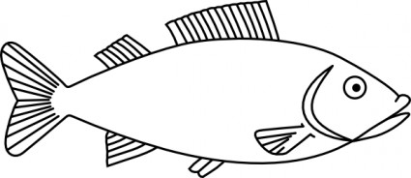**Experiment 1:**

Fish 1 Weight ___________

Fish 2 Weight ___________

Fish 3 Weight ___________

Average Fish Weight ______

Was it close to the true average weight of 29 grams? Record your 3-fish average on the class graph.

Would more observations help? Try it with 10 fish!

**Experiment 2:**

Fish 1 Weight ___________

Fish 2 Weight ___________

Fish 3 Weight ___________

Fish 4 Weight ___________

Fish 5 Weight ___________

Fish 6 Weight ___________

Fish 7 Weight ___________

Fish 8 Weight ___________

Fish 9 Weight ___________

Fish 10 Weight __________

Average Fish Weight ____________

Record your 10-fish average on the class graph. What do you conclude about sample sizes? How accurate are the two sampling techniques for estimating something about the population? How does the sample size affect the accuracy of your estimate? How is a fish population related to the “population” of atoms, ions, or molecules in a sample?

**_____________________________________________________________________________**

**_____________________________________________________________________________**

**_____________________________________________________________________________**

**_____________________________________________________________________________**

**Podcast: Distinguishing Between Atoms, Isotopes, and Molecules**

Distinguishing between Atoms

* How is an atom of hydrogen different from an atom of oxygen?

* Atomic Number:

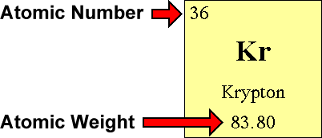

Nuclei of Atoms

* The total number of neutrons and protons is called the __________ __________.
* So if atomic number = protons (and electrons) we can determine _____________________________________
* Example How many neutrons does this isotope of gold have?

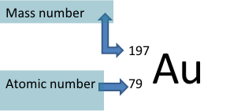

Isotopes

* ________________________ properties of isotopes stay the same because they have the same number of _______________ and ________________.
* Isotopes can be distinguished because they have different __________

Average Atomic Mass



* Reflects both the mass and the __________ ____________________ of the isotopes as they occur in nature
* Units = amu (atomic mass unit)
* To solve:

1.

2.

Example 1: Find the Average Atomic Mass for Oxygen

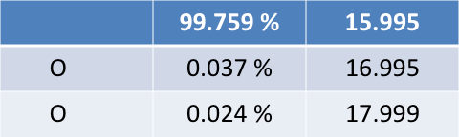

Example 2: Uranium has three common isotopes. If the abundance of 234U is 0.01%, the abundance of 235U is 0.71%, and the abundance of 238U is 99.28%, what is the average atomic mass of uranium?

Example 3: Mass Spectroscopy

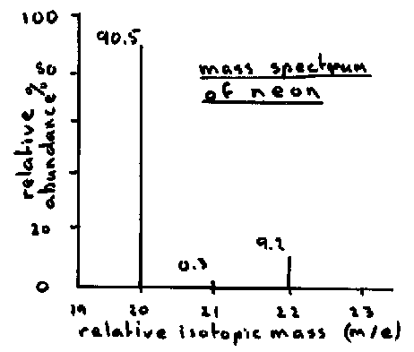

Example 4: Predict the number of protons, neutrons, and electrons for the following compounds:

1. 12852Te2-
2. 23892U
3. 12050Sn4+
4. 19578Pt
5. 8939Y
6. 146C4-

Distinguishing Between Molecules

* Molecular Formulas



* __________ Rule

**Podcast: Naming Compounds**

Forming Compounds








* What compound would form from C + S?

* Examples

1. Al,Br
2. K,S
3. Zn,O
4. Mg,N
5. C,Cl
6. Cu,O

Naming Ionic Compounds

Rules for naming

1.

2.

3.

Give formulas and names:

1. Ca + I
2. O + Mg
3. Na + S

Classical Naming of Ionic Compounds for Multivalent Metals

1.

2.

Copper = ________________; Cu1+ _____________, Cu2+ ______________

* L**o**wer = **______**, H**i**gher = **_______**

Give formulas and Latin names for:

1. Cu**2+** + Cl1-
2. Co**2+** + Cl1-

** Remember:

Multiple Valence: IUPAC Naming

1.

2.

* Cu**1+** is ______________ Cu**2+** is _______________
* Numbers refer to _______________ not to number of atoms

1. Cu**2+**+Cl-
2. Zn**2+**+ Cl-
3. Co**2+**+Cl-
4. Hg+S (both kinds of Hg)

Naming Compounds with Polyatomic Ions

“Polyatomic ions” are

These form _______________ compounds



1. Ca(OH)**2**
2. CuSO**4**
3. NH**4**NO**3**
4. Co**2**(CO**3**)**3**

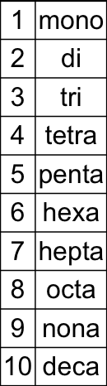

Naming **Covalent** Compounds




* Exception:

Write and name the following covalent compounds

1. CCl4
2. P2O3
3. IF7

Naming Acids: Binary acids

* Start with Hydrogen (HCl, H**2**SO**4**)

_______________ : H + non-metal. HCl

_______________ : H + polyatomic ion. H**2**SO**4**

Binary acids: naming depends on __________ of acid

* If it’s not aqueous:

HCl(g) = ________________________

* If it is aqueous:

HCl(aq) = ______________________

Naming Acids: Oxyacids – Naming does not depend on ________________

1)

2)

3)

4)

Example: H**2**SO**3**

You Try It!

HNO2 hypochlorous acid

H3PO4(aq) carbonic acid

**Podcast: Hydrated Compounds**

* **Hydrate**:

Example: calcium ethanoate heptahydrate ___________________________

* **Anhydrides**:
* Example: calcium ethanoate or anhydrous calcium ethanoate ______________________

Hydration Calculations

**Molar Mass**:

* + Example: Sodium Carbonate Decahydrate
  + Hint –

**Percent Water**:

* + Example: Sodium Carbonate Decahydrate

Remember: Use the law of conservation of mass to assist with hydrate problems!

* + If I have 100 g of a hydrate and 60 g of it is water, then …

Example Problem 1: Anhydrous cobalt (II) chloride has a characteristic blue color, while cobalt (II) chloride hexahydrate is pink. Please find the molar mass for each substance, then determine the percent of water bound up within the crystalline structure for hydrated cobalt (II) chloride.

Cobalt(ii) Chloride[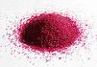](http://wpcontent.answers.com/wikipedia/commons/thumb/c/ca/Cobalt(II)-chloride-hexahydrate-sample.jpg/180px-Cobalt(II)-chloride-hexahydrate-sample.jpg)

Example Problem 2: Write a balanced equation showing the hydrates being heated to form their respective anhydrous salts and water vapors

1. magnesium Sulfate heptahydrate

Now You Try It!

1. iron (III) phosphate tetrahydrate
2. copper (II) sulfate pentahydrate

Example Problem 3: A 344 gram sample of hydrated calcium sulfate is heated to evaporate the water. The dry sample of calcium sulfate has a mass of 272 grams. What is the mole ratio between the calcium sulfate, CaSO4 and water, H2O? What is the formula of the hydrate?

Example Problem 4: What is the formula for a hydrate that is 90.7% SrC2O4 and 9.30% H2O?

Example Problem 5: What is the formula for a hydrate that is 433.5 grams of Mo2S5 and 66.5 grams of H2O?

**Assignment # 3: Hydrated Compounds**

1. Write a balanced equation showing the hydrates being heated to form their respective anyhyrous salts/water vapors.
2. Nickel(II) chloride hexahydrate
3. Cobalt(II) chloride hexahydrate
4. Copper(II) sulfate pentahydrate
5. Potassium aluminum sulfate dodecahydrate
6. A 2.852 gram sample of hydrated cobalt (II) chloride is heated to evaporate the water. The dry sample of calcium sulfate has a mass of 1.565 grams. What is the mole ratio between the cobalt (II) chloride, CoCl2 and water, H2O? What is the formula of the hydrate?
7. What is the formula for a hydrate that is 54.6% FeSO4 and 45.4% H2O?
8. What is the formula for a hydrate that is 284.12 grams of Na2SO4 and 543.48 grams of H2O?

**Assignment 4: Naming Compounds and Writing Chemical Formulas**

**DO EITHER ODDS OR EVENS, NOT BOTH!**

**Provide the correct name for the following compounds. Please use the stock name. Bonus points may be earned for also writing the classical name.**

1. Fe3(PO4)2 ______________________________________________________________
2. CuOH ______________________________________________________________
3. Cr(ClO3)3 ______________________________________________________________
4. Pb(MnO4)2 ______________________________________________________________
5. Sn(HSO4)2 ______________________________________________________________
6. Hg(NO2)2 ______________________________________________________________
7. Zn(CN)2 ______________________________________________________________
8. MnPO3 ______________________________________________________________
9. CoSiO3 ______________________________________________________________
10. NH4OH ______________________________________________________________
11. MnCr2O7 ______________________________________________________________
12. Fe2(SO3)3 ______________________________________________________________
13. CrPO4 ______________________________________________________________
14. Zn(ClO2)2 ______________________________________________________________
15. Sn(CrO4)2 ______________________________________________________________
16. K2SO4 ______________________________________________________________
17. MgSO4 ______________________________________________________________
18. Ca(OH)2 ______________________________________________________________
19. Al(NO3)3 ______________________________________________________________
20. LiC2H3O2 ______________________________________________________________

**Provide the correct chemical formula for the following substances:**

**PLEASE DO EITHER ODDS OR EVENS, NOT BOTH!**

1. Cupric Nirtrate

2. Lead (IV) Sulfate

3. Cobalt (II) ethanoate

4. Ferrous Phosphite

5. Zinc Permanganate

6. Tin (II) hydrogen Carbonate

7. Ammonium Nirtrate

8. Silver perchlorate

9. Mercuric cyanide

10. Stannic oxalate

11. Copper (I) chlorite

12. Iron (II) Silicate

13. Plumbous Carbonate

14. Chromic hypochlorite

15. Potassium Nitrate

16. Calcium phosphate

17. Sodium hydroxide

18. Aluminum ethanoate

19. Magnesium dichromate

20. Manganese (III) dihydrogen phosphate

**Gatorade Lab Report Rubric: Relationship Between Concentration of a Solution and the Amount of Transmitted Light Through the Solution**

|  |  |  |
| --- | --- | --- |
| **TABLE OF CONTENTS** | **Points Earned** | **Points Possible** |
| * Includes the title, page numbers, and date of experiment |  | 1 |
| **TITLE** |  |  |
| * Creative, relates to the experiments, centered at the top of the lab report |  | 1 |
| **PRELAB ACTIVITY** |  |  |
| Use the Stock Solution and its dilutions to construct a calibration curve of Absorbance vs Concentration.   * Appropriate Title * Labels with appropriate units on both x and y Axes * Data Correctly Plotted, Best Fit Line (not dot-to-dot) * Equation of Straight line in y=mx + b format with R2 value |  | 5 |
| **DATA** |  |  |
| * Organized table that shows the data you have collected during the experiment * Include an appropriate title   + - Clearly organize and label data columns and rows     - Units are clearly identified     - Accuracy of data is appropriate to measuring equipment or instruments     - Data from multiple trials is clearly shown * Data and table lines are neat and presentable (USE A RULER) * **Clearly show absorbance of Blue Gatorade and it’s corresponding concentration!** |  | 8 |
| **ANALYSIS/CONCLUSION** |  |  |
| 1. Determine the molar concentration of blue #1 dye in the sports drink. Show all work. 2. Determine the mass of blue #1 dye found in 500 mL of the drink. Show all work. |  | 3  3 |
| **POSTLAB ASSESSMENT** |  |  |
| 1. Suppose a solution was too concentrated for an accurate reading with the  spectrophotometer. The concentrated solution was diluted by placing 1.00 mL of  the concentrated solution in 4.00 mL of water. The solution was then placed in the  spectrophotometer and an absorbance was obtained and after a few calculations  the molar concentration was calculated to be 3.5x10–6 M. What was the concentration of the original stock solution before dilution?  2. If a 0.10 M solution of a colored substance has a maximum absorbance at 500 nm and an absorbance of 0.26 M at this wavelength, what will be the measured absorbance of a 0.20 M solution at 500 nm?  3. The spectrophotometer really measures the percent of light that is transmitted through the solution. The instrument then converts %T (transmittance) into absorbance by using the equation you determined in the prelab section. If the absorbance of a sample is 0.85, what is the percent of light transmitted through the colored sample at this collected wavelength? |  | 3  3  3 |
| **Total Points** |  | **30** |

**Podcast: Empirical Formulas and Combustion Analysis**

Review of Moles

* GAM (gram ____________ mass)
* Atomic mass of an _____________ expressed in grams 12C = 12.0 g/mol
* For compounds add sum of GAM
* SO3
* For Molecules = GMM (gram _______________ mass)
* For Ionic Compounds = GFM (gram ________________ mass)
* Molar Mass =
* STP – Standard Temperature and Pressure; T = __________, P = ___________________
* At STP, 1 mole of gas occupies ____________

Percent Composition -- % by mass of each element in a compound

% by mass of E =

Using Moles and Molar Mass

Empirical Formulas – ______________________________ of the atoms of the element in a compound.

1.

2.

3.

4.

Calculating Molecular Formulas

1.

2.

3.

Example 1: Epinephrine (adrenaline) is a hormone secreted into the bloodstream in times of danger or stress. Epinephrine contains 59.0% C, 7.1 % H, 26.2% O, and 7.7% N by mass. Its molar weight is 180 amu. Determine the empirical and molecular formulas.

Sketch Experimental Set Up for Combustion Analysis

Example 2: Combustion Analysis – Isopropyl alcohol, a substance sold as rubbing alcohol, is composed of C, H, and O. Combustion of 0.255 g of this compound produces 0.561 g CO2 and 0.306 g H2O. What is the empirical formula of isopropyl alcohol?

Example 3: Combustion Analysis – Caproic acid, which is responsible for foul-smelling socks, is composed of C, H, and O. Combustion of 0.255 g of this compound produces 0.512 g of CO2 and 0.209 g H2O.

* 1. What is the empirical formula?
  2. If the molar mass is 132 g/mol, then what is the molecular formula?

Example 4 You Try It! – A 0.2000 gram sample of ascorbic acid (vitamin C) composed of only C, H, and O is burned completely with excess O2 . 0.2998 g of CO2 and 0.0819 g of H2O are produced. What is the empirical formula?

**Podcast: The Meaning of A Balanced Equation**

Meaning of a Balanced Equation

* A balanced equation can be used to describe a reaction in molecules and atoms.
* **Not ______________**

Limiting Reagent

* Reactant that determines the amount of ______________ formed.
* The one you run out of first.
* Makes the least amount of product.
* To determine the limiting reagent requires that you do two ______________________ problems.
* Figure out how much product each reactant makes; the one that makes the ____________ is the limiting reagent.

Example 1

Ammonia is produced by the following reaction N2 + H2 🡪 NH3

1. What mass of ammonia can be produced from a mixture of 100. g N2 and 500. g H2 ?

B) How much unreacted material remains?

Excess Reagent: _____________________________________________________________

* The amount of stuff you make is the _______________.
* The ____________________ yield is the amount you would make if everything went perfect.
* The ____________________ yield is what you make in the lab.

Percent Yield

Example 2: Aluminum burns in bromine producing aluminum bromide. In a laboratory 6.0 g of aluminum reacts with excess bromine. 50.3 g of aluminum bromide are produced. What are the three types of yield?

Example 3: Years of experience have proven that the percent yield for the following reaction is 74.3%.

A) If 10.0 g of Hg and 9.00 g of Br2 are reacted, how much HgBr2 will be produced?

B) If the reaction did go to 74.3% completion, how much excess reagent would be left?

Example 4: Commercial brass is an alloy of Cu and Zn. It reacts with HCl by the following reaction

Zn(s) + 2HCl(aq) 🡪 ZnCl2 (aq) + H2(g). Cu does not react. When 0.5065 g of brass is reacted with excess HCl, 0.0985 g of ZnCl2 are eventually isolated. What is the percent composition of the brass?

**Assignment #5 Limiting Reagent**

**FRQ 2003B**  Answer the following questions that relate to chemical reactions.

(a) Iron(III) oxide can be reduced with carbon monoxide according to the following equation.

Fe2O3(*s*) + 3 CO(*g*) → 2 Fe(*s*) + 3 CO2(*g*)

A 16.2 L sample of CO(*g*) at 1.50 atm and 200.°C is combined with 15.39 g of Fe2O3(*s*).

1. How many moles of CO(g) are available for the reaction?
2. What is the limiting reactant for the reaction? Justify your answer with calculations. (iii) How many moles of Fe(s) are formed in the reaction?

(b) In a reaction vessel, 0.600 mol of Ba(NO3)2(*s*) and 0.300 mol of H3PO4(*aq*) are combined with deionized water to a final volume of 2.00 L. The reaction represented below occurs.

3 Ba(NO3)2(*aq*) + 2 H3PO4(*aq*) → Ba3(PO4)2(*s*) + 6 HNO3(*aq*)

(i) Calculate the mass of Ba3(PO4)2(*s*) formed.

(ii) Calculate the pH of the resulting solution.

(iii) What is the concentration, in mol L-1 , of the nitrate ion, NO -1 (*aq*), after the reaction reaches

completion?

**Assignment # 6 Decomposition of a Hydrate (2000 FRQ)**

Answer the following questions about BeC2O4 (s) and its hydrate.

(a) Calculate the mass percent of carbon in the hydrated form of the solid that has the formula BeC2O4 • 3H2O

(b) When heated to 220.°C, BeC2O4 • 3 H2O(s) dehydrates completely as represented below.

BeC2O4 • 3 H2O(s) → BeC2O4(s) + 3 H2O(g)

If 3.21 g of BeC2O4 • 3 H2O(s) is heated to 220.°C, calculate

(i) the mass of BeC2O4(s) formed, and,

(ii) the volume of the H2O(g) released, measured at 220.°C and 735 mm Hg.

(c) A 0.345 g sample of anhydrous BeC2O4 , which contains an inert impurity, was dissolved in sufficient water to produce 100. mL of solution. A 20.0 mL portion of the solution was titrated with KMnO4(aq).

The balanced equation for the reaction that occurred is as follows.

16 H+(aq) + 2 MnO4−(aq) + 5 C2O42−(aq) → 2 Mn2+(aq) + 10 CO2(g) + 8 H2O(l).

The volume of 0.0150 M KMnO4(aq) required to reach the equivalence point was 17.80 mL.

(i) Identify the reducing agent in the titration reaction.

(ii) For the titration at the equivalence point, calculate the number of moles of each of the following that reacted.

• MnO4−(aq)

• C2O42−(aq)

(iii) Calculate the total number of moles of C2O42−(aq) that were present in the 100. mL of prepared solution.

(iv) Calculate the mass percent of BeC2O4(s) in the impure 0.345 g sample.

**Assignment # 7 Combustion Analysis**

**FRQ 1991**

The molecular formula of a hydrocarbon is to be determined by analyzing its combustion products and investigating its colligative properties.

(a)  The hydrocarbon burns completely, producing 7.2 grams of water and 7.2 liters of CO2 at standard  conditions. What is the empirical formula of the hydrocarbon?

(b)  Calculate the mass in grams of O2 required for the complete combustion of the sample of the  hydrocarbon described in (a).

(d)  If the sample is analyzed by freezing-point depression, and the molecular mass is found to be 56.2 g/mol, what is the molecular formula of the hydrocarbon?

**1998**

An unknown compound contains only the three elements C,H, and O. A pure sample of the compound is analyzed and found to be 65.60 percent C and 9.44 percent H by mass.

(a)  Determine the empirical formula of the compound.

(b)  When 1.570 grams of the compound is vaporized at 300 °C and 1.00 atmosphere, the gas occupies a volume of 577 milliliters. What is the molar mass of the compound based on this result?

HINT: Molar Mass = (density*R * T)/P

Where R = gas constant = 0.0821 L atm mol-1 K-1 ; T = temperature in Kelvins; P = pressure in atm

(c)  Using freezing-point depression, the molar mass of the compound was determined to be 246 g/mol. Briefly describe what occurs in solution that accounts for the difference between the results obtained in parts (b) and (c).

**Podcast: Measuring with Solutions**

Concentration-

Molarity =

abbreviated

1 M =

Example 1: Calculate the molarity of a solution with 34.6 g of NaCl dissolved in 125 mL of solution.

Concentrations of Solutions

**Molarity (M)**

**Ion Concentration**

6.0 M HCl = _____ M H+ and _____ M Cl-

6.0 M Na2SO4 = _____ M SO42- and _____ M Na+

Example 2: Molarity can be used as a conversion factor in Dimensional Analysis (T-tables)

How many moles of HNO3 are in a 2.0 L solution of 0.200 M HNO3?

Example 3: If we have 0.30 M HNO3, what volume of solution is necessary to provide 2.0 mol of HNO3?

Example 4: Convert from Molarity to Mass – How many grams of solute are present in 50.0 mL of 0.360 M K2Cr2O7?

Solution Preparation (sketch each step)

Example 5: If 4.28 g of (NH4)2SO4 is dissolved in enough water to form 300 mL of solution, what is the molarity of the solution?

Example 6: How many grams of HCl would be required to make 50.0 mL of a 2.7 M solution?

**Assignment # 8 Molarity (M)**

$$Molarity= \frac{moles of solute}{liters of solution}$$

Solve the problems below.

1. What is the molarity of a solution in which 58 g of NaCl are dissolved in 1.0 L of solution?
2. What is the molarity of a solution in which 10.0 g of AgNO3 is dissolved in 500. mL of solution?
3. How many grams of KNO3 should be used to prepare 2.00 L of a 0.500 M solution?
4. To what volume should 5.0 g of KCl be diluted in order to prepare a 0.25 M solution?
5. How many grams of CuSO4•5H2O are needed to prepare 100. mL of a 0.10 M solution?

**Podcast: Precipitation Reaction Stoichiometry**

**Example 1:**

10.0 mL of 0.25M Barium chloride is reacted with 10.0mL of 0.35M sodium sulfate.

Write the balanced reaction

How many grams of ppt will form?

What are the concentrations of all ions present?

**Example 2:**

50.0mL of 0.10M sodium phosphate is mixed with 50.0mL of 0.10M copper II chloride.

Write the balanced reaction

How many grams of ppt will form?

What are the concentrations of all ions present?

**IN CLASS ACTIVITY**

**Mental Math – Number Sense**

**Factors of Ten**

1. 6.02 x 1000 =
2. 0.02 x 1000 =
3. 6.02 x 0.01 =
4. 0.3 x 1000 =
5. 0.1 x 1000 =
6. 602 x 0.001 =

**Fractions, Decimals, and Percents**

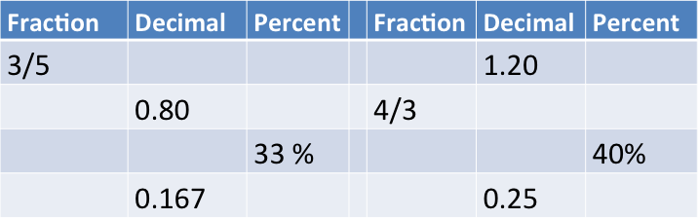



60 % of 80 =

80 % of 1200 =

33% of 360 =

125% of 1200 =

**Scientific Notation: Writing large or small numbers in scientific notation vastly simplifies operations!**

6.02 x 101 = ________

6.02 x 10-3 = ________

6.02 x 104 = ________

3.2 x 10-4  = 0.32 x 10? = 32 x 10?

1.6 x 108  = 16 x 10? = 0.16 x 10?

**Remember these exponent rules:**

*am* × *an = am+n*

*am* ÷ *an = am-n*

*(am)n = amxn*

(5 x 10-2) (5 x 10-5) = __________

(2.0 x 10-6)2(1.0 x 10-6) = _________

(0.00042)(200 000 000) = _______

(0.00042) ÷(200 000 000) =_____

(0.0050)2 =__________

(1.0 x 10-5)2 (0.5 x 10-5) = ________

**Fermi Estimation Rules**

1. Round all values to ONE significant digit.
2. Divide numerator and denominator by any obvious common number factor, especially powers of ten
3. Combine factors in the denominator and factors in the numerator, by multiplying, except for 100.

Apply Fermi estimation rules to approximate the following: **NO CALCULATOR!!!**

444 746 246 = 8.85 0.70 72.00 3.0 =

125 738 757 6.65 86.00

3.65 1000 4.15 323 = 48.0 303 1.0 =

676 1.00 706 11.0 298 1000

60.0 17.0 666 44.0 = 4.00 1.00 7.00 30.0 =

3.00 214 37.0 18.0 5.05 6.00

6.47 0.88 7.48 28.9 = 71.8 1.62 851 21.2 =

2.55 65.3 12.2 5.52 2.77 189 38.6 19.59

Solve the following problems without using a calculator.

1. When solid tin metal is heated in an atmosphere of chlorine gas, the product of the reaction is found to contain 62.2 percent Sn by mass and 37.4 percent Cl by mass. What is the empirical formula for this compound?
2. What mass of Iridium is produced when 0.0500 mol of Ir2O3 is reduced completely with excess H2?

2 H2O(l) + 4 MnO4 – (aq) + 3 ClO2 – (aq) 🡪 4 MnO2(s) + 3 ClO4 – (aq) + 4 OH – (aq)

1. According to the balanced equation above, how many moles of ClO2–(aq) are needed to react completely with 25 mL of 0.20 M KMnO4 solution