Series Circuit Summary
Suppose the ideal battery supplying the power for the resistors in the above example had an emf, or electromotive force, of ε = 40 volts. A graph of the voltage drops across the circuit could be illustrated as follows:
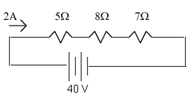 | 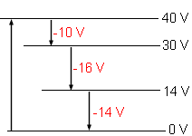
The battery is like a pump, it lifts the charges to a high potential so that they have the energy to flow through the resistors in the circuit. When the circuit is analyzed, the power supplied by the battery will equal the power consumed by the resistors.

R | I | V | P
5 Ω | 2 A | 10 V | 20 watts
8 Ω | 2 A | 16 V | 32 watts
7 Ω | 2 A | 14 V | 28 watts
 |  |  | 80 watts | total power consumer
 |  |  | P = Iε  = (2)(40)  = 80 watts | battery power supplied

Try These Problems!
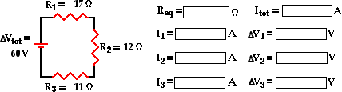
Parallell Circuit Summary
Suppose the ideal battery supplying the power for the resistors in the above example had an emf or electromotive force, of ε = 28.8 volts. Since R₁ and R₂ each occupy individual branches and are in parallel with the battery, each will lose the entire voltage supplied by the battery. A graph of the voltage drops across the circuit could be illustrated as follows:
The battery is like a pump, it lifts the charges to a high potential so that they have the energy to flow through the resistors in the circuit. When the circuit is analyzed, the power supplied by the battery will equal the power consumed by the resistors.
R | I | V | P
18 Ω | 1.6 A | 28.8 V | 46.08 watts
12 Ω | 2.4 A | 28.8 V | 69.12 watts
 |  |  | 115.20 watts | total power consumed
 |  |  | P = Iε  = (4)(28.8)  = 115.20 watts | battery power supplied
Try These Problems!
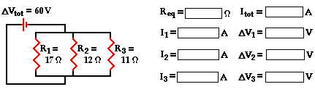

Ch. 16-18 Review – Current Electricity
- The diagram at the right shows a light bulb connected to a 12-V car battery. The + and - terminals are shown.
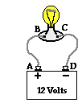
- As a + charge moves through the battery from D to A, it ________ (gains, loses) potential energy and ________ (gains, loses) electric potential. The point of highest energy within a battery is the ______ (+, -) terminal.
- As a + charge moves through the external circuit from A to D, it ________ (gains, loses) potential energy and ________ (gains, loses) electric potential. The point of highest energy within the external circuit is closest to the ______ (+, -) terminal.
- Use >, <, and = signs to compare the electric potential (V) at the four points of the circuit.
V_{A} V_{B} V_{C} V_{D}

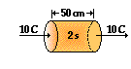
- The diagram at the right depicts a conducting wire. Two cross-sectional areas are located 50 cm apart. Every 2.0 seconds, 10 C of charge flow through each of these areas. What is the current in this wire?

- Your 60-watt light bulb is plugged into a 110-volt household outlet and left on for 3 hours. The utility company charges you $0.11 per kiloWatt•hr. Explain how you can calculate the cost of such a mistake.

- Calculate the resistance and the current of a 7.5-Watt night light bulb plugged into a US household outlet (120 V).

- A 541-Watt toaster is connected to a 120-V household outlet. What is the resistance (in ohms) of the toaster?

- 7. A color TV has a current of 1.99 Amps when connected to a 120-Volt household circuit. What is the resistance (in ohms) of the TV set?

- Which of the following will cause the current through an electrical circuit to decrease? Choose all that apply.
- decrease the voltage
- decrease the resistance
- increase the voltage
- increase the resistance

- As the number of resistors in a series circuit increases, the overall resistance __________ (increases, decreases, remains the same) and the current in the circuit __________ (increases, decreases, remains the same).

- As more and more resistors are added in parallel to a circuit, the equivalent resistance of the circuit ___________ (increases, decreases) and the total current of the circuit ____________ (increases, decreases).

- Consider the following two diagrams of series circuits. For each diagram, use arrows to indicate the direction of the conventional current. Then, make comparisons of the voltage and the current at the designated points for each diagram.
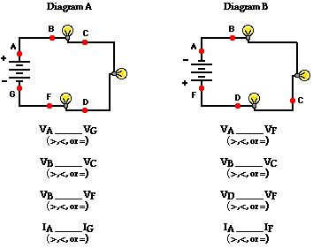

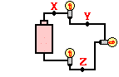
- Three identical light bulbs are connected to a D-cell as shown shown at the right. Which one of the following statements is true?

- All three bulbs will have the same brightness.
- The bulb between X and Y will be the brightest.
- The bulb between Y and Z will be the brightest.
- The bulb between Z and the battery will be the brightest.

- Three resistors are connected in series. If placed in a circuit with a 12-volt power supply. Determine the equivalent resistance, the total circuit current, and the voltage drop across and current at each resistor.
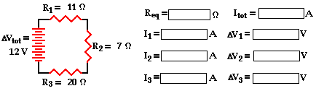

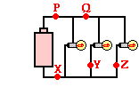
- Three identical light bulbs are connected to a D-cell as shown below. P, Q, X, Y and Z represent locations along the circuit. Which one of the following statements is true?
- The current at Y is greater than the current at P.
- The current at Y is greater than the current at Z.
- The current at P is greater than the current at Q.
- The current at Q is greater than the current at P.
- The current is the same at all locations.

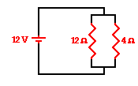
- A 12-V battery , a 12-ohm resistor and a 4-ohm resistor are connected as shown. The current in the 12-ohm resistor is ____ that in the 4-ohm resistor.
a. 1/3 | b. ½ | c. 2/3
d. the same as |  | e. 1.5 times
f. twice |  | g. three times
h. four times
- Three resistors are connected in parallel. If placed in a circuit with a 12-volt power supply. Determine the equivalent resistance, the total circuit current, and the voltage drop across and current in each resistor.
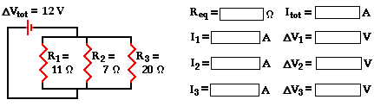

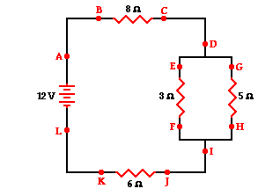
A combination circuit is shown in the diagram at the right. Use the diagram to answer the following questions.
  - The current at location A is _____ (greater than, equal to, less than) the current at location B.
  - The current at location B is _____ (greater than, equal to, less than) the current at location E.
  - The current at location G is _____ (greater than, equal to, less than) the current at location F.
  - The current at location E is _____ (greater than, equal to, less than) the current at location G.
  - The current at location B is _____ (greater than, equal to, less than) the current at location F.
  - The current at location A is _____ (greater than, equal to, less than) the current at location L.
  - The current at location H is _____ (greater than, equal to, less than) the current at location I.

- Use the concept of equivalent resistance to determine the unknown resistance of the identified resistor that would make the circuits equivalent.
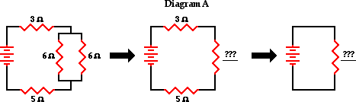
- Analyze the following circuit and determine the values of the total resistance, total current, and the current at and voltage drops across each individual resistor.
