**Chemistry Unit 11 – Stoichiometry Note-taking Guide**

**Podcast 8.1: The Meaning of A Balanced Equation**

Consider: 4NH**3** + 5O**2** → 6H**2**O + 4NO

* For every ______Ammonias and _________ Oxygens, you can make _____Waters and _________ Nitrogen Monoxides
* Chemists say “for every 4 moles of NH**3**, 5 moles of O**2** are required, etc.
* “Stoichiometry” refers to the relative quantities of moles. It also refers to calculations that make use of mole ratios.

Balanced Equations are Like Recipes

The recipe for a cheese sandwich:

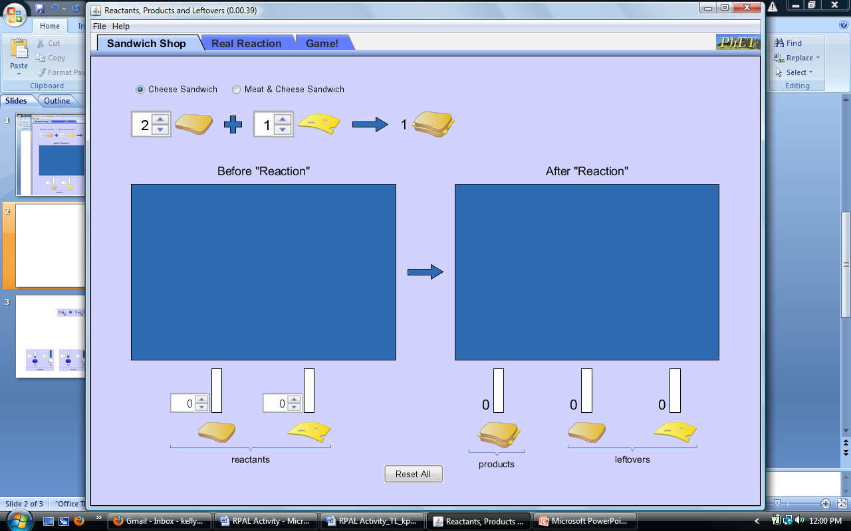

* Predict how many cheese sandwiches, as defined by the picture to the right, you can make if you have 6 pieces of bread and 4 slices of cheese. ________ Sandwiches
* If I need to make 14 sandwiches, how many slices of bread do I need? _____ Slices

The Chemistry Café cook has a loaf which had 33 slices and a package of cheese that has 15 slices. He is making sandwiches that have 2 pieces of both bread and cheese. How many sandwiches can he make?





* 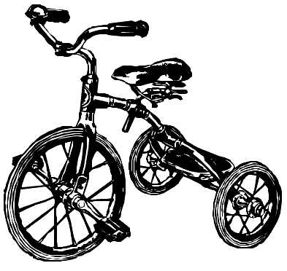Another Kind of Recipe: A tricycle factory gets a shipment with 400 seats and 600 wheels. How many tricycles can be made?

Example One

Consider : 4NH**3** + 5O**2** → 6H**2**O + 4NO

How many moles of H**2**O are produced if 0.176 mol of O**2** are used?

Example Two

Consider : 4NH**3** + 5O**2** → 6H**2**O + 4NO

How many moles of NO are produced in the reaction if 17 mol of H**2**O are also produced?

Example Three

Consider : 4NH**3** + 5O**2** → 6H**2**O + 4NO

How many grams of H**2**O are produced if 1.9 mol of NH**3** are combined with excess oxygen?

Example Four

Consider : 4NH**3** + 5O**2** → 6H**2**O + 4NO

How many grams of O**2** are required to produce 0.3 mol of H**2**O?

Example Five

Consider : 4NH**3** + 5O**2** → 6H**2**O + 4NO

How many grams of NO is produced if 12 g of O**2** is combined with excess ammonia?

**Podcast 8.2: Converting Amounts Using Stoichiometry**

The Balanced Chemical equation for producing water is

2 H2 + 1 O2 → 2 H2O

We cannot say that 2 grams of hydrogen combines with one gram of oxygen to form 2 grams of water… The reaction describes MOLES

* Many stoichiometry problems follow a pattern:

write the equation and label each part below

Example One

grams(x) ↔ moles(x) ↔ moles(y) ↔ grams(y)

For the reaction 2H**2** + O**2** → 2H**2**O what is the path we would take for the following:

1. Given 2 moles H2O, calculate grams H2O?
2. Moles O**2** required for 36 g H**2**?
3. Grams of H**2**O produced from 6 grams O**2**?

Example Two

Given: 4NH**3** + 5O**2** → 6H**2**O + 4NO

* 1. How many moles of H2O can be made using 0.5 mol NH3?
  2. what mass of NH3 is needed to make 1.5 mol NO?
  3. how many grams of NO can be made from 120 g of NH3?

Example Three

2 C4H10 + 13 O2 -> 8 CO2 + 10 H2O

a) what mass of O2 will react with 400 g C4H10?

b) What volume of carbon dioxide is formed?

Example Four

3 HCl + Al(OH)3 -> 3 H2O + AlCl3

How many grams of aluminum hydroxide will react with 5.3 moles of HCl?

Example Five

Ca(ClO3)2 -> CaCl2 + 3 O2

What mass of O2 results from the decomposition of 1.00 kg of calcium chlorate?

**Podcast 8.3: Limiting Reagents and Percent Yield**

* SGNRD079

Caution: this stuff is difficult to follow at first. Be patient!

* Cake example:
  + Recipe:

2 cups flour 1½ TBSP baking powder

2 eggs 1 cup water

1 cup sugar 1/3 cup oil

Suppose in your kitchen you have 14 cups flour, 4 eggs, 9 cups sugar, 15 TBSP baking powder, 10 cups of water, and 3 1/3 cups oil. How many cakes can be baked?

* MCj04124140000[1]Flour... need 2 cups, have 14 cups = ________
* Eggs…need 2 eggs, have 4 eggs =_________
* Sugar… need 1 cup, have 9 cups = _________
* Baking powder…need 1½ TBSP,

have 15 TBSP = __________

* Water…need 1 cup, have 10 cups = ________
* Oil…need 1/3 cup, have 3 1/3 = __________
* Back to the question, how many cakes can be baked?
* Answer is _______
  + Only 4 eggs, so we have extra of all the other ingredients
  + Eggs, in this case, is the **____________ reactant**

Example One:

How many moles of NO are produced if **__** mol NH**3** are burned in **__** mol O**2**?

4 mol NH**3**, 5 mol O**2** _____________________________________________

4 mol NH**3**, 20 mol O**2**_____________________________________________

8 mol NH**3**, 20 mol O**2**_____________________________________________

Example Two

Given: 4NH**3** + 5O**2** → 6H**2**O + 4NO

How many moles of NO are produced if **__** mol NH**3** are burned in **__** mol O**2**?

* 4 mol NH**3**, 2.5 mol O**2** _____________________________________________
* In limiting reagent questions we use the limiting reagent as the “given quantity” and ignore the reagent that is in excess

Example Three

How many grams of NO are produced if 4 moles NH**3** are burned in 20 mol O**2**?

Since NH**3** is the limiting reagent we will use this as our “given quantity” in the calculation

Example Four 4NH**3** + 5O**2** → 6H**2**O + 4NO

How many g NO are produced if 20 g NH**3** is burned in 30 g O**2**?

Step 1: Calculate the number of moles of EACH reactant

Step 2: Comparison chart

Step 3: Perform the stoichiometry using the ____________ ____________ as the “given” quantity (the starting place)

How many g NO are produced if 20 g NH**3** is burned in 30 g O**2**?

Example Five: The Shortcut 4NH**3** + 5O**2** → 6H**2**O + 4NO

* Do _________ separate calculations using both given quantities. The ___________ answer is correct.

How many g NO are produced if 20 g NH**3** is burned in 30 g O**2**? 4NH**3** + 5O**2**→ 6H**2**O+ 4NO

Example Six: Use the Shortcut

2Al + 6HCl → 2AlCl3 + 3H2

If 25 g aluminum was added to 90 g HCl, what mass of H2 will be produced?

Percent Yield

* _________________ is the amount of product made in a chemical reaction.

Three Types of yield:

* _______________ Yield –
  + What you actually get in the lab
* Theoretical Yield –
  + What the balanced equation tells *_____________* be made
* ___________________ Yield –

Percent Yield

* Percent yield tells us how ________________ a reaction is.
* Percent yield CANNOT be bigger than _________ unless contamination occurs
* Theoretical yield will always be larger than actual yield.
  + Why?
  + Impure reactants, competing side reactions, loss of product in filtering or transferring between containers

Example Seven

6.78 g of copper *is produced* when 3.92 g of Al are reacted with excess copper (II) sulfate.

* + - What is the actual yield? ________________
    - What is the theoretical yield? ________________
    - What is the percent yield? ________________

Example 8

MgCl2 + 2AgNO3 → Mg(NO3)2 + 2AgCl

52.29 g of silver chloride formed when 25 g magnesium chloride was added to 68 g silver nitrate. What is the percent yield in this reaction?