Podcast 9.1: Kinetic Molecular Theory
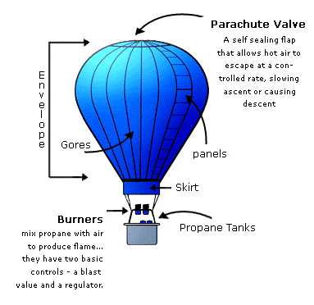
- __________________ ________________ = Energy due to motion
- All Matter consists of tiny particles that are in constant motion
- Add K.E. – Atoms and molecules move ____________________ and the object expands
- Lose K.E. – Atoms and molecules slow down and the object contracts
- To add or lose K.E., Temperature is adjusted
- Heat added = Energy added
- Additional K.E. causes atoms and molecules to collide more often
Gas Pressure
- Pressure = Force per area of an object
- Force is caused by ____________________ of gas particles
- Vacuum – empty space with no particles and no pressure.
- Compressibility – measure of how much the volume of a substance decreases under pressure
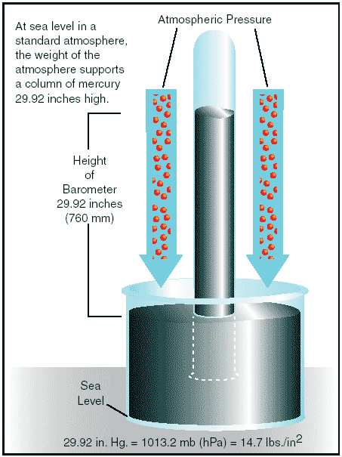
- Lots of empty space between gas particles
- Easily compressed, or squeezed, into a smaller volume
Atmospheric Pressure – results from collisions of particles in the air
- Pressure exerted on the earth by the layer of air around it
- Higher Elevation = fewer air particles = lower pressure
- Measured with a barometer

Vapor Pressure: a force exerted just above a liquid by the particles that have evaporated from the surface
- Higher Temp = Higher Vapor Pressure
- Lower Temp = Lower Vapor Pressure
- Sketch Vapor Pressure Below
Measuring Air Pressure
- Common Units
  - Pascal, Pa or____________________, SI UNIT FOR PRESSURE
  - atmosphere, atm
  - torr, or millimeters of mercury, mmHg
- Pressure Conversions: 1 atm = 760 mmHg = 760 torr = 101.3 kPa
- Since these are all equal, they can be used in t-tables to convert between pressure units
- Example 1: What is the pressure of 450 kPa in atm? mmHg?

Podcast 9.2: Phases of Matter
- Remember: Both Liquids and Gases take the shape of their containers
- However: Gases expand to fill their containers, whereas liquids do not! WHY???
Phases of Matter
- Intermolecular Forces, IMFs: Particles in liquids (and Solids) stay closer together because of the forces of attraction between positive and negative charges in atoms and molecules that keep particles close together
- In Gases, the Kinetic Energy is large enough to overcome the all of the IMFs
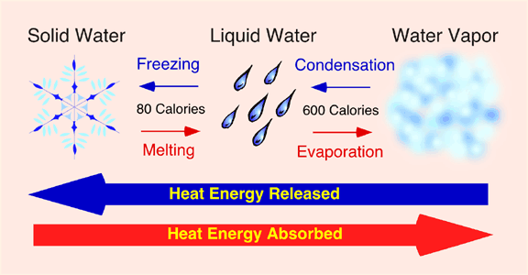
Phase Change Processes: Give simple definitions of each of the following
- Freezing ______________________________________________________________________________
- Condensation _________________________________________________________________________
- Deposition____________________________________________________________________________
- Dissolving_____________________________________________________________________________
- Melting______________________________________________________________________________
- Vaporizing____________________________________________________________________________
- Subliming_____________________________________________________________________________

The Process of Boiling
- ____________________: Changing a liquid into a gas. Occurs at the surface of a liquid
- Liquids evaporate faster when additional KE (heat) is added. Extra KE breaks the ____________________ between particles.
- Liquid molecules change to the gas phase, creating more __________________ __________________ just above the surface of the liquid
- When the vapor pressure equals the ____________________ ____________________, the liquid will boil. The temperature and pressure combination at which this occurs is called the BOILING POINT.
The Nature of Solids
- ____________________ Solids: particles are arranged in an orderly, repeating, three dimensional pattern called a lattice
  - Maintain own shape
  - Higher melting points
  - Typically good conductors
  - Examples: NaCl, Granulated Sugar, CuSO₄
- ____________________ Solids: lack an ordered internal structure
  - Moldable, can be formed into many shapes
  - Melt over a wide range of temperatures
  - Typically poor conductors
  - Examples: Ca(C₂H₂O₂)₂ , Powdered Sugar, Glass, Plastic, Wax
Phase Diagrams: Graph representing all 3 major states of matter for a substance E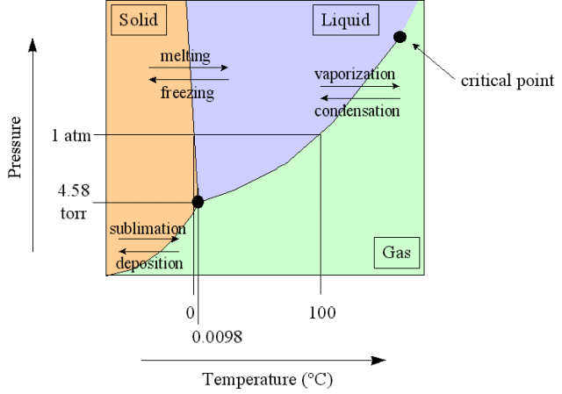
- Based on relationships between temperature and pressure
- Axes of graphs are typically distorted so all important points can still fit
- Interpreting Graphics – Refer to Handout
Podcast 9.3: Gas Laws: Summarize the Behavior of Gases and Relationships Between Temperature, Pressure, And Volume
Properties of Gases: Factors affecting gas pressure:
- ____________________ of gas: more particles (moles) increases pressure
- ____________________: reducing volume tends to increase pressure
- ____________________: increasing the temperature tends to increase pressure because particles collide more
Boyle’s Law
Pressure is the result of molecules colliding with the walls of a container (complete sketch below)

Volume = 4x4
Pressure = 1 atm

- Same # of particles in each box
- As the container gets smaller, collisions increase, so pressure increases (complete sketch below)

Volume = 2x2
Pressure = ______

- Still same # of particles in each box
- As the container gets smaller, collisions increase, so pressure increases (complete sketch below)
Volume = 1x1
Pressure = _______
- Sketch a graph to show how pressure changes
in response to increasing volume.

Boyle’s Law: Pressure and volume have an inverse relationship at a constant temperature
- $P =\frac{1}{V}$
- P₁V₁ = P₂V₂ OR $P_{1}\left(\frac{V_{1}}{V_{2}}\right)=P_{2}$ OR $V_{1}\left(\frac{P_{1}}{P_{2}}\right)=V_{2}$
Practice Problem 1:
P₁ = 1 atm V₁ = 8 mL V₂ = 10 mL
What is the final pressure (P₂)?

Charles’s Law - as the Kelvin temperature of a gas increases, the volume increases proportionally, provided that the pressure and amount of gas remain constant.
- There is a direct relationship between temperature and volume
- Sketch the graph of this relationship
- Hint: V/T = constant

$\frac{V_{1}}{T_{1}}=\frac{V_{2}}{T_{2}}$

- Doubling the Kelvin temperature of a gas sample doubles its volume
- Reducing the Kelvin temperature by one-half causes the gas volume to decrease by one-half

Practice Problem 2: A sample of gas occupies 3.5 L at 300 K. What volume will it occupy at 200 K?

Practice Problem 3: If a 1 L balloon is heated from 22°C to 100°C, what will its new volume be?

Gay-Lussac’s Law
- Pressure is directly proportional to Kelvin temperature if volume remains constant.
- If Temperature increases, then Pressure increases (and vice versa).
$$\frac{P_{1}}{T_{1}}=\frac{P_{2}}{T_{2}}$$

Combined Gas Law
- Describes the relationship among pressure, temp, and volume of a gas. Combines Boyle’s, Charles’s, and Gay-Lussac’s Laws
$$\frac{P_{1}V_{1}}{T_{1}}=\frac{P_{2}V_{2}}{T_{2}}$$

Podcast 9.4: Ideal Gases
Ideal Gas Law: Gas Law that incorporates all four possible variables P, V, T, and n (# of moles).

PV = nRT

- P=Pressure in kPa or atm
- V = Volume in Liters
- n = # of moles
- R = ideal gas constant
- T = Temperature in Kelvin

*Describes the condition of gases as they are now but the other gas laws predict what they WILL be
when conditions change.

- Values of R

If Pressure is in kPa, R = _______
If Pressure is in atm, R =________

Example Problem 1: How many kilograms of methane, CH₄ are in a 225 L container at 150 kPa and 35ºC?

Example Problem 2: Find the number of grams of CO₂ that exert a pressure of 785 torrs at a volume of 32.5L and a temperature of 32ºC.

Example Problem 3: If the density of a gas is 1.2 g/L at 745 torr and 20ºC, what is its molecular mass?

Ideal vs Real Gases

Ideal
- Follows gas laws at all temps and pressures
- Conforms precisely to ALL assumptions of KMT
- Particles have no volume
- No IMFs between particles
- DON’T EXIST
Real
- Factor in Particle Volume
- Look at IMFs between particles
- Differ mostly at low temps and high pressures
- True picture of gases

Gas Mixtures
- Partial Pressure: pressure exerted by one component in a mixture of gases
- Dalton’s Law of Partial Pressures: For a mixture, the total pressure is the sum of all the partial pressures of the gases
P_{total} = P₁ + P₂ + P₃ + …

Example Problem 4: A 250. mL sample of oxygen, O₂, is collected over water at 25ºC and 760.0 mmHg pressure. What is the pressure of the dry gas along? (Vapor pressure of water at 25ºC = 23.8 mmHg)

Movement of Gases
- Effusion: Gas escapes from a tiny hole in a container.
  - The smaller the gas particle is (ie, lower molar mass), the faster it effuses.
- Diffusion: Gas spreads out in space, moving from an area of high pressure to an area of low pressure
  - The smaller the gas particle, the faster if diffuses

