Name:___________________________

Period:__________________________

**Chemistry Unit 12 – Solutions**

Chemistry Daily Journal

|  |  |  |
| --- | --- | --- |
| Today’s Date | What do I need to accomplish? | What do I need to finish at home? |
|  |  |  |

|  |  |  |  |
| --- | --- | --- | --- |
| Objective | Learning Opportunities | Suggested Due Date | Date Completed |
| 12.1 Define components and properties of solutions. | * Read p. 471 – 477; Answer Q 1 – 3 * Podcast 12.1 Making Solutions * Solvent Lab * Kool-Aid Dilutions | 04/18 |  |
| 12.2 Describe the concentration of solutions using saturated, unsaturated, and molarity. | * Read p. 480-484; Answer Q8-13 * Podcast 12.2 Concentration of Solutions * Molarity * Podcast 12.3 Solution Stoichiometry * Solution Stoichiometry | 04/21 |  |
| 12.3 Evaluate the influence of temperature on solubility | * Podcast 12.4 Solubility and Temperature * Concentration Curves * Molarity and Solution Stoichiometry Quiz | 04/22 |  |
| 12.4 Write names and/or formulas of acids | * Read p. 271 -273; Answer Q28 – 30 * Podcast 5.4 Naming Acids * Naming Acids | 04/23 |  |
| 12.5 Use pH, pOH, and [H+] to describe the concentrations of acids and bases. | * Read p. 594 – 601; Answer Q 9 – 16 * Podcast 12.5 pH and pOH * Titration Demonstration * pH of Common Substances Lab * Acids and Bases Quiz | 04/23 |  |
| Unit 12 Test | * Unit 12 Test (Paper or Moodle) | 04/25 |  |

**Podcast 12.1: Making Solutions**

**Solute + Solvent = _____________________________**

* **Solution** – a homogeneous _______________ of __________ or more substances (ions or molecules)
* **_________________** – the part of a solution that is ______________ dissolved (usually the lesser amount)
* **Solvent** – the part of a solution that ________________ the solute (usually the greater amount)

Example One

One teaspoon of sugar (sucrose) is dissolved in a cup of water. Identify the:

* 1. Solute
  2. Solvent

[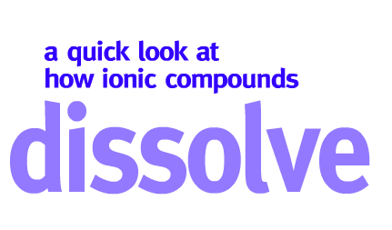](http://programs.northlandcollege.edu/biology/Biology1111/animations/dissolve.html)Summarize below what happens as substances dissolve <http://programs.northlandcollege.edu/biology/Biology1111/animations/dissolve.html>

Polarity

* Polar molecules are _________________ to other ______________ molecules and to electrically _________________ particles.
* _________________ substance are attracted to other _______________ substances
* Polar and non-polar _________ __________ dissolve in each other
* Water is considered a ______________ molecule.
* **Polar Molecule:** a molecule that has an ___________ distribution of ___________
* There is a ______________ region and a _______________ region.

Sketch Water Molecule Below

* ____________Compounds are crystalline or crystal-like
* Crystals are held together by the _____________ (+ and –) that attract.
* Dissolving Salt and Sugar
* Summarize the simulation

Name: ________________________

Per: _____ Date: _______________

## Solvents Lab

**Introduction:**

Is anything truly *insoluble* in water? It is likely that at least a few molecules or ions of any substance will dissolve in water. Thus, the term *insoluble* actually refers to substances that are only very, very slightly soluble in water. Lead (II) sulfide (PbS), which is technically considered insoluble, actually has a very low solubility of about 10-14 g (0.000 000 000 000 01 g) per liter of water at room temperature. Also, chalk is considered insoluble in water, even though 1.53 mg calcium carbonate (CaCO3), which is the main ingredient in chalk, can dissolve in 100 g water at 25 °C.

**Purpose:**

In this investigation, you will first address the solubilities of various molecular and ionic solutes in water.

**Part I:** **Investigating Solubility in Water**

You will determine the solubilities of a variety of substances by determining whether each solute is soluble (S), slightly soluble (SS), or insoluble (I) in room-temperature water.

In this experiment, keep these concerns in mind:

* Hexane is highly flammable.
* Avoid any direct contact of your skin with any solutes. Use wood splints to transfer solid samples.
* Mix test tube contents by gently tapping your forefinger against the side of the tube.
* Follow your teacher’s directions for waste disposal.
* Record your results in a data table that indicates which solutes are soluble (S), slightly soluble (SS), or insoluble (I) in water.

Here are the materials you have to work with at each station:

* + Test tube
  + Wooden splint
  + Pipets
  + Waste beaker
  + Distilled water (H2O)
  + Ethanol (C2H5OH)
  + Hexane (C6H14)
  + Urea (CO(NH2)2)
  + Glucose (C6H12O6)
  + Iodine (I2)
  + Copper (II) sulfate (CuSO4·5H2O)
  + Sodium chloride (NaCl)
  + Ammonium chloride (NH4Cl)
  + Naphthalene (C10H8)

Answer the following questions in regards to your data.

1. What particular observations will allow you to judge how well each solute dissolves in water? That is, how will you decide whether to classify a given solute as soluble, slightly soluble, or insoluble in water?

____________________________________________________________________________________________________________________________________________________________

______________________________________________________________________________

1. Which variables will you need to control? Why?

____________________________________________________________________________________________________________________________________________________________

1. How should the solute and solvent be mixed—all at once or a little at a time? Why?

______________________________________________________________________________

______________________________________________________________________________

|  |  |
| --- | --- |
| Data Table – Part I | |
| **Solute** | **Solubility**  **(S), (SS), or (I)** |
|  |  |
|  |  |
|  |  |
|  |  |
|  |  |
|  |  |
|  |  |
|  |  |
|  |  |
|  |  |

**Part II: Investigating Solubility in Ethanol and Hexane**

You will investigate the solubility in ethanol and hexane of the solutes from Part I. *In addition, test the solubility of water in ethanol and in hexane.* Gaining experience with three liquid solvents—hexane, ethanol, and water—will allow you to recognize some general patterns about solubility behavior.

Can you use the same procedure as you did for Part I? If not, what parts of that procedure should be revised?

_________________________________________________________________________________________________________________________________________________________________________________________________________________________________________________________________________________________________________________________________________________________________________________________________________________________________________________________________________________________________________________________________________________________________________________________________________________________________________________________________________

Before you start the laboratory work, test your interpretation of the Part I results by predicting what you think will be observed about solubility in each case. **Include these predictions in your data table for Part II,** then collect and record data for both solvents.

|  |  |  |  |
| --- | --- | --- | --- |
| Data Table – Part II | | | |
| **Solute** | Prediction | **Solubility**  **(S), (SS), or (I)** | |
| Ethanol | Hexane |
|  |  |  |  |
|  |  |  |  |
|  |  |  |  |
|  |  |  |  |
|  |  |  |  |
|  |  |  |  |
|  |  |  |  |
|  |  |  |  |
|  |  |  |  |
|  |  |  |  |

Questions

### Part I

1. According to your data, which of the solutes tested are *least* likely to be dissolved in a near-by river? Explain, and support your explanation with evidence from your completed investigation.
2. Compare your data with those of the rest of the class. Are there any differences? If so, how can you explain those differences?

### Part II

1. In dissolving sodium chloride (NaCl):
   1. How does ethanol as a solvent compare to water?
   2. How does ethanol as a solvent compare to hexane?
2. Compare your results with your predictions.
   1. Were any of your solubility observations unexpected?
   2. If so, explain what you expected, why you expected it, and what you actually observed.
3. Based on your data, what general pattern of solubility do you see between water and hexane? How about water?
4. Predict the solubility behavior of each solid solute if you tested it in:
   1. Lamp oil, a liquid that is essentially insoluble in water.
   2. Ethylene glycol, a liquid that is very soluble in ethanol.
5. Given that water is a polar solvent and hexane is a nonpolar solvent, classify each molecular solute tested as polar or nonpolar.

|  |  |  |
| --- | --- | --- |
| **Solute** | **Polar (water)** | **Nonpolar (hexane)** |
| Urea - CO(NH2)2 |  |  |
| Glucose - C6H12O6 |  |  |
| Iodine - I2 |  |  |
| Copper sulfate - CuSO4·5H2O |  |  |
| Sodium chloride - NaCl |  |  |
| Ammonium chloride - NH4Cl |  |  |
| Naphthalene - C10H8 |  |  |
| Ethanol - C2H5OH |  |  |

* 2. How did you decide?

1. How useful is the rule “like dissolves like” for predicting solubility? Explain your answer on the basis of your results.
2. In Part II, water was the solvent, but in Part III, it was a solute.
   1. How can it be both?
   2. How can you decide whether a substance is a solute or a solvent?

**Serial Dilutions, Molarity, and Taste Threshold Lab**

* What does concentration mean?
* How do we measure concentration?
* Is your sense of taste different from another’s?

All these questions and more will be answered in this lab today.

Goals for lab:

* Practice measuring and weighing substances
* Analyzing data.
* Understanding and applying knowledge of Molarity.

Pre-Lab questions:

* 1. How would a liter of Kool-Aid taste if it was made with two packs of flavoring instead of one?
  2. If you mixed 1 can of soda with 1 can of water, how would you describe the concentration of the soda?
  3. If you took 2 liters of seawater and boiled it until you have 1 liter of seawater, how would you describe the salt concentration of the remaining liquid?
  4. Have you ever eaten something that is too sweet? If so, what is it?

PURPOSE: The purpose of this experiment is to determine the lowest concentration of a substance dissolved in water, which can still be tasted – the taste threshold. We will specifically be working with sweetness.

PROCEDURE:

1. Calibrate a clean medicine cup by adding 10 ml of water to it using a sterile 1 ml dropper. Use a pen to carefully mark the level of the water on the outside of the cup.
2. You will now need to make a 1 M solution of sucrose, a disaccharide. (see below). What is the molecular formula for sucrose, a disaccharide composed of glucose and fructose?

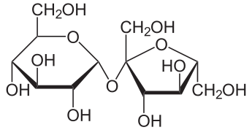

<http://en.wikipedia.org/wiki/File:Saccharose2.svg>

1. If the molecular formula is C12H22O11, then what is the mass (in grams) of 1 mole of sucrose?
2. To make a 1 M solution, you need to add the molar mass of sucrose to enough water to make 1 Liter of solution. Since you don't need 1 L of solution, you should make just what you need. If you want to make just 10 ml of 1M solution, how would you do that?

Add _________ g sucrose (molar mass/100) to enough water to make 10 ml. (read below first)

1. Measure out that mass of sucrose in a clean medicine cup that you have calibrated to 10 ml. Carefully use the dropper to add 8 ml of water to the cup. Stir with the dropper until the sugar dissolves. Add enough extra water to make 10 ml of your solution. You have just made a 1M sucrose solution!
2. You will now need to make a series of dilutions until you reach a dilution just below the typical taste threshold for sucrose. A series of dilutions is typically called a serial dilution. As you make your serial dilutions, be sure to label your cups so that you have one cup for each of the solutions that you will make. (There should be 7 cups total)
3. With a clean, sterile 1 mL graduated dropper, measure out 3 mL of water into a clean cup. Add 3 ml of your 1 M solution. This will give you a 0.5 M sucrose solution.
4. Add 1 ml of your 1 M solution to 9 ml of water. You have just made a 0.1 M sucrose solution.
5. You now need to repeat the above steps in order to make all of the dilutions listed in your data table. Use the chart below to help you make these solutions.

|  |  |  |
| --- | --- | --- |
| _____ ml 0.1 M | _____ ml water | 0.05 M solution |
| _____ ml 0.1 M | _____ ml water | 0.01 M solution |
| _____ ml 0.01 M | _____ ml water | 0.005 M solution |
| _____ ml 0.01 M | _____ ml water | 0.001 M solution |

1. Rinse your mouth with plain water. Pour a small amount of the 1.0 M solution into a medicine cup for each person. Sip and swirl around, over your tongue. If you can taste the sweetness, put a + in the data chart.

1. Rinse your mouth and repeat with the other solutions until you can no longer taste "sweet". The lowest concentration at which you can still taste the sweetness is your approximate taste threshold.

Results:

|  |  |  |
| --- | --- | --- |
| CONCENTRATION SWEET | TASTE / Yes | TASTE / No |
| 1.0 M |  |  |
| .50 M |  |  |
| .10 M |  |  |
| .05 M |  |  |
| .01 M |  |  |
| .005 M |  |  |
| .001 M |  |  |

What is your taste threshold for sweet (sucrose)? ____________ M sucrose

**Discussion Questions:**

Examples of some human thresholds:

Taste Substance Threshold for tasting

Salty (NaCl) 0.01 M

Sour (HCl) 0.0009 M

Sweet (Sucrose) 0.01 M

Bitter (Quinine) 0.000008 M

Umami (Glutamate) 0.0007 M

1. What is your taste threshold for sweet? How does this compare to known values? How does this compare to your classmates? (Use your graph to help you answer this)

2. Are your thresholds for all tastes the same? Why or why not?

3. What factors might account for differences in taste thresholds between people?

4. Will your taste thresholds be more likely to be higher or lower when you are fifty years old? Why?

**Podcast 12.2: Concentration of Solutions**

* Types of Solutions
* **______________________** – a solution that contains the ______________________ quantity of solute that dissolves at that temperature.
* **Unsaturated** – a solution that contains ___________ than the maximum amount of __________________ that can dissolve at a particular temperature.
* **______________________________** – a solution that contains __________________ solute than a saturated solution.
* Concentration
* **________________** – the amount of ______________ dissolved in a specific quantity of ______________
* Can be expressed as a ______________ (most common)
* __________ – for larger scale solutions (water treatment, industry, making pop, pools, etc.)
  + 1 ppm = 0.000001% or 10,000 ppm = 1%
  + ppt = parts per thousand

**Example 1 – Percent**

Making Orange Juice: Mix 1 can of frozen OJ concentrate with 3 cans of water

__ 1 can OJ______ =

1 can OJ + 3 cans water

**Example Two – Percent by Mass**

What is the concentration of each of these solutions as expressed as percent sucrose by mass?

1. 17 g sucrose in 183 g water
2. 30.0 g sucrose dissolved in 300.0 g water

**Example Three – Parts Per Million**

What is the concentration of each of these solution expressed in ppm?

* 1. 0.0020 g iron (III), Fe3+, ions dissolved in 500.0 g water
  2. 0.25 g calcium ions, Ca2+ , dissolved in 850.0 g water

Molarity

* Molarity = __________ of solute per ___________ of solution
* abbreviated ________
* _______________ =

**Example Four – Molarity**

Calculate the molarity of a solution with 34.6 g of NaCl dissolved in 125 mL of solution.

**Molarity (M)**

$$Molarity= \frac{moles of solute}{liters of solution}$$

Solve the problems below.

1. What is the molarity of a solution in which 58 g of NaCl are dissolved in 1.0 L of solution?
2. What is the molarity of a solution in which 10.0 g of AgNO3 is dissolvedin 500. mL of solution?
3. How many grams of KNO3 should be used to prepare 2.00 L of a 0.500 M solution?
4. To what volume should 5.0 g of KCl be diluted in order to prepare a 0.25 M solution?
5. How many grams of CuSO4•5H2O are needed to prepare 100. mL of a 0.10 M solution?

**Podcast 12.3 Solution Stoichiometry**

Using Molarity

____________ can be used as a _____________ factor in Dimensional Analysis (T-tables)

**Example One - How many moles of HNO3 are in a 2.0 L solution of 0.200 M HNO3?**

* Solution Preparation

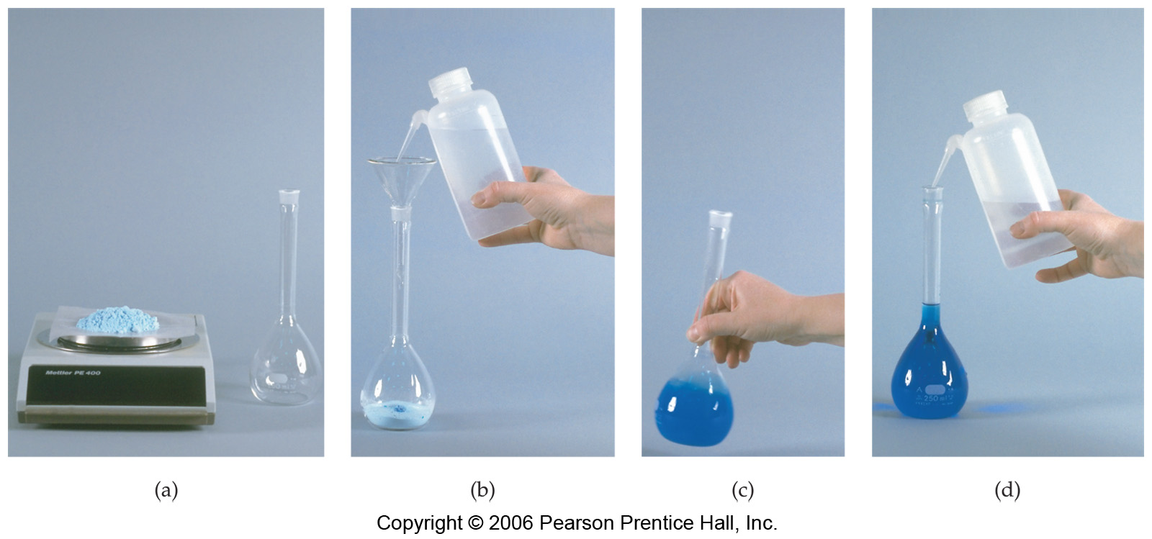

Step (a)

Step (b)

Step (c)

Step (d)

**Example Two – Solution Preparation**

How many grams of HCl would be required to make 50.0 mL of a 2.7 M solution?

Solution Stoichiometry

* _____________ x ____________ = Moles
* Use the _________ _________ in balanced equations to calculate amounts of substances in aqueous reactions.

**Example Three – Stoichiometry**

Calculate the mass of BaSO4 formed when excess 0.200 M Na2SO4 solution is added to 0.500L of 0.500 M BaCl2 solution.

**Example 4 – Finding the Molarity of an Acid**

20.0mL of 0.25M sodium hydroxide, NaOH, is titrated with 23.2mL of ethanoic acid, HC2H3O2 , to the pink phenophtalien endpoint. What is the concentration of the acetic acid?

**Example 5 – Calculating the Molar Mass of an Acid**

0.523 grams of an unknown monoprotic acid is titrated to the phenphtalien endpoint with 22.5mL of 0.103M NaOH. What is the molar mass of the acid?

**Solution Stoichiometry**

Please show all of your work. Remember you will need a balanced chemical equation and pay attention to sig figs.

1. Calculate the number of mL of 2.00 M HNO3 solution required to react with 216 grams of Ag according to the equation:

____Ag(s) + ____HNO3(aq) 🡪 ____AgNO3(aq) + ____NO2(g) + ____H2O(l)

2. Calculate in mL the volume of 0.500 M NaOH required to react with 3.0 grams of acetic acid. The equation is:

____NaOH(aq) + ____HC2H3O2(aq) 🡪 ____NaC2H3O2(aq) + ____H2O(l)

3. Calculate the number of grams of AgCl formed when 0.200 L of 0.200 M AgNO3 reacts with an excess of CaCl2. The equation is:

____AgNO3(aq) + ____CaCl2(aq) 🡪 ____AgCl(s) + ____Ca(NO3)2(aq)

4. Calculate the mass of AgCl formed when an excess of 0.100 M solution of NaCl is added to 0.100 L of 0.200 M AgNO3. Create your double replacement reaction before you begin.

5. Calculate the mass of BaSO4 formed when excess 0.200 M Na2SO4 solution is added to 0.500L of 0.500 M BaCl2 solution. Create your double replacement reaction before you begin.

**Podcast 12.4: Solubility and Temperature**

Solubility and Temperature

* Increasing the _______________ of a solvent __________ ______ the particle movement.
* This causes more ______________ particles to _______________ into the ____________,
* which results in solute particles ______________ loose and dissolving _________________.
* What are some other ways we could get the solvent to bump into the solute more often?

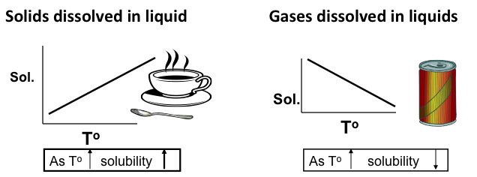

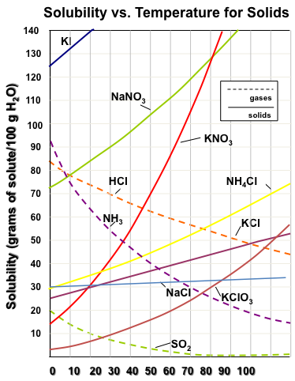Solubility Curve

* ____________ of the solubility of a compound at various temperatures.
* Each compound has a ______________ curve.

*\*Solubility is dependent on _____________________________*

***What trends do you see on the graph?***

***How is the solubility of gases and solids different?***

**If you stir faster, will that make you dissolve more?**

What term describes 39g NaCl at 70°C?

What about 30g at the same temperature?

What about 45g at the same temperature?

**Characteristic of substance:**

* + Each substance has a different ________________ amount that will dissolve, called ________________ __________________
  + Curves for ____________ have a negative slope
  + Curves for ____________ have a positive slope

**Unsaturated Solution**:

* Contains __________dissolved **solute** than the **solvent** can normally hold at that temperature.
* Anywhere below the line of saturation

**Super Saturated Solution:**

* Solution that contains ___________ **solute** than can usually be dissolved at that temperature
* Anywhere above the line of saturation

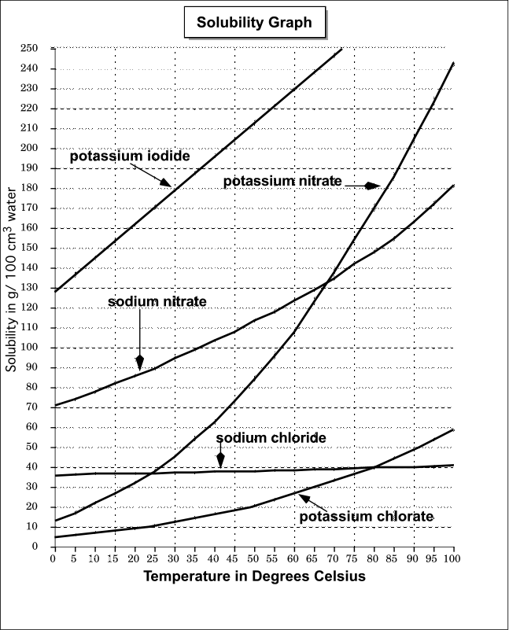**Example 1:**

At 45°C, how much potassium nitrate will dissolve in 100 g of water to form a saturated solution?

**Example 2:**

If at 60°C you put 80g of potassium nitrate in 100 g of water, what is the level of saturation for this solution?

**Example 3:**

How much sodium chloride is needed for a saturated solution at 75°C in *200 g* of water?

**Concentration Curves**

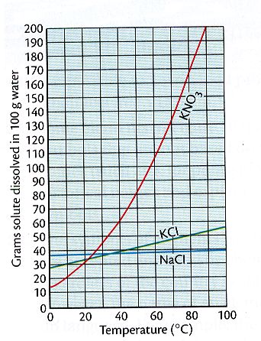**Using the given solubility curves, please solve the following problems.**

1. What is the solubility of potassium nitrate (KNO3) in 100.0g of water at80.0°C?
2. What is the solubility of potassium chloride (KCl) in 100.0g of water at 50.0°C?
3. What is the solubility of sodium chloride (NaCl) in 100.0g of water at 90.0°C?
4. What is the minimum temperature needed to dissolve 180.0g of KNO3 in 100.0g of water?
5. What is the minimum temperature needed to dissolve 35.0g of KCl in 100.0g of water?
6. At what temperature do KCl and KNO3 have the same solubility?
7. Compare how much KCl and KNO3 will dissolve at 90.0°C.
8. If 50.0g of NaCl is mixed with 100.0g of water at 80.0°C, how much will NOT dissolve?
9. If 15.0g of KCl is added to 100.0g of water at 30.0°C, how much more must be added to saturate the solution?
10. If a saturated solution of KNO3, at 20.0°C is heated to 80.0°C, how much more could be dissolved?
11. If a saturated solution if KCl at 90.0°C is cooled to 30.0°C. how much of the solid will precipitate?
12. How much NaCl will dissolve in 350.0g of water at 70.0°C?
13. How much KCl will dissolve in 50.0g of water at 50.0°C?
14. Classify as saturated or unsaturated a solution that contains 90.0g of KCl in 100.0g of water at 70.0°C.
15. Classify as saturated or unsaturated a solution that contains 50.0g of KCl in 100.0g of water at 70.0°C.
16. What temperature is needed to dissolve twice as much KNO3 as can be dissolved at 30.0°C in 100.0g of water?

**Please use the diagram on the right to answer questions 17 – 26.**

1. 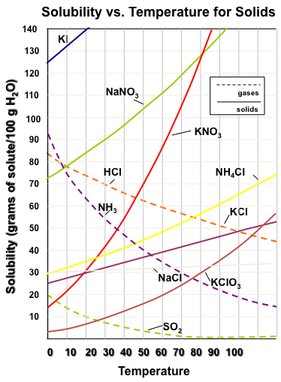Which salt is least soluble in water at 200 C?

1. How many grams of potassium chloride can be dissolved in 200 g of water at 800 C?
2. At 400 C, how much potassium nitrate can be dissolved in 300 g of water?

1. Which salt shows the least change in solubility from 00 - 1000 C?

1. At 300 C, 90 g of sodium nitrate is dissolved in 100g of water. Is this solution saturated, unsaturated or supersaturated?
2. A saturated solution of potassium chlorate is formed from one hundred grams of

water. If the saturated solution is cooled from 800 C to 500C how many grams of precipitate are formed?

1. What compound shows a decrease in solubility from 00 to 1000 C?
2. Which salt is most soluble at 100 C?

25. Which salt is least soluble at 500 C?

26. Which salt is least soluble at 900 C?

27. Summarize the relationship between temperature and solubility for:

a) Solids

b) Gases

**Podcast 5.4: Naming Acids and Hydrates**

Naming Acids: Binary acids

* All acids start with H (HCl, H**2**SO**4**)

_______________ : H + non-metal. HCl

_______________ : H + polyatomic ion. H**2**SO**4**

Binary acids: naming depends on state of acid

* If it’s **not** aqueous: hydrogen + non-metal

HCl(g) = hydrogen chloride

* If it is aqueous: hydro- nonmetal -ic acid

HCl(aq) = hydrochloric acid

Examples: Name the following compounds

1. HBr(s)
2. HI(aq)
3. H**2**S(aq)
4. H**2**S(g)

Naming Acids: Oxyacids – Naming does not depend on the state (aq)

1) name the polyatomic ion

2) replace _______ with ________, and _______ with ________

3) change root if necessary for pronunciation

4) add “acid” to the name

Example: H**2**SO**3**

Examples: Write the name for the following acids

1. HNO**2**
2. HClO4
3. H**3**PO**4**(aq)
4. HCO3

Writing Formulas from Names

1. Identify the _____________ involved
2. If the acid starts with “_____________”- then it’s NOT a polyatomic ion (no oxygen involved)
3. If there’s no hydro and the acid ends in –”_____”, the polyatomic ion must end in –”______”

Remember: “I –ate something –icky “

1. If there’s no hydro and the acid ends in –”__________”, the polyatomic ion must end in –”_________”
2. If there’s a __________ on the acid name, there’s a prefix on the polyatomic ion.

Hypochlorous acid comes from hypochlorite

1. Use the ____________ of the anion to decide how many hydrogens to use in the formula

Examples: Write the formulas

1. Carbonic acid
2. Nitrous acid
3. Sulfuric acid
4. Hydrochloric acid
5. Arsenic acid
6. Acetic acid
7. Hydrosulfuric acid
8. Phosphoric acid

Hydrates: A compound in which a specific number of _______________ ______________ associated with each formula unit (embedded in it’s crystal structure.)

Example: calcium acetate heptahydrate

* **_____________________**: pure crystalline form of a compound (no water added)
* Cobalt(ii) ChlorideExample: calcium acetate or _______________________________________

Hydrate vs Anhydrous Forms

Anhydrous cobalt (II) chloride has a characteristic __________ color

Cobalt (II) chloride hexahydrate is ____________.

Writing Formulas from Names

1. Identify the ions involved
2. Criss-cross the charges to write the formula
3. Use__________________ for polyatomic ions
4. 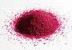Identify the number of waters in a hydrate with a _______ , and a prefix

Examples:

Magnesium sulfate heptahydrate

Cobalt (II) chloride hexahydrate

**Naming Acids**

Please write the name or write the formula for the following acids.

|  |  |
| --- | --- |
| Name | Formula |
| 1. nitric acid |  |
| 1. hydrofluoric acid |  |
| 1. hydrobromic acid |  |
| 1. chloric acid |  |
| 1. acetic acid or ethanoic acid |  |
| 1. carbonic acid |  |
| 1. hydrochloric acid |  |
|  | 1. H3P |
|  | 1. H2SO4 |
|  | 1. HCl |
|  | 1. H2S |
|  | 1. H3PO4 |
|  | 1. HI |
|  | 1. H3As |

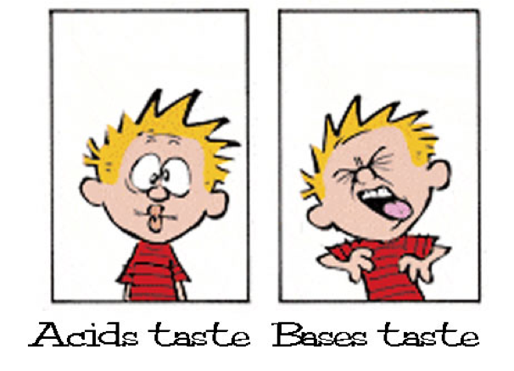

**Podcast 12.5 – pH and pOH**

Properties of Acids

1. Taste _____________
2. Give a sharp stinging pain in a cut
3. Reacts with _____________
4. Called a _____________ ___________
5. Have a high concentration of ____________
6. Range from ____________ on pH scale
7. _______ = strongest acid
8. _______ = weakest acid

Properties of Bases

1. Taste ____________
2. Feels ____________ (soap)
3. Can dissolve ______________ matter
4. Called a ____________ ________________
5. Have a high concentration of _____________
6. Range from _____________ on pH scale
7. _______ = strongest base
8. _______ = weakest base

Acid – Base Reactions

If you mix an acid with a base, it will either form _________ or ____________.

Reaction:

**pH Ranges of Acid-Base Indicators**

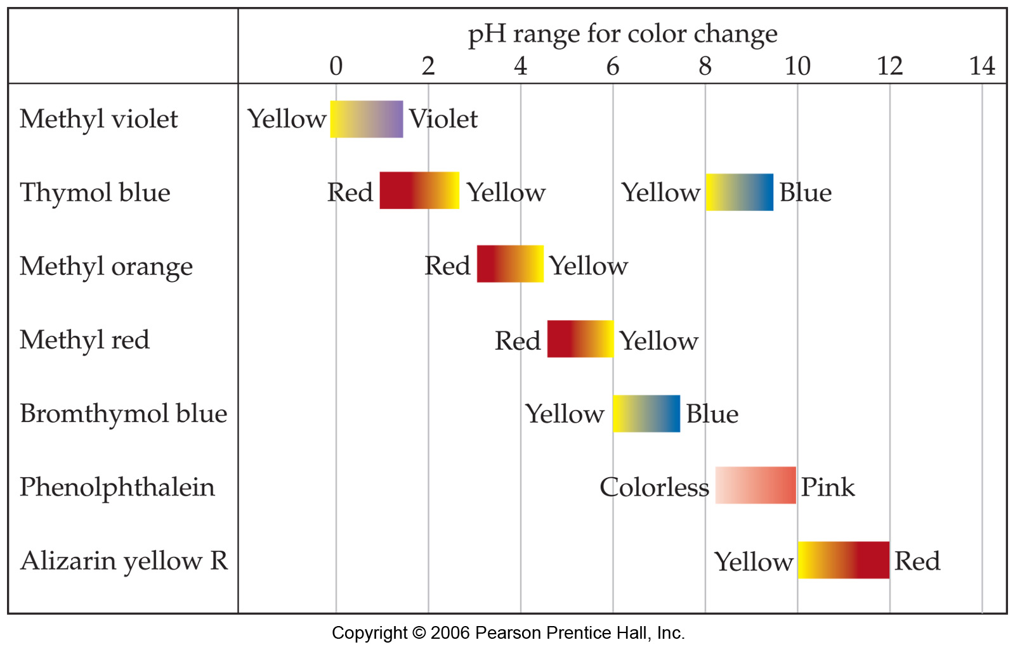

Acid Base Calculations

* In neutral solutions, molar concentrations of H+ and OH- are ______________
* In water, [H+] = [OH-] = _____________ M
* For other solutions, when [H+] ________________, then [OH-] will ________________ and vise versa

Using the pH Scale

* pH: “Power of ____________________”
* pH = 7 ________________ [H+] ___ 1 x 10-7
* pH < 7 ________________ [H+] ___ 1 x 10-7
* pH > 7 ________________ [H+] ___ 1 x 10-7
* pH = _______[H+]
* pOH : “Power of Hydroxide”
* pOH = __________ [OH-]
* pH + pOH = 14

**Example 1:** Calculate pH if [H+] = 1 x 10-7 M

**Example 2: Complete the following chart**



**Example 3 – Incomplete Dissociation**

What is the pH of a weak acid that is 8% dissociated as 0.100 M solution?

**pH and pOH**

The pH of a solution indicates how acidic or basic that solution is.

pH range of 0 – 7 acidic

7 neutral

7-14 basic

Since [H+] [OH-] = 10-14 at 25o C, if [H+] is known, the [OH-] can be calculated and vice versa

pH = -log [H+] So if [H+] = 10-6­M, pH = 6

pOH = -log [OH-] So if [OH-] = 10-8 M, pOH = 8

**Together, pH + pOH = 14**

Complete the chart.

|  |  |  |  |  |  |
| --- | --- | --- | --- | --- | --- |
|  | **[H+]** | **pH** | **[OH-]** | **pOH** | **Acidic or Basic** |
| **1.** | **10-5 M** | **5** | **10-9 M** | **9** | **Acidic** |
| **2.** |  | **7** |  |  |  |
| **3.** |  |  | **10-4 M** |  |  |
| **4.** | **10-2 M** |  |  |  |  |
| **5.** |  |  |  | **11** |  |
| **6.** |  | **12** |  |  |  |
| **7.** |  |  | **10-5 M** |  |  |
| **8.** | **10-11 M** |  |  |  |  |
| **9.** |  |  |  | **13** |  |
| **10.** |  | **6** |  |  |  |

**From Concentration to pH**

Calculate the pH of the solutions below.

1. 0.01 M HCl
2. 0.0010 M NaOH
3. 0.050 M Ca(OH)2
4. 0.030 M HBr
5. 0.150 M KOH
6. 2.0 M HC2H3O2 (Assume 5.0% dissociation)
7. 3.0 M HF (Assume 10.0% dissociation)
8. 0.50 M HNO3
9. 2.50 M NH4OH (Assume 5.00% dissociation)
10. 5.0 M HNO2 (Assume 1.0% dissociation)

Name: Date: Hr. ___

**pH of Common Substances Lab**

Litmus paper and Universal Indicator strips are small pieces of paper that are coated with an indicator solution to indicate the pH of a substance. An indicator is something that allows us to determine the pH of a substance. In this experiment, you will test the effects of many common substances on litmus paper, and measure the pH of those substances.

**Directions**:

Use a stir rod to obtain a small drop of one of the substances. Lightly touch a piece of red, blue and universal paper with the wet stir rod. Record the color change that you observe as well as the numerical value of the pH on the data table. **Rinse the stir rod in water and use a paper towel to wipe off the stir rod before proceeding with the next sample.**

**Data** **Table pH testing**

|  |  |  |  |
| --- | --- | --- | --- |
| **Sample** | **Red Litmus**  **Color** | **Blue Litmus**  **Color** | **Universal Indicator**  **pH Color Numerical pH** |
| 1. Ammonia |  |  |  |
| 2. Baking Soda  Solution |  |  |  |
| 3. Bleach |  |  |  |
| 4. Coke |  |  |  |
| 5. Hydrochloric acid |  |  |  |
| 6. Lemon |  |  |  |
| 7. Milk |  |  |  |
| 8. Orange Juice |  |  |  |
| 9. Sodium hydroxide |  |  |  |
| 10. Ketchup |  |  |  |
| 11. Vinegar |  |  |  |
| 12. Water |  |  |  |

**Questions and analysis:**

Describe the effects that the different substances had on the litmus papers, and describe when we would use the different litmus papers.

**More questions and calculations**

**Determine the pH** of the following concentrations AND describe the effects that this solution would have on Universal Indicator paper and litmus papers and tell if it is an acid or a base. **(SHOW ALL WORK TO RECEIVE FULL CREDIT!!!)**

1. [H+]= 1 x 10 –9 M

pH=

Effect/Color: Universal Indicator Litmus Paper: Acid/Base:

2. [H+]=1 x 10 –2 M

pH=

Effect/Color: Universal Indicator Litmus Paper: Acid/Base:

3. [H+]=1.50 x 10 –7 M

pH=

Effect/Color: Universal Indicator Litmus Paper: Acid/Base:

4. [H+]=2.5 x 10 –12 M

pH=

Effect/Color: Universal Indicator Litmus Paper: Acid/Base:

5. [OH-]=1 x 10 –9 M

pH=

Effect/Color: Universal Indicator Litmus Paper: Acid/Base:

6. [OH-]=1 x 10 –4 M

pH=

Effect/Color: Universal Indicator Litmus Paper: Acid/Base:

**Reflection on Learning:**

**How does this Lab (Determination of pH) relate to what you are currently learning in class?**