**Unit Three – Atoms**

**PODCAST 3.1: ATOMIC STRUCTURE**

CHEMICAL HISTORY

* **What is an atom?**
* **Atom:**
* **Who suggested the existence of atoms?**
* _____________________________________________ (460 B.C. – 370 B.C.)
* Believed that **matter consisted of tiny, indivisible, unchangeable particles called ___________________.**

Chemical History

* Atomic Theory – John Dalton (1766-1844)
* **Dalton’s Atomic Theory :**

1. All elements are composed of tiny ______________________ particles called atoms.
2. Atoms of the **same** element are ______________________.
3. Atoms of different elements can combine to form _______________________________.
4. ____________________ ___________________________ occur when atoms are separated, joined, or rearranged.

Distinguishing between Atoms: How is an atom of hydrogen different from an atom of oxygen?

* Elements are different because they contain different numbers of _____________.
* ______________________ Number: the number of protons in the nucleus of an atom of that element.

**The subatomic particles…**

___________________: Positively charged found inside the nucleus of an atom (p+)

* Has a charge of ________
* Mass = _________
* ALWAYS the same number as the atomic number

___________________: neutral particles also found inside the nucleus of an atom (n0)

* Has a charge of ___________________
* Mass = _______________
* Must calculate # of neutrons

Equation

Example 1: How many neutrons are in the average Cobalt atom?

1. Look up the mass number and round to the nearest whole number
2. Subtract the atomic number from the mass number

Example 2: How many neutrons does gold-197 have?

___________________ : negatively charged particles that form a shell around the atom (e-)

* found ___________________the nucleus of an atom
* Have a charge of __________
* Have a _______________________ mass

The total number of neutrons and protons is called the ________________ number.

So we can determine the number of neutrons in an atom.

Example

**Podcast 3.2: History of Chemistry and the Development of Atomic Theory**

Complete the History of Chemistry Chart in your packet as you listen to this podcast. You may need to add more details, so keep extra paper close by just in case.

Sketch of the Phlogiston Theory

Sketch of the Plum Pudding Model and JJ Thompson’s Cathode Ray Experiment

Sketch of the Gold Foil Experiment

Sketch of the Photoelectric Effect

Wave-Particle Nature – Sketch the [Double Slit Experiment](http://rdg.ext.hitachi.co.jp/rd/moviee/doubleslite-n.wmv)

Schroedinger’s Equations – Sketch of Atomic Orbitals described by Quantum Mechanics

**Podcast 3.3 – Mass of Atoms and ISOTOPES**

Isotopes

* + 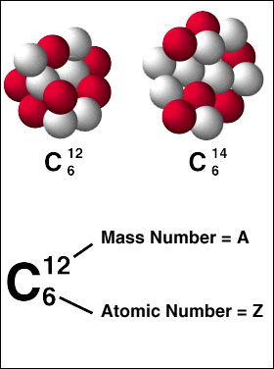 Atoms of an element that have the _________number of _______ and _______ but a different number of _________
  + Chemical properties of isotopes stay the same because they have the same number of electrons and protons.
* Atomic Mass: *Weighted __________ mass* of all atoms in a naturally occurring sample of the element.
* Reflects both the *________* and the *relative abundance* of the isotopes as they occur in nature

RECORD THE ANSWERS TO EXAMPLE PROBLEMS IN THE 5TH SLIDE ON YOUR ATOMIC STRUCTURE WORKSHEET IN YOUR UNIT 3 PACKET.



**How to solve for Average Atomic Mass**

**Steps:**

1. Multiply the % abundance of each isotope times the mass of each isotope.

2. Then find the sum of all the isotopes.

**Example**

99.759% 16O, 0.037% 17O, 0.024% 18O

Step #1: Multiply % abundance by mass

Step #2: Add values

**Example**

Rubidium has two common isotopes, 85Rb and 87Rb. If the abundance of 85Rb is 72.2% and the abundance of 87Rb is 27.8%. What is the average atomic mass of Rubidium?

**Example**



**Podcast 3.4**: **Bohr Models, Aufbau Diagrams, and Electron Configurations**

Locating Electrons in Atoms

* Electrons form a _________________around the nucleus
* The most stable configuration – ________________________
* Describing the location of electrons allows us to predict how an element reacts with others.

Bohr Diagram

* Electrons orbit the nucleus in specific concentric ________________________________________________
* Each ring is described by a specific amount of _______________________
* Use The Periodic Table of Elements to sketch the location of electrons in each energy level

Shortcut for Large Atoms

* Circles can be drawn as Arcs
* Nucleus can be represented using __p+ and __no

__p+

__no

What’s Wrong with the Bohr Model?

* Electrons don’t move in _____________________________ ________________________
* ____________________equations describe probability of finding an electron in any given location

SPDF

* Electrons are mapped out on The Periodic Table
* Each section represents a different orbital shape

Label and Color Code the periodic table below to represent each type of orbital (s, p, d, and f)

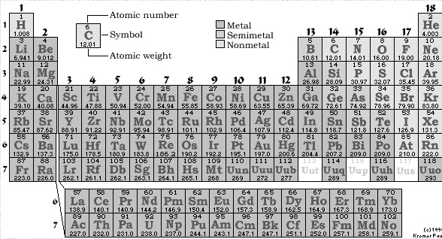

Aufbau Diagrams

* Aufbau = “____________________ ________”
* Represent the opposing spin of electrons using arrows (up or down)

1. _______________________________: Electrons fill lowest energy levels first
2. _______________________________: Every sub-orbital gets one electron before any pairing
3. _____________________________________: Electrons in the same sub-orbital must be opposite in spin

Aufbau Diagrams

**7s __**

**7p __ __ __**

**5f __ __ __ __ __**

**6d __ __ __ __**

**6s __**

**6p __ __ __**

**5d __ __ __ __**

**4f __ __ __ __ __**

**5s __**

**5p __ __ __**

**4d __ __ __ __**

**4s __**

**4p __ __ __**

**3d __ __ __ __**

**3s __**

**3p __ __ __**

**2s __**

**2p __ __ __**

**1s __**

**7s __**

**7p __ __ __**

**5f __ __ __ __ __**

**6d __ __ __ __**

**6s __**

**6p __ __ __**

**5d __ __ __ __**

**4f __ __ __ __ __**

**5s __**

**5p __ __ __**

**4d __ __ __ __**

**4s __**

**4p __ __ __**

**3d __ __ __ __**

**3s __**

**3p __ __ __**

**2s __**

**2p __ __ __**

**1s __**

Long-hand Electron Configuration

* Giving the electrons an address
* Utilize SPDF notation

Short-hand Electron Configuration

* Noble Gas configuration represents a ___________________________________ energy level
* Noble Gases are used to represent all but the valence-shell electrons

Very Large Atoms  
Thanks to Shorthand Configuration!