Chemistry Unit Nine – Scientific Measurement
Podcast 2.1 Scientific Notation
Scientific Measurement: Using and Expressing Measurements
Measurements in chemistry often involve very large or very small numbers
EXAMPLE.
2 grams of Hydrogen = 602,000,000,000,000,000,000,000 hydrogen atoms.
- Scientists use “Scientific Notation” to write numbers in Exponential form
- Notation is based on powers of _____
10 = 10¹
100 = 10²
1000 =
10,000 =
100, 000 =
Writing Numbers with Scientific Notation
- Move or add a decimal point so that only _______ digit is in front of the decimal.
- Write __________
- Count the number of decimal places you moved and write that number as superscript.
- Look which way you moved the decimal
  - Left = + superscript or b. Right = − superscript
Left LARGER Right REDUCES
Put the following numbers into or take them out of Scientific Notation:
1) 13400000
2) 0.000724
3) 5.903 x 10⁻⁸
4) 6.20 x 10³
Calculations with Numbers in Scientific Notation
- Addition: Change exponents so they match
EX. 1.03 x 10³ + 2.10 x 10²

Answer = ____________
- Subtraction: Change exponents so they match
EX. 1.03 x 10³ - 2.10 x 10²

Answer = _____________
- Multiplication: Multiply numbers and add exponents
EX. 1.03 x 10³ x 2.10 x 10²

Answer = ______________
- Division: Divide numbers and subtract exponents
EX. 1.03 x 10³ / 2.10 x 10²

Answer = ______________
Podcast 2.2: Accuracy, Precision, and Error
Uncertainties in Measurement
- _____________ – the closeness of a measurement to the true value of what is being measured.
- _____________ – is a measure of how close a series of measurements are to one another.
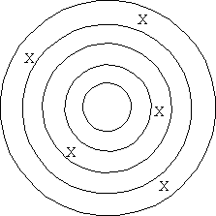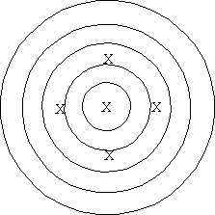
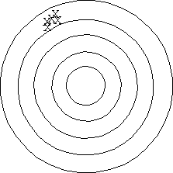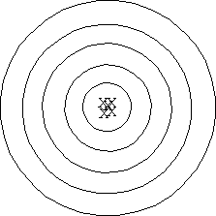
How do we measure Accuracy?
By determining _______________
- measured value – correct value
- Experimental value – Theoretical value
Error = “whatcha got” – “Whatcha shoulda got”
- Percent Error : How critical is the error?
Percent error =

Ex. Experimental = 1.24 g
Accepted = 1.30 g
Percent Error =
Causes of Error
Four types of Errors
- Instrumental error – error that deals with ________________ of instrument
- __________ error – error that deals with error in your human limitations to record observations
- Environmental error – occurs when uncontrolled environmental conditions effect the outcome
- ___________ error – introduced from abnormal chemical behavior.
Calculator Lesson: All calculators are NOT created equal
- Graphing calculators follow the _______________, so the use of parentheses is VERY important
- Simpler calculators do the operations as you put them in
Scientific Notation and your calculator
- Depending on the calculator, the exponential key may be labeled “EE” “EXP” or “EEX” or you may not have one…bummer
- Example: 4.56×10⁸
  - It’ll show up as either 4.56⁸ or 4.56E8
  - The ×10 is assumed so it’s not shown
- Example: What is 2.43 x 10²³ x 7.30?
- Enter it as 2.43 EE 23 × 7.30
Answer = __________________

Podcast 2.3: Significant Figures “Sig-Figs”
Measurement Uncertainty
- Measurements in science needs to be _____________ and therefore hopefully ______________
- Uncertainty on measurements are based upon the ___________________________ used
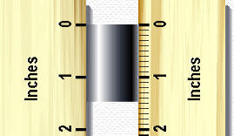
  - Made up of a number of digits that are certain, and one additional digit which represents an estimation
- Example: Use a ruler to measure the length of the metal rod.
  - The ___ and____ are the certain numbers
  - The _____ in the hundredth place is the uncertainty digit (based upon ruler provided)
Length of rod ____________
Significant Figures: ______________ digits in a MEASUREMENT
- Exact numbers are counted, have unlimited significant figures
- _______ _______ except zero are significant.
- Some zeros are, some aren’t…
Which Zeroes Count?
- ______________ other sig figs
- NOT _____________ the first number
- After the last number counts if and only if…
-- it is after the _________________ – or – the decimal point is written in
  - 3200 ___ sig figs
  - 3200. ___ sig figs
  - 320.0 ___ sig figs
How many sig figs do the following numbers have?

- 1.032
- -0.007
- 6800
- 1.30
- 2.46
- 10.02
- 6800.0

Doing the Math
For multiplication and division, your answer can only have as many sig-figs as the LEAST number of sig-figs in the problem
- Ex: 1.31 x 2.2 = ______________
For addition and subtraction, the number with the least number of decimal places is used.
- Ex. 1.31 + 2. 2 =
Try These:
- 2.36 + 1.7 + 3.284
- 1.89 x 2.03 x 3.277
- 8.2 / 3.74
Please report your results with the appropriate number of significant figures. Thanks!
- 2.090 x 1.23 x 1.9
- 12.036 – 3.42 – 2.067
- 1.096 + 7.09 + 5.2
- 13.040 / 3.23
Podcast 2.4 – SI and the Metric System (notes on Mega Metric Mania)

Podcast 2.5 – Measuring Temperature
Heat and Temperature
- ____________– the energy an object has due to the motion of it’s particles
- ____________ – the average kinetic energy of all particles in an object
Measures transfer of heat
Movement of Heat
- Heat always moves from ________ to ________
- Objects tend to ________________ with an increase in temperature and contract with decreasing temperature.
Measuring Temperature
- _________________ – the zero point on the Kelvin scale which is equal to -273 C. At this point all atomic motion theoretically stops.
- ______________ of Water – 100 ºC or 212 ºF
- ______________ of Water – 0 ºC or 32 ºF
Converting Temperature
Fahrenheit, Celsius, and Kelvin are all describing the same height of mercury on a thermometer, just using a different scale
F =

C =

K =
*Note: Kelvin is based on absolute zero, so it does not use “degrees of change”, don’t use a ” º ” with the unit K
Example Problems
- Convert 298 K to ºC
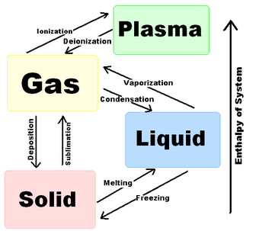
- Convert 37 C to Kelvin
- Convert 72 ºF to Kelvin
1st change to ºC
2nd change to K
- Convert 74 Kelvin to ºF
1st change to ºC
2nd change to ºF

Phase Change Diagram

Podcast 2.6: Density and Specific Gravity
Density – is the ratio of the mass of an object to its volume.
- Formula for Density

  - Units are given as _______ or _______
Example1: A copper rod has a mass of 0.52g. The volume was determined by water displacement to be 0.0581 mL. What is the density?

Example 2: A 1.60-L sample of tin (II) fluoride has a mass of 2.59 kg. What is the density of this substance in g/cm³?

Example 3: What is the volume of 7.4 x 10³ mg of copper if the density is 8.92 g/cm³ ?

Example 4: A beach ball with a volume of 21.8 cm³ has a mass of 16.1 g. Would this ball sink or float in water?

Specific Gravity: A comparison of the density of a substance with the density of a reference substance that is at the same temperature.
- Reference Substance = (usually) ___________ at 4º C
- Formula of Specific Gravity

- Specific Gravity is the only _____________ quantity.

Example: A chunk of granite weighing 31.2 grams displaces 11.8 cm³ of water. What is the specific gravity of this rock?

Podcast 2.7: Dimensional Analysis and T-Tables
Dimensional Analysis
- Using _________ to help solve problems
- A ______________________________ can be used to convert between different units.
- Conversion factors are reversible so that you can obtain the result you need.
T-Table and Conversions In chemistry we use a T-table to help us convert between different units.
Example 1: Convert 157 cs to s

Example 2: 8.25 x 10² cg to ng
Example 3: 0.44 mL/min to μL/s

Example 4: The radius of a potassium atom is 0.227 nm. Express this radius in the unit centimeters.

Please use T-Tables to convert the following units.
Example 5: The diameter of Earth is 1.3x10⁴ km. What is the diameter expressed in decimeters?

Example 6: Light travels at a speed of 3.00 × 10¹⁰cm/s. What is the speed of light in kilometers/hour?

Using T-tables to Solve Density Problems: Use density as a conversion factor to change mass to volume or volume to mass
g/mL or mL/g

Example 7: Convert 6 g to mL if the density of the substance is 12 g/mL

