Unit Four Note-taking Guide – Periodicity
Podcast 4.1 Organization of the Periodic Table
- Elements with similar properties were placed in vertical ______________ (columns) or _____________.
- Placed by increasing atomic weights in rows called ______________.
Families/Groups
- ______________ Metals
  - Group 1 – Lithium, Sodium, Potassium, Rubidium, Cesium, Francium
  - ____________electron in valence (outer) shell
  - Very, VERY reactive – not found free in nature
- ______________ ______________ Metals
  - Group 2 – Beryllium, Magnesium, Calcium, Strontium, Barium, Radium
  - ____________ electron in valence shell
  - Very reactive – not usually found pure in nature
- ______________ Group 18 – Helium, Neon, Argon, Krypton, Xenon, Radon
  - ______________ valence electron shell
  - Very stable (not reactive)
  - Under normal conditions do not form compounds with other elements
  - XeF₄ (xenon tetrafluoride) is the first reported stable compound of a noble gas - 1962
- ______________ Group 17 – Fluorine, Chlorine, Bromine, Iodine, Astatine
  - _____________ electrons in valence shell
  - Halogen means “salt former”
  - Compounds they form are called salts
- ______________ Metals
  - Groups 3 to 12, periods 4 to 7
  - ______________ electrons in valence electron shell
  - Hard and have a high melting point
  - Often used to form alloys (mixtures of metals)

Podcast 4.2: Early Periodic Tables
- Mid 1800’s – 60 Different Elements were identified
- 5 were ______________ at room temperature (all non-metals)
  - H, O, N, F, Cl
- 2 were ______________
  - Hg (metal)
  - Br (non-metal)
- The rest were ______________
- Scientists searched for a way to organize these elements
  - Elements with similar ______________ were placed near one another.
- Dimitri Mendeleev
  - In 1869 he published the first periodic table
  - Mendeleev’s Table arranged by
    - ______________ (Molar Mass)
    - Combining Capacity
- Modern Periodic Table arranged by
  - ______________
  - Number of valence electrons
  - Put together by Henry Mosely
- Why use Atomic Number rather than Atomic Weight?
  - ________________________________________________________________________
  - ________________________________________________________________________

Podcast 4.3: Ions – Charged Particles
Ions Are Charged Particles
- Atoms will transfer one or more _______________ to another to become more stable.
- Each atom is left with a _____________ outer shell.
- Atoms neutral; _______________ balance electrons
- Ions carry a charge because electrons (-) are gained or lost from a neutral atom.
Lewis Dot Diagrams: Represent Valence Electrons as Dots
- Example 1: Sodium + Chlorine

- Example 2: Magnesium + Bromine

- An atom that gains one or more electrons will have a ____________________ charge.
- An atom that loses one or more electrons will have a ____________________ charge.
- A positive ion is called a ______________ and a negative ion is called an _______________.
Ionization Equations
- To show how an ion forms, electrons are written as reactants (gained) or as products (lost) in a chemical equation
- Sodium

- Chlorine

- Magnesium

- Oxygen

Podcast 4.4: Periodic Trends
Nuclear Charge, Z
- The nucleus is made of __________________ and _______________
- The charge of the nucleus comes from the protons
- The more protons, the _____________ the charge
Electrostatic Force -- Coulomb’s Law
- The force of attraction is described by Coulomb’s Law
_{write equation here:}

Electron Affinity = Electronegativity
- How tightly held are the valence electrons?
- More Electronegativity pulls electrons ________
Atomic Radius
- Smaller atoms take up less space
- More closely-held electrons take up less space
Ionization Energy: The energy required to REMOVE an electron
- Higher energy means it’s harder to take the electron away
- Cations have ___________ ionization energies
- Anions have ___________ ionization energies
Flame Test Results
- Sodium
- Lithium
- Potassium
- Barium
Effects of Electron Shielding
- Back to Coulomb’s Law… distance from the nucleus ___________ the attraction experienced by valence electrons
- Other electrons get in the way – ___________ valence electrons from the nuclear charge
Which has more influence… Nuclear Charge or Shielding?
- As the principle energy level increases, effects of shielding ___________ .
Answer the question and explain your reasoning:

Electronegativity (Electron Affinity)
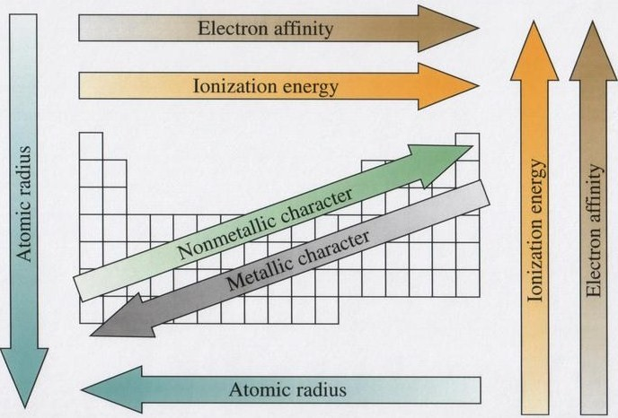
Atomic Radius
Ionization Energy

