Name:___________________________

Period:__________________________

**Chemistry Unit 4 – Periodic Table**

Chemistry Daily Journal

|  |  |  |
| --- | --- | --- |
| Today’s Date | What do I need to accomplish today? | What do I need to finish up at home? |
|  |  |  |

|  |  |  |  |
| --- | --- | --- | --- |
| Objective | Learning Opportunities | Suggested Due Date | Date Completed |
| 4.1 Explain how elements are organized in a periodic table and characteristics of groups/families | * Podcast 4.1 Organization of the Periodic Table * Read pp. 155-160, 3-7 p. 160 * Coloring the Periodic Table | 10/28 |  |
| 4.2 Compare early and modern periodic tables | * Podcast 4.2 Early Periodic Tables * Grouping the Elements Activity * Reactivity of Alkali Metals Demo | 10/31 |  |
| 4.3 Explain where core electrons and valence electrons are located | * Lewis (Electron) Dot Structures * Valence Electrons | 11/04 |  |
| 4.4 Apply nuclear charge and electron shielding to justify the different periodic trends | * Podcast 4.4 Periodic Trends * Read pp. 168-178; 16-21, 23 p. 178 * Vocabulary of the Periodic Table * 6.3 Periodic Trends | 11/07 |  |

Element Riddles

*Find the elements that best answer the riddles. For every 5 riddles you get correct, you earn an extra credit point. So that means this is worth 7 extra credit points!!*

Examples: What do you do with dead people? ***Barium (Ba)***

Storage place for street cars. ***Carbon (C)***

What most of your classes do (except this one, of course). ***Boron (B)***

1. Half a dime. ___________________
2. The Lone Ranger’s horse. ___________________
3. Not fat. ___________________
4. A man who gives admission slips to traffic courts. ___________________
5. Gin with water in it. ___________________
6. What I do when I’m hungry. ___________________
7. Male or the Ganese tribe. ___________________
8. What torpedoed ships do. ___________________
9. Greek streaker who wore shoes with wings. ___________________
10. What he did to a bucking horse. ___________________
11. Why she wears “MY SIN” perfume. ___________________
12. What she got after the divorce. ___________________
13. Big English theater. ___________________
14. What should be done to a wounded man. ___________________
15. A crazy inmate. ___________________
16. Night rider for Helen of Troy. ___________________
17. Donnie and Marie. ___________________
18. Not whole. ___________________
19. To grab someone. ___________________
20. Molly’s blue jeans. ___________________
21. What your mom did when you tore your pants. ___________________
22. Two people with no hair. ___________________
23. What doctors can’t do to people with the common cold. ___________________
24. A small cut on the butt. ___________________
25. What you do when you forget your calculator. ___________________
26. A jazz musician’s mink coat. ___________________
27. Guys and ___________________
28. Mickey’s dog. ___________________
29. She was buried in a ___________________ in the hill.
30. What the robber asked after the police left. ___________________
31. The golfer’s slave. ___________________
32. Person without a stomach. ___________________
33. What police do to loud parties. ___________________
34. It’s none of your ___________________
35. If a bee flies into your mouth, you get ___________________

**Unit Three Note-taking Guide – Periodicity**

**Podcast 4.1 Organization of the Periodic Table**

* Elements with similar properties were placed in vertical **______________** (columns) or **_____________.**
* Placed by increasing atomic weights in rows called **______________.**

Families/Groups

* **______________** Metals
  + Group 1 – Lithium, Sodium, Potassium, Rubidium, Cesium, Francium
  + **____________**electron in valence (outer) shell
  + Very, VERY reactive – not found free in nature
* **______________**  **______________** Metals
  + Group 2 – Beryllium, Magnesium, Calcium, Strontium, Barium, Radium
  + **____________** electron in valence shell
  + Very reactive – not usually found pure in nature
* **______________** Group 18 – Helium, Neon, Argon, Krypton, Xenon, Radon
  + **______________** valence electron shell
  + Very stable (not reactive)
  + Under normal conditions do not form compounds with other elements
  + XeF4 (xenon tetrafluoride) is the first reported stable compound of a noble gas - 1962
* **______________** Group 17 – Fluorine, Chlorine, Bromine, Iodine, Astatine
  + **_____________** electrons in valence shell
  + Halogen means “salt former”
  + Compounds they form are called salts
* **______________** Metals
  + Groups 3 to 12, periods 4 to 7
  + **______________** electrons in valence electron shell
  + Hard and have a high melting point
  + Often used to form alloys (mixtures of metals)

The Periodic Table

Use colored pencils to color in the periodic table. Follow the directions carefully…you only get one table to color.

1. The following elements are metalloids: B, Si, Ge, As, Sb, Te, and Po. Color them and be sure to color the key.
2. The elements in *periods (rows)* 2 through 7 that are to the left of the zigzagged line of separation are metals. Chose a color to outline (don’t color!) the metals (don’t forget the key).
3. The elements in *periods* 1 through 6 that are to the right of the zigzagged line of separation are nonmetals. Chose a color to outline (don’t color!) the nonmetals. Don’t forget hydrogen…it’s a little out of place.
4. Label the line of separation. This is the staircase line that starts between Boron and Aluminum and goes down the middle of the metalloids, finishing between Polonium and Astaine.
5. The alkali metals are in *group (column)* 1. They have only one electron in their outer shell. They are VERY reactive and have a low melting point. Color the alkali metals.
6. Alkaline earth metals are located in *group* 2. They have 2 electrons in their outer energy level. Color the alkaline earth metals.
7. The noble gases are found in *group* 18. Their outer energy level is filled, and they are very non reactive, colorless gases. Color the noble gases.
8. Halogens have seven electrons in their outer shell. They are located in *group* 17 on the periodic table. Halogens react with metals to form salts. Shade the halogens green.
9. The transition elements are found in groups 3 through 12 and periods 4 through 7. These elements have either one or two electrons in the outer energy level. They are often used to form alloys because they are hard and have high melting points. Color the transition metals.
10. Below the main part of the table are two rows of elements. These elements are part of the transition metal section. The top row is called the Lanthanide Series and the bottom section is called the Actinide Series. Label each series and color these rows using the same color you use for the transition metals.

**Answer these five questions on the back of your periodic table by writing the question then answering, or answer in complete sentences.**

1. What is a metalloid? (*Hint: notice where they are located on the Periodic Table*)
2. List 5 metals.
3. List 5 nonmetals.
4. What does the line of separation separate?
5. Where do the names Lanthanide and Actinide come from?(*hint: take a look at your periodic table and take note of the names of elements*)

Name: ____________________

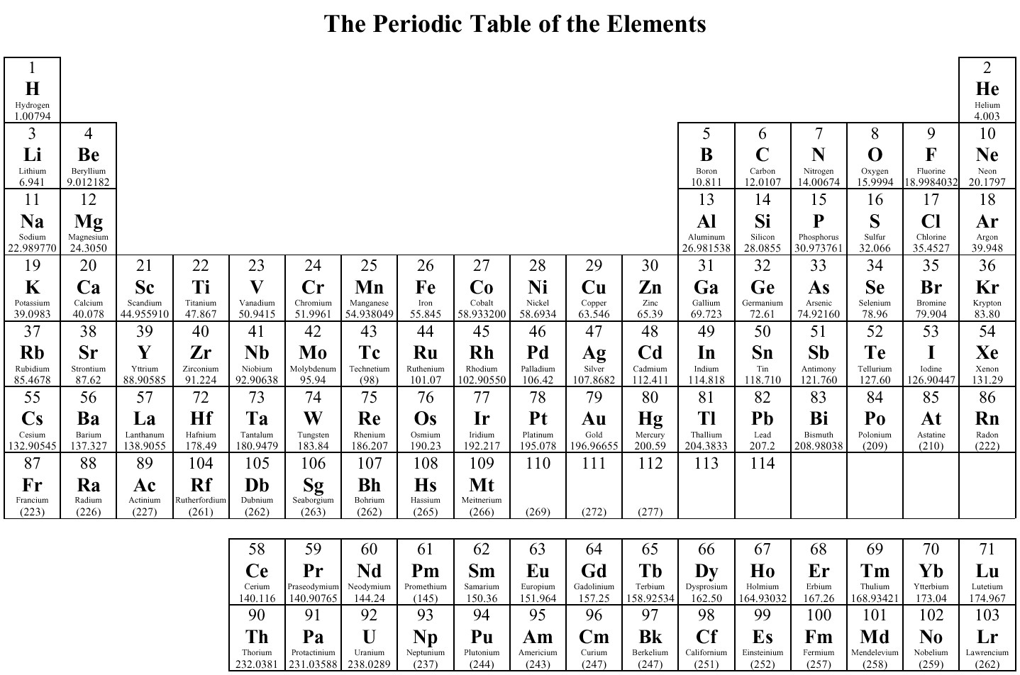

G 1

G 2

G 3

G 4

G 5

G 6

G 7

G 8

G 9

G 10

G 11

G 12

G 13

G 14

G 15

G 16

G 17

G 18

P 1

P 2

P 3

P 4

P 5

P 6

P 7



# **Metal Alkali Metals**

## Nonmetal Alkaline Earth Metals

Metalloids Halogens

Transition Metals Nobel Gases

**Grouping the Elements**

You will be given a set of 20 element data cards. Each card lists some properties of a particular element. You will be presenting your findings to the class. Answer the questions as you go through this process. These are guiding questions to help you with the process and with what you present to the class.

1. Cut out each of the Element Data Cards.
2. Arrange the cards in order of **increasing atomic weight**. (*Hint: as you are grouping your elements, try to keep them in increasing atomic weight order.*)
3. Arrange cards into different groups (or columns) based on data found on that card. Each group should include elements with similar properties (*try to match up all the different properties*). You might need to try several methods of grouping before you find one that makes sense to you.
4. For the BLANK Element Data Card, make a prediction for an element that might fit in with one of the groups you created. Write in the properties that your predicted element would have in order to fit in with that group.
5. **Answer the following questions:**
   1. How many different groups (columns) did you arrange your cards in?
   2. Why did you group each the way you did? What properties did you use the most?

**Podcast 4.2: Early Periodic Tables**

* Mid 1800’s – 60 Different Elements were identified
* 5 were **______________** at room temperature (all non-metals)
  + H, O, N, F, Cl
* 2 were **______________**
  + Hg (metal)
  + Br (non-metal)
* The rest were **______________**
* Scientists searched for a way to organize these elements
  + Elements with similar **______________** were placed near one another.
* Dimitri Mendeleev
  + In 1869 he published the first periodic table
  + Mendeleev’s Table arranged by
    - **______________** (Molar Mass)
    - Combining Capacity
* Modern Periodic Table arranged by
  + **______________**
  + Number of valence electrons
  + Put together by Henry Mosely
* Why use Atomic Number rather than Atomic Weight?
  + ________________________________________________________________________
  + ________________________________________________________________________

**Lewis (Electron) Dot Structures**

In 1916, Gilbert Lewis developed a system of arranging dots (representing valence electrons) around the symbols of the elements.

* The Symbol represents the Nucleus and Core Electrons for that Element.
* Dots represent the electrons.

Each Lewis Dot structure can have up to **8 valence electrons** represented because the outer most energy levels consist of only the s and p orbitals.

Transition metals can have 1, 2, or 3 valance electron depending on the metal and its state. If it has 1 valence electron, it will have a **roman numeral I in its name**, 2 valance electrons will have II, and so on.

**Making Lewis Dot Structures:**

1. Determine the number of valence electrons. Number of valence electrons equal the group the element is in going across the periodic table, but skipping the transition metals.
2. Write the atomic symbol of the element.
3. 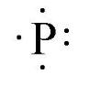Place the correct number of dots (electrons) around the symbol. The electrons need to be evenly spaced. Begin with putting one above, below, to the left, and to the right (4 total). Then if you have more valence electrons, pair them up with the ones already placed.

**Example:** Write the electron dot symbol for phosphorus.

Answer: P = Phosphorus, Group 5A, therefore, there are 5 valence electrons.

*Using Your Periodic Table, complete the table below.*

|  |  |  |  |  |  |
| --- | --- | --- | --- | --- | --- |
| **Name** | **Symbol** | **Atomic Number** | **Short Hand Configuration** | **Number of Valence Electrons** | **Lewis Dot Structure** |
| 1. Hydrogen | H | 1 |  | 1 | H· |
| 2. Selenium |  |  |  |  | Se-Lewis-dot-structure |
| 3. Oxygen | O |  |  | 6 |  |
| 4. Nitrogen |  | 7 |  |  |  |
| 5. Potassium | K |  |  |  |  |
| 6. Calcium |  |  |  | 2 |  |
| 7. Iron (III) |  |  |  | 3 |  |
| 8. Copper (I) |  |  |  |  | Cu· |
| 9. Carbon | C |  |  |  |  |
| 10. Krypton |  | 36 |  |  |  |

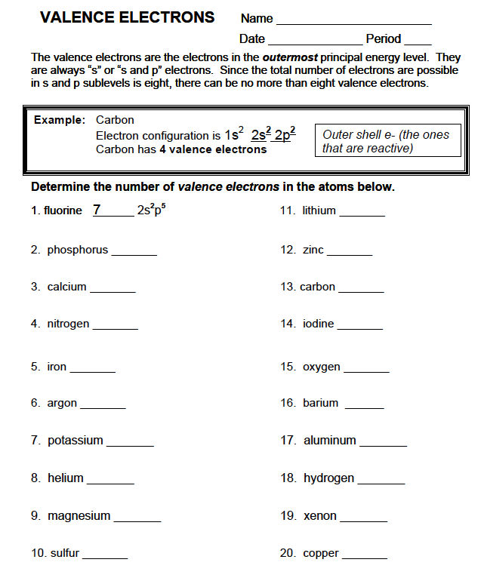

**CHEMISTRY NOVA VIDEO: “Hunting the Elements”**

Answers can be found online at: <http://video.pbs.org/video/2217713569/>

PART 1: Basics of Chemistry

Gold - Au

1. Write the number of subatomic particles in a gold atom:
   1. # of Protons:
   2. # of Neutrons:
   3. # of Electrons:
2. Give one property of gold.
3. How much gold is in one ton of the mined rock?
4. How much is each truckload of ore worth, once the gold is extracted?
5. What determines how reactive an element is?
6. Write and color code the noble metals on the blank periodic table.
7. Why is gold so heavy?

Copper - Cu

1. Write the number of subatomic particles in copper:
   1. Protons:
   2. Neutrons:
   3. Electrons:
2. List three uses of copper.
3. Give one property of copper.

Tin - Sn

1. What alloy does tin make when mixed with copper?
2. How are atoms arranged in pure metals?
3. Why isn’t pure copper used for bells instead of bronze?

Electron Microscope

1. How much would you have to zoom in on a map of the United States to replicate the power of an electron microscope?
2. Why is the microscope wrapped in acoustic blankets?
3. What part of the atom is actually visible under the microscope?
4. What do protons determine about an element?
5. What is the number of protons called? (The a_______ number)
6. Label the atomic number, symbol, and atomic mass of calcium below:



1. Give an example of a real-life object or product made from each of the following elements:
2. Calcium –
3. Bismuth –
4. Bromine –
5. What is a family of elements? (Are families columns or rows on the periodic table)
6. Where did the noble gases get their name?
7. What do electrons determine?
8. How many electrons can fill each of the orbital levels in the diagram below? Fill in Blanks

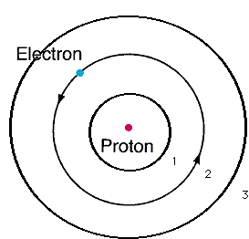

Level 1 = ______ maximum electrons

Level 2 = ______ maximum electrons

Level 3 = ______ maximum electrons

Chlorine - Cl

1. Give the number of atomic particles in chlorine:
2. Protons –
3. Neutrons –
4. Electrons –
5. Chlorine atoms tend to ( take / give away ) one electron, becoming an ( ion / isotope ).
6. Why do alkali metals and halogens react so strongly with other elements?
7. What do sodium and chlorine make when combined?
8. Compare the properties of each of the following:

|  |  |  |  |
| --- | --- | --- | --- |
|  | Sodium Atom (Na) | Chlorine Atom (Cl) | Sodium Chloride (NaCl)  Composed of IONS |
| State of Matter | Solid | gas | ? |
| Reactive or Stable |  |  |  |
| Practical Use |  |  |  |

Oxygen - O

1. What is ANFO?
2. What do each of the spikes on the ion chromatograph represent?
3. This is the chemical reaction of the ANFO explosion. Notice oxygen is NOT listed on the reactants side. Explain what happens during this reaction to release so much heat energy.

**3NH4NO3  + 2CH3NO2 -------> 4N2  + 2CO2 + 9H2O**

1. Below is the chemical equation for the burning candle. What gas is needed to start this reaction (what gas in on the reactants side? _________________)

**C25H52 (solid) + 38 O2 (gas)  → 25 CO2 (gas)  + 26 H2O (liquid)**

34. The chemical equation for the formation of rust (iron reacting with oxygen) is:

**4 Fe (solid) + 3 O2 (gas) => 2 Fe2O3 (solid)**

**What gas is on the reactants side? ______________________**

1. Compare the speed and explosive force of gunpowder, emulsion-gel, and C4. Which is the

fastest explosion? WHY? Part 2: Chemistry of Life, Rare Earth Elements, and Radioactivity

Elements of Life

1. List the six most common elements of life, a common object they are found in, and an important property. CHNOPS

|  |  |  |  |
| --- | --- | --- | --- |
| Element Symbol | Element Name | Common Object | Important Property |
| C |  |  |  |
| H |  |  |  |
| N |  |  |  |
| O |  |  |  |
| P |  |  |  |
| S |  |  |  |

What can happen when excessive trace elements are lost from the body?

1. Describe a body function or part that utilizes each of these trace elements:
   1. Calcium –
   2. Iron –
   3. Potassium –
   4. Zinc –
   5. Magnesium –
   6. Sodium –
2. What three conditions did the earliest bacteria need for energy production?
3. What do cyanobacteria use for energy production? What do they release as waste?
4. In the core sample collected from Yellowstone, which layer is the cyanobacteria?

Origin of the Elements

1. What is the origin of hydrogen, the smallest element?
2. Describe the process of fusion and how it produces helium.
3. What happens when a star runs low on hydrogen fuel?
4. What is created in supernova explosion?

Silicon and Glass

1. What elements is sand made of?
2. What is added to Gorilla Glass to make it stronger than normal glass?

Rare Earth Elements

1. Where do most of the rare earth elements come from?
2. How are the fifteen rare earth elements chemically similar?
3. What elements are rare earth magnets usually made of?
4. Why are rare earth elements in such short supply?

1. How do sharks react to rare earth metals?
2. Describe the following parts of the lemon shark experiment:

Independent Variable –

Dependent Variable –

Experimental Group –

Control Group -

Carbon Isotopes

1. What is the difference between the compositions of these carbon isotopes?

|  |  |  |  |
| --- | --- | --- | --- |
|  | Protons | Electrons | Neutrons |
| Carbon-12 |  |  |  |
| Carbon-13 |  |  |  |
| Carbon-14 |  |  |  |

1. What happens to Carbon-14 over time?
2. Define radioactive half-life:
3. Based on carbon dating, how long ago did the tree die?

Nuclear Radiation

1. Give the number of subatomic particles in uranium:
   1. Protons –
   2. Neutrons –
   3. Electrons
2. How is the mousetrap simulation similar to a fission chain reaction?
3. What element was used as fuel for the “Little Boy” bomb?
4. What element was used as fuel for the “Fat Man” bomb?

**Metal or Nonmetal Lab**

**Prelab Questions**

1. Classify each property tested in this activity as either a physical property or a chemical property.

## Appearance Physical Property Chemical Property

**Results of Crushing** Physical Property Chemical Property

**Conductivity** Physical Property Chemical Property

**Reaction with Water** Physical Property Chemical Property

**Reaction with acid** Physical Property Chemical Property

**Reaction with CuCl2** Physical Property Chemical Property

The relative metallic character can be predicted using the element's reactivity, their electron configurations and knowledge of the periodic trend, effective nuclear charge, Zeff.

**Zeff = Z – S**

In this formula Z equals number of protons in the nucleus (the atomic number) and S equals

the numbers of core electrons in an atom.

1. For each of the following elements write the noble gas electron configuration and calculate the effective nuclear charge.

|  |  |  |
| --- | --- | --- |
| **Metal** | **Noble gas**  **electron configuration** | **Zeff = Z - S** |
| Ca |  |  |
| Mg |  |  |
| Al |  |  |

1. How does an element with an effective nuclear charge of 1 compare with an element with an effective nuclear charge of 2 in terms of **METALLIC CHARACTER**?

Data Table

|  |  |  |  |  |  |  |
| --- | --- | --- | --- | --- | --- | --- |
| **Element** | **Appearance** | **Conductivity** | **Result of Crushing** | **Reaction with Water** | **Reaction with Acid** | **Reaction with CuCl2** |
| Element A |  |  |  |  |  |  |
| Element B |  |  |  |  |  |  |
| Element C |  |  |  |  |  |  |
| Element D |  |  |  |  |  |  |
| Element E |  |  |  |  |  |  |
| Element F |  |  |  |  |  |  |
| Element G |  |  |  |  |  |  |

**Analysis**

Using the following information, classify each tested element as a metal, nonmetal, or metalloid by marking an ‘x’ in the appropriate column.

* + Metals have a luster, are malleable, and conduct electricity.
  + Many metal react with acids; many metals also react with copper(II) chloride solution.
  + Nonmetals are usually dull in appearance, are brittle, and do not conduct electricity.
  + Metalloids have some properties of both metals and nonmetals.

|  |  |  |  |
| --- | --- | --- | --- |
| Element | **Metal** | **Nonmetal** | **Metalloid** |
| Element A |  |  |  |
| Element B |  |  |  |
| Element C |  |  |  |
| Element D |  |  |  |
| Element E |  |  |  |
| Element F |  |  |  |
| Element G |  |  |  |

1. Which substance proved to be the most reactive? ________ Was this what you expected?
2. What observation confirmed calcium’s labeling as an alkaline earth metal?
3. Was there any indication from this experiment that magnesium is an alkaline earth metal? ________ Explain:

4. The words basic and alkaline are often used interchangeably. Which of the metals you observed today could be called alkaline?

5. Which substances were easiest to classify? Why?

6. Which substances were most difficult to classify? What made it difficult?

**Podcast 4.4: Periodic Trends**

Nuclear Charge, Z

* The nucleus is made of __________________ and _______________
* The charge of the nucleus comes from the protons
* The more protons, the _____________ the charge

Electrostatic Force -- Coulomb’s Law

* The force of attraction is described by Coulomb’s Law

*write equation here:*

Electron Affinity = Electronegativity

* How tightly held are the valence electrons?
* More Electronegativity pulls electrons ________

Atomic Radius

* Smaller atoms take up less space
* More closely-held electrons take up less space

Ionization Energy: The energy required to REMOVE an electron

* Higher energy means it’s harder to take the electron away
* Cations have ___________ ionization energies
* Anions have ___________ ionization energies

Flame Test Results

* Sodium
* Lithium
* Potassium
* Barium

Effects of Electron Shielding

* Back to Coulomb’s Law… distance from the nucleus ___________ the attraction experienced by valence electrons
* Other electrons get in the way – ___________ valence electrons from the nuclear charge

Which has more influence… Nuclear Charge or Shielding?

* As the principle energy level increases, effects of shielding ___________ .

*Answer the question and explain your reasoning:*

**Vocabulary: The Periodic Table**

*Choose words from the list to fill in the blanks in the paragraphs below.*

**Word Bank**

actinide series

alkali metals

alkaline earth metal

atomic mass

atomic number

family

group

halogen

lanthanide series

Glenn Seaborg

metal

metalloid

noble gas

nonmetal

period

periodic law

periodic table

transition element

Henry Moseley

Dmitri Mendeleev developed a chart-like arrangement of the elements called the ___________________. He stated that if the elements were listed in order of increasing ____________________, their properties repeated in a regular matter. He called this the ____________________ of the elements. The arrangement used today differs from that of Mendeleev in that the elements are arranged in order of ____________________. ____________________ developed the table in this way. Each horizontal row of elements is called a(n) ____________________. Each vertical column is called a(n) ____________________, or, because of the resemblance between elements in the same column, a(n) ____________________.

In rows 4 through 7, there is a wide central section containing lements, each of which is called a(n) ____________________. Rows 6 and 7 also contain two other sets of elements that are listed below the main chart. These are called the ____________________(row 6) and the ____________________(row 7). These sets were named by ____________________. Each of these elements, as well as those in the first two columns at the left end of the chart, is classified as a(n) ____________________. Each of the elements at the right side of the chart is classified as a(n) ____________________. Each of the elements between these two main types, having some properties like one and other properties like the other type, is called a(n) ____________________.

Each of the elements in the column labeled 1A is called a(n) ____________________. Each of the elements in the column labeled 2A is called a(n) ____________________. Each of the elements in column in column 7A is called a(n) ____________________. Each of the elements in column 8A is called a(n) ____________________.

**Periodic Trends**

**Chapter 6.3**

*Read section 6.3 (pages 170-178) in your textbook to answer the following questions.*

1. Why can’t the radius of an atom be directly measured?

**Trends in Atomic Size**

1. What is an atomic radius?
2. What units are atomic radii typically measured in?
3. Look at figure 6.14. How is this graph plotted? Through how many elements?
4. Looking at figure 6.14, which alkali metal has an atomic radius of 238 pm?
5. Using the data from 6.14, predict if an atom of barium, atomic number 56, is smaller or larger than an atom of cesium (Cs – atomic number 55).
6. What is the general trend in atomic size within a group?

Defining shielding: the more energy levels between the valence electrons and the nucleus, the more

shielding there is in an atom. The inner electrons “shield” the attraction between the valence electrons and the protons in the nucleus.

1. What are TWO variables that affect atomic size within a group?
2. Which of these variables have a greater effect on the size?
3. What is the general trend in atomic size within a period?
4. What causes this trend?
5. For each pair of elements, pick the element with the largest atom.
   1. Helium and argon ____________________________
   2. Potassium and argon ____________________________

**Ions**

1. What is an ion?
2. How are ions formed?
3. Atoms of **metals** tend to form what kind of ion? Why?
4. What is a cation?
5. Atoms of **nonmetals** tend to form what kind of ion? Why?
6. What is an anion?
7. What is the difference between a cation and anion?

A hint to keep these straight: “Cats have paws” (a cation is positive)

**Trends in Ionization Energy**

1. What is ionization energy?
2. What is the general trend of ionization energy within groups and periods?
3. What is second ionization energy?
4. What can ionization energy help you predict?
5. What causes the ionization energy trend within a group?
6. What causes the ionization energy trend within a period?
7. Which element would have the larger first ionization energy – an alkali metal in period 2 or an alkali metal in period 4?

**Trends in Ionic Size**

1. Explain why cations are always smaller than the atom from which they form and why anions are always larger than the atoms from which they from. Be detailed in your explanation!
2. What is the general trend for ionic size within a group? Within a period?
3. Which ion has the larger ionic radius: Ca2+ or Cl-?

**Trends in Electronegativity**

1. What is electronegativity?
2. Why are electronegativity units called Paulings?
3. What is the general trend for electronegativity within a group? Within a period?
4. Why are noble gasses typically left out with electronegativity?
5. Using table 6.2, which element is the most electronegative and which is the least electronegative?

**Summary of Trends**

1. Using figure 6.22, label the two periodic tables below. For the periodic table titled “Increasing,” label all the group and periodic trends that show increasing values. For the periodic table titled “Decreasing,” label all the group and periodic trend that show decreasing values.

**Decreasing**

**Increasing**