**Unit Ten Note-taking Guide – Moles**

**Podcast 6.1:** Measuring the Amount of Substance

The Mole

Measuring the Amount of “Stuff”

* Suppose you needed to measure the amount of sand in a child’s sandbox…
* You could count each grain of sand (the number of ______________________)
* You could weigh the sand (_________________)
* You could measure how many bucketfulls of sand there are (_______________________)
* You could use **_________________** to convert the number of particles to mass or to volume and vice versa

It’s kinda like… Cooking!(only we don’t lick the spoon)

1 Mole = ______________________________ particles

Defining particles…

Elements have particles called ______________________

Compounds have particles called _______________________

Moles are like measuring cups

**Mollionaire**

Q: how long would it take to spend a mole of $1 coins if they were being spent at a rate of 1 billion per second?

A:

**Comparing sugar (C12H22O11) & H2O**

|  |  |  |
| --- | --- | --- |
| **Same** | **1 gram each** | **1 mole each** |
| **Volume?** |  |  |
| **Mass?** |  |  |
| **# of Moles?** |  |  |
| **# of Molecules?** |  |  |
| **# of Atoms?** |  |  |

Example: How many moles of magnesium is 1.25 x 1023 atoms of magnesium?

Practice Problems

1. What is Avogadro’s Number?

2. How many moles of sodium is 6.482 x 1023 atoms of sodium?

3. If there are 1.03 x 105 mol cesium, then how many atoms are there?

4. If there are 8.925 x 10-3 mol of sulfur, then how many atoms are there?

5. How many atoms are in 2.12 mol of propane (C3H8)?

6. You have 1.75 mol Ba3(PO4)2

a)What is the name of this compound.

b) How many atoms are there?

7. a) How many moles are there in 1.50 x 1023 molecules of NH3

b)What is the name of this compound?

**Podcast 6.2: Molar Mass**

**Molar Mass – Use the Periodic Table**

* The mass of one mole is called “molar mass”
* Example: 1 mol Li = ______________
* This is expressed as ______________

Examples

What are the following molar masses?

S

SO2

Cu3(BO3)2

Calculate molar masses (to 2 decimal places)

1. CaCl2
2. (NH4)2CO3
3. O2
4. Pb3(PO4)2
5. C6H12O6

Molar Mass – Don’t be fooled by other names!

* Gram Atomic Mass (GAM) – molar mass of an _________________________________

(all atoms are identical)

* Gram Molecular Mass (GMM) – molar mass of a __________________________________________ (atoms that are covalently bonded)
* Gram Formula Mass (GFM) molar mass of an _____________________________________________ (ions bound in specific simple mole ratios)

Converting between Grams and Moles

* If we are given the # of grams of a compound we can determine the # of moles, & vise-versa
* In order to convert from one to the other you must first calculate molar mass
* Use a t-table to decide which conversion factor to use.

|  |  |  |  |
| --- | --- | --- | --- |
| **Formula** | **Molar Mass**  **(g/mol)** | **Mass**  **(g)** | **Moles**  **(mol)** |
| HCl |  |  | 0.25 |
| H2SO4 |  | 53.15 |  |
| NaCl |  |  | 3.55 |
| Cu |  | 1.27 |  |

Mole Mass Practice Problems

1. How many moles are represented by 16.0 g of ethanol, C2H5OH?
2. How many grams of glucose are in 6.63 x 1023 molecules of glucose, C6H12O6?
3. How many moles of methanol, CH3OH, are in 6.53 x 1023 molecules of methanol?
4. How many moles of sodium chloride are in 16.0 g of sodium chloride?
5. How many molecules of potassium hydroxide are in 40.6 g?
6. How many grams of chromic chloride are in 7.14 moles of chromic chloride?

**Podcast 6.3: Volume of a Mole of Gas**

* Volume varies with a change in temperature of pressure
* The volume of a gas is usually measured at Standard Temperature and Pressure, _________
* **Standard Temperature**: _______oC
* **Standard Pressure**: _________ kPa or 1 atm

Volume at STP

* At STP, 1 mole of any gas fills ___________ L(molar volume of a gas)
* 22.4 L of a gas at STP has ____________ particles

Molar Density

* Density =
* Molar Density will always have the same t-table except for the first square

Mixed Mole Problems

1. How many grams are there in 1.5 x1025 molecules of CO2?
2. What volume would the same CO2 occupy at STP?
3. What is the molar density of CO2 at STP?

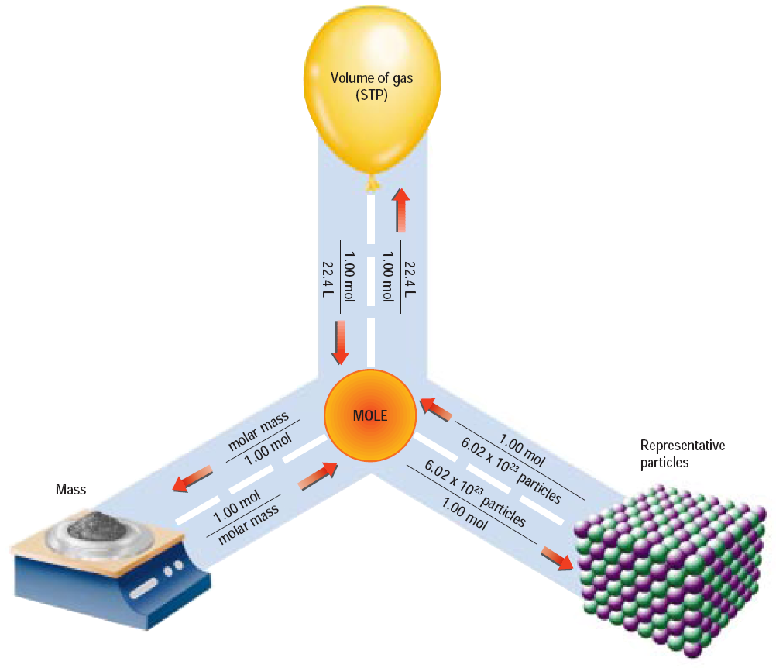**Podcast 6.4 Percent Composition**

* Percent Composition: The relative amounts of each _____________________________________ in a compound expressed as a percent
* Also called “percent by mass”
* % means “part over whole”

Example 1

8.2 g of Magnesium reacts completely with 5.40 g of Oxygen to form a compound. What is the percent composition of each element in the compound?

If all you are given is the formula or name of a compound, then you must use Molar Mass from the Periodic Table

* Example: Calculate the % composition of propane, C3H8.

Percent Composition can also be used as a conversion to solve for mass.

* Calculate the mass of carbon in 82.0 g of propane C3H8

**Podcast 6.5: Empirical and Molecular Formulas**

Consider NaCl (ionic) vs. H2O2 (covalent)

Sketch each compound

Example 1: Write empirical formulas for the following

1. propene (C3H6)
2. ethene (C2H2)
3. glucose (C6H12O6)
4. octane (C8H14)

Example 2: Identify these as an empirical formula, molecular formula, or both

1. H2O
2. C4H10
3. CH
4. NaCl

Steps to Calculate the Empirical Formula

What is the empirical formula of a compound that is 25.9% nitrogen and 74.1% oxygen?

1. Assume that the % given is equal to the number of grams.
2. Convert the number of grams to moles using GAM.
3. Divide by the lowest number of moles to obtain the simplest whole number ratio
4. If necessary, multiply by a whole number to obtain a whole-number ratio

Empirical Formulas

1. % to Mass
2. Mass to Moles
3. ÷ by small
4. × till whole
5. Write the chemical formula using these whole number ratios