Podcast 10.1 – Heat

* Define the System and the Surroundings
* Classify energy changes as Endothermic or Exothermic
* Use appropriate units to measure heat
* Calculate the amount heat transferred in a physical change or chemical change

Thermochemistry: Study of energy changes that occur during chemical reactions and changes in state.

* Kinetic Energy – energy of ____________. Chemists look at HEAT energy.
* Potential Energy – ______________ energy. Chemists look at energy stored in chemical bonds. (More bonds = more energy)
* _______ ,_____ – the energy that transfers form one object to another due to a difference in temperature
* Moves from warmer object to a cooler object
* q = mc∆T

Describing and Calculating Energy

* _________ – “where you focus attention”; chemical reaction, substance, particles, etc
* ________________ – “the rest of the universe”; typically medium surrounding your reaction (like the water in the beaker)
* Thermochemistry looks at the movement of heat between the **system** and **surroundings**
* Law of Conservation of Energy – Energy cannot be _____________ or destroyed
  + transformed from one type to another
  + transferred from one substance to another

Movement of Heat

* ________________: System absorbs heat from surroundings
  + Temperature of surroundings decreases
  + q is **positive**
* ________________: System releases heat to surroundings
  + Temperature of surroundings increases
  + q is **negative**

ΔE ___________ ΔE ___________

Units for Measuring Heat

* _________ (cal) – quantity of heat needed to raise the temp of 1 g of water by 1o C.
* 1 Calorie = 1 kilocalorie = 1000 calories
* _____________ – SI Unit for heat
  + Amount of energy required to move 1 kg a distance of 1 m with an acceleration of 1 m/s2
  + 4.184 J = 1 calorie

Heat Capacity – amount of heat needed to increase the temp. of an object by __________

* Depends on **mass** and **composition**
* Greater mass = larger heat capacity

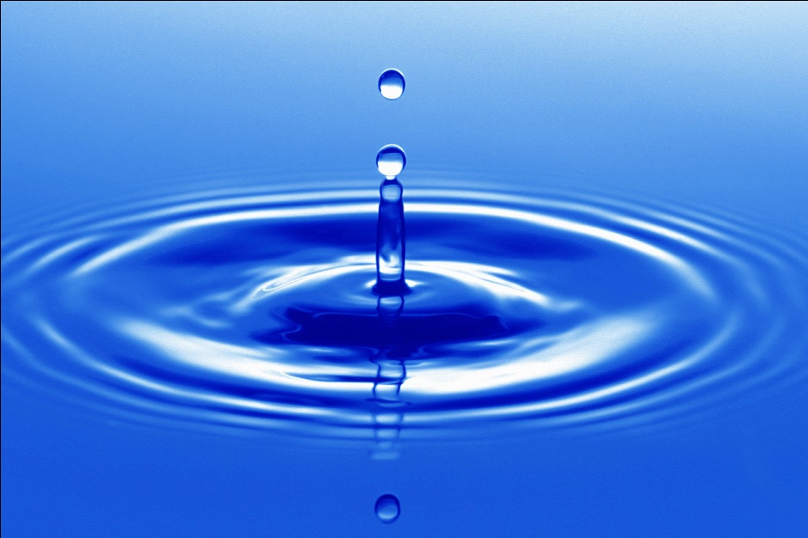

Specific Heat – amount of heat it takes to raise 1 gram of a substance by 1o C

* Heat affects temperature of substances with high specific heat much LESS than those with low specific heat

**q = mc∆T**

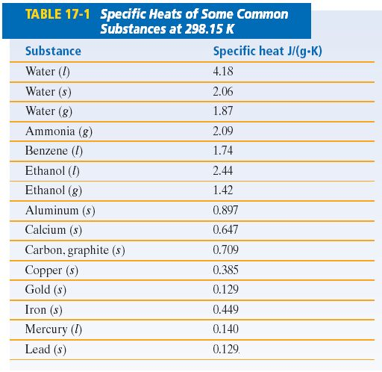Example 1

The specific heat of graphite is 0.71 J/gºC. Calculate the energy needed to raise the temperature of 75 kg of graphite from 294 K to 348 K.

Example 2

When 50.0 mL of water containing 0.50 mol HNO3 at 22.5o C is mixed with 50.0 mL of water containing 0.50 mol KOH at 22.50 C in a styrofoam cup calorimeter, the temperature of the solution increases to 27.3o C. How much heat (in kJ) was released by this reaction?

Podcast 10.2 – Calorimetry (Bookwork: 12-13, 16 pgs. 513-517)

* Explain how a calorimeter is used to calculate heat

absorbed or released by a system.

* Describe the relationship between heat, q, and enthalpy, ΔH.
* Use experimental data to determine the specific heat of a substance.

Calorimetry: precise measure of _______ flow into or out of a system

* Heat that is released or absorbed during many chemical reactions can be measured with ________________
* When heat is released by the system, the same amount is absorbed by the surroundings and vice versa
* Uses a devise to measure heat called a _______________
* Constant Pressure – ________________
* Constant Volume – __________________

Bomb Calorimeter

*Label the parts of the calorimeter in the diagram*

Example 1

The temperature of a piece of unknown metal with a mass of 18.0 g increases from 25.0C to 40C when the metal absorbs 124.2 J of heat. What is the specific heat of the unknown metal? Compare your answer to the values listed in Table 17.1 on p. 508 of your textbook. What is the identity of the unknown metal?

Example 2

An unknown metal with a mass of 10.86 g was heated to a temperature of 100oC, then placed in a calorimeter containing 40mL of water. The temperature of the water rose from 22oC to 27oC. What is the identity of the metal?

Podcast 10.3 – Heat of Reaction

* Apply calorimetry to calculate the amount of heat involved in a

chemical reaction.

* Determine the enthalpy of a reaction indirectly using related

reactions and Hess’s Law.

* Use the Heat of Formation in Hess’s Law to determine the overall heat of reaction.

_____________ – ΔH – Heat of reaction

* Sometimes called “change in enthalpy” or ∆H
* At constant pressure
* In Calorimetery
  + _____________ = substance or reaction
  + _____________ = water
* qsys = - qsurr
* so we can calculate heat for the system based on the temperature change of the surroundings
* msysc sys∆Tsys = -(msurr csurr∆Tsurr)

Thermochemical Equations

* A balanced chemical equation that shows the associated ____________ ___________
* ∆H = ____ (for coffee cup/constant pressure)
* ∆H = + _____________
* ∆H = - _____________

Example:

2NaHCO3 → Na2CO3 + H2O + CO2 ; ∆H = 129 kJ/mol

* Called “heat of _____________”

Hess’s Law

* Method to measure the heat of reaction indirectly
* If you add two or more thermochemical equations to give a final equation, then you can add the ________ ____ __________ (∆H) to give the final heat of reaction
* If you reverse (flip) a reaction, then the sign of ∆H will be _____________
* If you _____________ to adjust the coefficients, then ∆H must also be multiplied by that same number

Example 1: Use the thermochemical equations shown below to determine  
the enthalpy for the final reaction**:** CO2=>C(graphite) + O2

(**1**)3CO2+4H2O(l)→C3H8(g)+5O2(g) ΔH=2220**KJ**

(**2**)H2(g) + 1/2O2(g) → H2O(l) ΔH=-285**KJ**

(**3**)3 C(graphite)+4H2(g) → C3H8(g) ΔH =-104**KJ**

Standard Heats of Formation, ∆H0f

* Change in Enthalpy for the ____________ of one mol of a compound from it elements
* ∆H0f = 0 kJ/mol for pure elements (you can’t “form” elements)
* Used to calculate ∆H0rsn or ∆H0f

∆H0rxn = Σn∆H0f (products) - Σn∆H0f (reactants)

Example 2: What is the standard heat of reaction for the following reaction? (see p. 530 for ∆H0f data )  
2CO (g) + O2(g) 🡪 2CO2(g)

|  |  |
| --- | --- |
| Compound | ∆H0f (kJ/mol) |
| CO2 | -393.5 |
| CO | -110.5 |

Example 3: Calculate the Enthalpy change for the following reaction

CH4 + 2O2 🡪 CO2 + 2H2O; ∆H0rsn = ?

Compound ∆H0f (kJ/mol)

CH4 -74.86

O2 0

CO2 -393.5

H2O -241.8

Example 4:   
C6H5OH(s) + 7 O2(g) → 6 CO2(g) + 3H2O(l)   
When a 2.000-gram sample of pure phenol, C6H5OH(s), is completely burned according to the equation above, 64.98 kilojoules of heat is released.

1. Calculate the molar heat of combustion of phenol in kilojoules per mole at 25°C.
2. Calculate the standard heat of formation, ΔH°f, of phenol in kilojoules per mole at 25°C.

|  |  |
| --- | --- |
| Substance | Standard Heat of Formation, Δ*H*°f, at 25°C (kJ/mol) |
| C(graphite) | 0.00 |
| CO2(g) | -395.5 |
| H2(g) | 0.00 |
| H2O(l) | -285.85 |
| O2(g) | 0.00 |
| C6H5OH(s) | ? |

Podcast 10.4   
Heat in Changes of State

* Define the vocabulary used to describe enthalpy of a physical change.
* Calculate the amount of heat required to bring about a change in state.

Heat in Changes of State

|  |  |  |  |
| --- | --- | --- | --- |
| **Phase Change** | **Heat** | **Symbol** | **Movement of Energy** |
| Melting |  |  |  |
| Freezing |  |  |  |
| Vaporization |  |  |  |
| Condensation |  |  |  |
| Sublimation |  |  |  |
| Deposition |  |  |  |
| Solution |  |  |  |

Example 1: If the heat of fusion for water is 6.01 kJ/mol, how many grams of ice at 0oC will melt if 2.25 kJ of heat are added?

Example 2: How much heat (in kJ) is absorbed when 24.8 g H2O(l) at 100o C and 101.3 kPa is converted to steam at 100oC? The standard enthalpy of vaporization for water is ΔHvap = 40.7 kJ/mol

Example 3: How much heat is released (in kJ) when 2.500 mol NaOH(s) is dissolved in water?  
The molar heat of solution for NaOH is ΔHsoln = -445.11 kJ/mol