Electricity and Magnetism
Attraction or repulsion of charges depends on their signs positives or negatives. Attraction or repulsion of magnets depends on their magnetic ____: ___ or ____.

Opposite poles attract; like poles ____.

A magnetic field is produced by the movement (motion) of ____.

Clusters of magnetically aligned atoms are ____.

A current-carrying wire is surrounded by a ____ field.

When a current-carrying wire is made to form a coil around a piece of iron, the result is an ____.

A charged particle moving in a magnetic field experiences a deflecting ____ that is maximum when the charge moves ____ to the field.

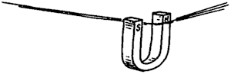

A current-carrying wire experiences a deflecting ____ that is maximum when the wire and magnetic field are ____ to one another.

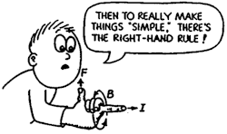

A simple instrument designed to detect electric current is the ____; when calibrated to measure current, it is an ____; when calibrated to measure voltage, it is a ____.

The largest size magnet in the world is the ____ itself.

Iron filings trace out patterns of magnetic field lines about a bar magnet. In the field are some magnetic compasses. The compass needle in only one compass is shown. Discuss with your partner, and draw on paper, the proper compass needle orientations for each compass.

Iron filings trace out the magnetic field pattern about the loop of current-carrying wire. Discuss with your partner, and draw on paper, the proper compass needle orientations for each compass.

