Freebody Diagrams

While studying mechanics, when we examine the forces acting on an object their are five "classic" types that are usually considered:
- weight
- normal
- friction
- tensions
- applied forces

We use freebody diagrams to illustrate the magnitude and direction of all of the forces acting directly on a single object (usually represented by a rectangle). Consider a scenario in which a mass is being pulled across a table by a cord.
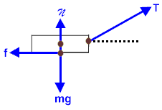
The weight vector begins at the object's center of mass and points towards the center of the earth.

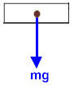
A normal vector begins at the point of contact between the mass and its supporting surface. It is directed perpendicularly away from the surface and passes through the object's center of gravity.
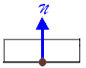
Tensions are forces conducted along strings, ropes, and wires. They begin at the point of contact and point in the direction in which they are pulling.
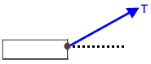
Friction forces begin at the same point as the normal and act parallel to the sliding surface. They always oppose motion.
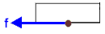
Applied forces is a catch-all, generic category encompassing any other interactions. In our current example, there are no generic applied forces.

If a force acts at an angle, then we usually work with its x- and y-components.
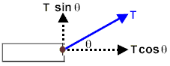
If an object is in static (at rest) or dynamic (constant velocity) equilibrium, then all of the forces acting on it are balanced.
- The magnitude of the forces acting to the left equals the magnitude of the forces acting to the right.
- The magnitude of the forces acting upwards equals the magnitude of the forces acting downwards.
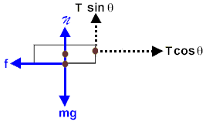
In this case:
x: f = T cos θ
y: + T sin θ = mg

If the forces were not balanced, then the object would be accelerated in the direction of the unbalanced force. For example, using the same forces as in our previous example, if T cos θ were greater than f, then Newton's Second Law will allow us the ability to calculate the object's acceleration towards the right as it starts gaining speed.
net F = ma
T cos θ - f = ma (a > 0)

However, if T cos θ were less than f, then the object would still move towards the right but it would be losing speed.
net F = ma
T cos θ - f = ma (a < 0)

