**Podcast 16.1 Organic Chemistry –Naming Hydrocarbons**

Straight-Chain Hydrocarbons: The Backbone of Organic Molecules

Modifying the Straight Chain: Double Bonds

1. Change ending from –_________ to –___________
2. Specify the location of the bond using number
3. Count carbons to get the ________________________ number in the name

Examples of Double-Bonded Hydrocarbons

1. CH3CH=CHCH2CH3
2. n-propene
3. 3-octene
4. 1,3-butadiene

Triple Bonds

1. Change ending from –____________ to –_____________
2. Specify the location of the bond using number
3. Count carbons to get the LOWEST number in the name

Examples of Triple-Bonded Hydrocarbons

1. n-butyne
2. CH Ξ CCH3
3. 3-heptyne

Branching Hydrocarbons

1. Name the _________________________ chain as the backbone
2. Identify branches by number of Carbons (methyl, ethyl, etc.)
3. Locate each branch using numbers on the backbone
4. List multiple branches in _________________________________________ order

* “Iso-” and “Tert-”

Draw the Structural Formula

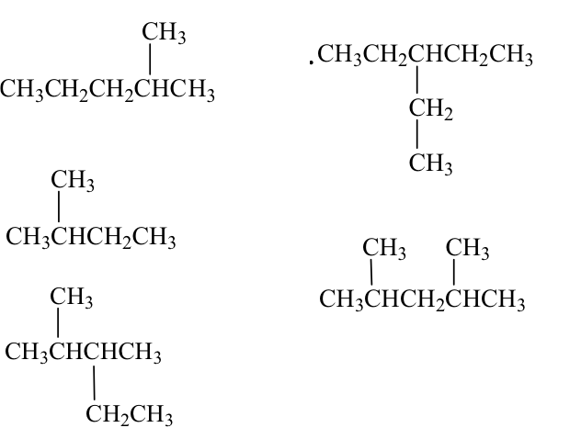2,2,4-Trimethylpentane, also called *isooctane*. This compound is the reference for octane ratings for gasoline

Examples of Branched Hydrocarbons

Cyclic Hydrocarbons

1. Use the prefix ___________________-
2. Name the hydrocarbon
3. Use counting for any branches off the cyclical hydrocarbon

Examples

cyclopentene

Benzene: A Special Cyclo-Alkene

* 6-carbons
* _________________________________ double and single bonds
* Particularly stable configuration

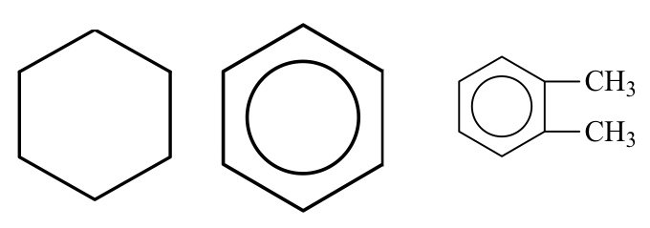

HYDROCARBONS

Fill in the name or formula for the following open-chain hydrocarbons (no cycloalkanes):

|  |  |
| --- | --- |
| 1. C3H8 ____________________  2. C5H8 ____________________  3. C2H4 ____________________  4. C7H16 ____________________  5. C4H10 ____________________  6. C8H16 ____________________  7. C9H16 ____________________  8. C10H22 ____________________  9. ­­­­________ butene  10. ________ octyne  11. ________ propene  12. ________ pentane  13. ________ nonene  14. ________ ethyne  15. ________ hexyne | 16. – 21. Draw and name the three isomers of pentane:  22. Name the following molecule:    23. Draw the molecule:  3-ethyl-2,2,5,5-tetramethyloctane |

**16.2 Functional Groups**

Halo-carbons: Halogens and Hydrocarbons

1. Name the hydrocarbon backbone
2. Add fluoro-, chloro- , bromo- , or iodo- as a prefix
3. Locate the halogen using _________________________________
4. Name multiple halogens in alphabetical order

Examples

1. trichloromethane
2. C6H5Cl
3. 2-bromo-3-methyl-2-butene
4. 

Isomers of C5H11Cl



Ammonia, NH3: Amines and Amides

1. Hydrocarbons can replace the hydrogen in ammonia
2. name the alkyl groups that are attached to the nitrogen
3. End with amine (no space)

Examples

1. triethylamine
2. diethylmethylamine
3. diisopropylamine
4. 

Alcohols: R-OH

1. The __________________ group indicates an alcohol
2. Name the hydrocarbon chain
3. Change the ending to –____________

Examples

1. Methanol
2. Ethanol
3. Isopropyl alcohol
4. 3-ethyl-2,4-dimethyl-3-hexanol



f)



g)



Carboxylic Acids: The “Electron-hog”, Oxygen

1. Name the hydrocarbon backbone
2. The acid is always on the end, so there’s no need to use numbering to locate it
3. Change the ending to –ic, and add the word “acid”

Examples

1. Ethanoic acid
2. Butanoic acid
3. Propenoic acid

Special Challenge Organic Acid

4-bromobenzoic acid

Aldehydes

1. Name the hydrocarbon backbone
2. Always at the end – no need to use numbers
3. Change the ending to –________________

Examples

1. Methanal
2. Propanal
3. 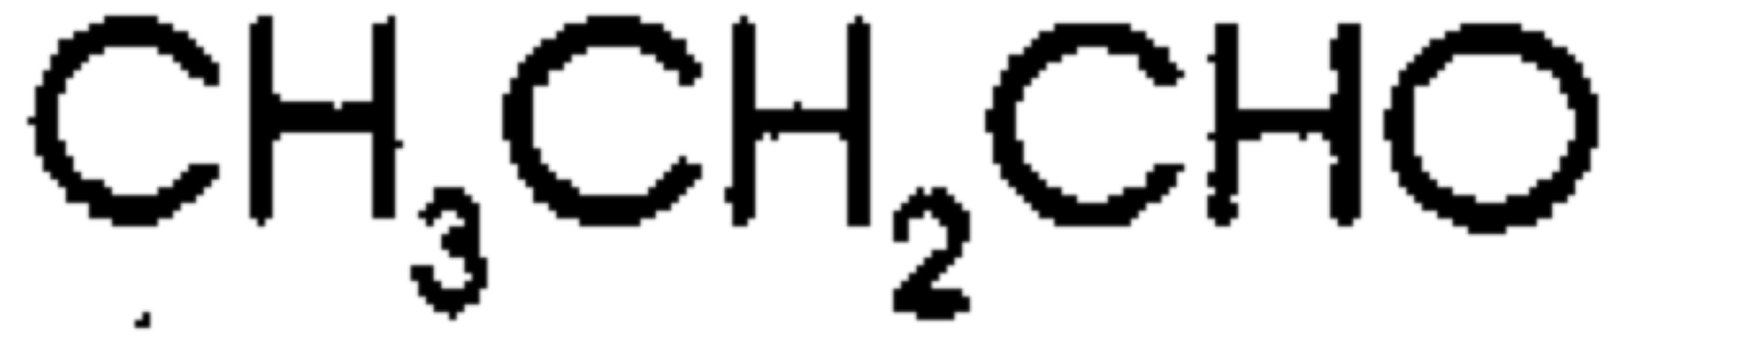

d)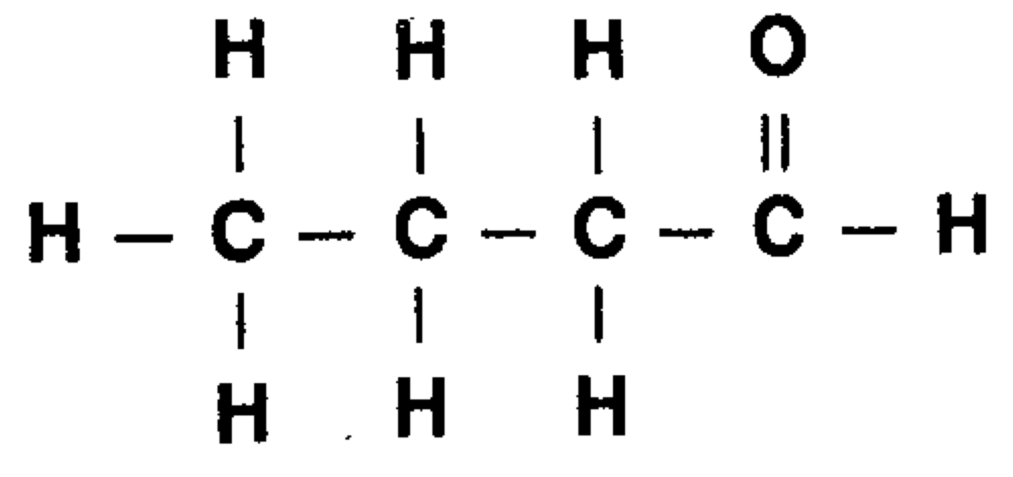

Aldehyde Challenges

2-ethyl-4-methylpentanal



Ketones: ____________________________________ Carbons, Double-bonded O (The carbonyl group)

1. Name the hydrocarbon backbone
2. Locate the ketone group using a number right before the base name
3. Change the ending to –________________________

Examples

1. 3-butanone
2. 2,5,5-trimethyl-4-heptone



Esters

1. Name the group attached to the single bond oxygen as a substituent. Put this in the _____________________________ of the name.
2. Add one space, and then name the carbon chain attached to the _________________________ carbon (double-bonded to the O)
3. Change the ending to –_______________________

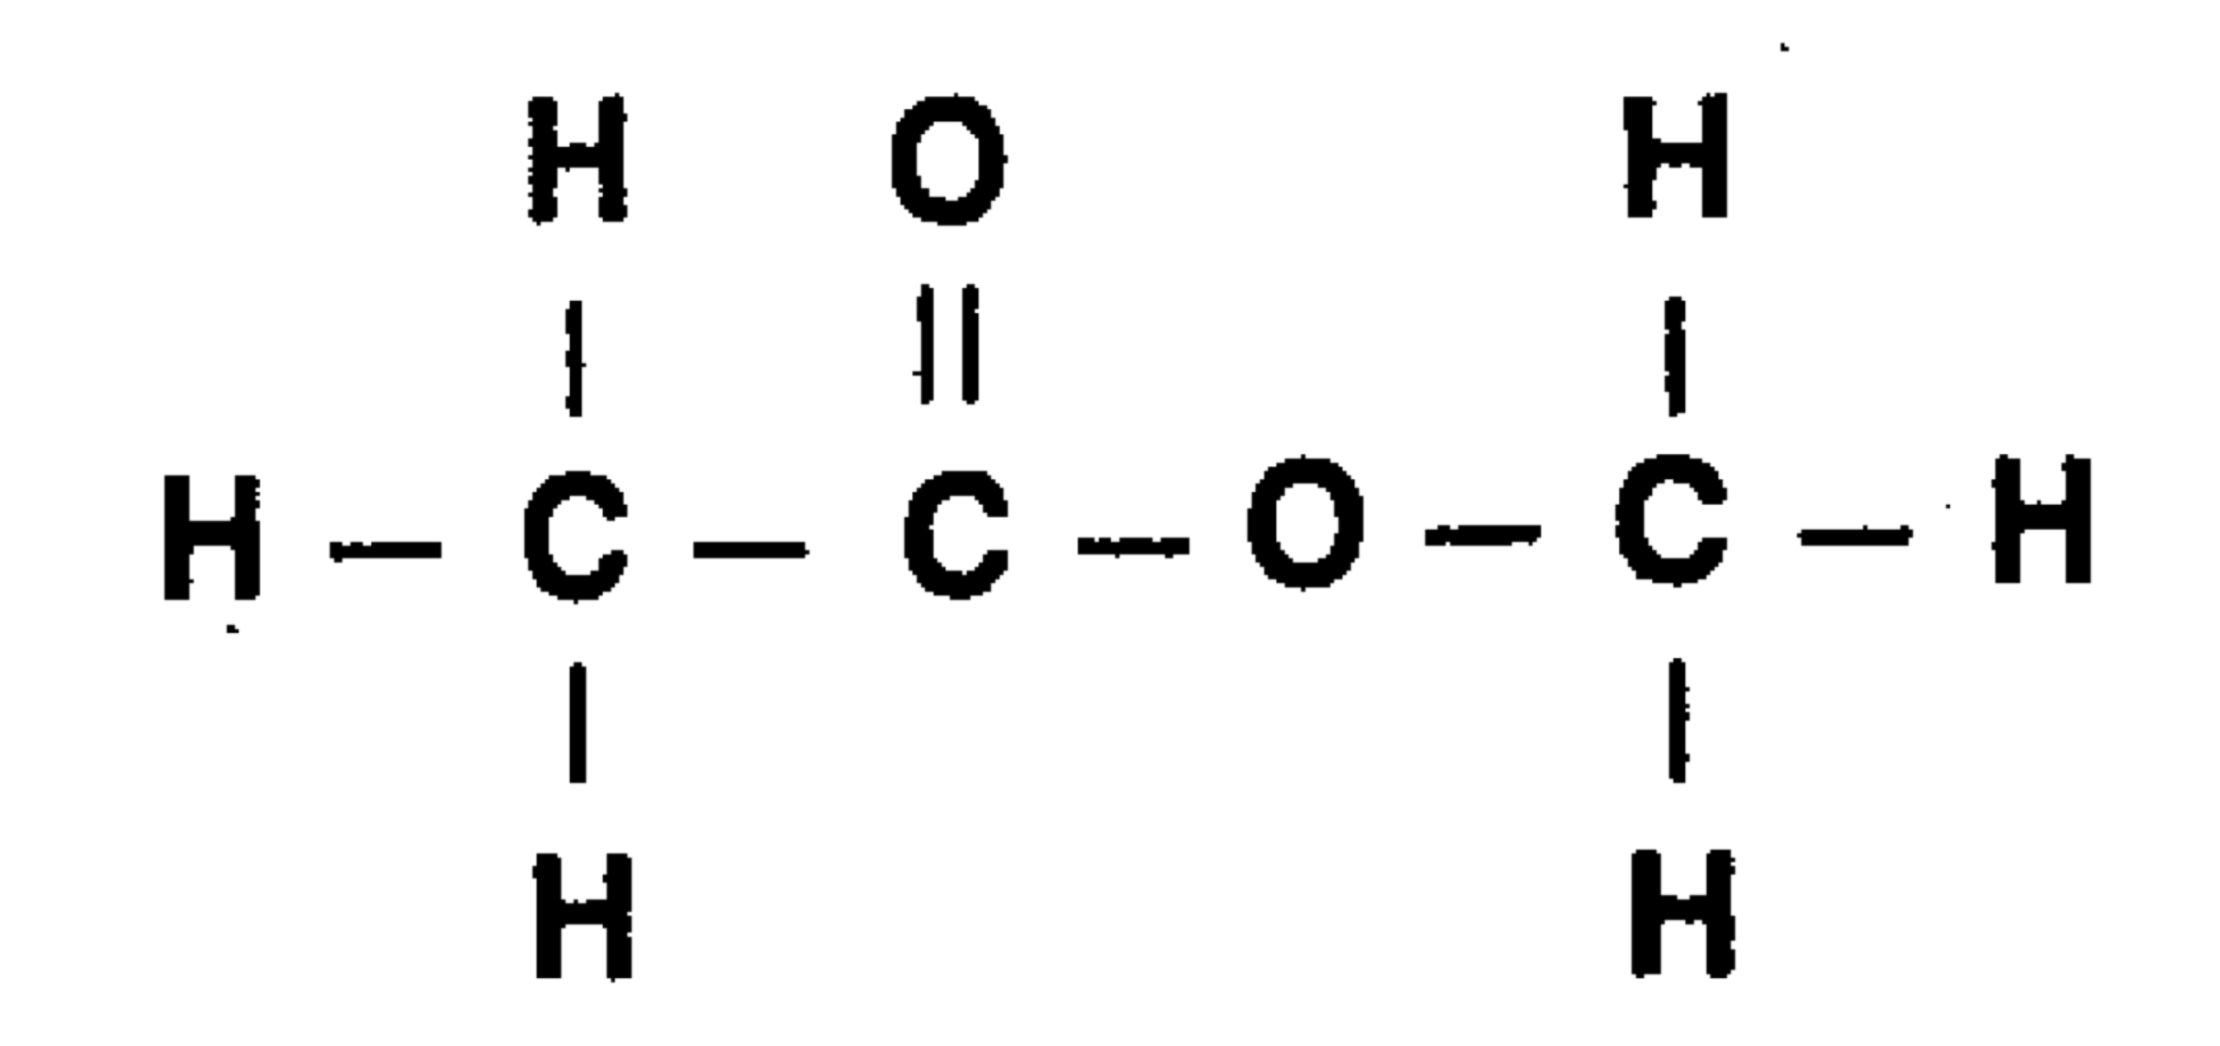Examples:

1. methyl butanoate
2. ethyl propanoate

Ethers

1. Name each hydrocarbon, changing the ending to –__________
2. Add one space, then the word “____________________”

Examples

1. Ethyl-methyl ether

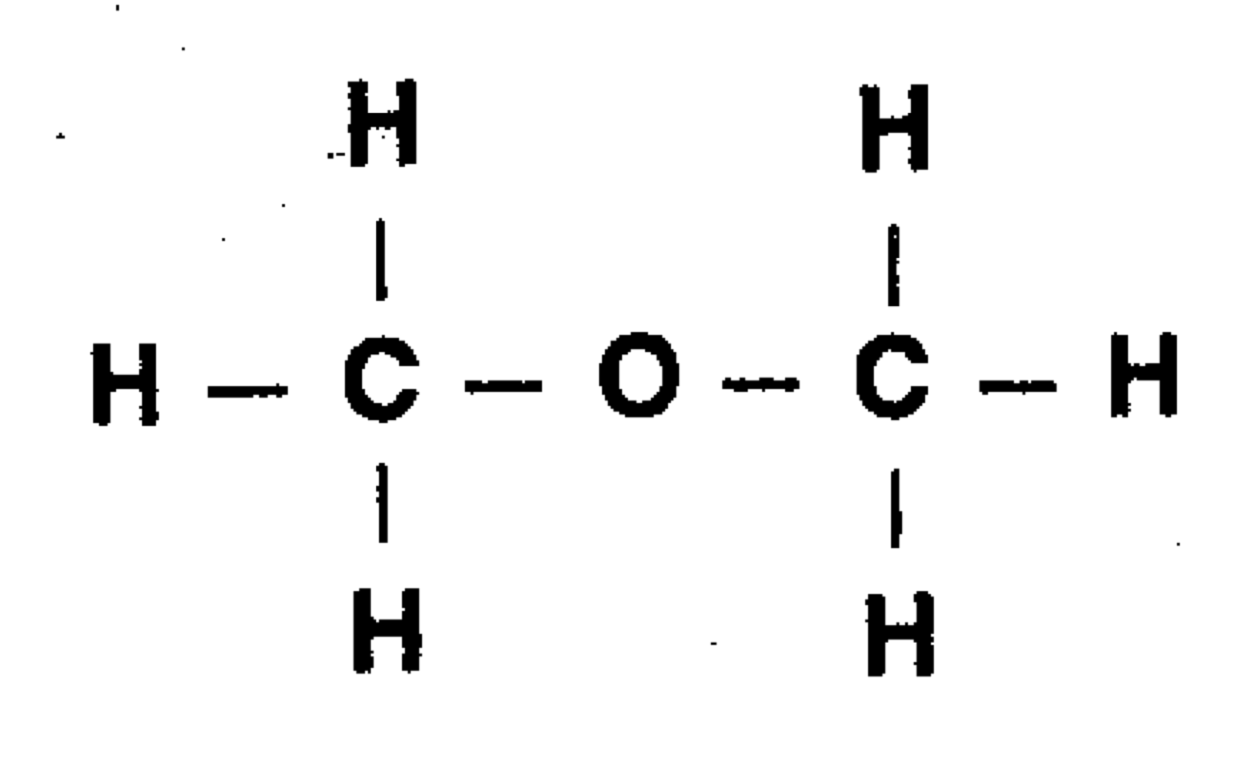

“Essential” to Life: Amino Acids

* Contain both an _____________________________ group and a ___________________________________
* Building blocks of _____________________________
* Do not form branching chains, but rather add together like beads on a necklace
* Folding determines shape
* Shape determines function

**Alanine**

|  |
| --- |
|  |

**Glycine**

|  |
| --- |
|  |

Name _________________________________

Date ___/___/___ Period _________

16 • Organic Chemistry

Organic Nomenclature Practice

|  |  |  |
| --- | --- | --- |
| **Name** | **Formula** | **Structural Formula** |
| **n-butane** | (1) **C4H10**  (2) **CH3CH2CH2CH3** |  |
|  |  |  |
|  |  |  |
|  |  |  |
|  |  |  |
|  |  |  |
|  |  |  |
|  |  |  |
|  |  |  |
|  |  |  |
|  |  |  |
|  |  |  |
|  |  |  |
|  |  |  |

16 • Organic Chemistry

STUDY QUESTIONS

1. Draw the structural formulas for:

a. 2-methylpentane b. 2,2-dimethylpropane

2. Classify the following as alkanes, alkenes, or alkynes

C2H4 C6H10 C3H8 C4H10 C5H12

3. Organic compounds have names with characteristic endings. To what classes of organic compounds do the following endings belong?

a. -oic acid d. -one

b. -ene e. -ol

c. -al f. -oate

4. Draw:

a. an aldehyde with the molecular formula C4H8O

b. a ketone with the molecular formula C4H8O

c. an ester with the molecular formula C3H6O2

d. an ether with the molecular formula C2H6O