Introduction
Crystal violet is a common, beautiful purple dye. In strongly basic solutions, the bright color of the dye slowly fades and the solution becomes colorless. The kinetics of this “fading” reaction can be analyzed by measuring the color intensity or absorbance of the solution versus time to determine the rate law.

Central Challenge
The purpose of this laboratory activity is to determine the rate law for the reaction of crystal violet (CV) and sodium hydroxide (NaOH).

Context for This Investigation
If you’re making something, you might think making it to last would always be a good thing. But what if you’re making a pesticide with known detrimental impacts on human health? Then you may only want it to stay intact for a few days after it has been applied to crops before it decomposes into what often are less harmful products. If its molecules stay intact for too long, the pesticide can persist in the environment and build up in drinking water. In 2000, over 20 million kilograms of the pesticide 1,3-dichloropropene (1,3-D) were applied to crops in the United States. Scientists investigated the rate of decomposition of 1,3-D in acidic, basic, and neutral solutions as well as in soil. For each case, they generated plots of the amount of intact 1,3-D persisting versus time and found that the reaction could be characterized as pseudo first-order. Knowing the order of the reaction allowed them to determine the half-life of intact 1,3-D. In acidic media, they found that the half-life for the decomposition of 1,3-D was about eight days, but in the presence of excess NaOH the half-life was reduced to about four days. Experimentally determined data like this is vital to the ability of society to use chemicals wisely in improving food production, while not endangering the end consumers or the people who work with the chemicals during the growing process.

Safety and Disposal
Crystal violet is a dye that stains skin and clothing. A sodium hydroxide solution is a corrosive skin irritant. You must wear an apron and splash-proof goggles during the lab and use disposable gloves in handling the aqueous solutions of crystal violet and sodium hydroxide. If any of the solutions spilled on your skin, wash with copious amounts of water.

Part I: Guiding Questions
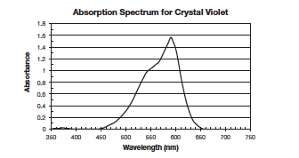
- Based on the absorption spectrum of 25 μM crystal violet in Figure 1 and taking into account the considerations that follow, what wavelength should you use for the Beer’s law calibration curve and subsequent reaction of CV with NaOH? Please explain your answer.
Figure 1. The visible spectrum of a 12.5 micromolar CV solution

- A calibration curve requires the preparation of a set of known concentrations of CV, which are usually prepared by diluting a stock solution whose concentration is known. Describe how to prepare 10. mL of a 5-, 10-, 15-, and 20- μM CV solution using a 25 μM CV stock solution.

- During the reaction of CV with NaOH, do you expect the colorimeter’s absorbance reading to change? How do you expect it to change if such a change is anticipated (i.e., increase, decrease, or no change) as the reaction proceeds? Explain your reasoning.

4. Answer the following questions for a reaction of CV with NaOH in these two scenarios: a solution with a 1:1 NaOH:CV
mole ratio and a solution similar to what you will be using with a 1000:1 NaOH:CV mole ratio.
a. Using your prior knowledge of reaction stoichiometry, what is the final percentage of each reactant
remaining if each reaction went to completion? Show work and reasoning to justify your answer.

b. Based on this result, describe how one gets Equations 3 and 4 from Equation 2 in the Explanation section.

- Using the kinetics chapter in your textbook and websites like “Chemical Kinetics – Integrated rate laws” http://www.chm.davidson.edu/vce/kinetics/IntegratedRateLaws.html, describe the graphical analysis that can be done to determine the order (considering only 0th,1st, or 2nd order) and the value of the pseudo-rate constant, k*, of a chemical reaction from concentration data collected through time.

- Match each linear graph shown below with that expected if the reaction is (a) zero order, (b) first order, and (c) second order with respect to [A].

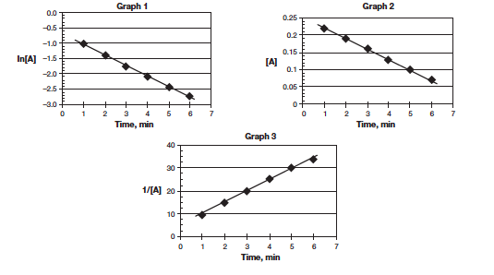

Explanation to Strengthen Student Understanding
As seen in the Gatorade Lab and the Percent of Copper in Brass Lab, Beer’s law is given by Equation 1 here.
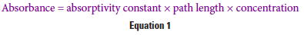
For a fixed concentration of solute and a fixed path length (e.g., fixed cuvette width), the amount of light absorbed by a solution varies directly with the absorptivity constant of the solute. Figure 1 below shows the visible light absorbance spectrum of CV for a fixed, 12.5 μM, concentration of CV and a fixed, 1.0 cm, path length. Because concentration and path length are both kept constant, Figure 1 reveals how the absorptivity constant for CV varies with the wavelength of light passing through the solution. Figure 1 was generated by a spectrophotometer. A colorimeter is an instrument which, like a spectrophotometer, measures how much light is absorbed when passed through a sample but does so for only a few, predetermined wavelengths of light set by the manufacturer.

If we still keep the path length fixed, but now choose only one particular wavelength of light to pass through the solution, thereby fixing the absorptivity constant, we can then observe how the absorbance of light at that wavelength changes as we change the concentration of CV. Under these conditions, Beer’s law describes a straight-line relationship for a graph of absorbance versus solute concentration whose slope is simply the product of the molar absorptivity constant and path length.

In the reaction of CV and sodium hydroxide (see Figure 2), the dye’s color will fade as it reacts with sodium hydroxide. A colorimeter (or spectrophotometer) will be used to follow the disappearance through time of CV by measuring the absorbance of a solution of CV during its reaction with NaOH. The raw absorbance measurements from the colorimeter (or spectrophotometer) can be transformed to molar concentration of CV via the use of a Beer’s law calibration curve.

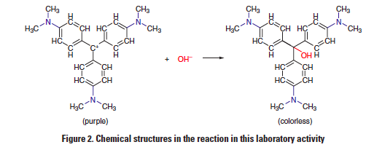
The net ionic equation for the reaction can be written as
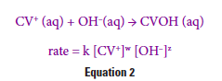
where k is the rate constant while w and z are the order of the reaction with respect to CV+ and OH-, respectively.
Under certain experimental conditions (see prelab Question 4), the rate law in Equation 2 simplifies to the following equation:
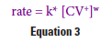
where
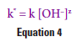
and k* is the pseudo-rate constant. Equation 3 is referred to as the pseudo-rate law, since it is an approximation to Equation 2, the actual rate law, and significantly simplifies the analysis.

A differential rate law describes the rate of a chemical reaction as a function of the concentration of the reactants, while an integrated rate law describes the concentration of a reactant as a function of time; both types of rate laws are related to each other by the use of calculus. Equation 3 is a differential rate law, in which a graphical analysis of the corresponding integrated rate law can be used to determine the value of the parameters in Equation 3 using least-squares linear regression analysis. The degree or extent of linear fit may be evaluated using the coefficient of determination (or square of the correlation coefficient), i.e., it may be used to identify the graph that has a linear relationship.
Laboratory Technique
Calibrate the colorimeter:
Use a blank filled with 6 mL H₂O and 4 mL 0.2 M NaOH to calibrate the colorimeter. Fill the cuvette with the prescribed solution. Set the wavelength on the colorimeter for the appropriate absorbance (see guiding question 1). Place the cuvette in the colorimeter and press the CAL button to calibrate, or zero, the colorimeter.

Trial One – Concentration vs Time:
Carefully measure 6 mL of the stock solution of crystal violet, CV, and 4 mL of 0.2 M NaOH. DO NOT MIX until you are ready to place the reaction into the cuvette. Press “Play” on the Labquest, then mix the solutions, quickly fill the cuvette, and measure the absorbance until the color has faded so much that the absorbance is no longer measureable. Use the known concentration of stock CV to calculate the new initial concentration of CV upon mixing the two solutions.

Trial Two – Concentration vs Time:
Carefully measure 6 mL of the stock solution of crystal violet, CV, and 2 mL of 0.2 M NaOH, and 2 mL H₂O. DO NOT MIX until you are ready to place the reaction into the cuvette. Press “Play” on the Labquest, then mix the solutions, quickly fill the cuvette, and measure the absorbance until the color has faded so much that the absorbance is no longer measureable. Use the known concentration of stock CV to calculate the new initial concentration of CV upon mixing the two solutions.

Analysis
- In your graphing calculator, enter time in L1 and absorbance in L2. Sketch a graph BY HAND of this same data.
- In L3, calculate ln[Abs]. Sketch a graph BY HAND of time (L1) vs ln[Abs] (L3).
- In L4, calculate [Abs]⁻¹ . Sketch a graph BY HAND of time (L1) vs [Abs]⁻¹ (L4).
- Obtain the equation of each line and the corresponding R² value using STATCALCLinReg. Write the equation next to each graph.
- Compare the three graphs and determine the order of the reaction with respect to CV. If necessary, view the Podcast 12.2B http://www.screencast.com/t/lfc0fRysr .
- Compare the slopes of the lines for Trial One and Trial Two, being sure to use the appropriate linear graph (the one whose R² value is closest to 1.00). Applying the differentiated rate law technique, determine the order of the reaction with respect to OH⁻. If necessary, view the Podcast 12.2A http://www.screencast.com/t/KbA0P4HHZ .
- Write the overall rate law for the reaction of the fading of crystal violet.

