Kinetics Simulation
Essential Questions:
- What is the rate at which the reactants are converted into products of a reaction?
- What factors influence the rate of the reaction?
- What is the sequence of steps, or the mechanism, by which the reactants are converted into products?
Reaction #1 http://introchem.chem.okstate.edu/DCICLA/KRGBM.htm
Record the number of particles initially present. Enable the reaction and record the number of particles when no more changes occur.
 | R | BG | B | RG
Initial amount

Amount after reaction

- What is the balanced equation for the reaction?

- How did we decide when the reaction was finished?

Reset the simulation and use the Tracking and Replay settings to watch again to determine which collision result in a change.
- Draw a picture in the box (right) showing how a collision between reactant molecules might form product molecules.
- Even those collisions between particles that can result in a change don’t do so 100% of the time. From your observations, can you propose at least two different reasons why some collisions result in a change and others don’t?

Reaction #2 http://introchem.chem.okstate.edu/DCICLA/K2GBM
Record the number of particles initially present. Enable the reaction and record the number of particles when no more changes occur.
 | G | B | G² | GB | G₂B | B₂
Initial amount

Amount after reaction
- What is the balanced equation for the reaction?

- How does the appearance of the strip chart change as the reaction proceeds?
Reset the simulation and use the Tracking and Replay settings to watch again to determine which collision result in a change.
- Write chemical equation(s) to summarize what’s happening.

- Do the reaction(s) occur at the same rate?

- Propose a mechanism for this reaction that shows how the reactants become products?

- An alternate mechanism is 2G + B G₂B Why is this mechanism less likely than the one you proposed?

Conclusions
- What is a rate law?

- Why does surface area influence the rate of a reaction?

- Why does altering concentration influence the rate of a reaction?

- Why does altering temperature influence the reaction rate?

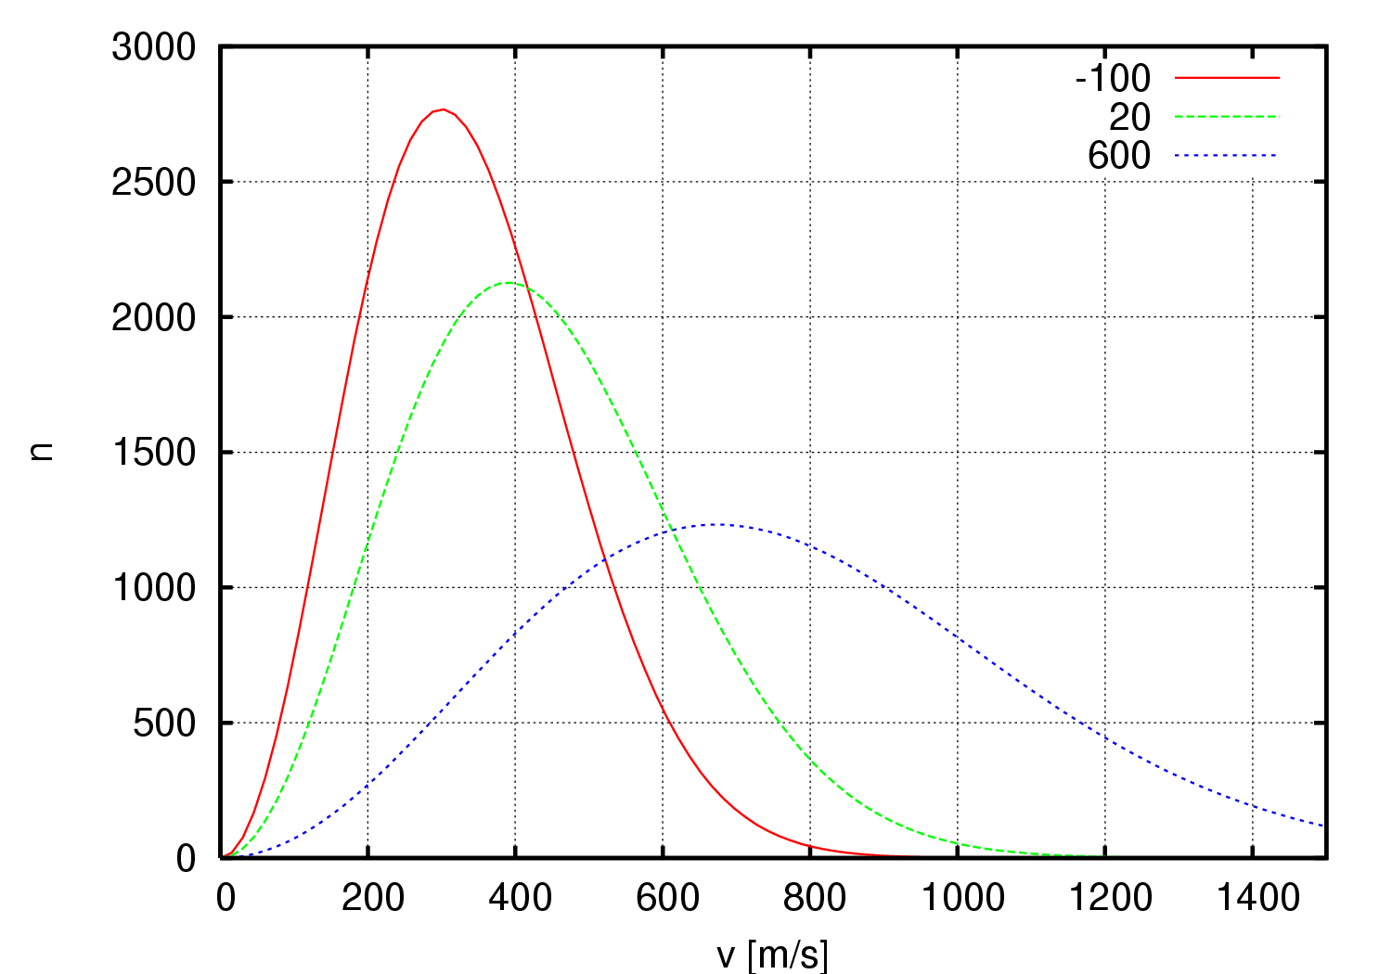

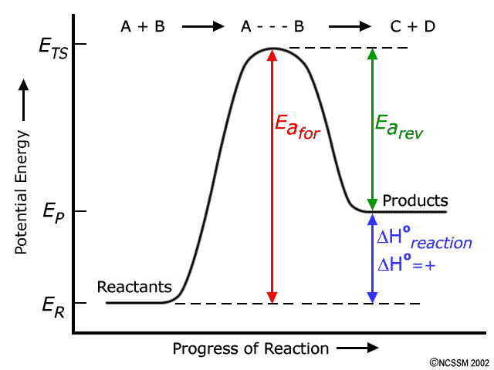
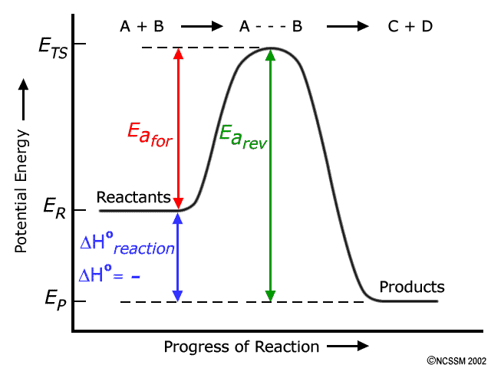

- To reach the activated complex or transition state, what two factors are required?

- In the lab, what are some techniques that can be utilized to measure reaction rates?

- What property of the following systems could be used to measure these reaction rates in real time?
  - 2NO(g) + O₂(g) 2NO₂(g)

  - 2Na₂O(s) + H₂O(l) 2NaOH(aq)

  - 2Fe(s) + 6HCl(aq) 2FeCl₃(aq) + 3H₂(g)

  - Br₂(aq) + HCOOH(aq) 2 Br⁻ (aq) + 2H⁺ (aq) + CO₂(g)

