Reflection and Transmission
Case 1: A pulse in a more dense medium is traveling towards the boundary with a less dense medium.
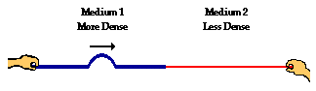
- The reflected pulse in medium 1 ________ (will, will not) be inverted because _________________________________
_______________________________________________
_______________________________________________.
2. The speed of the transmitted pulse will be ___________ (greater than, less than, the same as) the speed of the incident pulse.
3. The speed of the reflected pulse will be ______________ (greater than, less than, the same as) the speed of the incident pulse.
4. The wavelength of the transmitted pulse will be ___________ (greater than, less than, the same as) the wavelength of the incident pulse.
5. The frequency of the transmitted pulse will be ___________ (greater than, less than, the same as) the frequency of the incident pulse.

Case 2: A pulse in a less dense medium is traveling towards the boundary with a more dense medium.
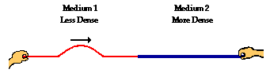
6. The reflected pulse in medium 2 ________ (will, will not) be inverted because _____________________________________
___________________________________________________
___________________________________________________.
7. The speed of the transmitted pulse will be ___________ (greater than, less than, the same as) the speed of the incident pulse.
8. The speed of the reflected pulse will be ______________ (greater than, less than, the same as) the speed of the incident pulse.
9. The wavelength of the transmitted pulse will be ___________ (greater than, less than, the same as) the wavelength of the incident pulse.
10. The frequency of the transmitted pulse will be ___________ (greater than, less than, the same as) the frequency of the incident pulse.

ANSWER KEY
1. will not... because the reflection occurs for a wave in a more dense medium heading towards a less dense medium.
2. faster
3. the same as
4. greater than
5. the same as
6. will... because the reflection occurs for a wave in a less dense medium heading towards a more dense medium.
7. less than
8. the same as
9. less than
10. the same as

