STUDENT LEARNING SCALE: Modifications to the Atomic Theory  4 – Justify the modifications to atomic theory by evaluating implications of each of the historical experiments that led to our current understanding of atomic structure, including but not limited to: John Dalton, Antoine LaVoisier, JJ Thomson, Ernst Rutherford, Max Planck, Niels Bohr, Louis DeBroglie, and Erwin Schroedinger.  3 - Using a variety of experimental data, explain how and why our ideas of relative size, charge, and location of protons, neutrons and electrons have been modified from the ancient Greeks to the Bohr Model.  2 – Describe how ideas of relative size, charge, and location of protons, neutrons and electrons change because of the Plum Pudding Model, the Gold Foil Experiment, and the Bohr Model.  1 – With help, Ss can describe how ideas of relative size, charge, and location of protons, neutrons and electrons change because of the Plum Pudding Model, the Gold Foil Experiment, and the Bohr Model.  0 - With help, Ss are not able to describe how ideas of relative size, charge, and location of protons, neutrons and electrons change because of the Plum Pudding Model, the Gold Foil Experiment, and the Bohr Model. | STUDENT LEARNING SCALE: Atomic Structure  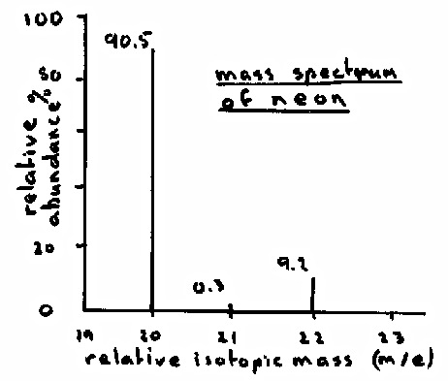  4 – SWBAT Differentiate between isotopes of the same element, ions and/or atoms of different elements to identify atomic number, mass number, and the numbers of protons, neutrons, and electrons using both symbols and models. Given graphical data about isotopes, analyze the average atomic mass for any given element.  Examples: ${{}_{52}^{128}{Te}}^{2-}$  3 – SWBAT Differentiate between isotopes of the same element and/or atoms of different elements to identify atomic number, mass number, and the numbers of protons, neutrons, and electrons using both symbols and models. Given data about isotopes, analyze the average atomic mass for any given element.  Examples: ${}_{39}^{89}Y$  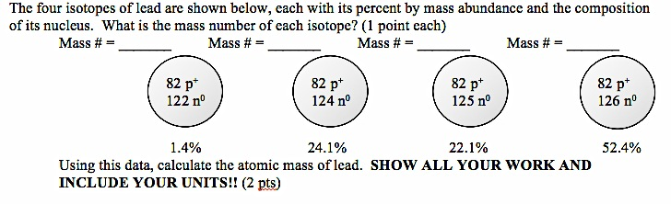  2 – SWBAT Using mass number and atomic number, give the number of protons, electrons, and neutrons in isotopes and/or atoms. Given data about 3 or fewer isotopes, calculate the average atomic mass for any given element.  1 – SWBAT With help, Ss are able to use mass number and atomic number to determine the number of protons, electrons, and neutrons in isotopes and/or atoms. Given data about 2 or 3 isotopes, calculate the average atomic mass for any given element.  0 – Even with help, Ss are not able to use mass number and atomic number to determine the number of protons, electrons, and neutrons in isotopes and/or atoms. Given data about 2 or 3 isotopes, calculate the average atomic mass for any given element.

Learning Scale Reflections:

Day 1: What content do YOU feel confident about? (What do you know)
What content do YOU still struggle with? (What do you need to know)
What are you going to do to increase your? (How will you get there)

Day 2: What content do YOU feel confident about? (What do you know)
What content do YOU still struggle with? (What do you need to know)
What are you going to do to increase your? (How will you get there)

Day 3: What content do YOU feel confident about? (What do you know)
What content do YOU still struggle with? (What do you need to know)
What are you going to do to increase your? (How will you get there)

Day 4: What content do YOU feel confident about? (What do you know)
What content do YOU still struggle with? (What do you need to know)
What are you going to do to increase your? (How will you get there)

Day 5: What content do YOU feel confident about? (What do you know)
What content do YOU still struggle with? (What do you need to know)
What are you going to do to increase your? (How will you get there)

