Unit 7 Review – Electrostatic Charges, Forces, and Fields
Helpful Hints
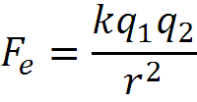
$$F_{e}=EQ$$
$$E=k\frac{Q}{r^{2}}$$
$$E=\frac{V}{d}$$
k = 9.00 x 10⁹ Nm²/C²
m_{e} = 9.11 x 10⁻³¹ kg
m_{p} = 1.67 x 10⁻²⁷ kg
e = -1.60 x 10 ⁻¹⁹ C
- When an electron is added to a neutral atom, the atom becomes
  - a negative ion
  - more massive
  - a positive ion
  - heavier

- A balloon is rubbed with a piece of fur. During the process, the balloon acquires a negative charge and the fur
  - acquires a positive charge also
  - could either be positively charged or negatively charged, depending on how hard the balloon was rubbed
  - remains neutral
  - acquires a negative charge

- Two charged objects attract each other with a certain force. If the charges on both objects are halved with no change in the distance between them, the force
  - Is reduced by half
  - increases, but we can’t say how much without knowing the distance between them
  - becomes zero
  - doubles
  - Is reduced by one fourth

- Sphere X carries a net charge and sphere Y is neutral. They are placed near each other on an insulated table. Which statement best describes the electrostatic force between them?
  - There is no force between them since one is neutral.
  - The force is attractive if X is charged positively and repulsive if X is charged negatively.
  - There is a force of repulsion between them.
  - There is a force of attraction between them.

- A piece of plastic has a net charge of -14.00 μC. How many more electrons than protons does this piece of plastic have? (Sketch not required)

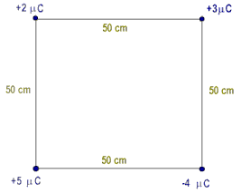
+3μC
40 mm
- There is a +3.0 μC charge at each of 3 corners of a square (each side 40. mm long). What is the force on +6.0 μC placed at the center of the square.
40 mm

+3μC
+3μC

- Consider a container of 1.0 grams of hydrogen atoms (one gram mole). Suppose you removed all the electrons and moved them to the other side of the Earth (Earth diameter 12740. km).
(a) How much charge is left behind?
(b) What is the attractive force between the protons here and the electrons at the other side of the Earth?

- In a lithium atom, ,the valence electron and 3-proton nucleus are separated by 0.20 nm.
  - What is the magnitude of the force on the electron?
  - What is the net force on the system?

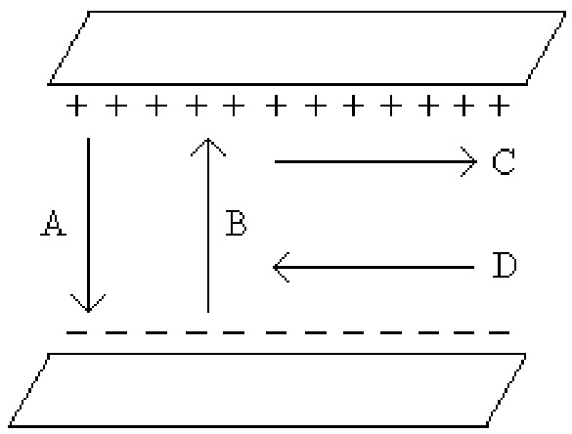
- Which of the arrows shown in the figure at right represents the correct direction that a negative charge would accelerate in the electric field between the two metal plates?
  - A
  - B
  - C
  - D
  - None of the above

- Electric field lines
  - are closer together the stronger the field.
  - start on positive charges and end on negative charges.
  - are perpendicular to the surface of the object.
  - all of the above
- In the diagram to the right, each of the charges shown are ±1.0 C.
  - What is the magnitude and direction of the electrical force on the negatively-charged particle?
  - If the negatively-charged particle has a mass of 25 grams, what is the magnitude and direction of the acceleration it will experience within this electrical field?
225cm
132cm
90º

- A test charge of -2.5 C in a field of strength 8.8 N/C would feel what force?

- What is the value of the electric field when a +8.6 V potential is found 0.9 mm from its center?

- What is the electrostatic potential found 0.83m from the center of a 9.2 V/m field?

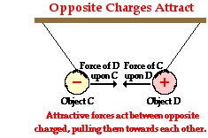

- A balloon, D is electrostatically charged with 4.35 μC of charge. A second balloon, C, 20 cm away is charged with -3.90 μC of charge. If you consider the balloons to be point charges, what is the force between them?

- If one of the balloons has a mass of 0.0620 kg, with what acceleration does it move toward or away from the other balloon?

- Calculate the tension force on one of the strings holding up the balloons.

