Sound and Light Review
Two major classes of waves are longitudinal and transverse. Sound waves are
longitudinal | transverse

The frequency of a sound signal refers to how frequently the vibrations occur. A high-frequency sound is heard at a high
pitch | wavelength | speed

The sketch below shows a snap shot of the compressions and rarefactions of the air in a tube as the sound moves toward the right. The dots represent molecules.
Using the ruler provided, the wavelength of the sound wave is measured to be

Compared to the wavelengths of high-pitched sounds, the wavelengths of low-pitched sounds are
long | short

Sound waves travel fastest in
solids | liquids | gases | ... the same speed in each

The accepted value for the speed of sound in air is 331 m/s at 0ºC. The speed of sound in air increases 0.6 m/s for each Celsius degree above zero. Compute the speed of sound at the temperature of the room you are now in.
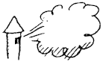
Refer to the following information for the next two questions.

Suppose you set your watch by the sound of the noon whistle from a factory 3 km away.
Compared to the correct time, your watch will be

It will differ from the correct time by
3 seconds | 6 seconds | 9 seconds

The first investigation that led to a determination of the speed of light was performed in about 1675 by the Danish astronomer Olaus Roemer. He made careful measurements of the period of Io, a moon about the planet Jupiter, and was surprised to find an irregularity in Io's observed period. While the earth was moving away from Jupiter, the measured periods were slightly longer than average. While the earth approached Jupiter, they were shorter than average. Roemer estimated that the cumulative discrepancy amounted to about 16.5 minutes. Later interpretations showed that what occurs is that light takes about 16.5 minutes to travel the extra distance across the earth's orbit. Aha! We have enough information to calculate the speed of light!
What is the diameter, in meters, of the earth's orbit around the sun?

According to Roemer, about how many seconds does it take light to travel across the diameter of the earth's orbit?

How do these two quantities determine the speed of light?

The sketch shows the shadow of your hand held in front of a white screen in a darkened room. The light source is red, so the screen looks red and the shadow looks black. Discuss below the colors belonging in each part of the sketch.
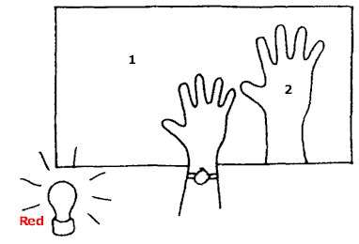

The color of region 1 on the diagram is
blue | cyan | green | magenta | red | yellow | black | white

The color of region 2 on the diagram is
blue | cyan | green | magenta | red | yellow | black | white

A green lamp is turned on and makes a second shadow. The formerly black shadow cast by the red light is no longer black, but is illuminated with green light. So it is green. Color or mark it green. The shadow cast by the green lamp is not black, because it is illuminated with the red light. Color or mark its color. The background receives a mixture of red and green light. Discuss below the colors belonging in each part of the sketch.
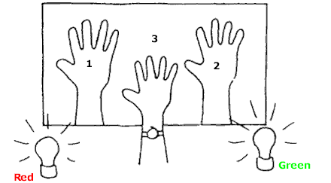

The color of region 1 on the diagram is
blue | cyan | green | magenta | red | yellow | black | white

The color of region 2 on the diagram is
blue | cyan | green | magenta | red | yellow | black | white

The color of region 3 on the diagram is
blue | cyan | green | magenta | red | yellow | black | white

Light from a flashlight shines on a mirror and illuminates one of the cards. Draw the reflected beam to indicate the illuminated card.

Which card would you see?

A periscope has a pair of mirrors in it. Draw the light path from the object to the eye of the observer.

At what angle must each mirror be tilted?
The ray diagram below shows one of the reflected rays from the plane mirror. Complete the diagram by drawing the three other reflected rays. (Assume that the candle and image are viewed by an observer on the left.)

How far "behind the mirror" is your image located? (remember to measure along a normal - that is, along a line that is perpendicular to the mirror)

The ray diagram below shows the reflection of one of the rays that strikes the parabolic mirror. Notice that the law of reflection is obeyed, and the angle of incidence (from the normal, the dashed line) equals the angle of reflection (from the normal). Complete the diagram by drawing the reflected rays of the other three rays that are shown.
Why are parabolic mirrors used in automobile headlights?

The sketch shows that due to refraction, the man sees the fish closer to the water surface than it actually is.

Discuss below the direction a ray beginning at the fish's eye would follow to show the fish's line of sight when it looks upward at 50° to the normal at the water surface. The critical angle for a water-air interface is 48º.

At the 50° angle, does the fish see the man, or does it see the reflected view of the starfish at the bottom of the pond? Explain.

To see the man, should the fish look higher or lower than the 50° path?
higher | lower

If the fish's eye were barely above the water surface, it would see the world above in a 180° view, horizon to horizon. The fish-eye view of the world above as seen beneath the water, however, is very different. Due to the 48° critical angle of water, the fish sees a normally 180° horizon-to-horizon view compressed within an angle of

A pair of toy cart wheels are rolled obliquely from a smooth surface onto two plots of grass - a rectangular plot as shown at the left, and a triangular plot as shown at the right. The ground is on a slight incline so that after slowing down in the grass, the wheels speed up again when emerging on the smooth surface.

Discuss below the path and direction of travel for each cart. You need to finish each sketch on a sheet of paper. Be sure to show the orientation of the wheels inside the plots and on the other side.

Describe the cart's path through the rectangular plot.

Describe the cart's path through the triangular plot.

Red, green, and blue rays of light are Incident upon a glass prism as shown below. The average speed of red light in the glass is less than in air, so the red ray is refracted. When it emerges into the air it regains its original speed and travels in the direction shown. Green light takes longer to get through the glass. Because of its slower speed it is refracted as shown. Blue light travels even slower in glass.

Discuss below the path and direction of travel of the blue ray.

Below we consider a prism-shaped hole in a piece of glass - that is, an "air prism."
Discuss below the path and direction of travel of the beams of red, green, and blue light as they pass through this "prism" and back into the glass.

Light of different colors diverges when emerging from a prism. Newton showed that with a second prism he could make the diverging beams become parallel again.
Which placement of the second prism will do this?

Rays of light bend as shown below when passing through several glass blocks.

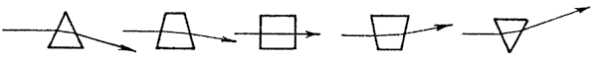

1. Discuss below how light rays bend when they pass through the arrangement of glass blocks shown below.

2. Sketch how light rays bend when they pass through the lens shown below. Is the lens a converging or a diverging lens? What is your evidence?

3. Discuss below how light rays bend when they pass through the arrangement of glass blocks shown below.

4. Sketch how light rays bend when they pass through the lens shown below. Is the lens a converging or a diverging lens? What is your evidence?

5a. Which type of lens is used to correct farsightedness?
#2, converging | #4, diverging

5b. Which type of lens is used to correct nearsightedness?
#2, converging | #4, diverging

